UNITED STATES
SECURITIES AND EXCHANGE COMMISSION
WASHINGTON, DC 20549

FORM 8-K

CURRENT REPORT

Pursuant to Section 13 or 15(d) of the Securities Exchange Act of 1934

Date of Report (Date of earliest event reported): August 6, 2026

Commission File Number: 001-39896

PLAYTIKA HOLDING CORP.
(Exact Name of Registrant as Specified in its Charter)

Delaware |  |  |  |  |  | 81-3634591
(State of other jurisdiction |  |  |  |  |  | (I.R.S. Employer
of incorporation or organization) |  |  |  |  |  | Identification No.)
c/o Playtika Ltd.
HaChoshlim St 8
Herzliya Pituach, Israel
972-73-316-3251
(Address, including zip code, and telephone number, including area code, of registrant’s principal executive offices)

Check the appropriate box below if the Form 8-K filing is intended to simultaneously satisfy the filing obligation of the registrant under any of the following provisions (see General Instruction A.2. below):

☐ Written communications pursuant to Rule 425 under the Securities Act (17 CFR 230.425)

☐ Soliciting material pursuant to Rule 14a-12 under the Exchange Act (17 CFR 240.14a-12)

☐ Pre-commencement communications pursuant to Rule 14d-2(b) under the Exchange Act (17 CFR 240.14d-2(b))

☐ Pre-commencement communications pursuant to Rule 13e-4(c) under the Exchange Act (17 CFR 240.13e-4(c))

Securities registered pursuant to Section 12(b) of the Act:
Title of each class |  |  | Trading Symbol(s) |  |  | Name of each exchange on which registered
Common Stock, $0.01 par value |  |  | PLTK |  |  | The Nasdaq Stock Market LLC

Indicate by check mark whether the registrant is an emerging growth company as defined in Rule 405 of the Securities Act of 1933 (§ 230.405 of this chapter) or Rule 12b-2 of the Securities Exchange Act of 1934 (§ 240.12b 2 of this chapter).
Emerging growth company ☐

If an emerging growth company, indicate by check mark if the registrant has elected not to use the extended transition period for complying with any new or revised financial accounting standards provided pursuant to Section 13(a) of the Exchange Act. ☐

Item 2.02 Results of Operations and Financial Condition.

On August 6, 2026, Playtika Holding Corp. issued a press release announcing its financial results for the quarter ended June 30, 2026. A copy of the press release is furnished herewith as Exhibit 99.1.

In accordance with General Instruction B.2. of Form 8-K, the information in this Item 2.02, including Exhibit 99.1, shall not be deemed “filed” for purposes of Section 18 of the Securities Exchange Act of 1934, as amended, or the Exchange Act, or otherwise subject to the liabilities of that Section, nor shall it be deemed incorporated by reference in any filing under the Securities Act of 1933, as amended, or the Exchange Act, except as expressly set forth by specific reference in such a filing.

Item 9.01 Financial Statements and Exhibits.

(d) Exhibits

99.1 |  |  |  |  |  | Press Release dated August 6, 2026
99.2 |  |  |  |  |  | Second Quarter 2026 Earnings Presentation
104 |  |  |  |  |  | Cover page interactive data file (embedded within the Inline XBRL document).

SIGNATURES

Pursuant to the requirements of the Securities Exchange Act of 1934, the registrant has duly caused this report to be signed on its behalf by the undersigned, thereunto duly authorized.

 |  |  | PLAYTIKA HOLDING CORP.
 |  |  | Registrant
By: |  |  | /s/ Tae Lee
 |  |  | Tae Lee
 |  |  | Chief Financial Officer
Dated as of August 6, 2026

Exhibit 99.1

Playtika Holding Corp. Reports Q2 2026 Financial Results
Revenue of $731.1 million and Direct-to-Consumer (“DTC”) Revenue of $286.9 million
Revenue Decreased (1.8)% Sequentially and Increased 5.0% Year Over Year
DTC Platforms Revenue Decreased (1.7)% Sequentially and Increased 63.1% Year Over Year

Herzliya, Israel - August 6, 2026 - Playtika Holding Corp. (NASDAQ: PLTK) today released financial results for its second quarter for the period ending June 30, 2026.

Financial Highlights

•Revenue of $731.1 million decreased (1.8)% sequentially and increased 5.0% year over year.
•DTC platforms revenue of $286.9 million decreased (1.7)% sequentially and increased 63.1% year over year.
•Net Income of $48.0 million and Adjusted Net Income of $53.6 million.
•Adjusted EBITDA of $206.1 million increased 64.6% sequentially and 23.4% year over year.
•Cash, cash equivalents, and short-term investments totaled $438.5 million as of June 30, 2026.

“Our second quarter results demonstrate what has always been at the heart of Playtika, we build games that keep players engaged for years, not quarters,” said Robert Antokol, Chief Executive Officer. “Disney Solitaire grew again this quarter even as we reduced our marketing investment and our margins expanded meaningfully. These results reflect the durability of our model and the discipline of our execution.”

“Our second quarter reflected the investment cadence we outlined last quarter, marketing stepped down materially, margins expanded, and SuperPlay became a positive Adjusted EBITDA contributor,” said Tae Lee, Chief Financial Officer.

Selected Operational Metrics and Business Highlights

•Average Daily Paying Users of 367K decreased (5.2)% sequentially and (2.9)% year over year.
•Average Payer Conversion of 4.6%, up from 4.5% in Q1 2026 and 4.3% in Q2 2025.
•Bingo Blitz revenue of $145.1 million decreased (5.6)% sequentially and (9.5)% year over year.
•Disney Solitaire revenue of $142.4 million increased 15.5% sequentially and 288.6% year over year.
•June’s Journey revenue of $74.7 million decreased (1.7)% sequentially and increased 8.1% year over year.

Financial Outlook

We are reaffirming our full-year 2026 guidance ranges of $2.75 - $2.85 billion in revenue and $750 - $790 million in Adjusted EBITDA. Based on current trends, including a more cautious view of consumer spending and the planned step-down in second-half marketing investment, we currently expect full-year results to finish toward the lower end of both ranges.

Conference Call

Playtika management will host a conference call at 5:30 a.m. Pacific Time (8:30 a.m. Eastern Time) today to discuss the company’s results. The conference call can be accessed via a webcast accessible at investors.playtika.com. A replay of the call will be available through the website one hour following the call and will be archived for one year.

Summary Operating Results of Playtika Holding Corp.

 |  |  | Three months ended June 30, |  |  |  |  |  |  |  |  |  |  |  | Six months ended June 30,
(in millions, except percentages, Average DPUs, and ARPDAU) |  |  | 2026 |  |  |  |  |  | 2025 |  |  |  |  |  | 2026 |  |  |  |  |  | 2025
Revenues |  |  | $ | 731.1 |  |  |  |  | $ | 696.0 |  |  |  |  | $ | 1,475.8 |  |  |  |  | $ | 1,402.0
Total costs and expenses |  |  | $ | 596.5 |  |  |  |  | $ | 586.3 |  |  |  |  | $ | 1,390.8 |  |  |  |  | $ | 1,224.5
Operating income (loss) |  |  | $ | 134.6 |  |  |  |  | $ | 109.7 |  |  |  |  | $ | 85.0 |  |  |  |  | $ | 177.5
Net income (loss) |  |  | $ | 48.0 |  |  |  |  | $ | 33.2 |  |  |  |  | $ | (9.5) |  |  |  |  | $ | 63.8
Adjusted EBITDA |  |  | $ | 206.1 |  |  |  |  | $ | 167.0 |  |  |  |  | $ | 331.3 |  |  |  |  | $ | 334.3
Net income margin |  |  | 6.6 |  | % |  |  |  | 4.8 |  | % |  |  |  | (0.6) |  | % |  |  |  | 4.6 |  | %
Adjusted EBITDA margin |  |  | 28.2 |  | % |  |  |  | 24.0 |  | % |  |  |  | 22.4 |  | % |  |  |  | 23.8 |  | %
Non-financial performance metrics
Average DAUs |  |  | 8.0 |  |  |  |  |  | 8.8 |  |  |  |  |  | 8.3 |  |  |  |  |  | 8.9
Average DPUs (in thousands) |  |  | 367 |  |  |  |  |  | 378 |  |  |  |  |  | 377 |  |  |  |  |  | 384
Average Daily Payer Conversion |  |  | 4.6 |  | % |  |  |  | 4.3 |  | % |  |  |  | 4.6 |  | % |  |  |  | 4.3 |  | %
ARPDAU |  |  | $ | 1.01 |  |  |  |  | $ | 0.87 |  |  |  |  | $ | 0.99 |  |  |  |  | $ | 0.87
Average MAUs |  |  | 24.8 |  |  |  |  |  | 30.0 |  |  |  |  |  | 27.5 |  |  |  |  |  | 30.9

About Playtika Holding Corp.

Playtika (NASDAQ: PLTK) is a mobile gaming entertainment and technology market leader with a portfolio of multiple game titles. Founded in 2010, Playtika was among the first to offer free-to-play social games on social networks and, shortly after, on mobile platforms. Headquartered in Herzliya, Israel, and guided by a mission to entertain the world through infinite ways to play, Playtika has employees across offices worldwide.

Forward Looking Information

This press release contains “forward-looking statements” within the meaning of the U.S. Private Securities Litigation Reform Act of 1995 and Section 21E of the Exchange Act. All statements other than statements of historical facts contained in this press release, including statements regarding our business strategy, plans and our objectives for future operations, are forward-looking statements. Further, statements that include words such as “anticipate,” “believe,” “continue,” “could,” “estimate,” “expect,” “future,” “intend,” “intent,” “may,” “might,” “potential,” “present,” “preserve,” “project,” “pursue,” “should,” “will,” or “would,” or the negative of these words or other words or expressions of similar meaning may identify forward-looking statements.

We have based these forward-looking statements largely on our current expectations and projections about future events and trends that we believe may affect our financial condition, results of operations, business strategy, short-term and long-term business operations and objectives, and financial needs. The achievement or success of the matters covered by such forward-looking statements involves significant risks, uncertainties and assumptions, including, but not limited to, the risks and uncertainties discussed in our filings with the Securities and Exchange Commission. Moreover, we operate in a very competitive and rapidly changing environment and industry. As a result, it is not possible for our management to assess the impact of all factors on our business or the extent to which any factor, or combination of factors, may cause actual results to differ materially from those contained in any forward-looking statements we may make. In light of these risks, uncertainties and assumptions, the forward-looking statements discussed in this press release may not occur and actual results could differ materially and adversely from those anticipated, predicted or implied in the forward-looking statements.

Important factors that could cause actual results to differ materially from estimates or projections contained in the forward-looking statements include without limitation:

•actions of our majority shareholder or other third parties that influence us;
•our reliance on third-party platforms, such as the iOS App Store and Google Play Store, to distribute our games and collect revenues, and the risk that such platforms may adversely change their policies;
•our reliance on a limited number of games to generate the majority of our revenue;
•our reliance on a small percentage of total users to generate a majority of our revenue;
•our free-to-play business model, and the value of virtual items sold in our games, is highly dependent on how we manage the game revenues and pricing models;
•our inability to refinance our indebtedness, including, without limitation, our $550 million revolving credit facility which is set to expire in March 2027, or to obtain additional financing on favorable terms or at all;
•our inability to identify acquisition targets that fit our strategy or complete acquisitions and integrate any acquired businesses successfully or realize the anticipated benefits of such acquisitions could limit our growth, disrupt our plans and operations or impact the amount of capital allocated to mergers and acquisitions;
•our ability to compete in a highly competitive industry with low barriers to entry;
•our ability to retain existing players, attract new players and increase the monetization of our player base;
•our ability to develop and/or launch new products and content or otherwise execute against our product roadmap strategy;
•we have significant indebtedness and are subject to the obligations and restrictive covenants under our debt instruments;
•the impact of an economic recession or periods of increased inflation, and any reductions to household spending on the types of discretionary entertainment we offer;
•our controlled company status;
•legal or regulatory restrictions or proceedings could adversely impact our business and limit the growth of our operations;
•risks related to our international operations and ownership, including our significant operations in Israel and Ukraine and the fact that our controlling stockholder is a Chinese-owned company;
•geopolitical events such as the Wars in Israel and Ukraine;
•our reliance on key personnel;
•market conditions or other factors affecting the payment of dividends, including the decision whether or not to pay a dividend;
•uncertainties regarding the amount and timing of repurchases under our stock repurchase program;
•security breaches or other disruptions could compromise our information or our players’ information and expose us to liability; and
•our inability to protect our intellectual property and proprietary information could adversely impact our business.

PLAYTIKA HOLDING CORP.
CONSOLIDATED BALANCE SHEETS
(In millions, except par value)
 |  |  | June 30, |  |  |  |  |  | December 31,
 |  |  | 2026 |  |  |  |  |  | 2025
 |  |  | (Unaudited)
ASSETS
Current assets
Cash and cash equivalents |  |  | $ | 438.5 |  |  |  |  | $ | 684.2
Short-term investments |  |  | — |  |  |  |  |  | 136.0
Restricted cash |  |  | 0.2 |  |  |  |  |  | 1.5
Accounts receivable |  |  | 163.2 |  |  |  |  |  | 161.8
Prepaid expenses and other current assets |  |  | 108.9 |  |  |  |  |  | 80.4
Total current assets |  |  | 710.8 |  |  |  |  |  | 1,063.9
Property and equipment, net |  |  | 94.9 |  |  |  |  |  | 102.9
Operating lease right-of-use assets |  |  | 109.2 |  |  |  |  |  | 124.2
Intangible assets other than goodwill, net |  |  | 375.1 |  |  |  |  |  | 425.7
Goodwill |  |  | 1,695.7 |  |  |  |  |  | 1,695.7
Deferred tax assets, net |  |  | 173.6 |  |  |  |  |  | 173.2
Investments in unconsolidated entities |  |  | 17.1 |  |  |  |  |  | 17.5
Other non-current assets |  |  | 116.3 |  |  |  |  |  | 115.8
Total assets |  |  | $ | 3,292.7 |  |  |  |  | $ | 3,718.9
LIABILITIES AND STOCKHOLDERS' EQUITY (DEFICIT)
Current liabilities
Current maturities of long-term debt |  |  | $ | 11.0 |  |  |  |  | $ | 11.1
Accounts payable |  |  | 87.7 |  |  |  |  |  | 80.3
Contingent consideration |  |  | 200.0 |  |  |  |  |  | 454.0
Operating lease liabilities |  |  | 25.1 |  |  |  |  |  | 27.5
Accrued expenses and other current liabilities |  |  | 301.2 |  |  |  |  |  | 395.0
Total current liabilities |  |  | 625.0 |  |  |  |  |  | 967.9
Long-term debt |  |  | 2,372.7 |  |  |  |  |  | 2,378.0
Contingent consideration |  |  | 170.0 |  |  |  |  |  | 280.0
Operating lease liabilities |  |  | 101.3 |  |  |  |  |  | 115.4
Deferred tax liabilities |  |  | 4.3 |  |  |  |  |  | 8.2
Other long-term liabilities |  |  | 419.3 |  |  |  |  |  | 380.8
Total liabilities |  |  | 3,692.6 |  |  |  |  |  | 4,130.3
Commitments and contingencies
Stockholders' equity (deficit)
Common stock of $0.01 par value; 1,600.0 shares authorized; 433.2 and 428.8 shares issued, respectively, and 381.4 and 377.0 shares outstanding, respectively |  |  | 4.3 |  |  |  |  |  | 4.3
Treasury stock at cost, 51.8 shares |  |  | (603.5) |  |  |  |  |  | (603.5)
Additional paid-in capital |  |  | 1,448.8 |  |  |  |  |  | 1,423.1
Accumulated other comprehensive income |  |  | 11.2 |  |  |  |  |  | 15.9
Accumulated deficit |  |  | (1,260.7) |  |  |  |  |  | (1,251.2)
Total stockholders' deficit |  |  | (399.9) |  |  |  |  |  | (411.4)
Total liabilities and stockholders’ deficit |  |  | $ | 3,292.7 |  |  |  |  | $ | 3,718.9

PLAYTIKA HOLDING CORP.
CONSOLIDATED STATEMENTS OF COMPREHENSIVE INCOME
(In millions, except for per share data)
(Unaudited)

 |  |  | Three months ended June 30, |  |  |  |  |  |  |  |  |  |  |  | Six months ended June 30,
 |  |  | 2026 |  |  |  |  |  | 2025 |  |  |  |  |  | 2026 |  |  |  |  |  | 2025
Revenues |  |  | $ | 731.1 |  |  |  |  | $ | 696.0 |  |  |  |  | $ | 1,475.8 |  |  |  |  | $ | 1,402.0
Costs and expenses
Cost of revenue |  |  | 192.9 |  |  |  |  |  | 195.8 |  |  |  |  |  | 385.1 |  |  |  |  |  | 393.2
Research and development |  |  | 96.4 |  |  |  |  |  | 114.5 |  |  |  |  |  | 194.4 |  |  |  |  |  | 218.3
Sales and marketing |  |  | 252.6 |  |  |  |  |  | 257.7 |  |  |  |  |  | 613.2 |  |  |  |  |  | 529.5
General and administrative |  |  | 54.1 |  |  |  |  |  | 17.9 |  |  |  |  |  | 197.6 |  |  |  |  |  | 83.1
Impairment charges |  |  | 0.5 |  |  |  |  |  | 0.4 |  |  |  |  |  | 0.5 |  |  |  |  |  | 0.4
Total costs and expenses |  |  | 596.5 |  |  |  |  |  | 586.3 |  |  |  |  |  | 1,390.8 |  |  |  |  |  | 1,224.5
Income from operations |  |  | 134.6 |  |  |  |  |  | 109.7 |  |  |  |  |  | 85.0 |  |  |  |  |  | 177.5
Interest and other, net |  |  | 66.1 |  |  |  |  |  | 64.6 |  |  |  |  |  | 90.3 |  |  |  |  |  | 91.3
Income (loss) before income taxes |  |  | 68.5 |  |  |  |  |  | 45.1 |  |  |  |  |  | (5.3) |  |  |  |  |  | 86.2
Provision for income taxes |  |  | 20.5 |  |  |  |  |  | 11.9 |  |  |  |  |  | 4.2 |  |  |  |  |  | 22.4
Net income (loss) |  |  | 48.0 |  |  |  |  |  | 33.2 |  |  |  |  |  | (9.5) |  |  |  |  |  | 63.8
Other comprehensive income (loss)
Foreign currency translation |  |  | — |  |  |  |  |  | 15.5 |  |  |  |  |  | — |  |  |  |  |  | 22.7
Change in fair value of derivatives |  |  | 2.6 |  |  |  |  |  | 7.8 |  |  |  |  |  | (4.7) |  |  |  |  |  | 1.1
Total other comprehensive income (loss) |  |  | 2.6 |  |  |  |  |  | 23.3 |  |  |  |  |  | (4.7) |  |  |  |  |  | 23.8
Comprehensive income (loss) |  |  | $ | 50.6 |  |  |  |  | $ | 56.5 |  |  |  |  | $ | (14.2) |  |  |  |  | $ | 87.6
Net income (loss) per share attributable to common stockholders, basic |  |  | $ | 0.13 |  |  |  |  | $ | 0.09 |  |  |  |  | $ | (0.03) |  |  |  |  | $ | 0.17
Net income (loss) per share attributable to common stockholders, diluted |  |  | $ | 0.13 |  |  |  |  | $ | 0.09 |  |  |  |  | $ | (0.03) |  |  |  |  | $ | 0.17
Weighted-average shares used in computing net income (loss) per share attributable to common stockholders, basic |  |  | 380.6 |  |  |  |  |  | 375.5 |  |  |  |  |  | 379.5 |  |  |  |  |  | 375.4
Weighted-average shares used in computing net income (loss) per share attributable to common stockholders, diluted |  |  | 382.2 |  |  |  |  |  | 375.6 |  |  |  |  |  | 379.5 |  |  |  |  |  | 375.8

PLAYTIKA HOLDING CORP.
CONSOLIDATED STATEMENTS OF CASH FLOWS
(In millions)
(Unaudited)

 |  |  | Six months ended June 30,
 |  |  | 2026 |  |  |  |  |  | 2025
Cash flows from operating activities |  |  | $ | 51.5 |  |  |  |  | $ | 164.9
Cash flows from investing activities
Purchase of property and equipment |  |  | (14.1) |  |  |  |  |  | (15.2)
Capitalization of internal use software costs |  |  | (12.9) |  |  |  |  |  | (15.9)
Purchase of software for internal use |  |  | (9.5) |  |  |  |  |  | (14.2)
Proceeds from maturities of marketable securities |  |  | 135.6 |  |  |  |  |  | —
Proceeds from short-term investments |  |  | — |  |  |  |  |  | 69.1
Purchase of short-term investments |  |  | — |  |  |  |  |  | (159.8)
Other investing activities |  |  | (0.1) |  |  |  |  |  | 0.8
Net cash provided by (used in) investing activities |  |  | 99.0 |  |  |  |  |  | (135.2)
Cash flows from financing activities
Dividend paid |  |  | (37.7) |  |  |  |  |  | (74.9)
Repayments on bank borrowings |  |  | (9.5) |  |  |  |  |  | (9.5)
Payment of tax withholdings on stock-based payments |  |  | (1.2) |  |  |  |  |  | (1.7)
Payment for share buyback |  |  | — |  |  |  |  |  | (10.9)
Payment of contingent consideration |  |  | (350.0) |  |  |  |  |  | —
Net cash used in financing activities |  |  | (398.4) |  |  |  |  |  | (97.0)
Effect of exchange rate changes on cash and cash equivalents and  restricted cash |  |  | 0.9 |  |  |  |  |  | 2.0
Net change in cash, cash equivalents and restricted cash |  |  | (247.0) |  |  |  |  |  | (65.3)
Cash, cash equivalents and restricted cash at the beginning of the period |  |  | 685.7 |  |  |  |  |  | 567.7
Cash, cash equivalents and restricted cash at the end of the period |  |  | $ | 438.7 |  |  |  |  | $ | 502.4

CALCULATION OF FREE CASH FLOW
(In millions)

 |  |  | Six months ended June 30,
 |  |  | 2026 |  |  |  |  |  | 2025
Cash flows from operating activities |  |  | $ | 51.5 |  |  |  |  | $ | 164.9
Purchase of property and equipment |  |  | (14.1) |  |  |  |  |  | (15.2)
Capitalization of internal use software costs |  |  | (12.9) |  |  |  |  |  | (15.9)
Purchase of software for internal use |  |  | (9.5) |  |  |  |  |  | (14.2)
Free Cash Flow |  |  | $ | 15.0 |  |  |  |  | $ | 119.6

Non-GAAP Financial Measures

Adjusted EBITDA and Adjusted Net Income are non-GAAP financial measures and should not be construed as an alternative to net income as an indicator of operating performance, nor as an alternative to cash flow provided by operating activities as a measure of liquidity, or any other performance measure in each case as determined in accordance with GAAP.

Our Credit Agreement defines Adjusted EBITDA as net income before (i) interest expense, (ii) interest income, (iii) provision for income taxes, (iv) depreciation and amortization expense, (v) impairment charges, (vi) stock-based compensation, (vii) contingent consideration, (viii) acquisition and related expenses, and (ix) certain other items. We calculate Adjusted EBITDA Margin as Adjusted EBITDA divided by revenues.

We define Adjusted Net Income as net income before (i) impairment charges, and (ii) contingent consideration.

Adjusted EBITDA, Adjusted EBITDA Margin and Adjusted Net Income as calculated herein may not be comparable to similarly titled measures reported by other companies within the industry and are not determined in accordance with GAAP. Our presentation of Adjusted EBITDA, Adjusted EBITDA Margin and Adjusted Net Income should not be construed as an inference that our future results will be unaffected by unusual or unexpected items.

RECONCILIATION OF NET INCOME TO ADJUSTED EBITDA
(In millions)

The following table sets forth a reconciliation of Adjusted EBITDA to net income, the closest GAAP financial measure:
 |  |  | Three months ended June 30, |  |  |  |  |  |  |  |  |  |  |  | Six months ended June 30,
 |  |  | 2026 |  |  |  |  |  | 2025 |  |  |  |  |  | 2026 |  |  |  |  |  | 2025
Net income (loss) |  |  | $ | 48.0 |  |  |  |  | $ | 33.2 |  |  |  |  | $ | (9.5) |  |  |  |  | $ | 63.8
Provision for income taxes |  |  | 20.5 |  |  |  |  |  | 11.9 |  |  |  |  |  | 4.2 |  |  |  |  |  | 22.4
Interest expense and other, net |  |  | 66.1 |  |  |  |  |  | 64.6 |  |  |  |  |  | 90.3 |  |  |  |  |  | 91.3
Depreciation and amortization |  |  | 45.2 |  |  |  |  |  | 61.0 |  |  |  |  |  | 90.1 |  |  |  |  |  | 120.2
EBITDA |  |  | 179.8 |  |  |  |  |  | 170.7 |  |  |  |  |  | 175.1 |  |  |  |  |  | 297.7
Stock-based compensation(1) |  |  | 12.6 |  |  |  |  |  | 17.5 |  |  |  |  |  | 26.7 |  |  |  |  |  | 43.0
Impairment charge |  |  | 0.5 |  |  |  |  |  | 0.4 |  |  |  |  |  | 0.5 |  |  |  |  |  | 0.4
Changes in estimated value of contingent consideration |  |  | 2.0 |  |  |  |  |  | (33.0) |  |  |  |  |  | 97.0 |  |  |  |  |  | (26.1)
Acquisition and related expenses(2) |  |  | 9.2 |  |  |  |  |  | 3.6 |  |  |  |  |  | 16.4 |  |  |  |  |  | 10.1
Other items(3) |  |  | 2.0 |  |  |  |  |  | 7.8 |  |  |  |  |  | 15.6 |  |  |  |  |  | 9.2
Adjusted EBITDA |  |  | $ | 206.1 |  |  |  |  | $ | 167.0 |  |  |  |  | $ | 331.3 |  |  |  |  | $ | 334.3
Net income margin |  |  | 6.6 |  | % |  |  |  | 4.8 |  | % |  |  |  | (0.6) |  | % |  |  |  | 4.6 |  | %
Adjusted EBITDA margin |  |  | 28.2 |  | % |  |  |  | 24.0 |  | % |  |  |  | 22.4 |  | % |  |  |  | 23.8 |  | %
_________

(1) Reflects stock-based compensation expense related to the issuance of equity awards to our employees and Directors.
(2) Includes costs incurred to evaluate and pursue acquisition activities as well as costs incurred by the Company in connection with the evaluation of strategic alternatives.
(3) Amounts for the three and six months ended June 30, 2026 consists primarily of $1.6 million and $15.3 million, respectively, incurred by the Company for severance.
Amounts for the three and six months ended June 30, 2025 consists of $7.8 million and $8.5 million, respectively, incurred by the Company related to restructuring activities.

RECONCILIATION OF NET INCOME TO ADJUSTED NET INCOME
(In millions)

The following table sets forth a reconciliation of Adjusted Net Income to net income (loss), the closest GAAP financial measure:
 |  |  | Three months ended June 30, |  |  |  |  |  |  |  |  |  |  |  | Six months ended June 30,
 |  |  | 2026 |  |  |  |  |  | 2025 |  |  |  |  |  | 2026 |  |  |  |  |  | 2025
Net income (loss) |  |  | $ | 48.0 |  |  |  |  | $ | 33.2 |  |  |  |  | $ | (9.5) |  |  |  |  | $ | 63.8
Impairment charge |  |  | 0.5 |  |  |  |  |  | 0.4 |  |  |  |  |  | 0.5 |  |  |  |  |  | 0.4
Changes in estimated value of contingent consideration |  |  | 2.0 |  |  |  |  |  | (33.0) |  |  |  |  |  | 97.0 |  |  |  |  |  | (26.1)
Income tax impact of adjustments |  |  | 3.1 |  |  |  |  |  | 5.9 |  |  |  |  |  | (20.8) |  |  |  |  |  | 4.6
Adjusted Net Income |  |  | $ | 53.6 |  |  |  |  | $ | 6.5 |  |  |  |  | $ | 67.2 |  |  |  |  | $ | 42.7

Contacts
Investor Relations
IR@playtika.com
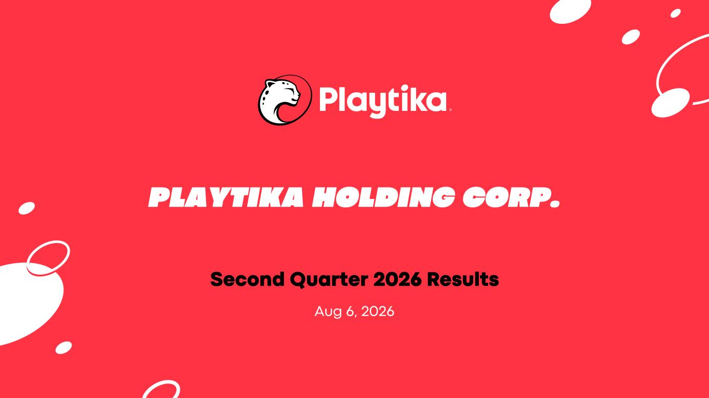

PLAYTIKA HOLDING CORP. Second Quarter 2026 Results Aug 6, 2026

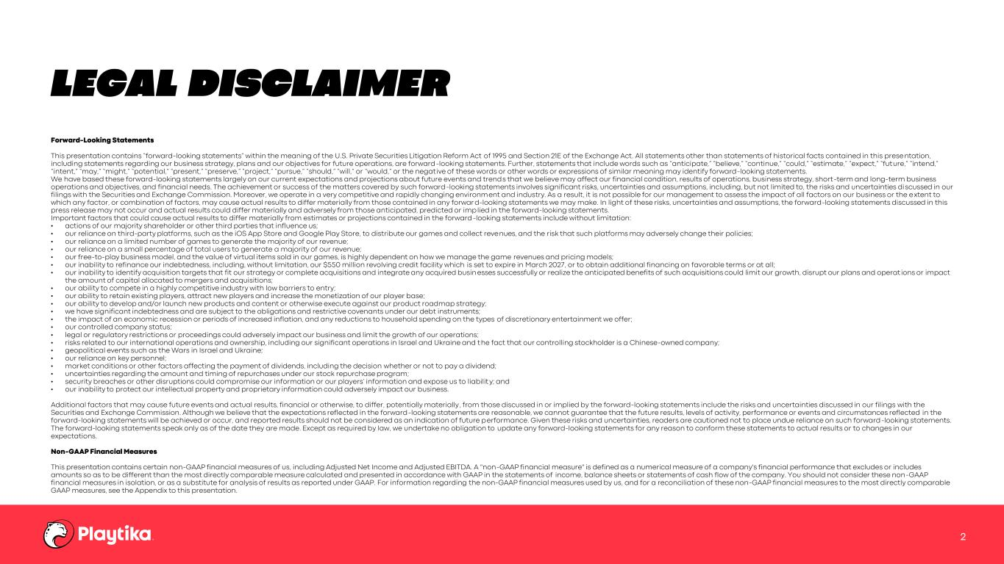
LEGAL DISCLAIMER 2 Forward-Looking Statements This presentation contains “forward-looking statements” within the meaning of the U.S. Private Securities Litigation Reform Act of 1995 and Section 21E of the Exchange Act. All statements other than statements of historical facts contained in this prese ntation, including statements regarding our business strategy, plans and our objectives for future operations, are forward-looking statements. Further, statements that include words such as “anticipate,” “believe,” “continue,” “could,” “estimate,” “expect,” “future,” “intend,” “intent,” “may,” “might,” “potential,” “present,” “preserve,” “project,” “pursue,” “should,” “will,” or “would,” or the negat ive of these words or other words or expressions of similar meaning may identify forward-looking statements. We have based these forward-looking statements largely on our current expectations and projections about future events and trends that we believe may affect our financial condition, results of operations, business strategy, short-term and long-term business operations and objectives, and financial needs. The achievement or success of the matters covered by such forward-looking statements involves significant risks, uncertainties and assumptions, including, but not limited to, the risks and uncertainties discussed in our filings with the Securities and Exchange Commission. Moreover, we operate in a very competitive and rapidly changing environment and industry. As a result, it is not possible for our management to assess the impact of all factors on our business or the extent to which any factor, or combination of factors, may cause actual results to differ materially from those contained in any forwar d-looking statements we may make. In light of these risks, uncertainties and assumptions, the forward-looking statements discussed in this press release may not occur and actual results could differ materially and adversely from those anticipated, predicted or implied in the forward-looking statements. Important factors that could cause actual results to differ materially from estimates or projections contained in the forward-looking statements include without limitation: • actions of our majority shareholder or other third parties that influence us; • our reliance on third-party platforms, such as the iOS App Store and Google Play Store, to distribute our games and collect revenues, and the risk that such platforms may adversely change their policies; • our reliance on a limited number of games to generate the majority of our revenue; • our reliance on a small percentage of total users to generate a majority of our revenue; • our free-to-play business model, and the value of virtual items sold in our games, is highly dependent on how we manage the game revenues and pricing models; • our inability to refinance our indebtedness, including, without limitation, our $550 million revolving credit facility which is set to expire in March 2027, or to obtain additional financing on favorable terms or at all; • our inability to identify acquisition targets that fit our strategy or complete acquisitions and integrate any acquired busin esses successfully or realize the anticipated benefits of such acquisitions could limit our growth, disrupt our plans and operat ions or impact the amount of capital allocated to mergers and acquisitions; • our ability to compete in a highly competitive industry with low barriers to entry; • our ability to retain existing players, attract new players and increase the monetization of our player base; • our ability to develop and/or launch new products and content or otherwise execute against our product roadmap strategy; • we have significant indebtedness and are subject to the obligations and restrictive covenants under our debt instruments; • the impact of an economic recession or periods of increased inflation, and any reductions to household spending on the types of discretionary entertainment we offer; • our controlled company status; • legal or regulatory restrictions or proceedings could adversely impact our business and limit the growth of our operations; • risks related to our international operations and ownership, including our significant operations in Israel and Ukraine and the fact that our controlling stockholder is a Chinese-owned company; • geopolitical events such as the Wars in Israel and Ukraine; • our reliance on key personnel; • market conditions or other factors affecting the payment of dividends, including the decision whether or not to pay a dividend; • uncertainties regarding the amount and timing of repurchases under our stock repurchase program; • security breaches or other disruptions could compromise our information or our players’ information and expose us to liability; and • our inability to protect our intellectual property and proprietary information could adversely impact our business. Additional factors that may cause future events and actual results, financial or otherwise, to differ, potentially materially , from those discussed in or implied by the forward-looking statements include the risks and uncertainties discussed in our filings with the Securities and Exchange Commission. Although we believe that the expectations reflected in the forward-looking statements are reasonable, we cannot guarantee that the future results, levels of activity, performance or events and circumstances reflected in the forward-looking statements will be achieved or occur, and reported results should not be considered as an indication of future performance. Given these risks and uncertainties, readers are cautioned not to place undue reliance on such forward-looking statements. The forward-looking statements speak only as of the date they are made. Except as required by law, we undertake no obligation to update any forward-looking statements for any reason to conform these statements to actual results or to changes in our expectations. Non-GAAP Financial Measures This presentation contains certain non-GAAP financial measures of us, including Adjusted Net Income and Adjusted EBITDA. A "non-GAAP financial measure" is defined as a numerical measure of a company's financial performance that excludes or includes amounts so as to be different than the most directly comparable measure calculated and presented in accordance with GAAP in the statements of income, balance sheets or statements of cash flow of the company. You should not consider these non-GAAP financial measures in isolation, or as a substitute for analysis of results as reported under GAAP. For information regarding the non-GAAP financial measures used by us, and for a reconciliation of these non-GAAP financial measures to the most directly comparable GAAP measures, see the Appendix to this presentation. `

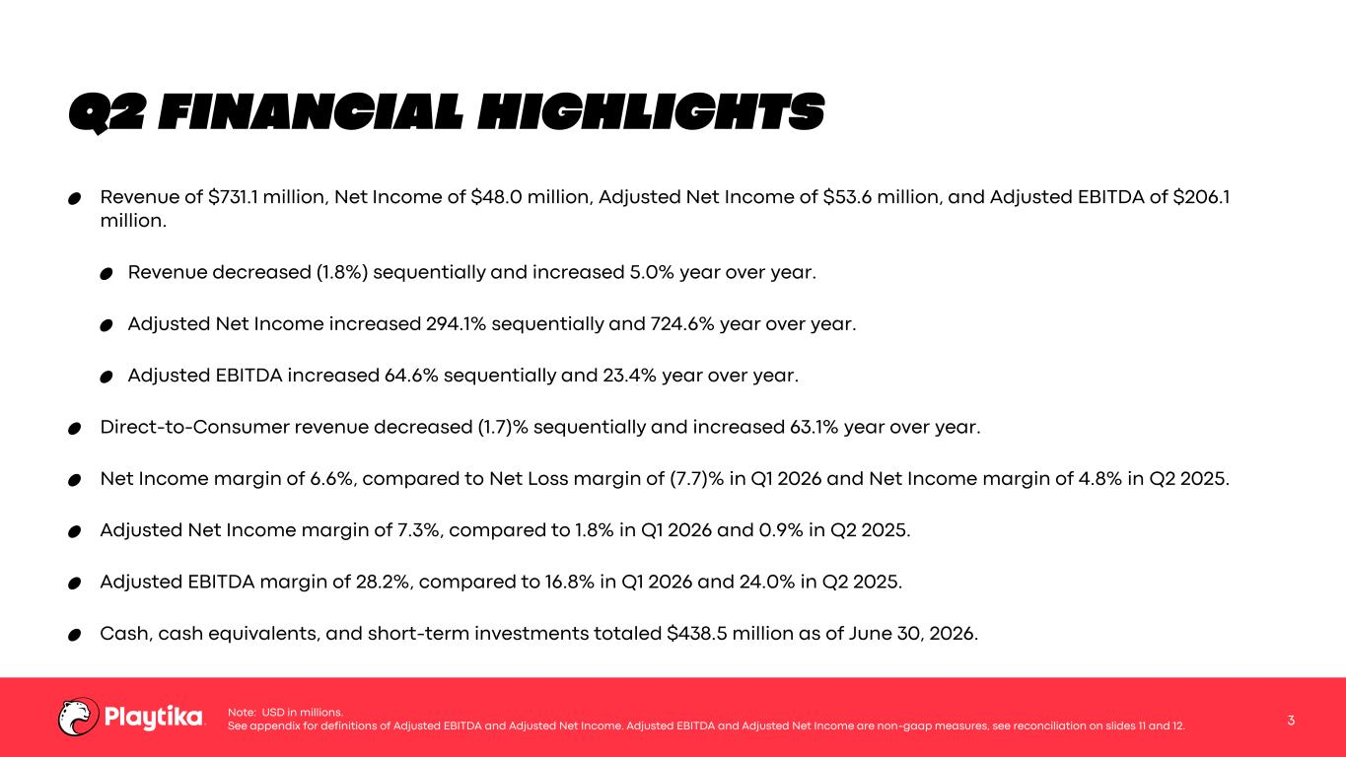
Q2 FINANCIAL HIGHLIGHTS Revenue of $731.1 million, Net Income of $48.0 million, Adjusted Net Income of $53.6 million, and Adjusted EBITDA of $206.1 million. Revenue decreased (1.8%) sequentially and increased 5.0% year over year. Adjusted Net Income increased 294.1% sequentially and 724.6% year over year. Adjusted EBITDA increased 64.6% sequentially and 23.4% year over year. Direct-to-Consumer revenue decreased (1.7)% sequentially and increased 63.1% year over year. Net Income margin of 6.6%, compared to Net Loss margin of (7.7)% in Q1 2026 and Net Income margin of 4.8% in Q2 2025. Adjusted Net Income margin of 7.3%, compared to 1.8% in Q1 2026 and 0.9% in Q2 2025. Adjusted EBITDA margin of 28.2%, compared to 16.8% in Q1 2026 and 24.0% in Q2 2025. Cash, cash equivalents, and short-term investments totaled $438.5 million as of June 30, 2026. 3 Note: USD in millions. See appendix for definitions of Adjusted EBITDA and Adjusted Net Income. Adjusted EBITDA and Adjusted Net Income are non-gaap measures, see reconciliation on slides 11 and 12.

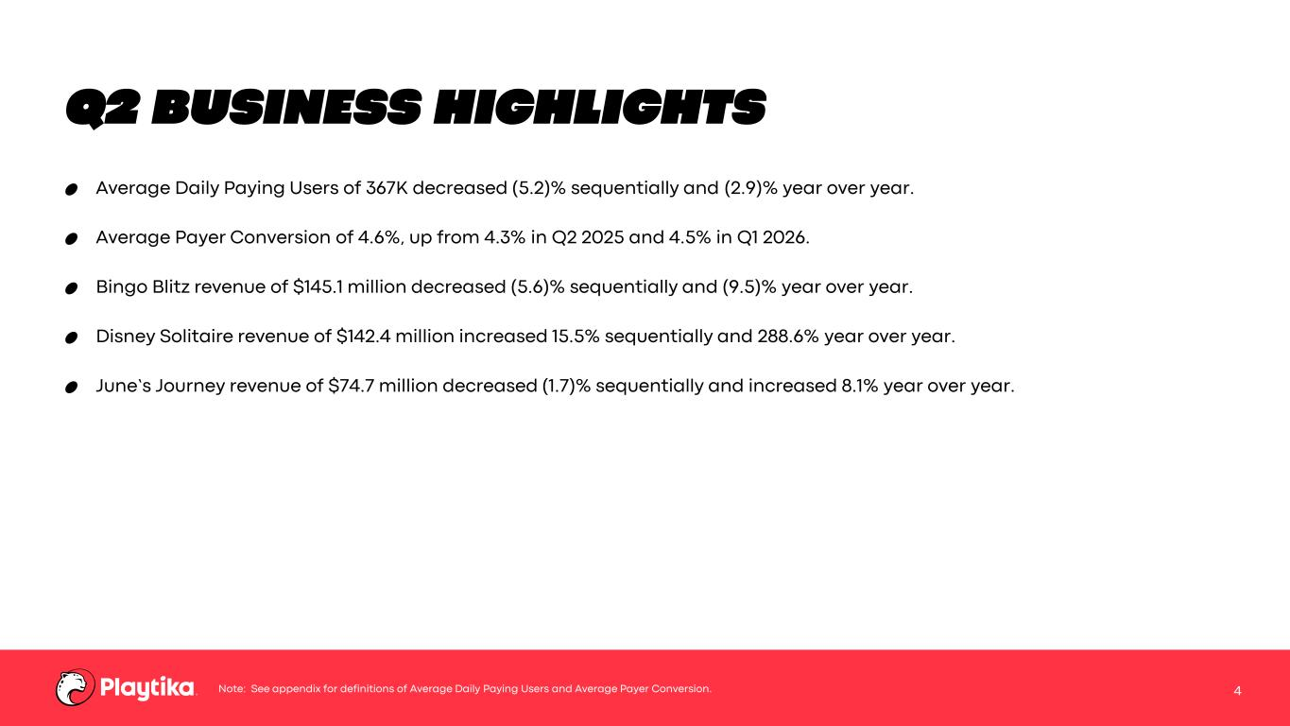
Q2 BUSINESS HIGHLIGHTS Average Daily Paying Users of 367K decreased (5.2)% sequentially and (2.9)% year over year. Average Payer Conversion of 4.6%, up from 4.3% in Q2 2025 and 4.5% in Q1 2026. Bingo Blitz revenue of $145.1 million decreased (5.6)% sequentially and (9.5)% year over year. Disney Solitaire revenue of $142.4 million increased 15.5% sequentially and 288.6% year over year. June’s Journey revenue of $74.7 million decreased (1.7)% sequentially and increased 8.1% year over year. 4Note: See appendix for definitions of Average Daily Paying Users and Average Payer Conversion.

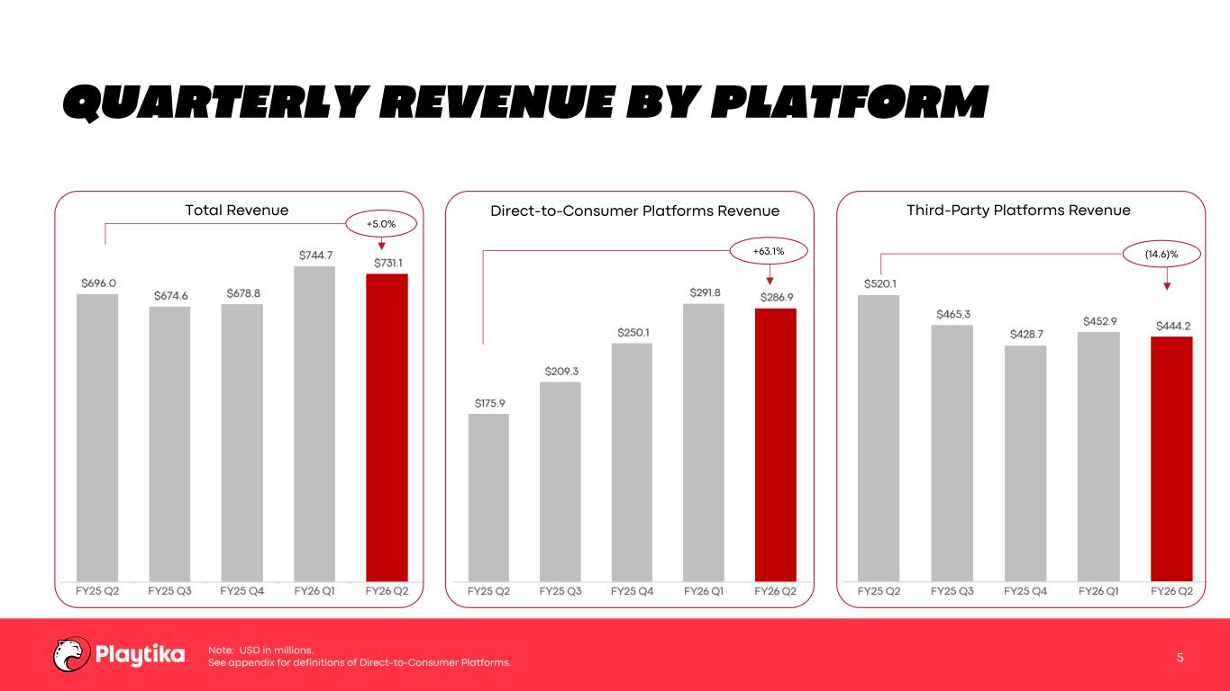
+63.1% QUARTERLY REVENUE BY PLATFORM 5 Direct-to-Consumer Platforms Revenue Third-Party Platforms RevenueTotal Revenue +5.0% (14.6)% Note: USD in millions. See appendix for definitions of Direct-to-Consumer Platforms.

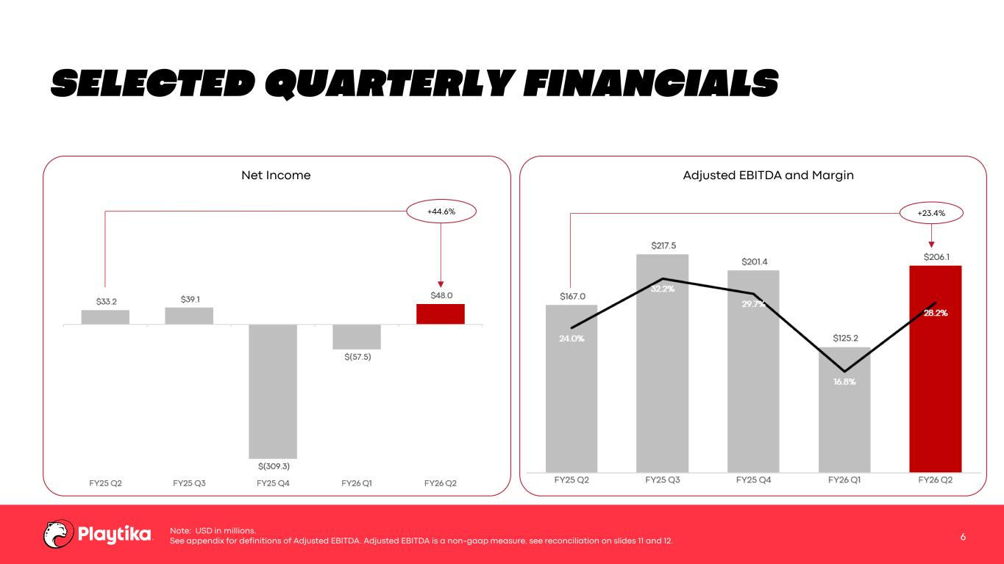
SELECTED QUARTERLY FINANCIALS 6 Note: USD in millions. See appendix for definitions of Adjusted EBITDA. Adjusted EBITDA is a non-gaap measure, see reconciliation on slides 11 and 12. Net Income Adjusted EBITDA and Margin +23.4%+44.6%

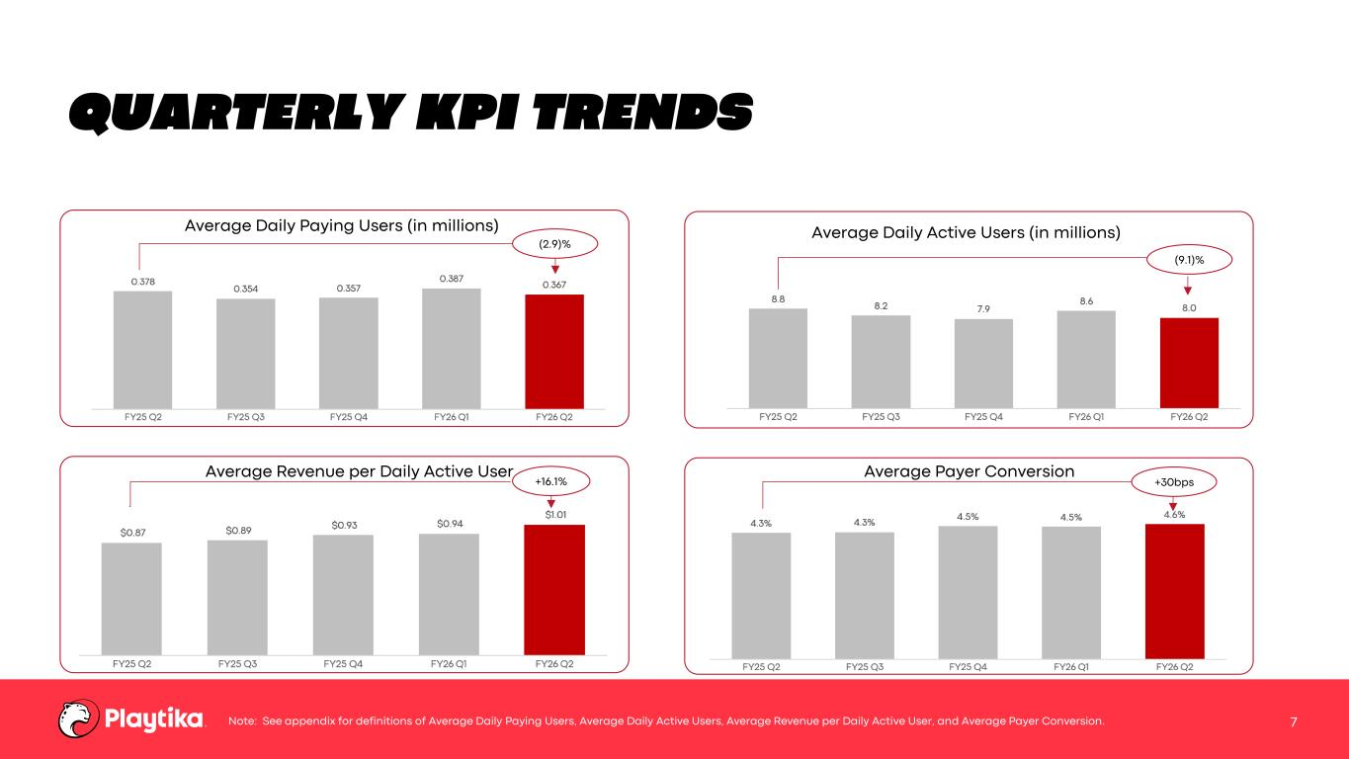
QUARTERLY KPI TRENDS 7 Average Daily Paying Users (in millions) Average Daily Active Users (in millions) Average Revenue per Daily Active User Average Payer Conversion (2.9)% (9.1)% +30bps Note: See appendix for definitions of Average Daily Paying Users, Average Daily Active Users, Average Revenue per Daily Active User, and Average Payer Conversion. +16.1%

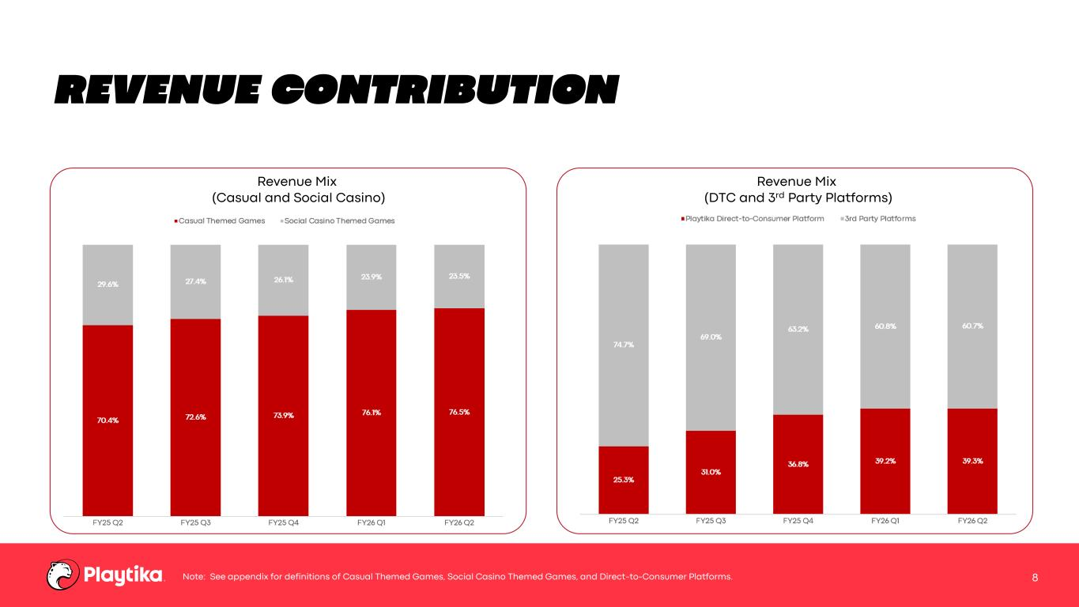
REVENUE CONTRIBUTION 8Note: See appendix for definitions of Casual Themed Games, Social Casino Themed Games, and Direct-to-Consumer Platforms. Revenue Mix (Casual and Social Casino) Revenue Mix (DTC and 3rd Party Platforms)

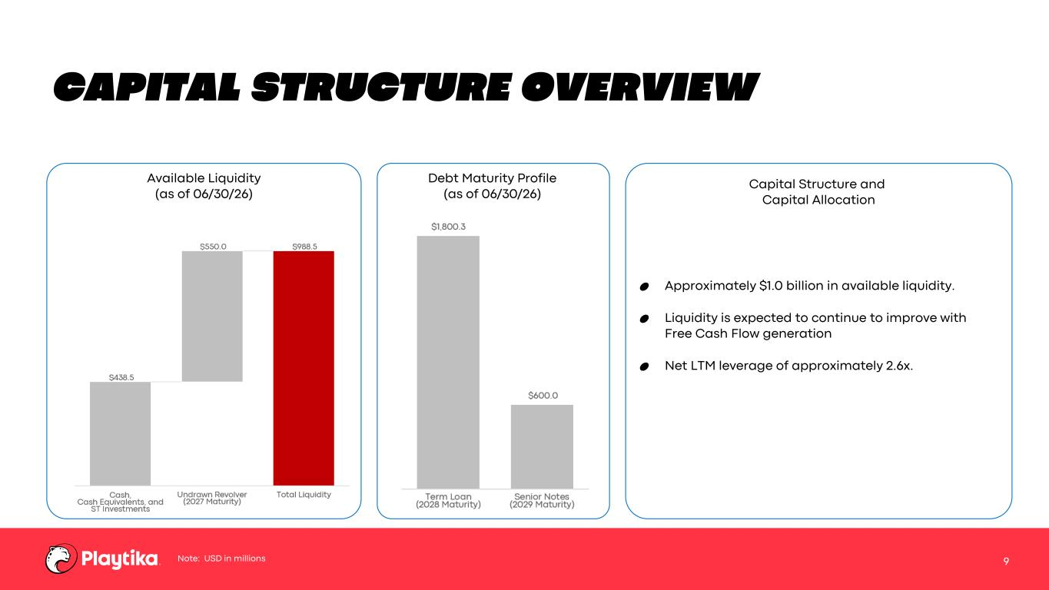
CAPITAL STRUCTURE OVERVIEW 9 Available Liquidity (as of 06/30/26) Debt Maturity Profile (as of 06/30/26) Approximately $1.0 billion in available liquidity. Liquidity is expected to continue to improve with Free Cash Flow generation Net LTM leverage of approximately 2.6x. Capital Structure and Capital Allocation Note: USD in millions

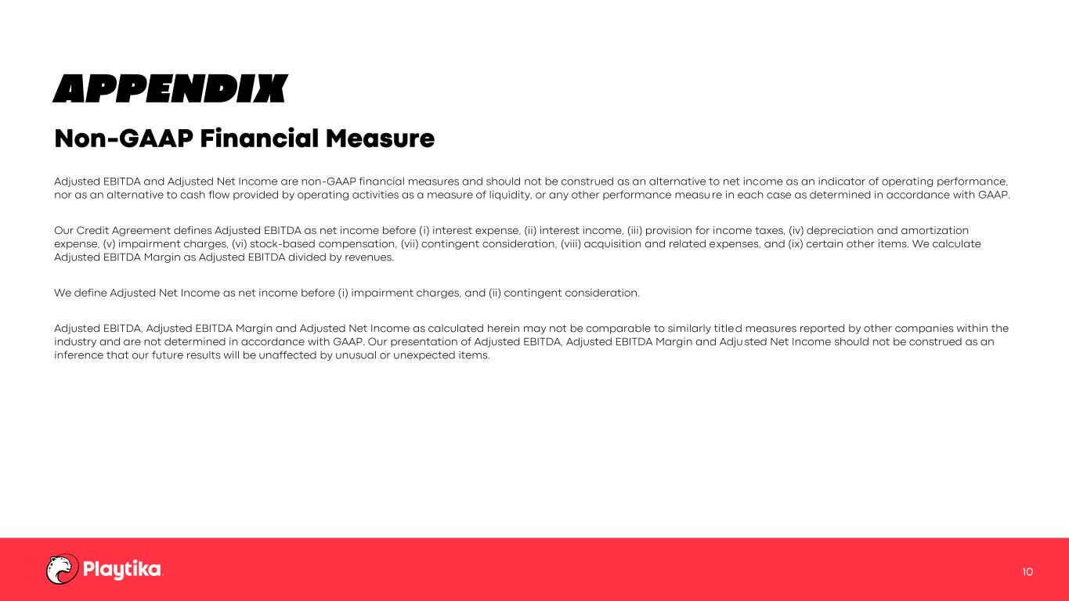
APPENDIX Adjusted EBITDA and Adjusted Net Income are non-GAAP financial measures and should not be construed as an alternative to net income as an indicator of operating performance, nor as an alternative to cash flow provided by operating activities as a measure of liquidity, or any other performance measu re in each case as determined in accordance with GAAP. Our Credit Agreement defines Adjusted EBITDA as net income before (i) interest expense, (ii) interest income, (iii) provision for income taxes, (iv) depreciation and amortization expense, (v) impairment charges, (vi) stock-based compensation, (vii) contingent consideration, (viii) acquisition and related expenses, and (ix) certain other items. We calculate Adjusted EBITDA Margin as Adjusted EBITDA divided by revenues. We define Adjusted Net Income as net income before (i) impairment charges, and (ii) contingent consideration. Adjusted EBITDA, Adjusted EBITDA Margin and Adjusted Net Income as calculated herein may not be comparable to similarly title d measures reported by other companies within the industry and are not determined in accordance with GAAP. Our presentation of Adjusted EBITDA, Adjusted EBITDA Margin and Adju sted Net Income should not be construed as an inference that our future results will be unaffected by unusual or unexpected items. Non-GAAP Financial Measure 10

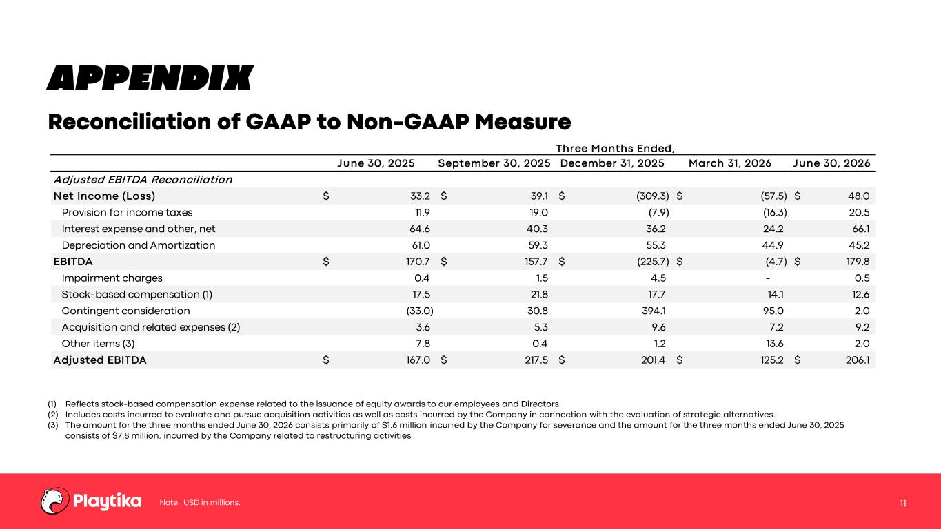
APPENDIX Reconciliation of GAAP to Non-GAAP Measure 11Note: USD in millions. (1) Reflects stock-based compensation expense related to the issuance of equity awards to our employees and Directors. (2) Includes costs incurred to evaluate and pursue acquisition activities as well as costs incurred by the Company in connection with the evaluation of strategic alternatives. (3) The amount for the three months ended June 30, 2026 consists primarily of $1.6 million incurred by the Company for severance and the amount for the three months ended June 30, 2025 consists of $7.8 million, incurred by the Company related to restructuring activities Three Months Ended, June 30, 2025 September 30, 2025 December 31, 2025 March 31, 2026 June 30, 2026 Adjusted EBITDA Reconciliation Net Income (Loss) 33.2$ 39.1$ (309.3)$ (57.5)$ 48.0$ Provision for income taxes 11.9 19.0 (7.9) (16.3) 20.5 Interest expense and other, net 64.6 40.3 36.2 24.2 66.1 Depreciation and Amortization 61.0 59.3 55.3 44.9 45.2 EBITDA 170.7$ 157.7$ (225.7)$ (4.7)$ 179.8$ Impairment charges 0.4 1.5 4.5 - 0.5 Stock-based compensation (1) 17.5 21.8 17.7 14.1 12.6 Contingent consideration (33.0) 30.8 394.1 95.0 2.0 Acquisition and related expenses (2) 3.6 5.3 9.6 7.2 9.2 Other items (3) 7.8 0.4 1.2 13.6 2.0 Adjusted EBITDA 167.0$ 217.5$ 201.4$ 125.2$ 206.1$

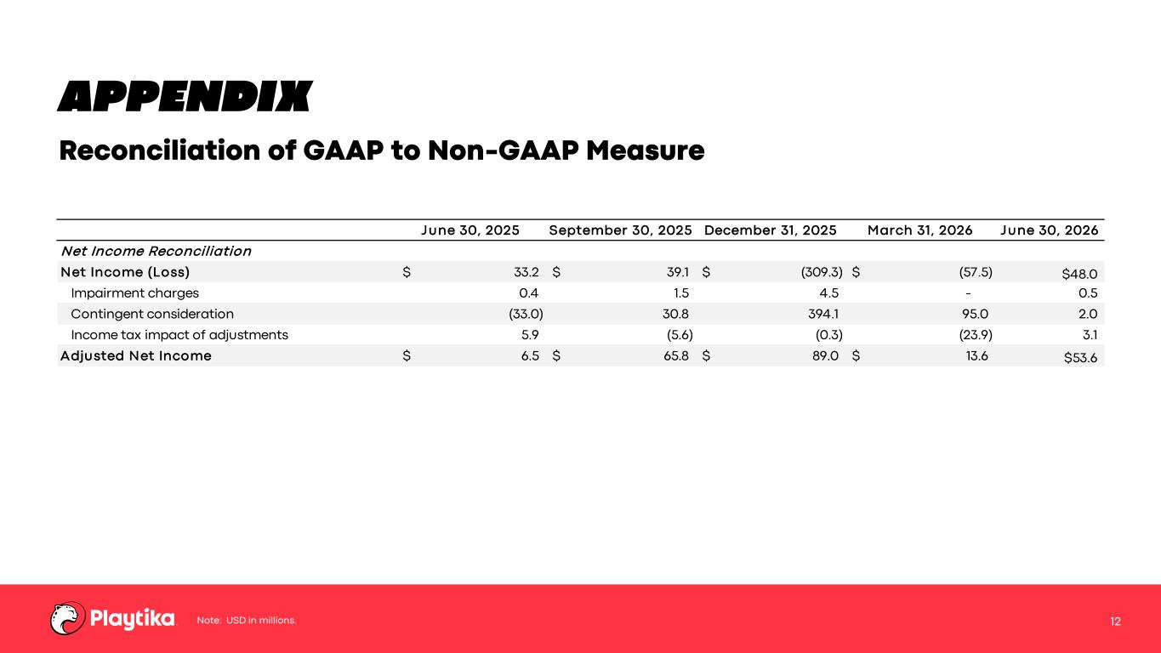
APPENDIX Reconciliation of GAAP to Non-GAAP Measure 12Note: USD in millions. June 30, 2025 September 30, 2025 December 31, 2025 March 31, 2026 June 30, 2026 Net Income Reconciliation Net Income (Loss) 33.2$ 39.1$ (309.3)$ (57.5)$ $48.0 Impairment charges 0.4 1.5 4.5 - 0.5 Contingent consideration (33.0) 30.8 394.1 95.0 2.0 Income tax impact of adjustments 5.9 (5.6) (0.3) (23.9) 3.1 Adjusted Net Income 6.5$ 65.8$ 89.0$ 13.6$ $53.6

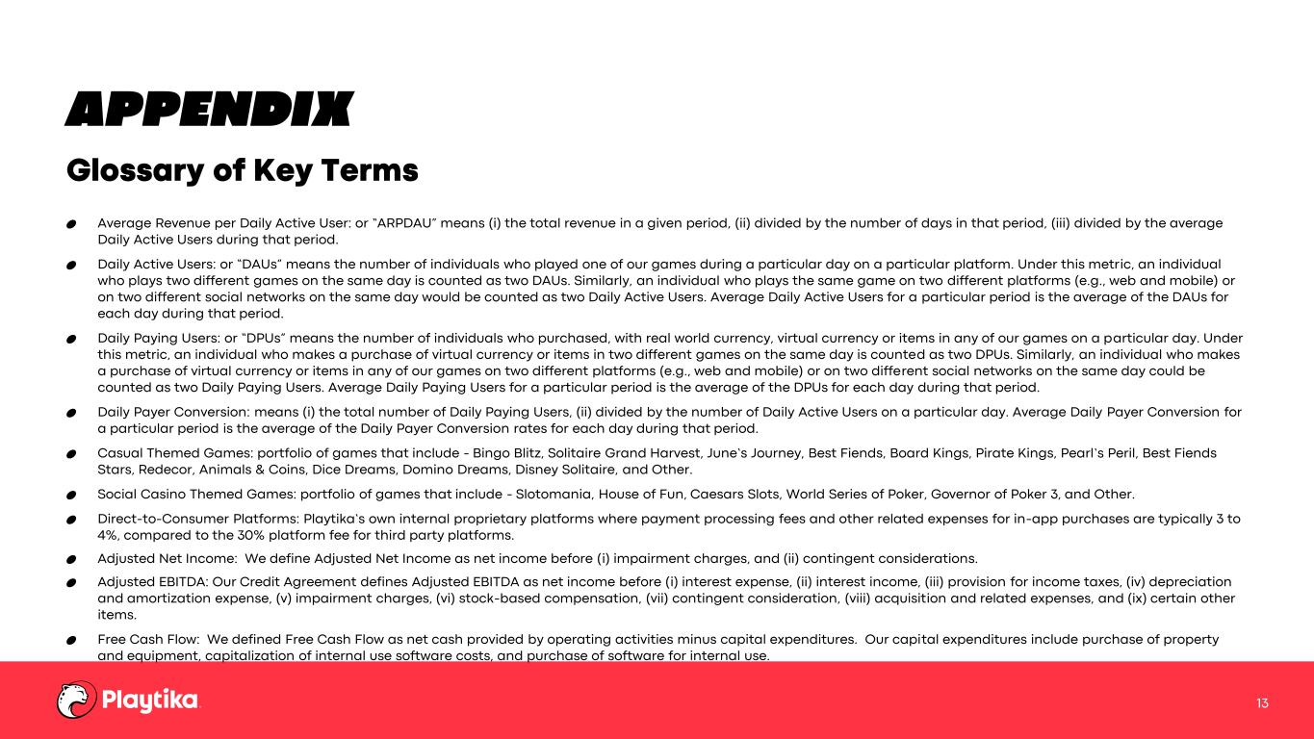
APPENDIX Average Revenue per Daily Active User: or “ARPDAU” means (i) the total revenue in a given period, (ii) divided by the number of days in that period, (iii) divided by the average Daily Active Users during that period. Daily Active Users: or “DAUs” means the number of individuals who played one of our games during a particular day on a particular platform. Under this metric, an individual who plays two different games on the same day is counted as two DAUs. Similarly, an individual who plays the same game on two different platforms (e.g., web and mobile) or on two different social networks on the same day would be counted as two Daily Active Users. Average Daily Active Users for a particular period is the average of the DAUs for each day during that period. Daily Paying Users: or “DPUs” means the number of individuals who purchased, with real world currency, virtual currency or items in any of our games on a particular day. Under this metric, an individual who makes a purchase of virtual currency or items in two different games on the same day is counted as two DPUs. Similarly, an individual who makes a purchase of virtual currency or items in any of our games on two different platforms (e.g., web and mobile) or on two different social networks on the same day could be counted as two Daily Paying Users. Average Daily Paying Users for a particular period is the average of the DPUs for each day during that period. Daily Payer Conversion: means (i) the total number of Daily Paying Users, (ii) divided by the number of Daily Active Users on a particular day. Average Daily Payer Conversion for a particular period is the average of the Daily Payer Conversion rates for each day during that period. Casual Themed Games: portfolio of games that include - Bingo Blitz, Solitaire Grand Harvest, June’s Journey, Best Fiends, Board Kings, Pirate Kings, Pearl’s Peril, Best Fiends Stars, Redecor, Animals & Coins, Dice Dreams, Domino Dreams, Disney Solitaire, and Other. Social Casino Themed Games: portfolio of games that include - Slotomania, House of Fun, Caesars Slots, World Series of Poker, Governor of Poker 3, and Other. Direct-to-Consumer Platforms: Playtika’s own internal proprietary platforms where payment processing fees and other related expenses for in-app purchases are typically 3 to 4%, compared to the 30% platform fee for third party platforms. Adjusted Net Income: We define Adjusted Net Income as net income before (i) impairment charges, and (ii) contingent considerations. Adjusted EBITDA: Our Credit Agreement defines Adjusted EBITDA as net income before (i) interest expense, (ii) interest income, (iii) provision for income taxes, (iv) depreciation and amortization expense, (v) impairment charges, (vi) stock-based compensation, (vii) contingent consideration, (viii) acquisition and related expenses, and (ix) certain other items. Free Cash Flow: We defined Free Cash Flow as net cash provided by operating activities minus capital expenditures. Our capital expenditures include purchase of property and equipment, capitalization of internal use software costs, and purchase of software for internal use. Glossary of Key Terms 13

