UNITED STATES

SECURITIES AND EXCHANGE COMMISSION
Washington, D.C. 20549

SCHEDULE TO

TENDER OFFER STATEMENT UNDER SECTION 14(d)(1) or 13(e)(1) OF

THE SECURITIES EXCHANGE ACT OF 1934

Playtika Holding Corp.

(Name of Subject Company (Issuer) and Filing Person (Offeror))

Options to Purchase Common Stock, Par Value $0.01 Per Share

(Title of Class of Securities)

72815L 107

(CUSIP Number of Class of Securities)

Robert Antokol

Chief Executive Officer

c/o Playtika Ltd.

HaChoshlim St 8

Herzliya Pituach, Israel

972-73-316-3251
(Name, address and telephone number of person authorized to receive notices and communications on behalf of filing person)

 | Copies to:
Michael A. Treska | Michael Cohen
Darren Guttenberg | Chief Legal Officer and Secretary
Latham & Watkins LLP | c/o Playtika Ltd.
650 Town Center Drive, 20th Floor | HaChoshlim St 8
Costa Mesa, CA 92626 | Herzliya Pituach, Israel
(714) 540-1235 | 972-73-316-3251

- Check the box if the filing relates solely to preliminary communications made before the commencement of a tender offer.

Check the appropriate boxes below to designate any transactions to which the statement relates:

- third-party tender offer subject to Rule 14d-1.

- issuer tender offer subject to Rule 13e-4.

- going-private transaction subject to Rule 13e-3.

- amendment to Schedule 13D under Rule 13d-2.

Check the following box if the filing is a final amendment reporting the results of the tender offer: ☐

This Tender Offer Statement on Schedule TO relates to an offer by Playtika Holding Corp., a Delaware corporation (“Playtika” or the “Company”), to exchange (the “Option Exchange”) outstanding eligible stock options (“eligible options”) to purchase up to an aggregate of 13,523,596 shares of Playtika’s common stock, whether vested or unvested, that were granted under Playtika’s 2020 Incentive Award Plan (the “2020 Plan”).

These eligible options may be exchanged for a lesser number of new restricted stock units (“RSUs”) to be granted under the 2020 Plan upon the terms and subject to the conditions set forth in the Offer to Exchange Certain Outstanding Stock Options for Restricted Stock Units dated November 14, 2022 (the “Offer to Exchange”), attached hereto as Exhibit (a)(1)(i), the Election Terms and Conditions, attached hereto as Exhibit (a)(1)(iv), the other exhibits hereto, and other related materials as may be amended or supplemented from time to time.

These documents, as they may be amended or supplemented from time to time, together constitute the “Disclosure Documents.” Employees, consultants and other individual service providers who are eligible for the option exchange (“eligible service providers”) include the active employees, consultants and other independent service providers of Playtika or of Playtika’s majority-owned subsidiaries who continue to provide services to Playtika or Playtika’s majority-owned subsidiaries through the completion of the Option Exchange, as further described in the Disclosure Documents. Members of Playtika’s board of directors do not hold any eligible options and are not eligible to participate in the Option Exchange.

The information in the Disclosure Documents, including all schedules and annexes to the Disclosure Documents, is incorporated herein by reference to answer the items required in this Schedule TO.

ITEM 1SUMMARY TERM SHEET.

The information set forth under the caption “Summary Term Sheet and Questions and Answers” in the Offer to Exchange is incorporated herein by reference.

ITEM 2SUBJECT COMPANY INFORMATION.

- Name and Address. Playtika Holding Corp., a Delaware corporation (“Playtika”), is the issuer of the securities subject to the Offer to Exchange. Playtika maintains its principal executive offices at HaChoshlim St 8, Herzliya Pituach, Israel. Playtika’s telephone number is 972-73-316-3251.

- Securities. The subject class of securities consists of the eligible options. The actual number of shares of common stock subject to the RSUs to be issued in the Option Exchange will depend on the number of shares of common stock subject to the unexercised options tendered by eligible service providers and accepted for exchange and cancelled. The information set forth in the Offer to Exchange under the captions “Summary Term Sheet and Questions and Answers,” “Risks of Participating in the Option Exchange,” and Sections 2, 6 and 9 of the Offer to Exchange under the caption “The Offer to Exchange” entitled “Types of Awards Granted in the Option Exchange; Number of New RSUs; Completion Date,” “Acceptance of Options for Exchange; Grant of New RSUs,” and “Source and Amount of Consideration; Terms of New RSUs” is incorporated herein by reference.

The subject class of securities consists of the eligible options. The actual number of new RSUs to be granted in the Option Exchange will depend on the number of shares of Playtika common stock subject to the eligible options that are exchanged. The information set forth in the Offer to Exchange under the captions “Summary Term Sheet and Questions and Answers” and “Risks of Participating in the Option Exchange,” and Sections 2, 6 and 9 of the Offer to Exchange under the caption “The Offer to Exchange” entitled “Types of Awards Granted in the Option Exchange; Number of New RSUs; Completion Date,” “Acceptance of Options for Exchange; Grant of New RSUs,” and “Source and Amount of Consideration; Terms of New RSUs,” respectively, is incorporated herein by reference.

2

- Trading Market and Price. The information set forth in Section 8 of the Offer to Exchange under the caption “The Offer to Exchange” entitled “Price Range of Shares Underlying the Options” is incorporated herein by reference.

ITEM 3IDENTITY AND BACKGROUND OF FILING PERSON.

Playtika is both the filing person and the issuer. The information set forth under Item 2(a) above is incorporated herein by reference. Pursuant to General Instruction C to Schedule TO, the information set forth on Schedule A to the Offer to Exchange is incorporated herein by reference.

ITEM 4TERMS OF THE TRANSACTION.

- Material Terms. The information set forth in the Offer to Exchange under the caption “Summary Term Sheet and Questions and Answers” and Sections 1, 2, 3, 4, 5, 6, 7, 8, 9, 12, 13, 14 and 15 of the Offer to Exchange under the caption “The Offer to Exchange” entitled “Eligibility,” “Types of Awards Granted in the Option Exchange; Number of New RSUs; Completion Date,” “Purposes of the Option Exchange and Reasons for Structure of the Option Exchange,” “Procedures for Electing to Exchange Options,” “Withdrawal Rights and Change of Election,” “Acceptance of Options for Exchange; Grant of New RSUs,” “Conditions of the Option Exchange,” “Price Range of Shares Underlying the Options,” “Source and Amount of Consideration; Terms of New RSUs,” “Status of Options Acquired by Us in the Option Exchange; Accounting Consequences of the Option Exchange,” “Legal Matters; Regulatory Approvals,” “Material Income Tax Consequences,” and “Extension of Option Exchange; Termination; Amendment,” respectively, and Schedules B through L to the Offer to Exchange is incorporated herein by reference.

- Purchases. The information set forth in Section 11 of the Offer to Exchange under the caption “The Offer to Exchange” entitled “Interests of Directors and Executive Officers; Transactions and Arrangements Concerning our Securities” is incorporated herein by reference.

ITEM 5PAST CONTACTS, TRANSACTIONS, NEGOTIATIONS AND AGREEMENTS.

- Agreements Involving the Subject Company’s Securities. The information set forth in Section 11 of the Offer to Exchange under the caption “The Offer to Exchange” entitled “Interests of Directors and Executive Officers; Transactions and Arrangements Concerning our Securities” is incorporated herein by reference. The terms and conditions of the 2020 Plan and related agreements listed as Exhibits (d)(1) through (d)(5) are incorporated herein by reference.

ITEM 6PURPOSES OF THE TRANSACTION AND PLANS OR PROPOSALS.

- Purposes. The information set forth in the section of the Offer to Exchange under the caption “Summary Term Sheet and Questions and Answers” and Section 3 under the caption “The Offer to Exchange” entitled “Purposes of the Offer and Reasons for Structure of the Option Exchange” is incorporated herein by reference.

- Use of Securities Acquired. The information set forth in Sections 6 and 12 of the Offer to Exchange under the caption “The Offer to Exchange” entitled “Acceptance of Options for Exchange; Grant of New RSUs” and “Status of Options Acquired by Us in the Option Exchange; Accounting Consequences of the Option Exchange,” respectively, is incorporated herein by reference.

- Plans. The information set forth in the Offer to Exchange under the caption “Summary Term Sheet and Questions and Answers” and Section 3 of the Offer to Exchange under the caption “The Offer to Exchange” entitled “Purposes of the Option Exchange and Reasons for Structure of the Option Exchange” is incorporated herein by reference.

3

ITEM 7SOURCE AND AMOUNT OF FUNDS OR OTHER CONSIDERATION.

- Source of Funds. The information set forth in Section 9 of the Offer to Exchange under the caption “The Offer to Exchange” entitled “Source and Amount of Consideration; Terms of New RSUs” is incorporated herein by reference.

- Conditions. The information set forth in Section 7 of the Offer to Exchange under the caption “The Offer to Exchange” entitled “Conditions of the Option Exchange” is incorporated herein by reference.

- Borrowed Funds. Not applicable.

ITEM 8INTEREST IN SECURITIES OF THE SUBJECT COMPANY.

- Securities Ownership. The information set forth in Section 11 of the Offer to Exchange under the caption “The Offer to Exchange” entitled “Interests of Directors and Executive Officers; Transactions and Arrangements Concerning our Securities” is incorporated herein by reference.

- Securities Transactions. The information set forth in Section 11 of the Offer to Exchange under the caption “The Offer to Exchange” entitled “Interests of Directors and Executive Officers; Transactions and Arrangements Concerning our Securities” is incorporated herein by reference.

ITEM 9PERSONS/ASSETS, RETAINED, EMPLOYED, COMPENSATED OR USED.

(a) Solicitations or Recommendations. Not applicable.

ITEM 10FINANCIAL STATEMENTS.

- Financial Information. The information set forth in Schedule B to the Offer to Exchange and Sections 10 and 17 of the Offer to Exchange under the caption “The Offer to Exchange” entitled “Information Concerning Playtika” and “Additional Information,” respectively, is incorporated herein by reference. The Company’s Annual Report on Form 10-K for the fiscal year ended December 31, 2021 and Quarterly Reports on Form 10-Q for the fiscal quarters ended March 31, 2022, June 30, 2022, and September 30, 2022 are available electronically on the Securities and Exchange Commission’s website at http://www.sec.gov.

- Pro Forma Financial Information. Not applicable.

ITEM 11ADDITIONAL INFORMATION.

- Agreements, Regulatory Requirements and Legal Proceedings. The information set forth in Sections 11 and 13 of the Offer to Exchange under the caption “The Offer to Exchange” entitled “Interests of Directors and Executive Officers; Transactions and Arrangements Concerning our Securities” and “Legal Matters; Regulatory Approvals,” respectively, is incorporated herein by reference.

- Other Material Information. Not applicable.

4

ITEM 12EXHIBITS.

Exhibit |  |  |  |  |  |  |  |  |  | Description
Number
(a)(1)(i) |  | Offer to Exchange Certain Outstanding Stock Options for Restricted Stock Units, dated November 14, 2022
(a)(1)(ii) |  | Announcement Email to All Eligible Service Providers from Shlomi Aizenberg, Chief Operating Officer, dated November 14,
 |  | 2022
(a)(1)(iii) |  | Email to All Eligible Service Providers With Additional Information About Option Exchange, from Playtika, dated November 15,
 |  | 2022
(a)(1)(iv) |  | Election Terms and Conditions
(a)(1)(v) |  | Form of Email Confirmation to Eligible Service Providers
(a)(1)(vi) |  | Form of First Reminder Email Communication
(a)(1)(vii) |  | Form of Second Reminder Email Communication
(a)(1)(viii) |  | Form of Final Reminder Email Communication
(a)(1)(ix) |  | Form of Notice Email to Eligible Service Providers Regarding Expiration of Offering Period
(a)(1)(x) |  | Screenshots of Option Exchange Website
(a)(1)(xi) |  | Option Exchange Frequently Asked Questions
(a)(1)(xii) |  | Option Exchange Presentation to Service Providers
(a)(1)(xiii) |  | Script of the Option Exchange Presentation to Service Providers
(a)(2) |  | Not applicable
(a)(3) |  | Not applicable
(a)(4) |  | Not applicable

- Not applicable

(d)(1) | 2020 Incentive Award Plan, including Sub-Plan for Israeli Participants (incorporated herein by reference to Exhibit 10.17 to the
 | Company’s Registration Statement on Form S-1, as filed with the SEC on December 18, 2020)
(d)(2) | Amendment No. 1 to Playtika Holding Corp. 2020 Incentive Award Plan (incorporated herein by reference to Exhibit 10.18 to the
 | Company’s Registration Statement on Form S-1, as filed with the SEC on December 18, 2020)
(d)(3) | Form of Restricted Stock Unit Agreement under 2020 Incentive Award Plan for U.S. Participants (incorporated herein by
 | reference to Exhibit 10.19 to the Company’s Registration Statement on Form S-1, as filed with the SEC on December 18, 2020)
(d)(4) | Form of Replacement Restricted Stock Unit Agreement for Israeli Participants (Section 102) under 2020 Incentive Award Plan
(d)(5) | Form of Restricted Stock Unit Agreement for Israeli Participants (Section 3(i)) under 2020 Incentive Award Plan
(d)(6) | Form of Restricted Stock Unit Agreement (for Participants in Jurisdictions Other than the U.S. and Israel) under 2020 Incentive
 | Award Plan

- Not applicable.

- Not applicable.

- Filing Fee Table.

ITEM 13INFORMATION REQUIRED BY SCHEDULE 13E-3.

- Not applicable.

5

SIGNATURE

After due inquiry and to the best of my knowledge and belief, I certify that the information set forth in this statement is true, complete and correct.

Dated: November 14, 2022 Playtika Holding Corp.

By: /s/ Craig Abrahams
Name: Craig Abrahams

Title: President and Chief Financial Officer

6

 |  | INDEX OF EXHIBITS
Exhibit |  | Description
Number |  | Description
(a)(1)(i) |  | Offer to Exchange Certain Outstanding Stock Options for Restricted Stock Units, dated November 14, 2022
(a)(1)(ii) |  | Announcement Email to All Eligible Service Providers from Shlomi Aizenberg, Chief Operating Officer, dated November 14, 2022
(a)(1)(iii) |  | Email to All Eligible Service Providers With Additional Information About Option Exchange, from Playtika, dated November 15,
 |  | 2022
(a)(1)(iv) |  | Election Terms and Conditions
(a)(1)(v) |  | Form of Email Confirmation to Eligible Service Providers
(a)(1)(vi) |  | Form of First Reminder Email Communication
(a)(1)(vii) |  | Form of Second Reminder Email Communication
(a)(1)(viii) |  | Form of Final Reminder Email Communication
(a)(1)(ix) |  | Form of Notice Email to Eligible Service Providers Regarding Expiration of Offering Period
(a)(1)(x) |  | Screenshots of Option Exchange Website
(a)(1)(xi) |  | Option Exchange Frequently Asked Questions
(a)(1)(xii) |  | Option Exchange Presentation to Service Providers
(a)(1)(xiii) |  | Script of the Option Exchange Presentation to Service Providers
(a)(2) |  | Not applicable
(a)(3) |  | Not applicable
(a)(4) |  | Not applicable
- Not applicable

(d)(1) | 2020 Incentive Award Plan, including Sub-Plan for Israeli Participants (incorporated herein by reference to Exhibit 10.17 to the
 | Company’s Registration Statement on Form S-1, as filed with the SEC on December 18, 2020)
(d)(2) | Amendment No. 1 to Playtika Holding Corp. 2020 Incentive Award Plan (incorporated herein by reference to Exhibit 10.18 to the
 | Company’s Registration Statement on Form S-1, as filed with the SEC on December 18, 2020)
(d)(3) | Form of Restricted Stock Unit Agreement under 2020 Incentive Award Plan for U.S. Participants (incorporated herein by reference
 | to Exhibit 10.19 to the Company’s Registration Statement on Form S-1, as filed with the SEC on December 18, 2020)
(d)(4) | Form of Replacement Restricted Stock Unit Agreement for Israeli Participants (Section 102) under 2020 Incentive Award Plan
(d)(5) | Form of Restricted Stock Unit Agreement for Israeli Participants (Section 3(i)) under 2020 Incentive Award Plan
(d)(6) | Form of Restricted Stock Unit Agreement (for Participants in Jurisdictions Other than the U.S. and Israel) under 2020 Incentive
 | Award Plan

- Not applicable.

- Not applicable.

107 Filing Fee Table.

7

Exhibit (a)(1)(i)

PLAYTIKA HOLDING CORP.

OFFER TO EXCHANGE CERTAIN OUTSTANDING STOCK OPTIONS

FOR RESTRICTED STOCK UNITS

THIS OFFER TO EXCHANGE AND YOUR WITHDRAWAL RIGHTS WILL EXPIRE AT 9:00 P.M. PACIFIC TIME, ON DECEMBER 12, 2022, UNLESS THE OFFER IS EXTENDED

Playtika Holding Corp., a Delaware corporation (the “Company,” “Playtika,” “our,” “us” or “we”), is offering eligible service providers the opportunity to exchange outstanding eligible stock options for a lesser number of new restricted stock units (“RSUs”) to be granted under the Playtika Holding Corp. 2020 Incentive Award Plan, as amended (the “2020 Plan”). The 2020 Plan is the only equity incentive plan we maintain. The new RSUs will be granted as of the completion date of this offer. We are making this offer upon the terms and subject to the conditions set forth in this Offer to Exchange Certain Outstanding Stock Options for Restricted Stock Units, which we refer to as the “Offer to Exchange.” We refer to the offer made pursuant to this Offer to Exchange as the “Option Exchange.”

Eligible Options. Stock options eligible for exchange, or eligible options, are those options, whether vested or unvested, that meet all of the following requirements:

- the options were granted under the 2020 Plan prior to November 10, 2022;

- the options are outstanding and unexercised as of the completion date of the Offer to Exchange;

- the options are held by an eligible service provider; and

- the options have, on the completion date, a per share exercise price more than the per share closing price of Playtika’s common stock on the completion date, as reported on the Nasdaq Global Select Market.

You are eligible to participate in the Option Exchange only if you meet all of the following requirements:

- you are an active service provider of Playtika or any of its majority-owned subsidiaries on the date this offer commences and remain an active service provider through the completion date of the Option Exchange;

- you are not employed or engaged by Playtika or its majority-owned subsidiaries in any country where we determine that the Option Exchange would have regulatory, tax or other implications that are inconsistent with Playtika’s compensation policies and practices or this offer is prohibited under local regulations as of the date of the completion of the Option Exchange; and

- you hold at least one eligible option.

An individual is not an “active service provider” if he or she (i) is on a “garden leave” or other leave that will result in a termination of employment with Playtika or one of Playtika’s majority-owned subsidiaries, (ii) has provided Playtika a notice of resignation or (iii) has received a notice of termination of employment or service from Playtika or one of Playtika’s majority-owned subsidiaries, in each case even if such resignation or termination will not take effect until following the completion of the Option Exchange.

The outstanding eligible options that you hold under our 2020 Plan give you the right, when vested, to purchase shares of our common stock once you exercise those options by paying the applicable exercise price of those options. Thus, wherever we use the term “option” in this Offer to Exchange, we refer to the actual options you hold to purchase shares of our common stock and not the shares of our common stock underlying those options.

As of November 3, 2022, 14,945,815 shares of our common stock were subject to outstanding options under our 2020 Plan, of which 13,523,596 options are eligible to participate in the Option Exchange as of the commencement date of the Option Exchange.

i

New RSUs. All eligible options that are properly surrendered in the Option Exchange and accepted by us for exchange pursuant to the Option Exchange will be cancelled as of the completion date of this offer, and the options accepted for exchange will no longer be exercisable after that time.

The new RSUs will be granted in exchange for the cancelled options as of the completion date of this offer under the 2020 Plan.

- If you participate in the Option Exchange, you will receive one new RSU (representing the right to receive one share of our common stock) for every 2.5 shares of our common stock underlying eligible stock options surrendered pursuant to the Option Exchange. The number of new RSUs will be rounded down to the nearest whole share on a grant-by-grant basis. Fractional RSUs will not be granted in the Option Exchange.

- New RSUs granted in the Option Exchange will not be vested on their date of grant regardless of whether the surrendered option was vested in whole or in part. Instead, the new RSUs granted in the Option Exchange will vest as follows:

  - Over three years in equal quarterly installments over the period beginning on the completion date of this offer and ending on the third anniversary of the completion date, unless you are employed or engaged by Playtika or its majority-owned subsidiaries in Finland or Romania.

  - If you are employed or engaged by Playtika or its majority-owned subsidiaries in Romania, your new RSUs will also vest over three years, with one-third of the new RSUs vesting on the first anniversary of the completion date, and the remaining RSUs vesting in equal quarterly installments over the two year period thereafter.

  - If you are employed or engaged by Playtika or its majority-owned subsidiaries in Finland, your new RSUs will also vest over three years, with one-third of the new RSUs vesting on February 1, 2024, and the remaining RSUs vesting in eight equal quarterly installments over the period commencing on the first anniversary of the completion date and ending on the third anniversary of the completion date (and, for the avoidance of doubt, the first such quarterly vesting date will be the last day of the three-month period following the first anniversary date of the completion date of the Option Exchange).

  - Your new RSUs will be subject to the terms and conditions of an RSU agreement between you and Playtika. In all events, vesting is subject to continued service with us through the applicable vesting date. Your participation in the Option Exchange and receipt of any new RSUs does not provide any guarantee or promise of continued service with us.

- The new RSUs granted in the Option Exchange will be governed by the terms and conditions of the 2020 Plan, an RSU agreement between you and Playtika, and any country-specific terms and conditions set forth in an appendix to the RSU agreement or the 2020 Plan.

If you are eligible to participate in the Option Exchange, you may elect whether to exchange your eligible options on a grant-by-grant basis. You may elect to exchange either all or none of the shares subject to any given eligible option grant. No partial exchanges of an eligible option grant will be permitted, except that if you exercised a portion of an eligible option grant prior to the commencement of this offer, only the portion of the option grant which has not yet been exercised will be eligible to be exchanged.

ii

IMPORTANT INFORMATION FOR

ELIGIBLE SERVICE PROVIDERS IN ISRAEL

If you participate in the Option Exchange and you are subject to tax in Israel, the exchange of eligible options for the grant of new RSUs in the Option Exchange may result in a taxable event and any new RSUs may not be eligible for favorable tax treatment under the 102 Capital Gains Track (as defined in the 2020 Plan) under Section 102 of the ITO. Playtika will seek a tax ruling from the Israel Tax Authorities (“ITA”) which states that eligible option holders participating in the Option Exchange will not be subject to tax as a result of the exchange of eligible options for the new RSUs in the Option Exchange and that the new RSUs will be granted under the 102 Capital Gains Track under Section 102 (the “Israel Tax Ruling”).

While Playtika will seek to obtain the Israel Tax Ruling as promptly as practicable, there can be no assurance when or if the Israel Tax Ruling will be obtained in respect of the Option Exchange. Playtika does not expect to receive a determination from the ITA as to whether the Israel Tax Ruling will be obtained in respect of the Option Exchange prior to the completion date. As a result, eligible service providers who are subject to tax in Israel will need to consider whether to exchange their eligible options for the grant of new RSUs in the Option Exchange in light of this uncertainty regarding the tax consequences to them of the Option Exchange in Israel.

Please read the “Impact of the Option Exchange” section in Schedule G to this Offer to Exchange for more information about the potential tax consequences to you of participation in the Option Exchange. If the Israel Tax Ruling is not obtained by Playtika, the Option Exchange may be a taxable event and any new RSUs may not be granted under the 102 Capital Gains Track of Section 102.

If you choose not to participate in the Option Exchange, you will continue to hold your eligible options on the same terms and conditions and pursuant to the 2020 Plan and the option agreements under which they were originally granted.

Shares of our common stock are quoted on the Nasdaq Global Select Market under the symbol “PLTK.” On November 3, 2022, the closing price of our common stock as quoted on the Nasdaq Global Select Market was $8.97 per share. We recommend that you obtain current market quotations for our common stock before deciding whether to elect to exchange your eligible options.

Although our board of directors has approved this offer, neither we nor our board of directors nor our management will make any recommendation as to whether you should exchange, or refrain from exchanging, any or all of your eligible options for new RSUs in the Option Exchange. You must make your own decision regarding whether to surrender your eligible options for exchange after taking into account your own personal circumstances or preferences. If you hold eligible options and are subject to taxation or social insurance contributions in a country other than the U.S., please refer to the Schedules attached to this Offer to Exchange for further details regarding income tax consequences, social insurance contributions and other issues for individuals subject to taxation and/or social insurance contributions outside the U.S. You are encouraged to consult your personal legal counsel, accountant, financial, and/or tax advisor(s) as you deem appropriate if you have questions about your financial or tax situation as it relates to this offer.

This offer is not conditioned upon a minimum total number of options being elected for exchange. This offer is subject to certain conditions which we describe under Section 7 of this Offer to Exchange, “Conditions of the Option Exchange,” and the terms and conditions described in this Offer to Exchange.

Please see the section entitled “Risks of Participating in the Option Exchange” in this Offer to Exchange for a discussion of risks and uncertainties that you should consider before surrendering your eligible stock options for exchange in the Option Exchange.

iii

IMPORTANT

If you want to participate in the Option Exchange, you must submit your election electronically via the Option Exchange website at www.myoptionexchange.com. Your election must be received on or before the expiration of the Option Exchange, currently expected to be 9:00 p.m., Pacific Time, on December 12, 2022, unless otherwise extended.

Your delivery of all documents regarding the Option Exchange, including elections, is at your own risk. Only elections that are properly completed and actually received by us by the deadline via the Option Exchange website at www.myoptionexchange.com will be accepted. Elections submitted by any other means, including hand delivery, interoffice, email, U.S. mail (or other post) and Federal Express (or similar delivery service) are not permitted. If you submit your election via the Option Exchange website, a confirmation statement will be generated by the Option Exchange website at the time that you complete and submit your election. You should print and keep a copy of the confirmation statement for your records. A copy of the confirmation statement will also be sent to your Playtika email. The printed confirmation statement will provide evidence that you submitted your election. If you do not receive a confirmation, it is your responsibility to confirm that we have received your election. If you do not receive a confirmation, we recommend that you confirm that we have received your election by sending an email to playtika@infiniteequity.com.

Neither the U.S. Securities and Exchange Commission (the “SEC”) nor any state or other securities commission or regulator has approved or disapproved of these securities or passed judgment upon the accuracy or adequacy of this Offer to Exchange. Any representation to the contrary is a criminal offense.

You should direct questions about the Option Exchange or requests for additional copies of this Offer to Exchange and the other offer documents to:

Playtika Holding Corp.

Email: to@playtika.com

We recommend that you discuss the personal tax consequences of the Option Exchange with your financial, legal and/or tax advisers.

You should rely only on the information contained in this Offer to Exchange or documents to which we have referred you. We have not authorized anyone to provide you with different information. We are not making an offer of the new RSUs in any jurisdiction where the Offer to Exchange is not permitted. However, at our discretion, we may take actions necessary for us to make an offer to option holders in any of these jurisdictions. You should not assume that the information provided in this Offer to Exchange is accurate as of any date other than the date as of which it is shown on the first page of this Offer to Exchange. This Offer to Exchange summarizes various documents and other information. These summaries are qualified in their entirety by reference to the documents and information to which they relate.

iv

OFFER TO EXCHANGE CERTAIN OUTSTANDING STOCK OPTIONS

FOR RESTRICTED STOCK UNITS

TABLE OF CONTENTS

 |  | Page
SUMMARY TERM SHEET AND QUESTIONS AND ANSWERS |  | 1
Summary Term Sheet and Questions and Answers |  | 2
Background Information |  | 2
Eligibility |  | 5
Participating in the Option Exchange |  | 11
Exchanged Options |  | 16
Tax Consequences |  | 17
Options Not Exchanged |  | 18
Changing or Withdrawing Previous Elections |  | 18
Changes to the Offer to Exchange and Conditions to the Option Exchange |  | 20
Availability of Additional Information |  | 21
FORWARD-LOOKING STATEMENTS |  | 22
RISKS OF PARTICIPATING IN THE OPTION EXCHANGE |  | 22
Risks that are Specific to this Offer |  | 22
Risks that are Related to Our Business and Common Stock |  | 25
THE OFFER TO EXCHANGE |  | 26
Section 1. | Eligibility. | 26
Section 2. | Types of Awards Granted in the Option Exchange; Number of New RSUs; Completion Date. | 27
Section 3. | Purposes of the Option Exchange and Reasons for Structure of the Option Exchange. | 28
Section 4. | Procedures for Electing to Exchange Options. | 30
Section 5. | Withdrawal Rights and Change of Election. | 32
Section 6. | Acceptance of Options for Exchange; Grant of New RSUs. | 34
Section 7. | Conditions of the Option Exchange. | 34
Section 8. | Price Range of Shares Underlying the Options. | 36
Section 9. | Source and Amount of Consideration; Terms of New RSUs. | 36
Section 10. | Information Concerning Playtika. | 40
Section 11. | Interests of Directors and Executive Officers; Transactions and Arrangements Concerning Our Securities. | 42
Section 12. | Status of Options Acquired by Us in the Option Exchange; Accounting Consequences of the Option Exchange. | 43
Section 13. | Legal Matters; Regulatory Approvals. | 44
Section 14. | Material Income Tax Consequences. | 44
Section 15. | Extension of Option Exchange; Termination; Amendment. | 46
Section 16. | Fees and Expenses. | 46
Section 17. | Additional Information. | 46
Section 18. | Miscellaneous. | 47

SCHEDULE A: Information Concerning the Executive Officers and Directors of Playtika Holding Corp.

SCHEDULE B: Summary Financial Information of Playtika Holding Corp.

SCHEDULES C-L: Guide to Tax Issues in Foreign Countries

v

SUMMARY TERM SHEET AND QUESTIONS AND ANSWERS

The following are answers to some of the questions that you may have about this Offer to Exchange. You should carefully read this entire Offer to Exchange, the accompanying announcement email from Playtika, and the Election Terms and Conditions, together with the associated instructions and agreement to the terms of the election. This Offer to Exchange is made subject to the terms and conditions of these documents as they may be amended. The information in this summary is not complete. Additional important information is contained in the remainder of this Offer to Exchange, the Election Terms and Conditions and other attached exhibits together with their associated instructions and agreement to the terms of the election, and the other related documents referenced in the Offer to Exchange. We have included in this summary references to other sections in this Offer to Exchange to help you find more complete information with respect to these topics.

Background Information
Q1. | What is the Option Exchange? | 2
Q2. | What are some key terms used in the Option Exchange? | 3
Q3. | Why is Playtika offering the Option Exchange? | 4
Q4. | How do RSUs differ from stock options? | 5
Eligibility
Q5. | How do I know whether I am eligible to participate in the Option Exchange? | 5
Q6. | How do I know which options are eligible for the Option Exchange? | 6
Q7. | Are there circumstances in which I would not be eligible to receive RSUs in the Option Exchange? | 6
Q8. | Can I exchange shares of Playtika common stock that I acquired upon a previous exercise of Playtika options? | 6
Q9. | How many new RSUs will I receive for the eligible options that I exchange? | 6
Q10. | Will the terms and conditions of my new RSUs be the same as my exchanged options? | 8
Q11. | Are there special considerations if I am located in Israel? | 9
Q12. | When will I receive my new RSUs? | 9
Q13. | When will my new RSU awards vest? | 10
Q14. | Do I need to exercise my new RSUs in order to receive shares? | 11
Participating in the Option Exchange
Q15. | How do I participate in the Offer to Exchange? | 11
Q16. | Am I required to participate in the Option Exchange? | 13
Q17. | Can I choose which eligible options I want to exchange? | 13
Q18. | Are there any restrictions on the number of eligible options grants I must elect to exchange in order to participate in the Option
 | Exchange? | 14
Q19. | What happens if I have an eligible option grant that is subject to a domestic relations order or comparable legal document as the result
 | of the end of a marriage? | 14
Q20. | Do I have to pay for the new RSUs? | 14
Q21. | How do I decide whether I should participate in the Option Exchange? | 15
Q22. | Is Playtika making any recommendation as to whether I should exchange my eligible options? | 15
Q23. | How will we determine whether an eligible option has been properly tendered? | 16
Q24. | Will my decision to participate in the Option Exchange have an impact on my ability to receive options or other equity awards in the
 | future.? | 16
Exchanged Options
Q25. | When will my exchanged options be cancelled? | 16
Q26. | Will I be required to give up all of my rights under the exchanged options? | 16
Q27. | After I have elected to exchange eligible options, is there anything I must do to receive new RSUs after the completion date? | 16
 | 1

Tax Consequences
Q28. | Will I have to pay taxes if I participate in the Option Exchange? | 17
Options Not Exchanged
Q29. | What happens to my eligible option grants if I choose not to participate or my eligible options are not accepted for exchange? | 18
Changing or Withdrawing Previous Elections
Q30. | Can I change my mind about which eligible options I want to exchange? | 18
Q31. | May I change my mind and withdraw from the Offer to Exchange? | 19
Q32. | What if I withdraw my election and then decide again that I want to participate in the Option Exchange? | 20
Changes to the Offer to Exchange and Conditions to the Option Exchange
Q33. | If Playtika extends the Option Exchange or changes the Offer to Exchange, how will you notify me? | 20
Q34. | Are there any conditions to the completion of the Option Exchange? | 20
Q35. | What if Playtika is acquired by another company? | 20
Availability of Additional Information
Q36. | Whom can I contact if I have questions about the Offer to Exchange, or if I need additional copies of communications issued to date? | 21

Summary Term Sheet and Questions and Answers

The following are answers to some of the questions that you may have about the Option Exchange. You should read carefully this Summary Term Sheet and Questions and Answers and the entire Offer to Exchange, the Election Terms and Conditions and other attached exhibits together with their associated instructions, and the other related documents referenced in the Offer to Exchange. The Offer to Exchange is made subject to the terms and conditions of these documents, which may be amended from time to time hereafter. The information in this Summary Term Sheet and Questions and Answers is not complete and may not contain all of the information that is important to you. Additional important and material information is contained in the Offer to Exchange and the other related documents referenced in the Offer to Exchange. Where appropriate, we have included in this Summary Term Sheet and Questions and Answers references to relevant sections in the Offer to Exchange to help you find more complete information with respect to these topics. Please review this Summary Term Sheet and Questions and Answers and the Offer to Exchange to ensure that you are making an informed decision regarding your participation in the Option Exchange.

Background Information

Q1. What is the Option Exchange?

A1. The Option Exchange is a one-time, voluntary opportunity for eligible service providers to exchange eligible “underwater” stock option awards for a lesser number of RSUs.

Further details can be found in Section 2 of the Offer to Exchange under “Types of Awards Granted in the Option Exchange; Number of New RSUs; Completion Date.”

See also: Answer to Question 7, “Are there circumstances in which I would not be eligible for RSUs in the Option Exchange?” of this Summary Term Sheet and Questions and Answers

2

Q2. What are some key terms used in the Option Exchange?

A2. Here are some key terms used when describing the Option Exchange:

Active service provider

An employee, consultant or other individual service provider of Playtika or Playtika’s majority-owned subsidiaries. An individual is not an “active service provider” if he or she (i) is on a “garden leave” or other leave that will result in a termination of employment with Playtika or one of Playtika’s majority-owned subsidiaries, (ii) has provided Playtika a notice of resignation or (iii) has received a notice of termination of employment or service from Playtika or one of Playtika’s majority-owned subsidiaries, in each case even if such resignation or termination will not take effect until following the completion of the Option Exchange.

Commencement date

November 14, 2022, the date the Option Exchange opens.

Completion date

The date and time the offering period for the Option Exchange expires, which is expected to be December 12, 2022, at 9:00 p.m., Pacific Time, but is subject to change. Playtika may extend the offering period and delay the completion date in its sole discretion.

The surrendered options will be cancelled, and the new RSUs will be granted, on the completion date of the Option Exchange.

Eligible service providers

Active employees, consultants or other individual service providers in eligible locations as of the commencement date who remain active employees, consultants or other individual service providers in eligible locations through the completion date.

Eligible locations

The countries, excluding Australia, where Playtika and its majority-owned subsidiaries employ or engage, as applicable, active service providers. Service providers located in Australia are not eligible to participate in the Option Exchange.

Eligible option

A stock option grant that was granted before November 10, 2022 and that remains outstanding and unexercised as of the completion date and is held by an eligible service provider.

An option will not be an eligible option (and any election with regard to such option will be disregarded) if, on the completion date, the per share exercise price of the option is less than the per share closing price of Playtika’s common stock on the completion date, as reported on the Nasdaq Global Select Market.

Exchanged options

Eligible options that, as of the completion date, an eligible service provider elects to exchange for new RSUs in the Option Exchange.

Exercise price

The purchase price per share of the common stock underlying a stock option, which is typically equal to the per share closing price of Playtika’s common stock on the grant date, as reported on the Nasdaq Global Select Market. The exercise price is a fixed price per share at which you can purchase Playtika common stock once the stock options vest.

Full vesting date

The date you fully own your equity award and can exercise or sell the shares underlying the award. For most stock options granted by Playtika, this date will be four years after the vesting commencement date of the option, which is usually the date of hire, promotion or grant, assuming continued employment with Playtika or one of Playtika’s majority-owned subsidiaries.

Grant date

The date an equity award, such as a stock option or RSU, is granted.

3

Intrinsic value

Intrinsic value with respect to an option is the absolute value of the difference between the trading price of Playtika’s common stock and the exercise price of the option. An underwater option has no intrinsic value since its exercise price is higher than the current trading price of the underlying common stock.

New RSUs

New RSUs that are granted to eligible service providers who choose to participate in the Option Exchange in exchange for the cancellation of their eligible options.

Offer to Exchange

The legal document entitled “Offer to Exchange Certain Outstanding Stock Options for Restricted Stock Units.” The Offer to Exchange contains the terms and conditions of the Option Exchange and may be amended and supplemented from time to time.

Offering period

The period between the commencement date and the completion date, during which eligible service providers can choose to exchange eligible options in and pursuant to the terms of the Option Exchange.

Currently, the offering period is November 14, 2022 through 9:00 p.m., Pacific Time, on December 12, 2022 but is subject to change. Playtika may extend the offering period and delay the completion date in its sole discretion.

Option Exchange

The exchange of eligible options for new RSUs pursuant to the offer in this Offer to Exchange.

Restricted stock unit (RSU)

The right to receive shares of Playtika’s common stock in the future; however, that right is “restricted” until the vesting criteria and other terms and conditions set forth in the 2020 Plan and the relevant RSU agreements are satisfied.

SEC

The U.S. Securities and Exchange Commission.

Option Exchange website

The website portal where eligible service providers can choose to participate in the Option Exchange and choose which, if any, eligible options they wish to exchange. The Option Exchange website also includes links to all of the documents referenced in the Offer to Exchange. The web address for the Option Exchange website is http://www.myoptionexchange.com.

Stock option expiration date

The date a stock option expires and is no longer available for exercise. For Playtika, this is typically 10 years following the grant date of a stock option.

Underwater

Stock option grants that have an exercise price that is higher than the current trading price of Playtika’s common stock are considered to be underwater.

Vesting date

The date on which a portion of your stock option grant vests and becomes available for exercise or a portion of your RSU grant vests and shares are released. Once an RSU vests, it becomes a share of Playtika common stock that you can hold, transfer, or sell.

Q3. Why is Playtika offering the Option Exchange?

A3. Playtika’s goal in providing equity compensation is not only to reward eligible service providers for their contributions, but also to help them think like stockholders, which we believe is critical to the company’s success. Playtika’s equity programs (e.g., stock options, RSUs) link service providers’ financial interests to those of our stockholders, and provide a way for service providers to share in the company’s long-term success.

Since Playtika’s initial public offering in January 2021, we have experienced a significant decline in our stock price. This decline in price has resulted in a considerable number of Playtika’s service providers holding stock options that are deeply “underwater”—making them less effective in helping us meet our goals.

4

Playtika is offering the Option Exchange to (i) provide a way for eligible service providers to realize value from eligible underwater options and

- to realign service provider and stockholder interests. The Option Exchange gives eligible service providers an opportunity to exchange certain options that are significantly “underwater” as of the commencement date for new RSUs that may provide value to eligible service providers, even if Playtika’s stock price does not increase. This approach of exchanging eligible options for a lesser number of new RSUs is consistent with Playtika’s current compensation strategy and provides what Playtika believes is a meaningful incentive for eligible service providers whose options are currently underwater.

See also: Section 3 of the Offer to Exchange

Q4. How do RSUs differ from stock options?

A4. The table below outlines some key differences between stock options and RSUs:

Stock Options RSUs

What they are

How they work

Example (assumes vested options and RSUs and no taxes)

The right to purchase a fixed number of shares of Playtika common stock at a fixed price for a fixed period of time.

Once a stock option grant vests, you can exercise the vested portion at any time until the expiration date of that option. Exercising an option means you buy the stock at the exercise price set on the date of the grant.

If the price of Playtika’s stock is greater than the exercise price when you exercise and sell the shares, you receive the gain (after any taxes, of course).

However, when Playtika’s stock price is less than the exercise price, the stock option has no intrinsic value and is considered to be underwater.

If you are awarded a stock option with a per share exercise price of $15 and the Playtika stock price subsequently increases to $20, the option will be worth $5 if exercised on that later date.

The right to receive shares of Playtika common stock in the future upon vesting at no cost to the holder.

Once an RSU vests, a share of Playtika stock is issued to you and at no cost to you, other than withholding for applicable taxes associated with the RSU. An RSU has value equal to the then-current Playtika stock price. Once Playtika stock is issued to you following the vesting of the RSU, you can either keep it as an investment or sell it.

If the stock price on the grant date of your RSU is $15, and the Playtika stock price subsequently increases to $20, each RSU will be worth $20 as of that later date.

If you are awarded a stock option with a per share

exercise price of $15 and the Playtika stock price

subsequently decreases to $10, the option will have no

intrinsic value as of that later date.

Eligibility

Q5. How do I know whether I am eligible to participate in the Option Exchange?

If the stock price on the grant date of your RSU is $15, and the Playtika stock price subsequently decreases to $10, each RSU will be worth $10 as of that later date.

A5. You will be eligible to participate in the Option Exchange if:

- You are an active service provider of Playtika or any of its majority-owned subsidiaries on the commencement date; 5

- You remain an active service provider of Playtika or any of its majority-owned subsidiaries through the completion date of the Option Exchange;

- You are not employed or engaged by Playtika or its majority-owned subsidiaries in any country where we determine that the Option Exchange would have regulatory, tax or other implications that are inconsistent with Playtika’s compensation policies and practices or this offer is prohibited under local regulations as of the date of the completion of the Option Exchange; and

- You hold at least one eligible option.

An individual is not an “active service provider” if he or she (i) is on a “garden leave” or other leave that will result in a termination of employment with Playtika or one of Playtika’s majority-owned subsidiaries, (ii) has provided Playtika a notice of resignation or (iii) has received a notice of termination of employment or service from Playtika or one of Playtika’s majority-owned subsidiaries, in each case even if such resignation or termination will not take effect until following the completion of the Option Exchange

Playtika reserves the right to withdraw the Offer to Exchange in any jurisdiction for which it determines that the Option Exchange would have regulatory, tax or other implications that are inconsistent with Playtika’s compensation policies and practices. If Playtika withdraws the Offer to Exchange in a particular jurisdiction, the Offer to Exchange will not be made to, nor will eligible options be accepted for exchange from or on behalf of, eligible service providers in that jurisdiction.

See also: Section 1 of the Offer to Exchange

Q6. How do I know which options are eligible for the Option Exchange?

A6. If you are eligible to participate in the Option Exchange, the Option Exchange website will indicate which of your stock options are eligible for exchange. In order for your stock option awards to be eligible, they must remain outstanding and unexercised on the commencement date and the completion date and have a per share exercise price more than the per share closing price of Playtika’s common stock on the completion date, as reported on the Nasdaq Global Select Market.

See also: Section 2 of the Offer to Exchange

Q7. Are there circumstances in which I would not be eligible to receive RSUs in the Option Exchange?

A7. Yes:

- If you cease being an active service provider prior to the completion date; and

- If you are located in Australia, you are not eligible to participate in the Option Exchange.

See also: Sections 1 and 2 of the Offer to Exchange

Q8. Can I exchange shares of Playtika common stock that I acquired upon a previous exercise of Playtika options?

A8. No. This Option Exchange relates only to outstanding Playtika options to purchase shares of our common stock. You may not exchange in this Option Exchange any shares of our common stock that you acquired upon a prior exercise of options or by any other means.

See also: Section 2 of the Offer to Exchange

Q9. How many new RSUs will I receive for the eligible options that I exchange?

A9. If you participate in the Option Exchange, you will receive one new RSU (representing the right to receive one share of our common stock) for every 2.5 shares of our common stock underlying eligible stock options surrendered pursuant to the Offer to Exchange. The number of new RSUs will be rounded down to the nearest whole share on a grant-by-grant basis. Fractional RSUs will not be granted in the Option Exchange.

New RSUs granted in the Option Exchange will not be vested on their date of grant regardless of whether the surrendered option was fully vested in whole or in part. Instead, the new RSUs granted in the Option Exchange will vest as follows:

6

- Over three years in equal quarterly installments over the period beginning on the completion date of this offer and ending on the third anniversary of the completion date, unless you are employed or engaged by Playtika or its majority-owned subsidiaries in Finland or Romania.

- If you are employed or engaged by Playtika or its majority-owned subsidiaries in Romania, your new RSUs will also vest over three years, with one-third of the new RSUs vesting on the first anniversary of the completion date, and the remaining RSUs vesting in equal quarterly installments over the two year period thereafter.

- If you are employed or engaged by Playtika or its majority-owned subsidiaries in Finland, your new RSUs will also vest over three years, with one-third of the new RSUs vesting on February 1, 2024, and the remaining RSUs vesting in eight equal quarterly installments over the period commencing on the first anniversary of the completion date and ending on the third anniversary of the completion date (and, for the avoidance of doubt, the first such quarterly vesting date will be the last day of the three-month period following the first anniversary date of the completion date of the Option Exchange).

- Your new RSUs will be subject to the terms and conditions of an RSU agreement between you and Playtika. In all events, vesting is subject to continued service with us through the applicable vesting date. Your participation in the Option Exchange and receipt of any new RSUs does not provide any guarantee or promise of continued service with us.

IMPORTANT INFORMATION FOR

ELIGIBLE SERVICE PROVIDERS IN ISRAEL

If you participate in the Option Exchange and you are subject to tax in Israel, the exchange of eligible options for the grant of new RSUs in the Option Exchange may result in a taxable event and any new RSUs may not be eligible for favorable tax treatment under the 102 Capital Gains Track (as defined in the 2020 Plan) under Section 102 of the ITO. Playtika will seek a tax ruling from the Israel Tax Authorities (“ITA”) which states that eligible option holders participating in the Option Exchange will not be subject to tax as a result of the exchange of eligible options for the new RSUs in the Option Exchange and that the new RSUs will be granted under the 102 Capital Gains Track under Section 102 (the “Israel Tax Ruling”).

While Playtika will seek to obtain the Israel Tax Ruling as promptly as practicable, there can be no assurance when or if the Israel Tax Ruling will be obtained in respect of the Option Exchange. Playtika does not expect to receive a determination from the ITA as to whether the Israel Tax Ruling will be obtained in respect of the Option Exchange prior to the completion date. As a result, eligible service providers who are subject to tax in Israel will need to consider whether to exchange their eligible options for the grant of new RSUs in the Option Exchange in light of this uncertainty regarding the tax consequences to them of the Option Exchange in Israel.

Please read the “Impact of the Option Exchange” section in Schedule G to this Offer to Exchange for more information about the potential tax consequences to you of participation in the Option Exchange. If the Israel Tax Ruling is not obtained by Playtika, the Option Exchange may be a taxable event and any new RSUs may not be granted under the 102 Capital Gains Track of Section 102.

The new RSUs granted in the Option Exchange will be governed by the terms and conditions of the 2020 Plan, an RSU agreement between you and Playtika, and any country-specific terms and conditions set forth in an appendix to the RSU agreement or the 2020 Plan.

7

Example

If you hold an eligible option to purchase 2,500 shares of Playtika common stock, you will receive 1,000 new RSUs on the completion date if you elect to participate in the Option Exchange.

You will not have to calculate the number of new RSUs you will receive for the eligible options you elect to exchange in the Option Exchange.

The Option Exchange website lists the number of new RSUs you are eligible to receive for each of your eligible option grants.

See also: Section 2 of the Offer to Exchange

Q10. Will the terms and conditions of my new RSUs be the same as my exchanged options?

A10. No. RSUs are a different type of award than stock options, and the terms and conditions of your new RSUs will be different from the exchanged options.

Options represent the right to purchase shares of Playtika shares at a fixed price for a specified term (generally ten years from the date of grant, subject to earlier termination in the event of your termination of employment or service). While the eligible options are currently underwater, in the event Playtika’s stock price increases in the future, the eligible options may have a greater value in the future than the new RSUs to be granted in the Option Exchange given that fewer new RSUs will be granted in exchange for the surrender of eligible options.

Also, the vesting schedule of new RSUs will be different from the vesting schedule of the exchanged options, many of which are vested as of the commencement date. For example, the awards granted to employees in January 2021 in connection with our initial public offering will be nearly 50% vested on the commencement date of the Option Exchange.

New RSUs granted in the Option Exchange will not be vested on their date of grant regardless of whether the surrendered option was fully vested in whole or in part. Instead, the new RSUs granted in the Option Exchange will vest as follows:

- Over three years in equal quarterly installments over the period beginning on the completion date of this offer and ending on the third anniversary of the completion date, unless you are employed or engaged by Playtika or its majority-owned subsidiaries in Finland or Romania.

- If you are employed or engaged by Playtika or its majority-owned subsidiaries in Romania, your new RSUs will also vest over three years, with one-third of the new RSUs vesting on the first anniversary of the completion date, and the remaining RSUs vesting in equal quarterly installments over the two year period thereafter.

- If you are employed or engaged by Playtika or its majority-owned subsidiaries in Finland, your new RSUs will also vest over three years, with one-third of the new RSUs vesting on February 1, 2024, and the remaining RSUs vesting in eight equal quarterly installments over the period commencing on the first anniversary of the completion date and ending on the third anniversary of the completion date (and, for the avoidance of doubt, the first such quarterly vesting date will be the last day of the three-month period following the first anniversary date of the completion date of the Option Exchange).

- Your new RSUs will be subject to the terms and conditions of an RSU agreement between you and Playtika. In all events, vesting is subject to continued service with us through the applicable vesting date. Your participation in the Option Exchange and receipt of any new RSUs does not provide any guarantee or promise of continued service with us.

The new RSUs granted in the Option Exchange will be governed by the terms and conditions of the 2020 Plan, an RSU agreement between you and Playtika, and any country-specific terms and conditions set forth in an appendix to the RSU agreement or 2020 Plan. Links to the 2020 Plan and the current forms of RSU

8

agreements under the 2020 Plan, including any country-specific appendices, and any other country-specific documentation, are included on the Option Exchange website as exhibits to a document Playtika filed with the SEC called a “Schedule TO,” which is available on the Option Exchange website and the SEC’s website at www.sec.gov.

In addition, the tax treatment and social insurance contribution obligations of the new RSUs may differ significantly from the tax treatment and social insurance contribution obligations of your exchanged options.

See also:

- Answers to Question 11, “Are there special considerations if I am located in Israel?”, Question 13, “When will my new RSU awards vest?” and Question 28, “Will I have to pay taxes if I participate in the Option Exchange?” of this Summary Term Sheet and Questions and Answers

- Sections 2 and 14 of the Offer to Exchange

- Schedules C through L of the Offer to Exchange, which contains country-specific tax disclosures

Q11. Are there special considerations if I am located in Israel?

A11. If you participate in the Option Exchange and you are subject to tax in Israel, the exchange of eligible options for the grant of new RSUs in the Option Exchange may result in a taxable event and any new RSUs may not be eligible for favorable tax treatment under the 102 Capital Gains Track (as defined in the 2020 Plan) under Section 102 of the ITO. Playtika will seek the Israel Tax Ruling from the ITA which states that eligible option holders participating in the Option Exchange will not be subject to tax as a result of the exchange of eligible options for the new RSUs in the Option Exchange and that the new RSUs will be granted under the 102 Capital Gains Track under Section 102.

If the Israel Tax Ruling is obtained, the new RSUs will be granted under the 102 Capital Gains Track pursuant to which the new RSUs and any shares acquired at vesting of the new RSUs will be held in trust by the trustee designated by Playtika for at least 24 months from the date of grant of the new RSUs to comply with the required holding period.

Your eligible options may also have been granted under the 102 Capital Gains Track. Please note that you will not receive any holding period credit on your new RSU grants for the time period your eligible options were held in trust prior to the Option Exchange; rather, the required holding period will start over on the date the new RSUs are granted.

While Playtika will seek to obtain the Israel Tax Ruling as promptly as practicable, there can be no assurance when or if the Israel Tax Ruling will be obtained in respect of the Option Exchange. Playtika does not expect to receive a determination from the ITA as to whether the Israel Tax Ruling will be obtained in respect of the Option Exchange prior to the completion date. As a result, eligible service providers who are subject to tax in Israel will need to consider whether to exchange their eligible options for the grant of new RSUs in the Option Exchange in light of this uncertainty regarding the tax consequences to them of the Option Exchange in Israel.

Please read the “Impact of the Option Exchange” section in Schedule G to this Offer to Exchange for more information about the potential tax consequences to you of participation in the Option Exchange. If the Israel Tax Ruling is not obtained by Playtika, the Option Exchange may be a taxable event and any new RSUs may not be granted under the 102 Capital Gains Track of Section 102.

Q12. When will I receive my new RSUs?

A12. The grant date of the new RSUs will be the completion date. If the offering period is extended, the completion date and the grant of the new RSUs will be correspondingly delayed. Please note that it may

9

take a few weeks from the completion date for you to receive an email related to your new RSUs and for the grant of new RSUs to be reflected in your online Shareworks account. Please review and accept your grant documents in your online Shareworks account. If your account has not been updated for the new RSUs within a few weeks following the completion date, please contact to@playtika.com. You will receive the shares of Playtika common stock subject to your new RSUs if and when your new RSUs vest.

See also:

- Answer to Question 13, “When will my new RSU awards vest?” of this Summary Term Sheet and Questions and Answers

- Sections 6 and 9 of the Offer to Exchange

Q13. When will my new RSU awards vest?

A13. New RSUs granted in the Option Exchange will not be vested on their date of grant regardless of whether the surrendered option was fully vested in whole or in part. Instead, the new RSUs granted in the Option Exchange will vest as follows:

- Over three years in equal quarterly installments over the period beginning on the completion date of this offer and ending on the third anniversary of the completion date, unless you are employed or engaged by Playtika or its majority-owned subsidiaries in Finland or Romania.

- If you are employed or engaged by Playtika or its majority-owned subsidiaries in Romania, your new RSUs will also vest over three years, with one-third of the new RSUs vesting on the first anniversary of the completion date, and the remaining RSUs vesting in equal quarterly installments over the two year period thereafter.

- If you are employed or engaged by Playtika or its majority-owned subsidiaries in Finland, your new RSUs will also vest over three years, with one-third of the new RSUs vesting on February 1, 2024, and the remaining RSUs vesting in eight equal quarterly installments over the period commencing on the first anniversary of the completion date and ending on the third anniversary of the completion date (and, for the avoidance of doubt, the first such quarterly vesting date will be the last day of the three-month period following the first anniversary date of the completion date of the Option Exchange).

- Your new RSUs will be subject to the terms and conditions of an RSU agreement between you and Playtika. In all events, vesting is subject to continued service with us through the applicable vesting date. Your participation in the Option Exchange and receipt of any new RSUs does not provide any guarantee or promise of continued service with us.

New RSUs granted in the Option Exchange will only vest if the holder remains in continuous service under the terms and conditions of the 2020 Plan, the applicable RSU agreement and other relevant Playtika policies, as each may be amended from time to time. Generally, new RSUs that are not vested at termination of continuous service to Playtika, as determined in accordance with the 2020 plan, will be forfeited.

10

IMPORTANT INFORMATION FOR

ELIGIBLE SERVICE PROVIDERS IN ISRAEL

Regardless of whether the Israel Tax Ruling is obtained, your new RSUs will be granted under the terms of the 2020 Plan, including the Sub-Plan for Israeli Participants. As mentioned above, if an Israel Tax Ruling is obtained, the new RSUs will be granted under the 102 Capital Gains Track pursuant to which the new RSUs and any shares acquired at vesting of the new RSUs will be held in trust by the trustee designated by Playtika for at least 24 months from the date of grant of the new RSUs to comply with the required holding period.

Your eligible options may also have been granted under the 102 Capital Gains Track. Please note that you will not receive any holding period credit on your new RSU grants for the time period your eligible options were held in trust prior to the Option Exchange; rather, the required holding period will start over on the date the new RSUs are granted.

While Playtika will seek to obtain the Israel Tax Ruling as promptly as practicable, there can be no assurance when or if the Israel Tax Ruling will be obtained in respect of the Option Exchange. Playtika does not expect to receive a determination from the ITA as to whether the Israel Tax Ruling will be obtained in respect of the Option Exchange prior to the completion date. As a result, eligible service providers who are subject to tax in Israel will need to consider whether to exchange their eligible options for the grant of new RSUs in the Option Exchange in light of this uncertainty regarding the tax consequences to them of the Option Exchange in Israel.

Please read the “Impact of the Option Exchange” section in Schedule G to this Offer to Exchange for more information about the potential tax consequences to you of participation in the Option Exchange. If the Israel Tax Ruling is not obtained by Playtika, the Option Exchange may be a taxable event and any new RSUs may not be granted under the 102 Capital Gains Track of Section 102.

Q14. Do I need to exercise my new RSUs in order to receive shares?

A14. Unlike stock options, which you must exercise in order to receive the vested shares subject to the option, you do not need to exercise RSUs in order to receive shares. If your new RSUs vest in accordance with the vesting schedule set forth in the applicable RSU agreement, you will automatically receive the shares subject to the new RSUs promptly thereafter (less taxes, of course). Generally, new RSUs that do not vest will be forfeited to Playtika, as determined in accordance with the 2020 Plan.

See also: Section 9 of the Offer to Exchange

Participating in the Option Exchange

Q15. How do I participate in the Offer to Exchange?

A15. If you choose to participate in the Option Exchange, you must take action no later than 9:00 p.m., Pacific Time, on the completion date.

- First, you need to learn about the Offer to Exchange—what it is, whether you are eligible (eligibility varies by country based on regulatory requirements) and which stock options can be exchanged.

- Next, evaluate your options. You will be able to model how many new RSUs you would receive for your eligible options on the Option Exchange website. Keep in mind that you can exchange some, all or none of your eligible option grants for new RSUs.

- Lastly, choose which eligible options to exchange, if any. You must make your election online at the Option Exchange website during the offering period (i.e., between the commencement date and the completion date). Just follow these simple steps:

11

- Click on the link to the Option Exchange website in the announcement email you received from Shlomi Aizenberg, Chief Operating Officer, dated November 14, 2022, announcing the Option Exchange, or go to the Option Exchange website at http://www.myoptionexchange.com/Identity/Account/Register. Log in to the Option Exchange website using the login instructions provided to you in the announcement email (or if you previously logged into the Option Exchange website, your updated login credentials).

- After logging in to the Option Exchange website, review the information and proceed through to the “Election Form” page. You will be provided with personalized information regarding each eligible option grant you hold, including:

  - the grant date of the eligible option grant;

  - the per share exercise price of the eligible option grant;

  - the number of vested and unvested shares of our common stock subject to the eligible option grant as of December 12, 2022 (assuming vesting in accordance with the applicable vesting schedule, and no exercise or early termination occurs, through such date);

  - the number of shares of our common stock subject to the new RSU grant that would be granted in exchange for the eligible option grant; and

  - the vesting schedule of the new RSU grant.

- On the “Election Form” page, make your selection next to each of your eligible option grants to indicate which eligible option grants you choose to exchange in the Option Exchange by selecting “Exchange” or choose not to exchange in the Option Exchange by selecting “Do Not Exchange.”

- Proceed through the Option Exchange website by following the instructions provided. Review your election and confirm that you are satisfied with your election. After reviewing, acknowledging and agreeing to the terms and conditions stated on the Confirm Elections page and in the Option Exchange documents, submit your election. If you do not acknowledge and agree to the terms and conditions, you will not be permitted to submit your election.

- Upon submitting your election, a confirmation statement will be generated by the Option Exchange website. Please print and keep a copy of the confirmation statement for your records. A copy of the confirmation statement will also be sent to your Playtika email. At this point, you will have completed the election process via the Option Exchange website.

We must receive your properly completed and submitted election by the expiration of the Option Exchange, currently expected to be 9:00 p.m., Pacific Time, on December 12, 2022, unless otherwise extended. If you are unable to submit your election via the Option Exchange website as a result of technical failures of the Option Exchange website such as the Option Exchange website being unavailable or the Option Exchange website not enabling you to submit your election, please email to@playtika.com prior to the expiration of the Option Exchange.

If you elect to exchange any portion of an individual eligible option grant in the Offer to Exchange, you must elect to exchange the entire individual eligible option grant. If you hold more than one individual eligible option grant, however, you may choose to exchange one or more of such individual eligible option grants, on a grant-by-grant basis, without having to exchange all of your individual eligible option grants. No partial exchanges of an eligible option grant will be permitted. If you are eligible to participate in the Option Exchange, the Option Exchange website will list all of your eligible options.

We may extend this Option Exchange. If we extend the offering period, we will issue a press release, email or other communication disclosing the extension no later than 6:00 a.m., Pacific Time, on December 13, 2022 (the U.S. business day following the previously scheduled completion date).

12

This is a one-time offer, and we will strictly enforce the offering period. We reserve the right to reject any option tendered for exchange that we determine is not in the appropriate form or that we determine is unlawful to accept. Subject to the terms and conditions of this Option Exchange, we will accept all properly tendered eligible option grants promptly after the expiration of this Option Exchange.

IMPORTANT INFORMATION FOR

ELIGIBLE SERVICE PROVIDERS IN ISRAEL

If you participate in the Option Exchange and you are subject to tax in Israel, the exchange of eligible options for the grant of new RSUs in the Option Exchange may result in a taxable event and any new RSUs may not be eligible for favorable tax treatment under the 102 Capital Gains Track (as defined in the 2020 Plan) under Section 102 of the ITO. Playtika will seek the Israel Tax Ruling from the ITA which states that eligible option holders participating in the Option Exchange will not be subject to tax as a result of the exchange of eligible options for the new RSUs in the Option Exchange and that the new RSUs will be granted under the 102 Capital Gains Track under Section 102.

While Playtika will seek to obtain the Israel Tax Ruling as promptly as practicable, there can be no assurance when or if the Israel Tax Ruling will be obtained in respect of the Option Exchange. Playtika does not expect to receive a determination from the ITA as to whether the Israel Tax Ruling will be obtained in respect of the Option Exchange prior to the completion date. As a result, eligible service providers who are subject to tax in Israel will need to consider whether to exchange their eligible options for the grant of new RSUs in the Option Exchange in light of this uncertainty regarding the tax consequences to them of the Option Exchange in Israel.

Please read the “Impact of the Option Exchange” section in Schedule G to this Offer to Exchange for more information about the potential tax consequences to you of participation in the Option Exchange. If the Israel Tax Ruling is not obtained by Playtika, the Option Exchange may be a taxable event and any new RSUs may not be granted under the 102 Capital Gains Track of Section 102.

See also:

- Answer to Question 16, “Am I required to participate in the Option Exchange?” of this Summary Term Sheet and Questions and Answers

- Section 4 of the Offer to Exchange

Q16. Am I required to participate in the Option Exchange?

A16. No. Participation in the Option Exchange is voluntary. If you choose not to participate in the Option Exchange, you will continue to hold your eligible options on the same terms and conditions and pursuant to which they were originally granted.

See also: Section 2 of the Offer to Exchange

Q17. Can I choose which eligible options I want to exchange?

A17. You may choose to exchange some, all or none of your eligible options in the Offer to Exchange entirely at your discretion. However, if you elect to participate in the Option Exchange, to exchange an individual eligible option grant, you must elect to exchange the entire individual eligible option grant. Playtika is not accepting partial tenders of individual eligible option grants, except that you may elect to exchange the

13

entire remaining portion of an eligible option grant that you have exercised partially. You otherwise may not elect to exchange only some of the shares covered by any particular individual eligible option grant.

See also: Section 2 of the Offer to Exchange

Q18. Are there any restrictions on the number of eligible options grants I must elect to exchange in order to participate in the Option Exchange?

A18. No. There is no minimum number of eligible options that you must elect to exchange in order to participate. However, if you elect to participate in the Option Exchange, to exchange an individual eligible option grant, you must elect to exchange the entire individual eligible option grant. Playtika is not accepting partial tenders of individual eligible option grants, except that you may elect to exchange the entire remaining portion of an eligible option grant that you have exercised partially. You otherwise may not elect to exchange only some of the shares covered by any particular individual eligible option grant.

Please note that there may be brokerage and/or wire fees associated with selling the shares of Playtika common stock acquired upon vesting of new RSUs which could affect the benefit you can realize from such sale.

See also:

- Answer to Question 20, “Do I have to pay for the new RSUs?” of this Summary Term Sheet and Questions and Answers

- Section 9 of the Offer to Exchange

Q19. What happens if I have an eligible option grant that is subject to a domestic relations order or comparable legal document as the result of the end of a marriage?

A19. If you have an eligible option grant that is subject to a domestic relations order (or comparable legal document as the result of the end of a marriage) and a person who is not an eligible service provider beneficially owns a portion of that eligible option grant, then in order to participate in the Option Exchange with respect to such eligible option grant, you may accept this Option Exchange with respect to the entire remaining outstanding portion of the eligible option grant, including the portion beneficially owned by the other person, as long as you are the legal owner of the eligible option grant. As described in Answer to Question 17, we are not accepting partial tenders of an eligible option grant, so you may not accept this Option Exchange with respect to a portion of an eligible option grant that is beneficially owned by you while rejecting it with respect to the portion beneficially owned by someone else. As you are the legal owner of the eligible option grant, we will respect an election properly made by you, but will not be responsible to you or the beneficial owner of the eligible option grant for any errors made by you with respect to such eligible option grant.

See also: Section 2 of the Offer to Exchange

Q20. Do I have to pay for the new RSUs?

A20. You do not have to make any cash payment to Playtika to receive a grant of new RSUs in exchange for your exchanged options. You also do not have to pay Playtika to receive the shares of Playtika common stock that become issuable to you if your new RSUs vest; however, you may have taxes due on the vesting of the RSUs.

Please also note that you will incur brokerage and/or wire fees in the event you decide to sell the shares of Playtika common stock issued to you upon vesting of your new RSUs.

See also:

- Answer to Question 28, “Will I have to pay taxes if I participate in the Option Exchange?” of this Summary Term Sheet and Questions and Answers

14

- Section 9 and 14 of the Offer to Exchange

- Schedules C through L of the Offer to Exchange, which contain country-specific tax disclosures

Q21. How do I decide whether I should participate in the Option Exchange?

A21. First, review all of the materials provided to you in connection with the Offer to Exchange, including this Summary Term Sheet and Questions and Answers. These materials can all be found on the Option Exchange website and in, or filed as exhibits to, a document filed by Playtika with the SEC called a “Schedule TO,” which is available on the SEC website at http://www.sec.gov.

In addition to reviewing the materials, please note the following:

- It’s not a one-for-one exchange. You will receive fewer new RSUs than the number of shares of our common stock underlying eligible options that you surrender for exchange.

- RSUs provide value upon vesting even if Playtika’s stock price does not increase after the grant date. However, because you will receive fewer new RSUs than the options you elect to exchange, it is possible that, at some point in the future, options you choose to exchange could be economically more valuable than the new RSUs received by you pursuant to the Option Exchange.

- New RSUs granted in the Option Exchange will be subject to a new vesting schedule, even if the eligible options you exchange were vested in whole or in part.

- Do not forget to consider taxes and social insurance contributions. In general, your new RSUs will be taxed, and social insurance contributions made, if applicable, when they vest. But taxation and social insurance contribution rules vary from country to country, so you will want to review all of the documents provided in connection with the Offer to Exchange carefully. If you are a resident of or subject to the tax laws in more than one country, you should be aware that there may be additional or different tax consequences and social insurance contributions that may apply to you.

- Please also note that no one from Playtika is, or will be, authorized to provide you with advice or recommendations or to provide you additional information not included in the Offer to Exchange or the documents referenced in the Offer to Exchange. You must make your own personal decision as to whether or not to participate in the Option Exchange. You are strongly encouraged to consult with your personal legal counsel, accountant, financial, and/or tax advisor(s) for further advice.

See also:

- Sections 3 and 9 of the Offer to Exchange

- Schedules C through L of the Offer to Exchange, which contain country-specific tax disclosures

- Risks of Participating in the Option Exchange in the Offer to Exchange

Q22. Is Playtika making any recommendation as to whether I should exchange my eligible options?

A22. No. Playtika is providing you with as much information as possible to assist you in making your own informed decision. However, Playtika is not making any recommendation as to whether you should accept the Offer to Exchange. No one from Playtika is, or will be, authorized to provide you with advice or recommendations or to provide you additional information not included in the Offer to Exchange or the documents referenced in the Offer to Exchange. You must make your own personal decision as to whether or not to participate in the Option Exchange. You are strongly encouraged to consult with your personal legal counsel, accountant, financial, and/or tax advisor for further advice.

See also:

15

- Section 3 of the Offer to Exchange

- Schedules C through L of the Offer to Exchange, which contain country-specific tax disclosures

- Risks of Participating in the Option Exchange in the Offer to Exchange

Q23. How will we determine whether an eligible option has been properly tendered?

A23. We will determine, in our discretion, all questions about the validity, form, eligibility (including time of receipt) and acceptance of the documents you submit to accept the Option Exchange for any of your eligible options. Our determination of these matters will be given the maximum deference permitted by law. However, you have all rights accorded to you under applicable law to challenge such determination in a court of competent jurisdiction. Only a court of competent jurisdiction can make a determination that will be final and binding upon the parties. We reserve the right to reject any election or any options tendered for exchange that we determine is not in appropriate form or that we determine is unlawful to accept. We will accept all properly tendered eligible options that are not validly withdrawn, subject to the terms of this Option Exchange. No tender of eligible options will be deemed to have been made properly until all defects or irregularities have been cured or waived by us. We have no obligation to give notice of any defects or irregularities in any election, and we will not incur any liability for failure to give any notice.

See also: Section 4 of the Offer to Exchange

Q24. Will my decision to participate in the Option Exchange have an impact on my ability to receive options or other equity awards in the future?

A24. No. Your election to participate or abstain from participating in the Option Exchange will have no effect on our making future grants of options, other equity awards, or any other rights to you or anyone else.

See also: Section 1 of the Offer to Exchange

Exchanged Options

Q25. When will my exchanged options be cancelled?

A25. Your exchanged options will be cancelled as of the completion date. If the Offer to Exchange is extended and the completion date delayed, the cancellation of your exchanged options and the grant date of any new RSUs will be correspondingly delayed. Exchanged options that are cancelled will no longer be displayed through your online Shareworks account following the completion date.

See also: Section 6 of the Offer to Exchange

Q26. Will I be required to give up all of my rights under the exchanged options?

A26. Yes. Once Playtika has accepted your exchanged options, your exchanged options will be cancelled and you will no longer will have any rights under those exchanged options. Playtika will cancel all exchanged options as of the completion date. However, if the completion date is delayed, the date the exchanged options are cancelled and the grant date of any new RSUs will be correspondingly delayed.

See also: Section 6 of the Offer to Exchange

Q27. After I have elected to exchange eligible options, is there anything I must do to receive new RSUs after the completion date?

A27. No. Once your exchanged options have been cancelled, you do not need to take additional action in order to receive your new RSUs. Your new RSUs will be granted to you as of the completion date. If the Offer to Exchange is extended and the completion date delayed, the date on which new RSUs are granted will be correspondingly delayed. In order to receive the shares covered by the new RSU grant, you must continue

16

to be an active service provider and eligible for vesting under Playtika’s policies, as amended from time to time, through the applicable vesting date.

Please note that it may take a few weeks from the completion date for you to receive an email related to your new RSUs and for the grant of new RSUs to be reflected in your online Shareworks account. You will be required to accept your grant documents in your online Shareworks account.

See also:

- Answer to Question 13, “When will my new RSU awards vest?” of this Summary Term Sheet and Questions and Answers

- Section 9 of the Offer to Exchange

Tax Consequences

Q28. Will I have to pay taxes if I participate in the Option Exchange?

A28. If you participate in the Option Exchange, you generally will not be required to recognize income for income taxes, social insurance contributions or other tax purposes at the time of the exchange, or when the new RSUs are granted. You generally will recognize income for income tax, social insurance contributions and other tax purposes when the new RSUs vest and the shares underlying the new RSUs are issued to you. If you are subject to tax in Israel, the timing of the taxes on your new RSUs may differ from this general statement. See below for more information.

You should consult with your personal legal counsel, accountant, financial, and/or tax advisor(s) to determine the personal tax consequences to you of participating in the Option Exchange. If you are a resident of or subject to the tax laws in more than one country, you should be aware that there may be additional or different income tax, social insurance contributions and other tax consequences that may apply to you.

If your eligible options were granted while you were providing services in one jurisdiction and you now work for Playtika in another jurisdiction, you may be subject to income taxes, social insurance contributions and other taxes at the time of the exchange in the jurisdiction in which the eligible option was originally granted. You should consult with your personal legal counsel, accountant, financial, and/or tax advisor(s) to determine the tax effect of your individual circumstances.

IMPORTANT INFORMATION FOR

ELIGIBLE SERVICE PROVIDERS IN ISRAEL

If you participate in the Option Exchange and you are subject to tax in Israel, the exchange of eligible options for the grant of new RSUs in the Option Exchange may result in a taxable event and any new RSUs may not be eligible for favorable tax treatment under the 102 Capital Gains Track (as defined in the 2020 Plan) under Section 102 of the ITO. Playtika will seek the Israel Tax Ruling from the ITA which states that eligible option holders participating in the Option Exchange will not be subject to tax as a result of the exchange of eligible options for the new RSUs in the Option Exchange and that the new RSUs will be granted under the 102 Capital Gains Track under Section 102.

While Playtika will seek to obtain the Israel Tax Ruling as promptly as practicable, there can be no assurance when or if the Israel Tax Ruling will be obtained in respect of the Option Exchange. Playtika does not expect to receive a determination from the ITA as to whether the Israel Tax Ruling will be obtained in respect of the Option Exchange prior to the completion date. As a result, eligible service providers who are subject to tax in Israel will need to consider whether to exchange their

17

eligible options for the grant of new RSUs in the Option Exchange in light of this uncertainty regarding the tax consequences to them of the Option Exchange in Israel.

Please read the “Impact of the Option Exchange” section in Schedule G to this Offer to Exchange for more information about the potential tax consequences to you of participation in the Option Exchange. If the Israel Tax Ruling is not obtained by Playtika, the Option Exchange may be a taxable event and any new RSUs may not be granted under the 102 Capital Gains Track of Section 102.

See also:

- Section 14 of the Offer to Exchange

- Schedules C through L of the Offer to Exchange, which contain country-specific tax disclosures

Options Not Exchanged

Q29. What happens to my eligible option grants if I choose not to participate or my eligible options are not accepted for exchange?

A29. If you choose not to participate or your eligible options are not accepted for exchange, your eligible option grants will remain outstanding until they are exercised or expire by their terms, retain their current exercise price, retain their current vesting schedule and retain all of the other terms and conditions as set forth in the 2020 Plan and option agreement related to such eligible option grants.

See also: Section 6 of the Offer to Exchange

Changing or Withdrawing Previous Elections

Q30. Can I change my mind about which eligible options I want to exchange?

A30. To change an election you previously made with respect to some or all of your eligible option grants, including an election to withdraw all of your eligible options from this Option Exchange, you must deliver a valid new election indicating only the eligible option grants you wish to exchange in the Option Exchange or a valid new election indicating that you reject the Option Exchange with respect to all of your eligible options, by completing the election process via the following method outlined below on or before the completion date, currently expected to be 9:00 p.m., Pacific Time, on December 12, 2022, unless otherwise extended:

Election changes and withdrawals via the Option Exchange website

- Log in to the Option Exchange website at www.myoptionexchange.com.

- After logging in to the Option Exchange website, review the information and proceed through to the “Election Form” page, where you will find personalized information regarding each eligible option grant you hold, including:

  - the grant date of the eligible option grant;

  - the per share exercise price of the eligible option grant;

  - the number of vested and unvested shares of our common stock subject to the eligible option grant as of December 12, 2022 (assuming vesting in accordance with the applicable vesting schedule, and no exercise or early termination occurs, through such date);

    - the number of shares of our common stock subject to the new RSU grant that would be granted in exchange for the eligible option grant; and

18

•the vesting schedule of the new RSU grant.

- On the “Election Form” page, change your selection next to each of your eligible option grants to indicate which eligible option grants you choose to exchange in the Option Exchange by selecting “Exchange” or choose not to exchange in the Option Exchange by selecting “Do Not Exchange.”

- Proceed through the Option Exchange website by following the instructions provided. Review your selections and confirm that you are satisfied with your selections. After reviewing, acknowledging and agreeing to the terms and conditions stated on the Confirm Elections page and in the Option Exchange documents, submit your election. If you do not acknowledge and agree to the terms and conditions, you will not be permitted to submit your election.

- Upon submitting your election, a confirmation statement will be generated by the Option Exchange website. Please print and keep a copy of the confirmation statement for your records. A copy of the confirmation statement will also be sent to your email. At this point, you will have completed the process for changing your previous election or withdrawing from participation in the Option Exchange via the Option Exchange website.

We must receive your properly completed and submitted election by the expiration of the Option Exchange, currently expected to be 9:00 p.m., Pacific Time, on December 12, 2022, unless otherwise extended. If you are unable to submit your election via the Option Exchange website as a result of technical failures of the Option Exchange website such as the Option Exchange website being unavailable or the Option Exchange website not enabling you to submit your election, please email to@playtika.com.

Your delivery of all documents regarding the Option Exchange, including elections, is at your risk. If you submit your election via the Option Exchange website, a confirmation statement will be generated by the Option Exchange website at the time that you complete and submit your election. You should print and keep a copy of the confirmation statement for your records. A copy of the confirmation statement will also be sent to your email. The printed confirmation statement will provide evidence that you submitted your election. If you do not receive a confirmation, it is your responsibility to confirm that we have received your election. If you do not receive a confirmation, we recommend that you confirm that we have received your election by emailing playtika@infiniteequity.com. Only responses that are properly completed and actually received by us by the deadline through the Option Exchange website at www.myoptionexchange.com will be accepted. Responses submitted by any other means, including hand delivery, interoffice, email, U.S. mail (or other post) and Federal Express (or similar delivery service), are not permitted.

See also:

- Answer to Question 16, “Am I required to participate in the Option Exchange” of this Summary Term Sheet and Questions and Answers

- Sections 4 and 5 of the Offer to Exchange

Q31. May I change my mind and withdraw from the Offer to Exchange?

A31. Yes. You may change your mind after you have submitted an election and withdraw from the Offer to Exchange at any time on or before the completion date (which currently is expected to be December 12, 2022, at 9:00 p.m., Pacific Time) and retain your eligible options under their existing terms. If we extend the completion date, you may withdraw your election at any time until the extended Offer to Exchange expires. You may change your mind as many times as you wish, but you will be bound by the properly submitted election we receive last on or before the completion date.

See also:

Answer to Question 16, “Am I required to participate in the Option Exchange” of this Summary Term Sheet and Questions and Answers

19

- Section 5 of the Offer to Exchange

Q32. What if I withdraw my election and then decide again that I want to participate in the Option Exchange?

A32. If you have withdrawn your election to participate with respect to some or all of your eligible option grants and then decide again that you would like to participate in this Option Exchange, you may reelect to participate by submitting a new properly completed election via the Option Exchange website at www.myoptionexchange.com on or before the completion date, in accordance with the procedures described in Question 30, “Can I change my mind about which eligible options I want to exchange?” and Section 4 of the Offer to Exchange.

See also:

- Answer to Question 16, “Am I required to participate in the Option Exchange” of this Summary Term Sheet and Questions and Answers

- Sections 4 and 5 of the Offer to Exchange

Changes to the Offer to Exchange and Conditions to the Option Exchange

Q33. If Playtika extends the Option Exchange or changes the Offer to Exchange, how will you notify me?

A33. If Playtika extends the Option Exchange or otherwise changes the Offer to Exchange, Playtika will issue a press release, email and/or other form of communication disclosing the extension no later than 6:00 a.m., Pacific Time, on the next U.S. business day following the previously scheduled completion date.

See also: Sections 2 and 14 of the Offer to Exchange

Q34. Are there any conditions to the completion of the Option Exchange?

A34. Yes. The completion of the Option Exchange is subject to a number of customary conditions that are described in Section 7 of the Offer to Exchange. If any of these conditions are not satisfied, Playtika will not be obligated to accept and exchange properly tendered eligible option grants, though Playtika may elect to do so at its sole discretion.

The offer is not conditioned upon a minimum number of eligible stock options being surrendered for exchange or a minimum number of eligible service providers participating.

See also: Sections 2 and 7 of the Offer to Exchange

Q35. What if Playtika is acquired by another company?

A35. If Playtika merges or consolidates with or is acquired by another entity prior to the completion date, or enters into an agreement to do so, you may choose to withdraw any options which you tendered for exchange and your options will be treated in accordance with the 2020 Plan and applicable option agreement. Further, if Playtika is acquired prior to the completion date, Playtika reserves the right to withdraw the offer, in which case your eligible options and your rights under them will remain intact and exercisable for the time period set forth in your option agreement and you will receive no new RSUs in exchange for them pursuant to the Offer to Exchange. If Playtika is acquired prior to the completion date but does not withdraw the offer, Playtika (or the successor entity) will notify you of any material changes to the terms of the Offer to Exchange or the new RSUs, including any adjustments to the number of shares that will be subject to the new RSUs. Under such circumstances, the type of security and the number of shares covered by your new RSUs would be adjusted based on the consideration per share given to holders of Playtika’s common stock in connection with the acquisition. As a result of this adjustment, you may receive new RSUs covering more or fewer shares of the acquirer’s common stock than the number of shares subject to the eligible options that you tendered for exchange or than the number you would have received pursuant to the new RSUs if no acquisition had occurred.

20

Availability of Additional Information

Q36. Whom can I contact if I have questions about the Offer to Exchange, or if I need additional copies of communications issued to date?

A36. You may download copies of all of the documents referred to in the Offer to Exchange and this Summary Term Sheet and Questions and Answers from the Option Exchange website. Playtika has also publicly filed the documents with the SEC on exhibits to a document called a “Schedule TO,” which is available at http://www.sec.gov.

You may also direct questions about the Offer to Exchange and requests for additional copies of the Offer to Exchange and the other documents to herein to:

Email: to@playtika.com

See also: Section 17 of the Offer to Exchange

21

FORWARD-LOOKING STATEMENTS

Participating in the Option Exchange involves a number of risks, including those described below. The risks described below, as well as the risk factors in our Quarterly Report on Form 10-Q for our fiscal quarter ended September 30, 2022, and our Annual Report on Form 10-K for our fiscal year ended December 31, 2021, filed with the SEC, highlight some of the material risks related to Playtika and which may impact your decision whether to participate in this Option Exchange. You should consider these risks carefully, and you are encouraged to speak with an investment and tax adviser as necessary before deciding whether to participate in the Option Exchange. In addition, we urge you to read the sections in this Offer to Exchange discussing the tax consequences of participating in the exchange of options pursuant to the Option Exchange, as well as the rest of this Offer to Exchange document, for a more in-depth discussion of the risks that may apply to you before deciding to participate in the Option Exchange.

In addition, this Offer to Exchange and our SEC reports referred to above include “forward-looking statements.” These statements involve known and unknown risks, uncertainties, assumptions, and other factors that may cause our actual results, performance, or achievements to be materially different from any future results, performance, or achievements expressed or implied by the forward-looking statements. Forward-looking statements include statements that are not historical facts and can be identified by terms such as “anticipates,” “believes,” “could,” “seeks,” “estimates,” “expects,” “intends,” “may,” “plans,” “potential,” “predicts,” “projects,” “should,” “will,” “would,” or similar expressions and the negatives of those terms. These statements are based on our management’s beliefs and assumptions and on information currently available to our management. The documents we file with the SEC, including the reports referred to above, discuss some of the risks that could cause our actual results to differ from those contained or implied in the forward-looking statements. Factors that could cause or contribute to such differences include, but are not limited to, those identified below and those discussed in the section titled “Risk factors” included in our Quarterly Report on Form 10-Q for the quarter ended September 30, 2022 and our Annual Report on Form 10-K for the year ended December 31, 2021. Furthermore, such forward-looking statements speak only as of the date hereof. Except as required by law, we undertake no obligation to update any forward-looking statements to reflect events or circumstances after the date of such statements.

RISKS OF PARTICIPATING IN THE OPTION EXCHANGE

Risks that are Specific to this Offer

New RSUs granted to you in the Offer to Exchange will be entirely unvested as of the grant date of those new RSUs and will vest over a three-year period following the completion date of this Option Exchange. Such vesting requires that you remain in the service of Playtika. If your service with us terminates for any or no reason, your unvested new RSUs will expire automatically.

New RSUs granted to you will be unvested as of the completion date and subject to a new three-year vesting schedule as follows:

- Over three years in equal quarterly installments over the period beginning on the completion date of this offer and ending on the third anniversary of the completion date, unless you are employed or engaged by Playtika or its majority-owned subsidiaries in Finland or Romania.

- If you are employed or engaged by Playtika or its majority-owned subsidiaries in Romania, your new RSUs will also vest over three years, with one-third of the new RSUs vesting on the first anniversary of the completion date, and the remaining RSUs vesting in equal quarterly installments over the two year period thereafter.

- If you are employed or engaged by Playtika or its majority-owned subsidiaries in Finland, your new RSUs will also vest over three years, with one-third of the new RSUs vesting on February 1, 2024, and the remaining RSUs vesting in eight equal quarterly installments over the period commencing on the first anniversary of the completion date and ending on the third anniversary of the completion date (and, for the avoidance of doubt, the first such quarterly vesting date will be the last day of the three-month period following the first anniversary date of the completion date of the Option Exchange).

22

This is true even if your exchanged options are already vested in whole or in part. Vesting requires the passage of time and that your services to us continue through each vesting date. If you do not remain an employee or other service provider with us through each date your new RSUs are scheduled to vest, you will not have the right to receive all of the shares subject to those new RSUs. Instead, the unvested portion of your new RSUs generally will expire immediately upon your termination. As a result, you may not receive any value from your new RSUs. Nothing in the Offer to Exchange should be construed to confer upon you the right to remain an employee or other service provider of Playtika. The terms of your employment or service with us remain unchanged. We cannot guarantee or provide you with any assurance that you will not be subject to involuntary termination or that you will otherwise remain in service with Playtika until the completion date or thereafter.

Because the Option Exchange is not on a one-for-one basis, your new RSUs may not be worth as much as your exchanged options if our stock price increases following the completion date.

If the price of our common stock increases after the date on which your exchanged options are cancelled, your exchanged options might be worth more than the new RSUs that you receive in exchange for them.

Because the exchange ratio of this offer is not one-for-one with respect to exchanged options, it is possible that, at some point in the future, your exchanged options could be economically more valuable than the new RSUs received by you pursuant to the Option Exchange. For example, if you exchange an eligible option to purchase 2,500 shares with an exercise price of $17 per share and a stock option expiration date of January 2031, you would receive 1,000 new RSUs. Assume, for illustrative purposes only, that the price of our common stock increases to $40 per share following the completion date of the Option Exchange. Under this example, if you are a U.S. employee and had kept your exchanged options and exercised and sold the underlying shares at $40 per share, you would have realized a pre-tax gain of $57,500, but if you exchanged your eligible option grant for new RSUs, and immediately sold the shares subject to the new RSU grant upon vesting when the price of our common stock is $40 per share, you would realize a pre-tax gain of only $40,000.

In addition, you may pay more taxes on your new RSUs than you would on your eligible option grant that you surrendered. For example, if you exchange an eligible option grant for 2,500 shares with an exercise price of $17 and a stock option expiration date of January 2031, you would receive 1,000 new RSUs. If you were a U.S. taxpayer and the eligible option grant was exercised for $17 per share while the fair market value of our common stock was $20 per share, you would recognize ordinary income on $7,500 at exercise. If you later sold the shares at $40 per share, you would have capital gain on $20 per share, which is the difference between the sale price of $40 and the $20 fair market value at exercise. If you were a U.S. taxpayer and you held the shares more than 12 months, this would be taxed at long-term capital gains rates (currently a maximum of 25% for U.S. taxpayers), and if you held the shares for 12 months or less, this would be taxed at short-term capital gains rates (currently a maximum of 37% for U.S. taxpayers). If, instead, you exchange your eligible option grant for new RSUs, you would recognize ordinary income (currently at a maximum rate of 37% for U.S. taxpayers) on the full fair market value of the shares you receive at the time you receive them (i.e., when they vested). For instance, if you are a U.S. taxpayer and vest in 1,000 new RSUs on a day when the fair market value of our stock is $40 per share, you will recognize ordinary income on $40,000. You then would be subject to additional long- or short-term capital gain, as applicable (depending on the length of time you have held such shares) on any additional gain when you sell the shares. For instance, if you sold the shares at $60 per share, you would have a capital gain of $20 per share. When analyzing the tax consequences to you, you should keep in mind that you do not pay a cash purchase price for new RSUs or the shares thereunder, while, in the example above, you would have paid $17 per share of post-tax dollars for the shares subject to your eligible option grant.

Furthermore, a transaction involving us, such as a merger or other acquisition, could result in a reduction in our workforce. If your provision of continuous service to us terminates for any reason before your new RSUs vest, you will not receive any value from your new RSUs. Your new RSUs will not be vested on the grant date, and if your continuous service with Playtika or one of its majority-owned subsidiaries terminates prior to the vesting of such new RSUs, you will not receive full value (or potentially, any value) for your new RSUs.

The vesting schedule of new RSUs will be different from the vesting schedule of the exchanged options, many of which are vested as of the commencement date of the Option Exchange. For example, the awards granted to employees in January 2021 in connection with our initial public offering will be nearly 50% vested on the commencement date of the Option Exchange.

23

The new RSUs will be subject to a new vesting schedule. If your service with Playtika or one of its majority-owned subsidiaries terminates (whether voluntarily or involuntarily) prior to the date your new RSUs are scheduled to vest, you will not receive the shares subject to those new RSUs. Instead, your new RSUs will expire immediately upon your termination of continuous service, within the meaning of the 2020 plan and applicable RSU agreement. As a result, you would not receive full value (or potentially, any value) from your new RSUs. See Section 9 of this Offer to Exchange entitled “Source and Amount of Consideration; Terms of New RSUs” for more information.

The Option Exchange may have tax ramifications on you if you are a U.S. taxpayer.

If you are a U.S. taxpayer and participate in the Option Exchange, you will not be required under current U.S. law to recognize income for U.S. federal income tax purposes at the time of the exchange and, with respect to new RSUs, on the grant date. However, you generally will have taxable ordinary income when the new RSUs vest and the shares underlying your new RSUs are issued to you, at which time Playtika generally also will have a tax withholding obligation. We will satisfy all tax withholding obligations in the manner specified in your RSU agreement. You also may have taxable capital gains when you sell the shares underlying the new RSUs. Note that the tax treatment of new RSUs differs significantly from the tax treatment of your exchanged options, and as a result of your participation in this offer, your tax liability could be higher than if you had kept your exchanged options. Please see Section 14 and Schedules C through L of the Offer to Exchange entitled “Material Income Tax Consequences” for a discussion of the general tax consequences associated with exchanged options.

The Option Exchange may have tax ramifications on you if you are an eligible service provider subject to tax outside of the U.S.

Service providers in jurisdictions outside of the U.S. should carefully review Schedules C through L to this Offer to Exchange and consult with their personal legal counsel, accountant, financial, and/or tax advisor(s) to determine whether participation in the Offer to Exchange could trigger any negative tax consequences. In some jurisdictions, the surrender of your eligible options or the new RSU grant may result in an immediate tax consequence to you. Please consult with your personal legal counsel, accountant, financial, and/or tax advisor(s) with regard to questions you have after reviewing Schedules C through L.

IMPORTANT INFORMATION FOR

ELIGIBLE SERVICE PROVIDERS IN ISRAEL

If you participate in the Option Exchange and you are subject to tax in Israel, the exchange of eligible options for the grant of new RSUs in the Option Exchange may result in a taxable event and any new RSUs may not be eligible for favorable tax treatment under the 102 Capital Gains Track (as defined in the 2020 Plan) under Section 102 of the ITO. Playtika will seek the Israel Tax Ruling from the ITA which states that eligible option holders participating in the Option Exchange will not be subject to tax as a result of the exchange of eligible options for the new RSUs in the Option Exchange and that the new RSUs will be granted under the 102 Capital Gains Track under Section 102.

While Playtika will seek to obtain the Israel Tax Ruling as promptly as practicable, there can be no assurance when or if the Israel Tax Ruling will be obtained in respect of the Option Exchange. Playtika does not expect to receive a determination from the ITA as to whether the Israel Tax Ruling will be obtained in respect of the Option Exchange prior to the completion date. As a result, eligible service providers who are subject to tax in Israel will need to consider whether to exchange their eligible options for the grant of new RSUs in the Option Exchange in light of this uncertainty regarding the tax consequences to them of the Option Exchange in Israel.

Please read the “Impact of the Option Exchange” section in Schedule G to this Offer to Exchange for more information about the potential tax consequences to you of participation in the Option Exchange. If the Israel Tax Ruling is not obtained by

24

Playtika, the Option Exchange may be a taxable event and any new RSUs may not be granted under the 102 Capital Gains Track of Section 102.

The Option Exchange may have tax ramifications on you if you are a tax resident of multiple countries or have transferred employment between two or more countries.

If you are subject to the tax laws in more than one jurisdiction, you should be aware that there may be tax and social insurance contribution consequences in more than one country that may apply to you. You should consult your personal legal counsel, accountant, financial, and/or tax advisor(s) to discuss these tax consequences.

If you have been employed by us in more than one tax jurisdiction, you should be aware that there may be tax and social insurance contribution consequences in each jurisdiction that may apply to you. For example, if you were employed by us in Israel when you received an eligible option from us and you have transferred to another jurisdiction, you could face potential tax consequences in Israel if you exchange your eligible options for new RSUs. See Schedule G (Israel) to this Offer to Exchange for more information on potential tax consequences in Israel. You should consult your personal legal counsel, accountant, financial, and/or tax advisor(s) to discuss the tax consequences of your eligible options if you have transferred employment in more than one tax jurisdiction.

Risks that are Related to Our Business and Common Stock

You should carefully review the risk factors contained in our periodic and other reports filed with the SEC, including those in our Quarterly Report on Form 10-Q for the quarter ended September 30, 2022, and our Annual Report on Form 10-K for the year ended December 31, 2021, and also the other information provided in this Offer to Exchange (including the Schedules to this Offer to Exchange) and the other materials that we have filed with the SEC, before making a decision on whether to surrender your eligible stock options for exchange. You may access these filings electronically at the SEC’s website at http://www.sec.gov or on our Investor Relations website at http://investors.playtika.com. In addition, upon request we will provide you with a copy of any or all of the documents to which we have referred you (without charge to you). See Section 17 entitled “Additional Information” for more information regarding reports we filed with the SEC and how to obtain copies of or otherwise review these reports.

25

THE OFFER TO EXCHANGE

INDEX OF THE OFFER TO EXCHANGE

Section | Title |  | Page
1. | Eligibility. |  | 26
2. | Types of Awards Granted in the Option Exchange; Number of New RSUs; Completion Date. |  | 27
3. | Purposes of the Option Exchange and Reasons for Structure of the Option Exchange. |  | 28
4. | Procedures for Electing to Exchange Options. |  | 30
5. | Withdrawal Rights and Change of Election. |  | 32
6. | Acceptance of Options for Exchange; Grant of New RSUs. |  | 34
7. | Conditions of the Option Exchange. |  | 34
8. | Price Range of Shares Underlying the Options. |  | 36
9. | Source and Amount of Consideration; Terms of New RSUs. |  | 36
10. | Information Concerning Playtika. |  | 40
11. | Interests of Directors and Executive Officers; Transactions and Arrangements Concerning Our Securities. |  | 42
12. | Status of Options Acquired by Us in the Option Exchange; Accounting Consequences of the Option Exchange. |  | 43
13. | Legal Matters; Regulatory Approvals. |  | 44
14. | Material Income Tax Consequences. |  | 44
15. | Extension of Option Exchange; Termination; Amendment. |  | 46
16. | Fees and Expenses. |  | 46
17. | Additional Information. |  | 46
18. | Miscellaneous. |  | 47
SCHEDULE A: |  | Information Concerning the Executive Officers and Directors of Playtika Holding Corp.
SCHEDULE B: |  | Summary Financial Information of Playtika Holding Corp.
SCHEDULES C-L: |  | Guide to Tax Issues in Foreign Countries

THE OFFER TO EXCHANGE

The following represents the Offer to Exchange. You should read carefully this entire Offer to Exchange, the Summary Term Sheet and Questions and Answers, the Election Terms and Conditions and other attached exhibits together with their associated instructions, and the other related documents referenced in this Offer to Exchange. This Offer to Exchange is made subject to the terms and conditions of these documents, which may be amended from time to time hereafter. The information in this Offer to Exchange is not complete and may not contain all of the information that is important to you. Additional important and material information is contained in the related documents referenced in this Offer to Exchange. Please review this Offer to Exchange to ensure that you are making an informed decision regarding your participation in the Option Exchange. Certain terms used in this Offer to Exchange are defined in the answer to Question 2 of the Summary Term Sheet and Questions and Answers, “What are some key terms used in the Option Exchange?”

Section 1. Eligibility.

In order to participate in the Option Exchange, you must be an eligible service provider holding outstanding eligible options as of the commencement date and the completion date.

You are an “eligible service provider” if you are an active employee or consultant or other individual service provider in an eligible location as of the commencement date and you remain an active service provider in an eligible location through the completion date. You will not be an “eligible service provider” for purposes of this offer if you cease to be an active service provider for any reason prior to the completion of the Option Exchange, including a termination of your employment or service by reason of retirement, disability, death or for cause. You will not be considered to be an “active service provider” if you are (i) on a “garden leave” or other leave that will result in a termination of employment with Playtika or one of Playtika’s majority-owned subsidiaries, (ii) have

26

provided a notice of resignation to Playtika or one of Playtika’s majority-owned subsidiaries; or (iii) have received a notice of termination of employment or service from Playtika or one of Playtika’s majority-owned subsidiaries, in each case even if such resignation or termination will not take effect until following the completion of the Option Exchange. Members of our board of directors, who are listed on Schedule A to this Offer to Exchange, do not hold outstanding stock options and are not eligible to participate in the Option Exchange. Service providers located in Australia are not eligible to participate in the Option Exchange. Playtika has determined that it is inconsistent with Playtika’s compensation policies and practices to offer the Option Exchange to its service providers in Australia due to local tax and regulatory implications, which outweighed the potential benefits of the Option Exchange and made it cost prohibitive.

To receive a grant of new RSUs, you must remain an active service provider to Playtika or one of Playtika’s majority-owned subsidiaries through the completion date. If you do not remain an active service provider to Playtika or one of Playtika’s majority-owned subsidiaries through the completion date, you will keep your current eligible options and they will vest and expire in accordance with their existing terms. If the offering period is extended and the completion date delayed, then the cancellation date of the exchanged options and the grant of new RSUs will be correspondingly delayed.

If you are an employee, except as provided by applicable law and/or any employment agreement between you and Playtika, your employment with Playtika and its majority-owned subsidiaries remains “at-will” and can be terminated by you or your employer at any time, with or without cause or notice. Participation in Playtika’s equity plan is entirely voluntary, and the benefits afforded under the 2020 Plan do not form an employment or service contract with Playtika or any of its affiliates. The grant of new RSUs in connection with the Offer to Exchange is a one-time benefit and will not provide you with the right to receive any future equity award grants under Playtika’s equity plan or otherwise. In order to vest in your new RSUs and receive the shares subject to the new RSUs, you generally must provide continuous service to Playtika or one of Playtika’s majority-owned subsidiaries through each scheduled vesting date. If you cease providing continuous service to Playtika and Playtika’s majority-owned subsidiaries before your new RSUs vest, your new RSUs will expire unvested and you will not be issued any shares of common stock pursuant to any unvested portion of your new RSUs.

Only eligible options will be accepted for exchange in the Option Exchange. An “eligible option” must meet all of the following criteria:

- the option was granted prior to November 10, 2022 under the 2020 Plan;

- the option is held by an eligible service provider;

- the option is outstanding and unexercised as of the completion date;

- the option is properly elected to be exchanged; and

- the election to exchange the option is not validly withdrawn before 9:00 p.m., Pacific Time, on the completion date.

In addition, an option will not be eligible for exchange (and any election with regard to such option will be disregarded), if, on the completion date, the per share exercise price of the option is less than the per share closing price of Playtika’s common stock on the Nasdaq Global Select Market on such date.

Section 2. Types of Awards Granted in the Option Exchange; Number of New RSUs; Completion Date.

Playtika will be granting new RSUs to eligible service providers in exchange for the cancellation of eligible options. If you elect to participate in the Option Exchange, you will receive new RSUs in exchange for the cancellation of your eligible options.

Fractional RSUs will be rounded down to the nearest whole RSU on a grant-by-grant basis. Fractional RSUs will not be granted in the Option Exchange.

Participation in this offer is completely voluntary. You may decide which of your eligible options you wish to exchange. If you hold more than one eligible option grant, you may choose to exchange one or more eligible option

27

grants without having to exchange all of your eligible option grants. If you elect to participate in the Option Exchange, you must exchange all of the shares subject to any individual eligible option grant that you choose to exchange. We are not accepting partial tenders of eligible option grants. However, if you elect to participate in this offer with respect to any partially exercised eligible option grant, you must exchange the entire remaining portion of such eligible option grant.

For example (and except as otherwise described below), if you hold (i) an eligible option grant to purchase 1,000 shares, 700 of which you have already exercised, (ii) an eligible option grant to purchase 1,000 shares, and (iii) an eligible option grant to purchase 3,000 shares, you may choose to exchange all three eligible option grants, or only two of the three eligible option grants, or only one of the three grants, or none at all. However, you may not elect to exchange a partial amount under any eligible option grant (such as an election to exchange only 150 shares of the remaining 300 shares under the first eligible option grant).

All eligible options that are properly surrendered in the Option Exchange and accepted by us for exchange pursuant to this Option Exchange will be cancelled as of the completion date, and eligible options elected for exchange will no longer be exercisable after that time. The new RSUs will be granted in exchange for the exchanged options as of the completion date.

The completion date will be 9:00 p.m., Pacific Time, on December 12, 2022, unless we extend the offer at our sole discretion. If we extend the offer, the completion date will refer to the latest time and date at which the extended offer expires. See Section 15 of this Offer to Exchange for a description of our rights to extend, terminate and amend the offer.

Section 3. Purposes of the Option Exchange and Reasons for Structure of the Option Exchange.

Purpose of the Option Exchange

The purpose of the Option Exchange is to restore the retention and incentive benefits of our equity awards. We believe the Option Exchange will foster retention of our valuable service providers and better align the interests of our eligible service providers and stockholders to maximize stockholder value. We granted the currently outstanding options to attract and retain the best available personnel and to provide additional incentive to our eligible service providers. We and other technology companies have been impacted by the global economic downturn, as well as other macroeconomic factors. As a result of these factors, substantially all our outstanding options, whether or not they are currently exercisable, have exercise prices that are significantly higher than the current market price for our stock. These options are commonly referred to as being “underwater.” The new RSUs may have greater retention value than the exchanged options and therefore benefit Playtika in its efforts to retain valuable service providers.

In determining how to increase the retentive and motivational value of equity awards for service providers, different alternatives were considered. The structure of the Option Exchange was chosen as it provides the further benefit of reducing the overhang represented by the outstanding eligible options. Although these options are not likely to be exercised as long as our stock price is lower than the applicable exercise price, they will remain on our books with the potential to dilute stockholders’ interests for up to the full term of the options unless they are surrendered or cancelled. The Option Exchange will help to remedy the fact that we are obligated to recognize compensation expense for the underwater options, even though they are not providing their intended incentive and retention benefits, which we feel is not an efficient use of our resources. We also believe that the structure of the offer is in accordance with our current compensation philosophy to align equity incentives with current compensation.

We have adopted the provisions of Financial Accounting Standards Board (FASB) Accounting Standards Codification (ASC) Topic 718, Stock Compensation (“Topic 718”). Under Topic 718, the Option Exchange with respect to all eligible options is considered a modification of those options exchanged and as a result we may be required to recognize incremental compensation expense, if any, resulting from the new RSUs granted in the Option Exchange. The incremental compensation will be measured as the excess, if any, of the fair value of each new RSU granted to eligible service providers in exchange for the exchanged options, measured as of the date the new RSUs are granted, over the fair value of the eligible options exchanged for the new RSUs, measured immediately prior to the exchange. This incremental compensation expense will be recognized over the remaining requisite service period of the new RSUs. In the event that any of the new RSUs are forfeited prior to their vesting due to termination of employment or other service, any incremental compensation expense of the forfeited new RSUs will not be recognized.

28

Plans and Proposals

On June 27, 2022, Playtika Holding UK II Limited (“PHUKII”), our largest stockholder, entered into a Stock Purchase Agreement (the “PHUKII - Joffre SPA”) with Joffre Palace Holdings Limited (“Joffre”), pursuant to which, among other things, Joffre agreed to acquire 106,102,467 shares (the “Purchased Shares”) of our common stock of from PHUKII, subject to certain terms and conditions, which, as of the date of this offer to purchase, has not been consummated.

As a condition to the transactions contemplated by the PHUK II - Joffre SPA, within two weeks of June 27, 2022, a director nominee proposed by Joffre had to be appointed to our Board (the “First Joffre Director”), and immediately prior to such appointment, a director affiliated with PHUKII had to resign from the our Board. The Joffre SHA also included a condition that we appoint a second Joffre director to our Board prior to the closing of the transactions contemplated by the PHUKII - Joffre SPA. On July 11, 2022, James Fu Bin Lu to our Board as the First Joffre Director, and Ms. Liu resigned as a director.

In connection with the transactions contemplated by the PHUKII - Joffre SPA, and concurrently with the appointment of Mr. Lu to our Board as the First Joffre Director, on July 11, 2022, we entered into that certain Stockholders Agreement (the “Joffre SHA”), with Joffre pursuant to which (i) Joffre will vote, and will cause its affiliates to vote, at any of our stockholders meeting or upon any request for written consent of our stockholders, all of the Purchased Shares (x) in favor of the election of each of the nominees that have been nominated by our Board for election as a director and (y) against the election of any nominees that have not been nominated by our Board for election as a director, in each case, as long as Mr. Lu or any other director nominee proposed by Joffre for appointment to our Board (each, a “Joffre Director”) is serving as a director on the Board; and (ii) Joffre will cause Mr. Lu and any other Joffre Director to immediately and unconditionally resign from the Board if: (a) the PHUKII - Joffre SPA is terminated for any reason prior to the occurrence of the Closing (as defined in the PHUKII - Joffre SPA), (b) the Pre-Closing (as defined in the PHUKII - Joffre SPA) has not occurred by December 26, 2022, or if the Closing has not occurred by June 26, 2023, without the consent of the Board (or applicable committee thereof), or (c) Joffre and its affiliates cease in the aggregate to beneficially own fifteen percent (15%) or more of the total outstanding shares of our common stock during the period of time beginning from and after the Pre-Closing (collectively, the “Resignation Triggers”).

Except as otherwise disclosed in or incorporated by reference into this Offer to Exchange, while we regularly review our strategic alternatives, we presently have no plans, proposals, or negotiations that relate to or would result in:

- any extraordinary transaction, such as a merger, reorganization or liquidation, involving us or our subsidiaries;

- any purchase, sale or transfer of a material amount of our or our subsidiaries’ assets;

- any material change in our present dividend rate or policy, or our indebtedness or capitalization;

- any change in our present board of directors or management, including, but not limited to, any plans or proposals to change the number or the term of directors or to fill any existing board vacancies or to change any named executive officer’s material terms of employment;

- any other material change in our corporate structure or business;

- our common stock being delisted from any national securities exchange or ceasing to be authorized for quotation in an automated quotation system operated by a national securities association;

- our common stock becoming eligible for termination of registration pursuant to Section 12(g)(4) of the U.S. Securities Exchange Act of 1934, as amended (the “Exchange Act”);

- the suspension of our obligation to file reports pursuant to Section 15(d) of the Exchange Act;

- the acquisition by any person of an additional amount of our securities or the disposition of an amount of any of our securities; or

29

- any change in our certificate of incorporation or bylaws, or any actions that may impede the acquisition of control of us by any person.

In the ordinary course of business, Playtika makes changes in the composition and structure of its board of directors and/or management. Playtika expects that it will continue to make changes in this regard.

Section 4. Procedures for Electing to Exchange Options.

Proper election to exchange options

Participation in this Option Exchange is voluntary. If you are an eligible service provider, at the start of the Option Exchange you will have received an announcement email from Shlomi Aizenberg, Chief Operating Officer, dated November 14, 2022, announcing this Option Exchange. If you do not want to participate, then no action is necessary. If you choose to participate in the Option Exchange, you must do the following before 9:00 p.m., Pacific Time, on the completion date, which is expected to be December 12, 2022.

- Click on the link to the Option Exchange website in the announcement email you received from Shlomi Aizenberg, Chief Operating Officer, dated November 14, 2022, announcing the Option Exchange, or go to the Option Exchange website at http://www.myoptionexchange.com/Identity/Account/Register. Log in to the Option Exchange website using the login instructions provided to you in the announcement email (or if you previously logged into the Option Exchange website, your updated login credentials).

- After logging in to the Option Exchange website, review the information and proceed through to the “Election Form” page. You will be provided with personalized information regarding each eligible option grant you hold, including:

  - the grant date of the eligible option grant;

  - the per share exercise price of the eligible option grant;

  - the number of vested and unvested shares of our common stock subject to the eligible option grant as of December 12, 2022 (assuming vesting in accordance with the applicable vesting schedule, and no exercise or early termination occurs, through such date);

  - the number of shares of our common stock subject to the new RSU grant that would be granted in exchange for the eligible option grant; and

  - the vesting schedule of the new RSU grant.

3, On the “Election Form” page, make your selection next to each of your eligible option grants to indicate which eligible option grants you choose to exchange in the Option Exchange by selecting “Exchange” or choose not to exchange in the Option Exchange by selecting “Do Not Exchange.”

- Proceed through the Option Exchange website by following the instructions provided. Review your election and confirm that you are satisfied with your election. After reviewing, acknowledging and agreeing to the terms and conditions stated on the Confirm Elections page and in the Option Exchange documents, submit your election. If you do not acknowledge and agree to the terms and conditions, you will not be permitted to submit your election.

- Upon submitting your election, a confirmation statement will be generated by the Option Exchange website. Please print and keep a copy of the confirmation statement for your records. A copy of the confirmation statement will also be sent to your email. At this point, you will have completed the election process via the Option Exchange website.

We must receive your properly completed and submitted election by the expiration of the Option Exchange, currently expected to be 9:00 p.m., Pacific Time, on December 12, 2022. If you are

30

unable to submit your election via the Option Exchange website as a result of technical failures of the Option Exchange website such as the Option Exchange website being unavailable or the Option Exchange website not enabling you to submit your election, please email to@playtika.com.

If you elect to exchange any portion of an individual eligible option grant in the Offer to Exchange, you must elect to exchange the entire individual eligible option grant. If you hold more than one individual eligible option grant, however, you may choose to exchange one or more of such individual eligible option grants, on a grant-by-grant basis, without having to exchange all of your individual eligible option grants. No partial exchanges of an eligible option grant will be permitted. If you are eligible to participate in the Option Exchange, the Option Exchange website will list all of your eligible options.

We may extend this Option Exchange. If we extend the offering period, we will issue a press release, email or other communication disclosing the extension no later than 6:00 a.m., Pacific Time, on December 13, 2022 (the U.S. business day following the previously scheduled completion date). This is a one-time offer, and we will strictly enforce the offering period. We reserve the right to reject any option tendered for exchange that we determine is not in the appropriate form or that we determine is unlawful to accept. Subject to the terms and conditions of this Option Exchange, we will accept all properly tendered eligible option grants promptly after the expiration of this Option Exchange.

You may change your mind after you have submitted an election and withdraw from the Option Exchange at any time on or before the completion date, as described in Section 5 below. You may change your mind as many times as you wish, but you will be bound by the properly submitted election we receive last on or before the completion date. You also may change your mind about which of your eligible option grants you wish to have exchanged. If you wish to include more or fewer eligible option grants in your election, you must complete and submit a new election on or before the completion date by following the procedures described in Section 5 below. This new election must be properly submitted after any prior elections you have submitted and must list all eligible option grants you wish to exchange. Any prior election will be disregarded. If you wish to withdraw some or all of the eligible option grants you elected for exchange, you may do so at any time on or before the completion date by following the procedures described in Section 5 below.

Your delivery of all documents regarding the Option Exchange, including elections, is at your risk. If you submit your election via the Option Exchange website, a confirmation statement will be generated by the Option Exchange website at the time that you complete and submit your election. You should print and keep a copy of the confirmation statement for your records. A copy of the confirmation statement will also be sent to your email. The printed confirmation statement will provide evidence that you submitted your election. If you do not receive a confirmation, it is your responsibility to confirm that we have received your election. If you do not receive a confirmation, we recommend that you confirm that we have received your election by emailing playtika@infiniteequity.com. Only responses that are properly completed and actually received by us by the deadline through the Option Exchange website at www.myoptionexchange.com will be accepted. Responses submitted by any other means, including hand delivery, interoffice, email, U.S. mail (or other post) and Federal Express (or similar delivery service), are not permitted.

This is a one-time offer, and we will strictly enforce the offering period. We reserve the right to reject any option tendered for exchange that we determine is not in the appropriate form or that we determine it is unlawful to accept. Subject to the terms and conditions of this Option Exchange, we will accept all properly tendered eligible option grants promptly after the expiration of this Option Exchange.

Our receipt of your election is not by itself an acceptance of your options for exchange. For purposes of this Option Exchange, we will be deemed to have accepted options for exchange that are validly elected to be exchanged and are not properly withdrawn as of the time when we give oral or written notice to the option holders generally of our acceptance of options for exchange. We may issue this notice of acceptance by press release, email or other form of communication. Options accepted for exchange will be cancelled on the cancellation date, which we presently expect will be December 12, 2022.

Determination of validity; rejection of options; waiver of defects; no obligation to give notice of defects

31

We will determine, in our discretion, all questions about the validity, form, eligibility (including time of receipt) and acceptance of any eligible options. Our determination of these matters will be given the maximum deference permitted by law. However, you have all rights accorded to you under applicable law to challenge such determination in a court of competent jurisdiction. Only a court of competent jurisdiction can make a determination that will be final and binding upon the parties. We reserve the right to reject any election of any option tendered for exchange that we determine is not in an appropriate form or that we determine is unlawful to accept. We will accept all properly tendered eligible options that are not validly withdrawn, subject to the terms of this Option Exchange. We also reserve the right to waive any of the conditions of the Option Exchange or any defect or irregularity in any tender of any particular options or for any particular option holder, provided that if we grant any such waiver, it will be granted with respect to all option holders and tendered options in a uniform and nondiscriminatory manner. No tender of options will be deemed to have been made properly until all defects or irregularities have been cured or waived by us. We have no obligation to give notice of any defects or irregularities in any election and we will not incur any liability for failure to give any such notice. This is a one-time offer. We will strictly enforce the offering period, subject only to an extension that we may grant in our discretion.

Our acceptance constitutes an agreement

Your election to exchange options through the procedures described above constitutes your acceptance of the terms and conditions of this Option Exchange. Our acceptance of your options for exchange will constitute a binding agreement between Playtika and you upon the terms and subject to the conditions of this Option Exchange.

Section 5. Withdrawal Rights and Change of Election.

You may change an election you previously made with respect to some or all of your eligible options, including an election to withdraw all of your eligible options from this Option Exchange, only in accordance with the provisions of this section. You may change your mind after you have submitted an election and withdraw some or all of your elected eligible options from the Option Exchange at any time before the expiration of the Option Exchange, currently expected to be 9:00 p.m., Pacific Time, on December 12, 2022. If we extend the completion date, you may change or withdraw your election of tendered options at any time until the extended Option Exchange expires. In addition, under U.S. securities laws, if we have not accepted your options by 9:00 p.m., Pacific Time, on January 11, 2023 (which is the 40th U.S. business day following the commencement of the Option Exchange), you may withdraw your options at any time thereafter up to such time as Playtika does accept your properly tendered options.

To change an election you previously made with respect to some or all of your eligible option grants, including an election to withdraw all of your eligible option grants from this Option Exchange, you must deliver a valid new election indicating only the eligible option grants you wish to exchange in the Option Exchange or a valid new election indicating that you reject the Option Exchange with respect to all of your eligible options, by completing the election process via the following method outlined below on or before the expiration of the Option Exchange, currently expected to be 9:00 p.m., Pacific Time, on December 12, 2022, unless otherwise extended.

Proper election changes and withdrawals

Election changes and withdrawals via the Option Exchange website

- Log in to the Option Exchange website at www.myoptionexchange.com.

- After logging in to the Option Exchange website, review the information and proceed through to the “Election Form” page, where you will find personalized information regarding each eligible option grant you hold, including:

  - the grant date of the eligible option grant;

  - the per share exercise price of the eligible option grant;

32

  - the number of vested and unvested shares of our common stock subject to the eligible option grant as of December 12, 2022 (assuming vesting in accordance with the applicable vesting schedule, and no exercise or early termination occurs, through such date);

  - the number of shares of our common stock subject to the new RSU grant that would be granted in exchange for the eligible option grant; and

  - the vesting schedule of the new RSU grant.

- On the “Election Form” page, change your selection next to each of your eligible option grants to indicate which eligible option grants you choose to exchange in the Option Exchange by selecting “Exchange” or choose not to exchange in the Option Exchange by selecting “Do Not Exchange.”

- Proceed through the Option Exchange website by following the instructions provided. Review your election and confirm that you are satisfied with your election. After reviewing, acknowledging and agreeing to the terms and conditions stated on the Confirm Elections page and in the Option Exchange documents, submit your election. If you do not acknowledge and agree to the terms and conditions, you will not be permitted to submit your election.

- Upon submitting your election, a confirmation statement will be generated by the Option Exchange website. Please print and keep a copy of the confirmation statement for your records. A copy of the confirmation statement will also be sent to your email. At this point, you will have completed the process for changing your previous election or withdrawing from participation in the Option Exchange via the Option Exchange website.

You may change your mind as many times as you wish, but you will be bound by the properly submitted election we receive last on or before the expiration of the Option Exchange, currently expected to be 9:00 p.m., Pacific Time, on December 12, 2022. Any options with respect to which you do not revise your election will be bound to your prior election. If you are unable to submit your election via the Option Exchange website as a result of technical failures of the Option Exchange website such as the Option Exchange website being unavailable or the Option Exchange website not enabling you to submit your election, please email to@playtika.com.

If you change your election to withdraw some or all of your eligible option grants, you may elect later to exchange the withdrawn eligible option grants again at any time on or before the expiration of the Option Exchange. All eligible option grants that you withdraw will be deemed not properly tendered for purposes of the Option Exchange, unless you subsequently properly elect to exchange such eligible option grants on or before the expiration of the Option Exchange. To reelect to exchange some or all of your eligible option grants, you must submit a new election by completing a new election on the “Election Form” page of the Option Exchange website on or before the expiration of the Option Exchange by following the procedures described in Section 4 of this Offer to Exchange. This new election must be properly submitted after your previously submitted election and must list all eligible option grants you wish to exchange. Upon our receipt of your properly submitted election, any prior election will be disregarded in its entirety and will be considered replaced in full by the new election. Each time you make an election on the Playtika Option Exchange website, please be sure to make an election with respect to each of your eligible option grants.

Neither we nor any other person is obligated to give you notice of any defects or irregularities in any election, nor will anyone incur any liability for failure to give any notice. We will determine, in our discretion, all questions as to the form and validity, including time of receipt, of elections. Our determination of these matters will be given the maximum deference permitted by law. However, you have all rights accorded to you under applicable law to challenge such determination in a court of competent jurisdiction. Only a court of competent jurisdiction can make a determination that will be final and binding upon the parties.

Your delivery of all documents regarding the Option Exchange, including elections, is at your risk. If you submit your election via the Option Exchange website, a confirmation statement will be generated by the Option Exchange website at the time that you complete and submit your election. You should print and keep a copy of the confirmation statement for your records. A copy of the confirmation statement will also be sent

33

to your email. The printed confirmation statement will provide evidence that you submitted your election. If you do not receive a confirmation, it is your responsibility to confirm that we have received your election. If you do not receive a confirmation, we recommend that you confirm that we have received your election by emailing playtika@infiniteequity.com. Only responses that are properly completed and actually received by us by the deadline on the Option Exchange website at www.myoptionexchange.com will be accepted. Responses submitted by any other means, including hand delivery, interoffice, email, U.S. mail (or other post) and Federal Express (or similar delivery service), are not permitted.

Section 6. Acceptance of Options for Exchange; Grant of New RSUs.

Upon the terms and conditions of this Option Exchange and promptly following the expiration of this Option Exchange on the completion date, we will accept for exchange and cancel all eligible options properly elected for exchange and not validly withdrawn before the expiration of this Option Exchange. Once the eligible options are cancelled, you no longer will have any rights with respect to those eligible options. Subject to the terms and conditions of this Option Exchange, if your eligible options are properly tendered by you for exchange and accepted by us, these eligible options will be cancelled as of the cancellation date, which we anticipate to be December 12, 2022.

For purposes of the Option Exchange, we will be deemed to have accepted options for exchange that are validly tendered and are not properly withdrawn as of the expiration of the Option Exchange and the cancellation date. Promptly following the completion date and cancellation date, we will give oral or written notice to the option holders generally of our acceptance for exchange of the options. This notice may be made by press release, email or other method of communication. Subject to our rights to terminate the Option Exchange, discussed in Section 15 of this Offer to Exchange, we currently expect that we will accept, promptly after the expiration of this Option Exchange, all properly tendered options that are not validly withdrawn.

We will grant the new RSUs on the new RSU grant date, which is the same calendar day as the cancellation date. We expect the new RSU grant date will be December 12, 2022. All new RSUs granted to you will be granted under our 2020 Plan and will be subject to a new RSU agreement between you and Playtika. You will receive 1 new RSU in exchange for every 2.5 shares of our common stock underlying eligible options that are exchanged. Shortly after the new RSU grant date, you will receive your new RSU agreement through your Shareworks account. You should follow the same electronic procedures that ordinarily apply to any Playtika equity awards granted to you in the normal course. Your new RSUs will vest in accordance with the vesting schedule described in Section 9 of this Offer to Exchange.

Options that we do not accept for exchange will remain outstanding until they are exercised or cancelled or expire by their terms and will retain their current exercise price, current vesting schedule and current term.

Section 7. Conditions of the Option Exchange.

Notwithstanding any other provision of this offer, we will not be required to accept any options tendered for exchange, and we may terminate the offer or postpone our acceptance and cancellation of any options tendered for exchange (in each case, subject to Rule 13e-4(f)(5) under the Exchange Act), if at any time on or after the commencement date and before the completion date, any of the following events shall have occurred, or shall have been determined by us, in our reasonable judgment, to have occurred:

- any general suspension of trading in, or limitation on prices for, our securities on any national securities exchange or in an over-the-counter market in the U.S.;

- the declaration of a banking moratorium or any suspension of payments in respect of banks in the U.S.or abroad;

- any limitation, whether or not mandatory, by any governmental, regulatory or administrative agency or authority on, or any event that, in our reasonable judgment, might affect the extension of credit to us by banks or other lending institutions in the U.S. or abroad;

34

- in our reasonable judgment, any extraordinary or material adverse change in U.S. financial markets generally, including without limitation a decline of at least 10% in either the Dow Jones Industrial Average, the Nasdaq Index or the Standard & Poor’s 500 Index measured during any time period after the date of commencement of the offer;

- any significant change in the market price of the shares of our common stock or any changes in the general political, market, economic or financial conditions in the U.S.or abroad that have resulted or are reasonably likely to result in a material adverse effect on our business, condition (financial or other), operating results, operations or prospects or on the trading in our common stock;

- the commencement, continuation, or escalation of a war or other national or international calamity which reasonably could be expected to affect materially or adversely, or to delay materially, the completion of the offer;

- if any of the situations described above existed at the time of commencement of the offer and that situation, in our reasonable judgment, deteriorates or worsens materially after commencement of the offer;

- a written threat, instituted or pending action, proceeding or litigation seeking to enjoin, make illegal or delay completion of the offer or otherwise relating in any manner, to the offer;

- any order, stay, judgment or decree is issued by any court, government, governmental authority or other regulatory or administrative authority and is in effect, or any statute, rule, regulation, governmental order or injunction will have been proposed, enacted, enforced or deemed applicable to us or the offer, any of which might restrain, prohibit or delay completion of the offer or impair the contemplated benefits of the offer to us (see Section 3 of this Offer to Exchange for a description of the contemplated benefits of the offer to us);

- a tender or exchange offer, other than this offer by us, for some or all of our shares of outstanding common stock, or a merger, acquisition or other business combination proposal involving us, will have been proposed, announced or made by another person or entity or will have been disclosed publicly or we will have learned that:

  - any person, entity or “group” within the meaning of Section 13(d)(3) of the Exchange Act acquires more than 5% of our outstanding shares of stock, other than a person, entity or group which had publicly disclosed such ownership with the SEC prior to the date of commencement of the offer,

  - any such person, entity or group which had publicly disclosed such ownership prior to such date will acquire additional shares constituting more than 1% of our outstanding shares, or

  - any new group will have been formed that beneficially owns more than 5% of our outstanding shares that in our judgment in any such case, and regardless of the circumstances, makes it inadvisable to proceed with the offer or with such acceptance for exchange of eligible options;

- there will have occurred any change, development, clarification or position taken in generally accepted accounting principles that could or would require us to record for financial reporting purposes compensation expense against our earnings in connection with the offer, other than as contemplated as of the commencement date of this offer (as described in Section 12 of this Offer to Exchange);

- any event or events occur that have resulted or may result, in our reasonable judgment in a material impairment of the contemplated benefits of the offer to us (see Section 3 of this Offer to Exchange for a description of the contemplated benefits of the offer to us); or

- any rules or regulations by any governmental authority, Nasdaq, or other regulatory or administrative authority or any national securities exchange have been enacted, enforced, or deemed applicable to Playtika.

35

If any of the above events occur, we may, in our sole discretion:

- terminate the offer and promptly return all tendered eligible options to tendering holders;

- complete and/or extend the offer and, subject to your withdrawal rights, retain all tendered eligible options until the extended offer expires;

- amend the terms of the offer; or

- waive any unsatisfied condition and, subject to any requirement to extend the period of time during which the offer is open, complete the offer.

The conditions to this offer are for our benefit. We may assert them in our sole discretion regardless of the circumstances giving rise to them before the completion date. We may waive any condition to this offer, in whole or in part, at any time and from time to time before the completion date, in our discretion, whether or not we waive any other condition to this offer. Our failure at any time to exercise any of these rights will not be deemed a waiver of any such rights but will be deemed a waiver of our ability to assert the condition that was triggered with respect to the particular circumstances under which we failed to exercise our rights. The waiver of any of these rights with respect to particular facts and circumstances will not be deemed a waiver with respect to any other facts and circumstances. Any determination we make concerning the events described in this Section 7 may be challenged only in a court of competent jurisdiction. A nonappealable determination with respect to such matter by a court of competent jurisdiction will be final and binding upon all persons.

Section 8. Price Range of Shares Underlying the Options.

The shares of Playtika common stock underlying your options are traded on the Nasdaq Global Select Market under the symbol “PLTK.” The following table shows, for the periods indicated, the high and low intraday sales price per share of our shares as reported on the Nasdaq Global Select Market.

 | HIGH |  |  | LOW
Fiscal Year Ended December 31, 2022
Fourth Quarter (through November 3, 2022) | $ | 9.17 |  | $ | 8.94
Third Quarter | $ | 9.77 |  | $ | 9.38
Second Quarter | $ | 13.70 |  | $ | 13.16
First Quarter | $ | 19.71 |  | $ | 19.22
Fiscal Year Ended December 31, 2021
Fourth Quarter | $ | 17.88 |  | $ | 16.85
Third Quarter | $ | 27.77 |  | $ | 26.65
Second Quarter | $24.15 |  |  | $23.68
First Quarter | $ | 27.92 |  | $ | 26.94

As of November 3, 2022, the last sale price of our shares, as reported on the Nasdaq Global Select Market, was $8.97 per share. As of November 3, 2022, there were 361,124,426 outstanding shares of Playtika common stock.

Among other things, you should evaluate current market quotations for shares of our common stock before deciding whether or not to accept this offer.

Section 9. Source and Amount of Consideration; Terms of New RSUs.

Consideration

We will grant new RSUs in exchange for eligible options properly elected to be exchanged by you and accepted by us for exchange. New RSUs are equity awards under which Playtika promises to issue shares in the future, provided the vesting criteria are satisfied. Subject to the terms and conditions of this offer, upon our acceptance of your properly tendered eligible options, you will be entitled to receive a lesser number of new RSUs as described in Section 2 of this Offer to Exchange. Fractional RSUs will be rounded down to the nearest whole RSU or nearest whole share on a grant-by-grant basis. Fractional RSUs will not be granted in the Option Exchange. You do not have to make any cash payment to Playtika to receive your new RSUs. You also do not have

36

to make any cash payment to Playtika to receive the shares subject to RSUs upon vesting. The receipt of shares upon vesting of new RSUs may be subject to taxation as described in Section 14 and Schedules C through L of this Offer to Exchange. In addition, you may incur brokerage and/or wire fees if you sell shares of Playtika common stock issued to you upon vesting of new RSUs.

If we receive and accept tenders from eligible service providers of all options eligible to be tendered, options to purchase an aggregate of 13,523,596 shares would be surrendered and we will grant new RSUs covering a total of approximately 5,409,438 shares of Playtika common stock.

General Terms of New RSUs

New RSUs will be granted under the 2020 Plan and will be subject to an RSU agreement between you and Playtika, including any country-specific terms and conditions set forth in an appendix to the RSU agreement or the 2020 Plan. RSUs are a different type of equity award than stock options and, therefore, the terms and conditions of the RSUs will vary from the terms and conditions of the eligible options that you tendered for exchange. You should also note that the vesting schedule of your new RSUs will differ from your exchanged options, as described below.

Options represent the right to purchase shares of Playtika common stock at a fixed price for a specified term (generally ten years from the date of grant, subject to earlier termination in the event of your termination of employment or service). While the eligible options are currently underwater, in the event Playtika’s stock price increases in the future, the eligible options may have a greater value in the future than the new RSUs to be granted in the Option Exchange given that fewer new RSUs will be granted in exchange for the surrender of eligible options. In addition, you may pay more taxes on your new RSUs than you would on your eligible options that you surrendered. See Please see the section entitled “Risks of Participating in the Option

Exchange” in this Offer to Exchange for a discussion of risks and uncertainties that you should consider before surrendering your eligible stock options for exchange in the Option Exchange.

The following description summarizes the material terms of the 2020 Plan. Our statements in this Offer to Exchange concerning the 2020 Plan and the new RSUs are merely summaries and do not purport to be complete. The statements are subject to, and are qualified in their entirety by reference to, the 2020 Plan, the forms of RSU agreements under the 2020 Plan and the forms of option agreements under the 2020 Plan, including, in each case, any country-specific appendix thereto, and any other country-specific documentation. Each of these documents is included as an exhibit to the Schedule TO, which is available on the SEC website at www.sec.gov. You may also visit your Shareworks account to download a copy of these documents. We will promptly furnish to you copies of these documents upon request at our expense.

2020 Incentive Award Plan

The 2020 Plan permits the granting of incentive stock options, non-qualified stock options, restricted stock, RSUs, stock appreciation rights, performance shares, performance stock units, dividend equivalents, stock payments, deferred stock units, other stock-based awards, and performance-based awards. As of November 3, 2022, the number of shares subject to equity awards outstanding under the 2020 Plan was 48,480,554. The 2020 Plan is administered by the compensation committee of our board of directors. Subject to the other provisions of the 2020 Plan, our compensation committee has the power to determine the terms, conditions and restrictions of the awards granted under the 2020 Plan, including the number of shares subject to an award and the vesting criteria. Our compensation committee also has the authority to delegate such responsibilities.

Purchase Price or Exercise Price

The purchase price, if any, of an RSU granted under the 2020 Plan generally is determined by the compensation committee. For purposes of this offer, your RSUs will not have a cash purchase price and you do not have to make any cash payment to Playtika to receive your new RSUs or the shares upon vesting, though the receipt of shares may be subject to taxation and withholding requirements. See Section 14 and Schedules C through L of this Offer to Exchange.

37

Vesting

Each new RSU will represent a right to receive one share of Playtika’s common stock on a specified future date but only if the new RSU vests.

New RSUs granted in the Option Exchange will not be vested on their date of grant regardless of whether the surrendered option was vested in whole or in part. For example, the awards granted to employees in January 2021 in connection with our initial public offering will be nearly 50% vested on the commencement date of the Option Exchange. Instead, the new RSUs granted in the Option Exchange will vest as follows:

- Over three years in equal quarterly installments over the period beginning on the completion date of this offer and ending on the third-anniversary of the completion date, unless you are employed or engaged by Playtika or its majority-owned subsidiaries in Finland or Romania.

- If you are employed or engaged by Playtika or its majority-owned subsidiaries in Romania, your new RSUs will also vest over three years, with one-third of the new RSUs vesting on the first anniversary of the completion date, and the remaining RSUs vesting in equal quarterly installments over the two year period thereafter.

- If you are employed or engaged by Playtika or its majority-owned subsidiaries in Finland, your new RSUs will also vest over three years, with one-third of the new RSUs vesting on February 1, 2024, and the remaining RSUs vesting in eight equal quarterly installments over the period commencing on the first anniversary of the completion date and ending on the third anniversary of the completion date (and, for the avoidance of doubt, the first such quarterly vesting date will be the last day of the three-month period following the first anniversary date of the completion date of the Option Exchange).

- Your new RSUs will be subject to the terms and conditions of an RSU agreement between you and Playtika. In all events, vesting is subject to continued service with us through the applicable vesting date. Your participation in the Option Exchange and receipt of any new RSUs does not provide any guarantee or promise of continued service with us.

New RSUs granted in the Option Exchange will only vest if the holder remains an active service provider who is eligible for vesting under the terms and conditions of the applicable RSU agreement, the relevant terms of the 2020 Plan and other relevant Playtika policies, as each may be amended from time to time.

IMPORTANT INFORMATION FOR

ELIGIBLE SERVICE PROVIDERS IN ISRAEL

If you participate in the Option Exchange and you are subject to tax in Israel, the exchange of eligible options for the grant of new RSUs in the Option Exchange may result in a taxable event and any new RSUs may not be eligible for favorable tax treatment under the 102 Capital Gains Track (as defined in the 2020 Plan) under Section 102 of the ITO. Playtika will seek the Israel Tax Ruling from the ITA which states that eligible option holders participating in the Option Exchange will not be subject to tax as a result of the exchange of eligible options for the new RSUs in the Option Exchange and that the new RSUs will be granted under the 102 Capital Gains Track under Section 102.

If the Israel Tax Ruling is obtained, the new RSUs will be granted under the 102 Capital Gains Track pursuant to which the new RSUs and any shares acquired at vesting of the new RSUs will be held in trust by the trustee designated by Playtika for at least 24 months from the date of grant of the new RSUs to comply with the required holding period.

Your eligible options may also have been granted under the 102 Capital Gains Track. Please note that you will not receive any holding period credit on your new RSU grants

38

for the time period your eligible options were held in trust prior to the Option Exchange; rather, the required holding period will start over on the date the new RSUs are granted.

While Playtika will seek to obtain the Israel Tax Ruling as promptly as practicable, there can be no assurance when or if the Israel Tax Ruling will be obtained in respect of the Option Exchange. Playtika does not expect to receive a determination from the ITA as to whether the Israel Tax Ruling will be obtained in respect of the Option Exchange prior to the completion date. As a result, eligible service providers who are subject to tax in Israel will need to consider whether to exchange their eligible options for the grant of new RSUs in the Option Exchange in light of this uncertainty regarding the tax consequences to them of the Option Exchange in Israel.

Please read the “Impact of the Option Exchange” section in Schedule G to this Offer to Exchange for more information about the potential tax consequences to you of participation in the Option Exchange. If the Israel Tax Ruling is not obtained by Playtika, the Option Exchange may be a taxable event and any new RSUs may not be granted under the 102 Capital Gains Track of Section 102.

Form of payout

New RSUs granted pursuant to the Option Exchange and subsequently vested based on the eligible service provider’s continued service will be paid out in shares of Playtika common stock. We will satisfy all tax withholding and social insurance contribution obligations in the manner specified in your RSU agreement.

Adjustments upon certain events

Events Occurring Before the Grant Date. If we merge or consolidate with or are acquired by another entity prior to the completion date, you may choose to withdraw any options which you tendered for exchange and your options will be treated in accordance with the 2020 Plan and the applicable option agreement. Further, if Playtika is acquired prior to the completion date, we reserve the right to withdraw the offer, in which case your options and your rights under them will remain intact and exercisable for the time period set forth in your option agreement and you will receive no new RSUs in exchange for them. If Playtika is acquired prior to the completion date but does not withdraw the offer, we (or the successor entity) will notify you of any material changes to the terms of the offer or the new RSUs, including any adjustments to the number of shares that will be subject to the new RSUs. Under such circumstances, the type of security and the number of shares covered by your new RSUs would be adjusted based on the consideration per share given to holders of our shares in connection with the acquisition. Because of this adjustment, you may receive new RSUs covering more or fewer shares of the acquirer’s shares than the number of shares subject to the eligible options that you tendered for exchange or than the number you would have received pursuant to the new RSUs if no acquisition had occurred.

A transaction involving us, such as a merger or other acquisition, could have a substantial effect on our stock price, including significantly increasing the price of our shares. Depending on the structure and terms of this type of transaction, option holders who elect to participate in the offer might be deprived of the benefit of the appreciation in the price of our shares resulting from the merger or acquisition. This could result in a greater financial benefit for those eligible service providers who did not participate in the Option Exchange and retained their original options.

Finally, if another company acquires us, that company, as part of the transaction or otherwise, may decide to terminate some or all of our service providers before the completion of this Option Exchange. Termination of your service for this or any other reason before the grant date means that the tender of your eligible options will not be accepted, you will keep your tendered options in accordance with their existing terms, and you will not receive any new RSUs or other benefit for your tendered options.

Events Occurring After the Grant Date. In the event of any change resulting from a stock split, reverse stock split, stock dividend, combination or reclassification of our shares, or any other change in the number of issued shares of Playtika common stock effected without receipt of consideration by us, our Compensation Committee will

39

proportionately adjust the number of shares subject to outstanding equity awards, including RSUs, granted under the 2020 Plan and outstanding shares subject to and the exercise price of options granted under the 2020 Plan, as well as the number of shares that have been authorized for issuance under the 2020 Plan but as to which no awards have been granted.

In the event of a transaction described in the 2020 Plan, such as a merger, consolidation, sale of all or substantially all of our assets or our liquidation or dissolution, our Compensation Committee, may in its discretion determine the effect that such a transaction may have upon each outstanding award or option granted under the 2020 Plan. Our Compensation Committee may determine that upon such a transaction, an outstanding award granted under the 2020 Plan shall become fully vested and, if applicable, exercisable either for a limited period following such a transaction or for the remainder of its term, shall terminate upon or after such a transaction, shall be cancelled in exchange for cash in the amount of the excess of the fair market value of the shares subject to the award or option over any applicable exercise price upon termination, or shall be treated as provided under a combination of the above, or shall be so treated only if not adequately assumed or substituted for by a surviving or successor entity in such a transaction.

Transferability of New RSUs

New RSUs generally may not be transferred, other than by will or the laws of descent and distribution, unless our Compensation Committee indicates otherwise in your RSU agreement. In the event of your death, any person who acquires your new RSUs by bequest or inheritance may be issued the shares subject to the new RSUs if vested or exercised, respectively.

Registration and Sale of Shares Underlying New RSUs

All of the shares of our common stock issuable upon the vesting of the new RSUs have been registered under the U.S. Securities Act of 1933, as amended, or the Securities Act on registration statements on Form S-8 filed with the SEC. Unless you are an employee who is considered an affiliate of Playtika for purposes of the Securities Act, you will be able to sell the shares issuable upon vesting of your RSUs free of any transfer restrictions under applicable U.S. securities laws. Please see Schedules C through L for additional information on restrictions that may apply to service providers located outside of the U.S..

U.S. Federal Income Tax Consequences

You should refer to Section 14 of this Offer to Exchange for a discussion of the U.S. federal income tax consequences of the new RSUs and exchanged options, as well as the consequences of accepting or rejecting this offer. We strongly recommend that you consult with your personal legal counsel, accountant, financial, and/or tax advisor(s) to discuss the consequences to you of this transaction.

U.S. Federal Income Tax Consequences in Multiple Jurisdictions

If you are a citizen or tax resident of the U.S., and are also subject to the tax laws of another non-U.S. jurisdiction, you should be aware that there might be other tax and social insurance contribution consequences that may apply to you. Certain eligible service providers may be subject to the tax laws in the U.S. and to the tax laws in other jurisdictions.

Tax Consequences in Other Jurisdictions

If you are subject to the tax laws in other jurisdictions, please see the description of the tax consequences under the tax laws of such jurisdiction, which is included in Schedules C through L to this Offer to Exchange.

Section 10. Information Concerning Playtika.

General

We are one of the world’s leading developers of mobile games creating fun, innovative experiences that entertain and engage our users. We have

built best-in-class live game operations services and a proprietary technology platform to support our portfolio of games which enable us to drive strong user engagement and monetization. Our

40

games are free-to-play, and we are experts in providing novel, curated in-game content and offers to our users, at optimal points in their game journeys. Our players love our games because they are fun, creative, engaging, and kept fresh through a steady release of new features that are customized for different player segments.

We have primarily grown our game portfolio through acquisitions. Once we acquire games, we enhance the scale and profitability of those games by applying our live operations services and our technology platform, the Playtika Boost Platform. By leveraging this platform, our game studios can dedicate a greater portion of their time to creating innovative content, features, and experiences for players. We also develop new games using our internal development teams and infrastructure, applying learnings from our existing games.

We were founded in Israel in 2010. On January 15, 2021, we became a publicly traded company with our common stock traded on the Nasdaq Global Select Market under the ticker symbol “PLTK.” Playtika Holding Corp. was incorporated under Delaware law in 2016. The address and phone number for our principal executive offices are: HaChoshlim St 8, Herzliya Pituach, Israel (telephone number: 972-73-316-3251). Our website is located at http://www.playtika.com. Information contained on our website is not a part of the Offer to Exchange.

Availability of Reports and Other Information

We are subject to the informational filing requirements of the Exchange Act, which obligate us to file reports, statements and other information with the SEC relating to our business, financial condition and other matters. Information, as of particular dates, concerning our directors and officers, their remuneration, options granted to them, the principal holders of our securities and any material interest of these persons in transactions with us is required to be disclosed in proxy statements distributed to our stockholders and filed with the SEC. As required by Exchange Act Rule 13e-4(c)(2), we have also filed with the SEC the Schedule TO, which includes additional information relating to the Option Exchange.

These reports, statements and other information, including the Schedule TO and documents incorporated by reference, are available to the public on the SEC’s site at https://www.sec.gov. This website address is not intended to function as a hyperlink, and the information contained on the SEC’s website is not incorporated by reference in this Offer to Exchange and it should not be considered to be a part of this Offer to Exchange.

Incorporation by Reference

The rules of the SEC allow us to “incorporate by reference” information into this document, which means that we can disclose important information to you by referring you to another document filed separately with the SEC. The following documents contain important information about us, and we incorporate them by reference (other than any portions of the respective filings that were furnished to, rather than filed with, the SEC under applicable SEC rules):

SEC Filings

Date Filed

Annual Report on Form 10-K for the fiscal year ended December 31, 2021 (the “2021 Form 10-K”)

March 2, 2022

Quarterly Report on Form 10-Q for the fiscal quarter ended September 30, 2022

November 8, 2022

Quarterly Report on Form 10-Q for the fiscal quarter ended June 30, 2022

August 4, 2022

Quarterly Report on Form 10-Q for the fiscal quarter ended March 31, 2022

May 10, 2022

Current Reports on Form 8-K

January 12, 2022, February 11, 2022, June 10, 2022, July 11, 2022,

August 24, 2022 and September 19, 2022

Proxy Statement on Schedule 14A (but only to the extent that such information was incorporated by reference into the 2021 Form 10-K)

April 28, 2022

41

Any statement contained in any document incorporated by reference into this Offer to Exchange shall be deemed to be modified or superseded to the extent that an inconsistent statement is made in this Offer to Exchange or any subsequently filed document. Any statement so modified or superseded shall not be deemed, except as so modified or superseded, to constitute a part of this Offer to Exchange.

You can obtain any of the documents incorporated by reference in this document from us or from the SEC’s website at the address described above. Documents incorporated by reference are available from us without charge, excluding any exhibits to those documents, at our principal executive offices located at Corporate Secretary, Playtika Holding Corp., HaChoshlim St 8, Herzliya Pituach, Israel. Please be sure to include your complete name and address in your request. If you request any incorporated documents, we will promptly mail them to you by first class mail, or another equally prompt means. You may also find additional information by visiting our website at http://www.playtika.com. Information on our website does not form part of the Option Exchange and is not incorporated by reference in this Offer to Exchange.

We had a book value of ($0.21) per share as of September 30, 2022 (calculated using the book value of ($88.4 million) as of September 30, 2022, divided by the number of outstanding shares of 412,735,477 as of September 30, 2022).

Section 11. Interests of Directors and Executive Officers; Transactions and Arrangements Concerning Our Securities.

A list of our current directors and executive officers as of November 3, 2022 is attached to this Offer to Exchange as Schedule A. Our executive officers may participate in the Option Exchange. No non-employee members of our board of directors hold outstanding options and accordingly, our non-employee members of our board of directors will not participate in the Option Exchange. As of November 3, 2022, our executive officers and directors (15 persons) as a group held options unexercised and outstanding options under our 2020 Plan to purchase a total of 4,833,186 of our shares, 4,573,824 RSUs, and 2,727,027 performance-based RSUs (“PSUs”) (at “target” levels), which collectively represented approximately 37.8% of the shares subject to all equity awards outstanding under our 2020 Plan as of that date.

The table below sets forth the beneficial ownership of each of our named executive officers and our executive officers as a group of options, RSUs and PSUs outstanding as of November 3, 2022. None of the members of our board of directors held options, RSUs or PSUs as of November 3, 2022. The percentages in the tables below are based on the total number of outstanding options (i.e., whether or not eligible for exchange), RSUs and PSUs under our 2020 Plan, which was 14,945,815, 13,637,183 and 3,478,378, respectively, as of November 3, 2022 (with PSUs reflected at “target” levels).

 |  |  |  | Percentage |  |  |  | Percentage |  |  |  | Percentage
 |  | Number of |  | of Total |  | Number of |  | of Total |  | Number of |  | of Total
Name of Beneficial Owner |  | Options |  | Outstanding |  | RSUs |  | Outstanding |  | PSUs |  | Outstanding
 |  | Outstanding |  | Options |  | Outstanding |  | RSUs |  | Outstanding* |  | PSUs*
Directors and Executive Officers
Robert Antokol |  | — |  | — |  | 4,391,100 |  | 32.2% |  | 810,811 |  | 23.3%
Marc Beilinson |  | — |  | — |  | — |  | — |  | — |  | —
Hong Du |  | — |  | — |  | — |  | — |  | — |  | —
Dana Gross |  | — |  | — |  | — |  | — |  | — |  | —
Tian Lin |  | — |  | — |  | — |  | — |  | — |  | —
James Lu |  | — |  | — |  | — |  | — |  | — |  | —
Bing Yuan |  | — |  | — |  | — |  | — |  | — |  | —
Craig Abrahams |  | 960,000 |  | 6.4% |  | — |  | — |  | 378,378 |  | 10.9%
Ofer Kinberg |  | 720,000 |  | 4.8% |  | — |  | — |  | 297,297 |  | 8.5%
Shlomi Aizenberg |  | 720,000 |  | 4.8% |  | — |  | — |  | 297,297 |  | 8.5%
Michael Cohen |  | 760,000 |  | 5.1% |  | — |  | — |  | 202,703 |  | 5.8%
 |  |  |  | 42

All directors and executive officers as a group (15 persons) | 4,833,186 | 32.3% | 4,573,824 | 33.5% | 2,727,027 | 78.4%

- PSUs are included based on “target” levels.

Except as otherwise described in this Offer to Exchange or in our filings with the SEC, and other than outstanding options to purchase our shares of common stock, RSUs or PSUs granted from time to time to our executive officers and directors under our 2020 Plan, neither we nor, to the best of our knowledge, any of our executive officers or directors is a party to any agreement, arrangement or understanding with respect to any of our securities, including, but not limited to, any agreement, arrangement or understanding concerning the transfer or the voting of any of our securities, joint ventures, loan or option arrangements, puts or calls, guarantees of loans, guarantees against loss or the giving or withholding of proxies, consents or authorizations.

Transaction
Date |  | Name |  | Type |  | Shares |  |  | Price
10/10/2022 |  | Playtika Holding UK II Ltd |  | Open market or private sale of |  | 27,943,900 |  | $ | 11.58
 |  | Alpha Frontier Ltd |  | non-derivative or derivative security
 |  | Chonqing Cibi Business Information Consultancy Co. Ltd.
 |  | Equal Sino Ltd
 |  | Giant Network Group Co. Ltd.
 |  | Hazlet Global Ltd
 |  | Jing Shi
 |  | Shi Yuzhu
10/17/2022 |  | Troy J. Vanke |  | Payment of exercise price or tax |  | 504 |  | $ | 9.87
 |  |  |  | liability by delivering or withholding
 |  |  |  | securities incident to the receipt,
 |  |  |  | exercise or vesting of a security
 |  |  |  | issued in accordance with Rule 16b-3

Except as otherwise described in the table above, to the best of our knowledge, no other executive officers or directors, nor any affiliates of ours, were engaged in transactions involving our common stock, options to purchase our shares of common stock or RSUs during the past 60 days before and including November 3, 2022.

On August 29, 2022, Playtika filed a Tender Offer Statement on Schedule TO with the SEC relating to the offer by Playtika to purchase up to 51,813,472 shares of its common stock at a price of $11.58 per share to the seller in cash, less any applicable withholding taxes and without interest (the “Offer to Purchase”), which expired one minute after 11:59 p.m. New York City time, on October 3, 2022. Playtika accepted for purchase approximately 51,813,472 shares of its common stock, for an aggregate cost of approximately $600 million, excluding fees and expenses relating to the Offer to Purchase. The number of shares of common stock that Playtika accepted for purchase in the Offer to Purchase represented approximately 12.6% of the total number of shares of common stock outstanding as of September 30, 2022. Playtika had approximately 360,922,005 Shares outstanding immediately following payment for the shares of common stock purchased in the Offer to Purchase.

Section 12. Status of Options Acquired by Us in the Option Exchange; Accounting Consequences of the Option Exchange.

Exchanged options that we acquire through the Option Exchange will be cancelled and the shares of our common stock subject to those options will be returned to the pool of shares of our common stock available for grants of awards under the 2020 Plan, including any new RSUs granted under the Option Exchange. To the extent shares returning to the 2020 Plan are not fully reserved for issuance upon receipt of the new RSUs to be granted in connection with the Option Exchange, the shares will be available for issuance pursuant to future equity awards to employees and other eligible 2020 Plan participants without further stockholder action.

43

We have adopted the provisions of FASB Topic 718. Under Topic 718, the Option Exchange with respect to all eligible options is considered a modification of those options exchanged and as a result we may be required to recognize incremental compensation expense, if any, resulting from the new RSUs granted in the Option Exchange. The incremental compensation will be measured as the excess, if any, of the fair value of each new RSU granted to eligible service providers in exchange for the exchanged options, measured as of the date the new RSUs are granted, over the fair value of the eligible options exchanged for the new RSUs, measured immediately prior to the exchange. This incremental compensation expense will be recognized over the remaining requisite service period of the new RSUs. In the event that any of the new RSUs are forfeited prior to their vesting due to termination of employment or other service, any incremental compensation expense of the forfeited new RSUs will not be recognized.

Section 13. Legal Matters; Regulatory Approvals.

We are not aware of any license or regulatory permit that appears to be material to our business that might be affected adversely by our exchange of options and grant of new RSUs as contemplated by the Option Exchange, or any Nasdaq listing requirements that would be required for the acquisition or ownership of new RSUs or the shares subject thereto as contemplated herein. Should any additional approval or other action be required, we presently contemplate that we will seek such approval or take such other action. We cannot assure you that any such approval or other action, if needed, could be obtained or what the conditions imposed in connection with such approvals would entail or whether the failure to obtain any such approval or other action would result in adverse consequences to our business. Our obligation under the Option Exchange to accept tendered options for exchange and to grant new RSUs for exchanged options is subject to the conditions described in Section 7 of this Offer to Exchange.

If we are prohibited by applicable laws or regulations from granting new RSUs on the grant date, we will not grant such new RSUs. We are unaware of any such prohibition at this time, and we will use reasonable efforts to effect the grant, but if the grant is prohibited on the grant date we will not grant the new RSUs and you will not receive any other benefit for the options you tendered and your eligible options will not be accepted for exchange.

Section 14. Material Income Tax Consequences.

Material U.S. Federal Income Tax Consequences

The following is a summary of the material U.S. federal income tax consequences of the exchange of options for new RSUs pursuant to the Option Exchange for those eligible service providers subject to U.S. federal income tax. This discussion is based on the U.S. Internal Revenue Code, its legislative history, treasury regulations promulgated thereunder, and administrative and judicial interpretations as of the date of this Offer to Exchange, all of which are subject to change, possibly on a retroactive basis. This summary does not discuss all of the tax consequences that may be relevant to you in light of your particular circumstances, nor is it intended to be applicable in all respects to all categories of eligible service providers. This summary does not address applicable state or local taxes to which you may be subject.

If you are a citizen or a resident of the U.S., but also are subject to the tax laws of another country, you should be aware that there might be other tax and social insurance consequences that may apply to you. In addition, if you are a citizen or a resident of the U.S. but were granted options while employed by Playtika in Israel, please refer to Schedule G (Israel) to this Offer to Exchange for more information on the tax consequences of the Option Exchange.

Eligible service providers who are U.S. taxpayers who exchange outstanding options for new RSUs will not be required to recognize income for U.S. federal income tax purposes on the exchanged options at the time of the exchange. However, please refer to the tax discussion below regarding a discussion of the tax consequences of receiving new RSUs in connection with the Option Exchange.

We strongly recommend that you consult your personal legal counsel, accountant, financial, and/or tax advisor(s) with respect to the federal, state, local and foreign tax consequences of participating in the offer, as the tax consequences to you are dependent on your individual tax situation.

44

Restricted Stock Units

If you are a U.S. taxpayer, you generally will not have taxable income at the time you are granted an RSU. Instead, you will recognize ordinary income as the RSUs vest and we deliver the shares to you, at which time Playtika generally will have an obligation to withhold applicable federal and state income taxes as well as social security taxes. The amount of ordinary income you recognize will equal the fair market value of the shares delivered to you. We will satisfy all tax withholding obligations in the manner specified in your RSU agreement. Any gain or loss you recognize upon the sale or exchange of shares that you acquire through a grant of RSUs generally will be treated as capital gain or loss and will be long-term or short-term depending upon how long you hold the shares. Shares held more than 12 months are subject to long-term capital gain or loss, while shares held 12 months or less are subject to short-term capital gain or loss.

We strongly recommend that you consult your personal legal counsel, accountant, financial, and/or tax advisor(s) with respect to the federal, state, and local tax consequences of participating in the Option Exchange.

In addition, if you are a resident of more than one country, you should be aware that there might be tax and social insurance consequences for more than one country that may apply to you. We strongly recommend that you consult with your personal legal counsel, accountant, financial, and/or tax advisor(s) to discuss the consequences to you of this transaction.

Stock Options

If you are employed by us in the U.S. and participate in this Option Exchange, your eligible options will be exchanged for new RSUs. So that you are able to compare the tax consequences of the new RSUs to that of your eligible options, we have included the following summary as a reminder of the tax consequences generally applicable to options under U.S. federal tax law. All stock options granted by Playtika are non-qualified stock options for U.S. federal tax purposes.

Under current law, an option holder who is a U.S. taxpayer generally will not realize taxable income upon the grant of a non-qualified stock option. When you exercise a non-qualified stock option, you generally will have ordinary income to the extent the fair market value of the shares on the date of exercise you receive is greater than the exercise price you pay.

Upon disposition of the shares, any gain or loss is treated as capital gain or loss. The capital gain or loss will be long-term or short-term depending on whether the shares were held for more than one year. The holding period for the shares generally will begin upon exercise. The amount of such gain or loss will be the difference between: (i) the amount realized upon the sale or exchange of the shares, and (ii) the value of the shares at the time of exercise.

If you were an employee at the time of the grant of the option, any income recognized upon exercise of a non-qualified stock option generally will constitute wages for which applicable federal, state and local income taxes and social security tax withholdings will be required.

Material Non-U.S. Tax Consequences

The tax consequences for individuals employed by us or providing services to us outside of the U.S. and individuals otherwise subject to income tax and social insurance contributions outside of the U.S. may differ from the U.S. federal income tax consequences summarized above and will depend on the tax rules and regulations in the applicable jurisdiction. Please see Schedules C through L to this Offer to Exchange for more information.

We strongly recommend that you consult your personal legal counsel, accountant, financial, and/or tax advisor(s) with respect to the federal, state, local and foreign tax consequences of participating in the offer.

In addition, if you are a resident of more than one country, you should be aware that there might be tax and social insurance consequences for more than one country that may apply to you. We strongly recommend that you consult with your personal legal counsel, accountant, financial, and/or tax advisor(s) to discuss the consequences to you of this transaction.

45

Section 15. Extension of Option Exchange; Termination; Amendment.

We reserve the right, in our sole discretion, at any time and regardless of whether or not any event listed in Section 7 of this Offer to Exchange has occurred or is deemed by us to have occurred, to extend the period of time during which the offer is open and delay the acceptance for exchange of any surrendered eligible options. If we elect to extend the period of time during which this offer is open, we will give you written notice of the extension and delay, as described below. If we extend the offer and delay the completion date, we also will extend your right to withdraw tenders of eligible options until such delayed completion date. In the case of an extension, we will issue a press release, email or other form of communication no later than 6:00 a.m., Pacific Time, on the next U.S. business day following the previously scheduled completion date. We also reserve the right, in our discretion, before the completion date to terminate or amend the offer and to postpone our acceptance and cancellation of any options elected to be exchanged if any of the events listed in Section 7 of this Offer to Exchange occurs, by giving oral or written notice of the termination or postponement to you or by making a public announcement of the termination. Our reservation of the right to delay our acceptance and cancellation of options elected to be exchanged is limited by Rule 13e-4(f)(5) under the Exchange Act, which requires that we must pay the consideration offered or return the options promptly after termination or withdrawal of a tender offer.

Subject to compliance with applicable law, we further reserve the right, before the completion date, in our discretion, and regardless of whether any event listed in Section 7 of this Offer to Exchange has occurred or is deemed by us to have occurred, to amend the offer in any respect, including by decreasing or increasing the consideration offered in this offer to option holders or by decreasing or increasing the number of options being sought in this offer.

The minimum period during which the offer will remain open following material changes in the terms of the offer or in the information concerning the offer, other than a change in the consideration being offered by us or a change in amount of existing options sought, will depend on the facts and circumstances of such change, including the relative materiality of the terms or information changes. If we modify the number of eligible options being sought in this offer or the consideration being offered by us for the eligible options in this offer, the offer will remain open for at least ten U.S. business days from the date of notice of such modification. If any term of the offer is amended in a manner that we determine constitutes a material change adversely affecting any holder of eligible options, we promptly will disclose the amendments in a manner reasonably calculated to inform holders of eligible options of such amendment, and we will extend the offer’s period so that at least ten U.S. business days, or such longer period as may be required by the tender offer rules, remain after such change.

For purposes of the offer, a “business day” means any day other than a Saturday, Sunday or a U.S. federal holiday and consists of the time period from 12:01 a.m. through 12:00 midnight, Eastern Time.

Section 16. Fees and Expenses.

We will not pay any fees or commissions to any broker, dealer or other person for soliciting the surrender of eligible options to be exchanged through this offer. You will be responsible for any expenses incurred by you in connection with your election to participate in the offer, including, but not limited to, any expenses associated with any personal legal counsel, accountant, financial, and/or tax advisor(s) consulted or retained by you in connection with this offer.

Section 17. Additional Information.

This Offer to Exchange is part of a Tender Offer Statement on Schedule TO that we have filed with the SEC. This Offer to Exchange does not contain all of the information contained in the Schedule TO and the exhibits to the Schedule TO. We recommend that you review the Schedule TO, including its exhibits, and the following materials that we have filed with the SEC before making a decision on whether to elect to exchange your options:

- Our Annual Report on Form 10-K for our fiscal year ended December 31, 2021, filed with the SEC on March 2, 2022.

- Our definitive Proxy Statement on Schedule 14A (but only to the extent that such information was incorporated by reference into the 2021 Form 10-K), filed with the SEC on April 28, 2022;

46

- Our Quarterly Report on Form 10-Q for our fiscal quarter ended March 31, 2022, filed with the SEC on May 10, 2022;

- Our Quarterly Report on Form 10-Q for our fiscal quarter ended June 30, 2022, filed with the SEC on August 4, 2022;

- Our Quarterly Report on Form 10-Q for our fiscal quarter ended September 30, 2022, filed with the SEC on November 8, 2022; and

- Our Current Reports on Form 8-K filed with the SEC on January 12, 2022, February 11, 2022, June 10, 2022, July 11, 2022, August 24, 2022, and September 19, 2022.

You can obtain any of the documents incorporated by reference in this document from us or from the SEC’s website at the address described above. Documents incorporated by reference are available from us without charge, excluding any exhibits to those documents, at our principal executive offices located at Corporate Secretary, Playtika Holding Corp., HaChoshlim St 8, Herzliya Pituach, Israel. Please be sure to include your complete name and address in your request. If you request any incorporated documents, we will promptly mail them to you by first class mail, or another equally prompt means. You may also find additional information by visiting our website at http://www.playtika.com. Information on our website does not form part of the Option Exchange and is not incorporated by reference in this Offer to Exchange.

The information contained in this Offer to Exchange about us should be read together with the information contained in the documents to which we have referred you in making your decision as to whether or not to participate in this offer.

Section 18. Miscellaneous.

We are not aware of any jurisdiction where the making of the offer is not in compliance with applicable law. If we become aware of any jurisdiction where the making of the offer is not in compliance with any applicable law, we will make a good faith effort to comply with such law. If, after such good faith effort, we cannot comply with such law, the offer will not be made to, nor will any eligible options be accepted from the option holders employed by us in such jurisdiction.

You should rely only on the information contained in this Offer to Exchange or documents to which we have referred you. We have not authorized anyone to provide you with different information. We are not making an offer of the new RSUs in any jurisdiction where the Offer to Exchange is not permitted. However, at our discretion, we may take actions necessary for us to make an offer to option holders in any of these jurisdictions. You should not assume that the information provided in this Offer to Exchange is accurate as of any date other than the date as of which it is shown on the first page of this Offer to Exchange. This Offer to Exchange summarizes various documents and other information. These summaries are qualified in their entirety by reference to the documents and information to which they relate.

Playtika Holding Corp.

November 14, 2022

47

SCHEDULE A

INFORMATION CONCERNING THE EXECUTIVE OFFICERS AND DIRECTORS OF PLAYTIKA HOLDING CORP.

Our executive officers and directors as of November 3, 2022 are set forth in the following table:

Name |  | Title
Robert Antokol |  | Chief Executive Officer and Chairperson of the Board
Craig Abrahams |  | President and Chief Financial Officer
Ofer Kinberg |  | Chief Revenue Officer
Shlomi Aizenberg |  | Chief Operating Officer
Michael Cohen |  | Chief Legal Officer and Corporate Secretary
Nir Korczak |  | Chief Marketing Officer
Erez Rachmil |  | Chief Technology Officer
Eric Rapps |  | Chief Strategy Officer
Yael Yehudai |  | Chief Human Resources Officer
Marc Beilinson |  | Director
Hong Du |  | Director
Dana Gross |  | Director
Tian Lin |  | Director
James Lu |  | Director
Bing Yuan |  | Director

The address of each executive officer and director is:

Playtika Holding Corp.

c/o Playtika Ltd.

HaChoshlim St 8

Herzliya Pituach, Israel

Members of our board of directors do not hold outstanding options and are not eligible to participate in this offer.

48

SCHEDULE B

SUMMARY FINANCIAL INFORMATION OF PLAYTIKA HOLDING CORP.

The following summary financial information has been derived from and should be read in conjunction with our audited consolidated financial statements for the year ended December 31, 2021 and the quarter ended September 30, 2022 that are incorporated by reference in this document.

CONSOLIDATED STATEMENTS OF COMPREHENSIVE INCOME INFORMATION

(In millions, except per share amounts)

 |  | Year Ended |  |  |  |  | Year Ended |  |  |  |  |  | Quarter |  |  |  |  |  | Quarter
 |  |  |  |  |  |  |  |  |  |  |  |  | Ended |  |  |  |  |  | Ended
 |  | December 31, |  |  |  |  | December 31, |  |  |  |  | September 30, |  |  |  |  |  | September 30,
 |  |  |  |  |  |  |  |  |  |  |  |  | 2022 |  |  |  |  |  | 2021
 |  | 2021 |  |  |  |  | 2020 |  |  |  |  | (Unaudited) |  |  |  |  |  | (Unaudited)
Revenues |  | $ |  | 2,583.0 |  |  | $ 2,371.5 |  |  |  |  | $ | 647.8 |  |  |  |  | $ | 635.9
Income from operations |  |  |  | 562.2 |  |  |  |  | 387.2 |  |  |  | 131.4 |  |  |  |  |  | 154.4
Income before income taxes |  |  |  | 408.4 |  |  |  |  | 194.4 |  |  |  | 107.1 |  |  |  |  |  | 129.6
Net income |  | $ |  | 308.5 |  |  | $ |  | 92.1 |  |  | $ |  |  | 68.2 |  |  | $ | 80.5
Net income per share attributable to common stockholders:
Basic |  | $ |  | 0.75 |  |  | $ |  | 0.24 |  |  | $ |  |  | 0.17 |  |  | $ | 0.20
Diluted |  | $ |  | 0.75 |  |  | $ |  | 0.24 |  |  | $ |  |  | 0.17 |  |  | $ | 0.20
Weighted-average shares used in computing net income per share attributable to
common stockholder:
Basic |  |  |  | 408.9 |  |  |  |  | 384.7 |  |  |  | 412.7 |  |  |  |  |  | 409.6
Diluted |  |  |  | 411.0 |  |  |  |  | 384.7 |  |  |  | 412.7 |  |  |  |  |  | 411.6
 | CONSOLIDATED BALANCE SHEET INFORMATION
 | (In millions, except per share amounts)
 |  | September 30, |  |  |  |  | December 31, |  |  |  |  |  | December 31,
 |  |  |  | 2022
 |  |  | (Unaudited) |  |  |  |  |  | 2021 |  |  |  |  |  | 2020
 | Total current assets |  | $ | 1,495.7 |  |  |  | $ | 1,335.7 |  |  |  |  | $ | 754.5
 | Total assets | $ |  | 2,993.4 |  |  | $ |  | 2,803.3 |  |  |  | $ |  | 1,776.2
 | Total current liabilities | $ |  | 525.9 |  |  | $ |  | 569.7 |  |  |  | $ |  | 640.4
 | Total liabilities | $ |  | 3,081.8 |  |  | $ |  | 3,181.0 |  |  |  | $ |  | 3,019.7
 | Total stockholders’ equity (deficit) |  |  | (88.4) |  |  |  |  | (377.7) |  |  |  |  |  | (1,243.5)
Total Liabilities and stockholders’ deficit |  |  | $ | 2,993.4 |  |  |  | $ | 2,803.3 |  |  |  |  | $ | 1,776.2
 | B-1
49

SCHEDULE C

GUIDE TO TAX ISSUES IN AUSTRIA

The following is a general summary of the material tax consequences of the voluntary cancellation of eligible options in exchange for the grant of new RSUs pursuant to the Offer to Exchange for eligible service providers subject to tax in Austria. This summary is based on the tax laws in effect in Austria as of November 2022. This summary is general in nature and does not discuss all of the tax consequences that may be relevant to you in light of your particular circumstances, nor is it intended to be applicable in all respects to all categories of eligible service providers. Please note that tax laws change frequently and occasionally on a retroactive basis. As a result, the information contained in this summary may be out-of-date at grant or vesting of the new RSUs, or when you sell shares acquired upon settlement of your new RSUs. Accordingly, you are strongly encouraged to consult with your personal legal counsel, accountant, financial and/or tax advisor(s) regarding the tax consequences of the Option Exchange and grant of new RSUs in Austria.

Please note that the information contained in this summary related to withholding and reporting requirements for any income you receive as a result of your new RSUs is based on the laws in effect as of November 2022. The withholding and reporting requirements may change in the future due to tax law changes or to accommodate Playtika’s recharge of its cost related to the new RSUs to the local employer.

If you are a citizen or resident of more than one country, or are considered a resident of more than one country for local law purposes, the information contained in this summary may not be applicable to you. You generally will receive grant documentation for your new RSUs based on the country where you are physically employed by (or under contract as an independent contractor with) Playtika or one of its majority–owned subsidiaries on the grant date of the new RSUs. Accordingly, you are strongly encouraged to consult with your personal legal counsel, accountant, financial and/or tax advisor(s) as to how the tax or other laws in your country apply to your specific situation.

Option Exchange

You will not be subject to tax as a result of the exchange of eligible options for the grant of new RSUs.

Grant of RSUs

You will not be subject to tax when the new RSUs are granted to you.

Vesting of RSUs

When your new RSUs vest and are settled in shares, the difference between the exercise price (if any) and the fair market value of the shares of common stock issued under the RSUs on the settlement date will be taxable as ordinary employment income for income tax and social insurance contribution purposes (to the extent the applicable contribution ceiling has not been exceeded). Your employer will generally be required to withhold taxes on such income. Income derived from an award may be subject to income tax exemption up to EUR 3,000 per year. Further conditions must be met to benefit from such tax exemption. Among others, the employer must retain the common stock received under an award for at least five calendar years. You should consult with your personal tax advisor to determine the exact prerequisites to obtain the tax exemption.

Your employer will report the taxable amount as taxable income on the pay slip (Lohnzettel) to the tax authorities by January 31 of the year following the year in which the taxable event occurs. This deadline is extended until the end of February if the pay slip is submitted electronically.

Sale of Shares

When you subsequently receive dividends or sell your shares of common stock, you will be subject to additional taxation on the dividends or on any capital gains you realize from the sale of the common stock. The taxable amount will be the amount of the dividends or equal to the difference between the sale proceeds and the participant’s cost basis in the shares (generally, the fair market value of the shares on the date of acquisition). Subject to any

50

applicable Double Taxation Treaty (see below), any dividend and gain will be subject to tax at a rate of 27.5% Austrian capital gains tax. If the flat rate exceeds your (progressive) personal income tax rate, you may elect a personal assessment to apply your personal income tax rate.

Note that any dividends paid to you will be subject to U.S. income tax at source pursuant to the applicable Double Taxation Treaty (most likely 15%). This U.S. source tax can be credited towards your Austrian tax burden. You might be eligible for a tax credit in the U.S. if the U.S. tax authority withholds from the dividends an amount greater than the stipulated source tax pursuant to the Double Taxation Treaty.

If you sell shares of common stock issued under the RSUs at a price which is less than your cost basis in the shares, you will realize a capital loss.

Capital losses may be offset from capital gains realized in the same tax year.

You will personally be responsible for directly paying and reporting any tax liabilities attributable to dividends or the sale of the shares of common stock to the local tax authorities on your annual income tax return to be filed by April 30 of the subsequent calendar year or June 30, if filed electronically. The receipt of dividends from common stock in Playtika or the sale of shares of common stock in Playtika does not need to be filed in the event you deposit the shares with an Austrian bank or, in the event that the sale is arranged by a foreign bank, the capital gains are paid out by an Austrian bank. In this case, the Austrian bank will withhold the capital gains tax.

Income Tax Withholding and Reporting Requirements

Under current laws, withholding and reporting for income tax and social insurance contributions (subject to the applicable contribution ceiling) are required when you vest in the RSUs, except to the extent that the exemptions for income tax (which also apply to social insurance contributions) apply. If required to do so, your employer will report and withhold on your taxable earnings at vesting to the Austrian tax authorities accordingly. Your employer may redeem a sufficient number of ordinary shares issued when RSUs vest to satisfy the tax and social insurance contribution withholding obligation. Alternatively, it may withhold from your salary or from the proceeds of the sale of the shares. You are responsible for reporting any income resulting from the sale of shares and the receipt of any dividends and paying all corresponding taxes. Additionally, if you hold securities (including common stock issued under the RSUs) or cash (including proceeds from the sale of the common stock) outside of Austria, you may be subject to reporting obligations to the Austrian National Bank. You should consult with your personal tax advisor to determine your personal reporting obligations.

Exchange Control Information

If you sell shares of common stock, or receive any cash dividends or dividend equivalent payments, you may have exchange control obligations if you hold the cash proceeds outside of Austria. If the transaction volume of all your accounts abroad exceeds a certain threshold (i.e., EUR 10,000,000), you must report the movements and balances of all accounts on a monthly basis, as of the last day of the month, on or before the 15th day of the following month, on the prescribed form (Meldungen SI-Forderungen und/oder SI-Verpflichtungen). You should consult with your personal tax advisor to determine your personal reporting obligations.

51

SCHEDULE D

GUIDE TO TAX ISSUES IN BELARUS

The following is a general summary of the material tax consequences of the voluntary cancellation of eligible options in exchange for the grant of new RSUs pursuant to the Offer to Exchange for eligible service providers subject to tax in Belarus. This summary is based on the tax laws in effect in Belarus as of November 2022. This summary is general in nature and does not discuss all of the tax consequences that may be relevant to you in light of your particular circumstances, nor is it intended to be applicable in all respects to all categories of eligible service providers. Please note that tax laws change frequently and occasionally on a retroactive basis. As a result, the information contained in this summary may be out-of-date at grant or vesting of the new RSUs, or when you sell shares acquired upon settlement of your new RSUs. Accordingly, you are strongly encouraged to consult with your personal legal counsel, accountant, financial and/or tax advisor(s) regarding the tax consequences of the Option Exchange and grant of new RSUs in Belarus.

Please note that the information contained in this summary related to withholding and reporting requirements for any income you receive as a result of your new RSUs is based on the laws in effect as of November 2022. The withholding and reporting requirements may change in the future due to tax law changes or to accommodate Playtika’s recharge of its cost related to the new RSUs to the local employer.

If you are a citizen or resident of more than one country, or are considered a resident of more than one country for local law purposes, the information contained in this summary may not be applicable to you. You generally will receive grant documentation for your new RSUs based on the country where you are physically employed by (or under contract as an independent contractor with) Playtika or one of its majority–owned subsidiaries on the grant date of the new RSUs. Accordingly, you are strongly encouraged to consult with your personal legal counsel, accountant, financial and/or tax advisor(s) as to how the tax or other laws in your country apply to your specific situation.

Option Exchange

You will not be subject to tax as a result of the exchange of eligible options for the grant of new RSUs.

Grant of RSUs

You will not be subject to tax when the new RSUs are granted to you.

Vesting of RSUs

You will not be subject to income tax when you vest in your RSUs. Upon settlement of RSUs, you will be subject to income tax on the value of the shares transferred to you at nil cost at the rate of 13%. The taxable amount will be the fair market value of the shares, provided there are no documents or information on the value of the shares from Playtika.

Sale of Shares

When you subsequently sell the shares acquired upon settlement of RSUs, you may be subject to income tax at the rate of 13% on any increase in value over the value on which the income tax was paid at the stage of the transfer of the shares to you at nil cost and other additional costs related to acquisition, keeping and sale of shares.

You will be subject to income tax in Belarus at the rate of 13% when you receive dividends from Playtika (after settlement of the RSUs and, if applicable, after grant of RSUs).

Social Insurance Contributions, Income Tax Withholding and Reporting Requirements

With respect to RSUs, there are no:

- obligations for Playtika, you or your employer to pay social insurance contributions in Belarus; 52

- withholding obligations for Playtika, you or your employer in Belarus;

- reporting obligations for Playtika and your employer in Belarus.

You are required to notify the tax authority no later than 10 business days from the day of becoming a shareholder of Playtika (acquiring the shares upon settlement of RSUs).

You must file a tax return in Belarus if you have received foreign sourced income. The tax return can be filed in person, by post or through the personal account of a taxpayer on the web site of tax authorities.

- Tax period: from 1 January to 31 December.

- Reporting deadline: 31 March in the year following the expired tax period (year).

- You must pay the income tax personally no later than 1 June in the year following the reporting tax period (year).

Exchange Control Information

To acquire the RSUs and the shares issued at vesting, no registration with the National Bank of the Republic of Belarus (“NBRB”) is required, provided that RSUs are granted for free and settlement of the RSUs does not involve any payments by the participants. To open an account in a foreign bank, generally, no permit of NBRB is required.

If an eligible option was previously registered at the NBRB website, you must submit on the NBRB website information on the full fulfillment of obligations under the eligible option no later than 15 calendar days from the completion of the Option Exchange.

NBRB jointly with the Council of Ministers of the Republic of Belarus may introduce currency restrictions, including, inter alia, introduction of special permits of NBRB for conducting currency transactions, restrictions on opening and maintaining accounts with foreign banks, for a period not exceeding 1 year in case there is a threat to the economic security of the Republic of Belarus and the situation cannot be resolved by other economic policy measures. As of November 2022, there are no currency restrictions imposed.

53

SCHEDULE E

GUIDE TO TAX ISSUES IN FINLAND

The following is a general summary of the material tax consequences of the voluntary cancellation of eligible options in exchange for the grant of new RSUs pursuant to the Offer to Exchange for eligible service providers subject to tax in Finland. This summary is based on the tax laws in effect in Finland as of November 2022. This summary is general in nature and does not discuss all of the tax consequences that may be relevant to you in light of your particular circumstances, nor is it intended to be applicable in all respects to all categories of eligible service providers. Please note that tax laws change frequently and occasionally on a retroactive basis. As a result, the information contained in this summary may be out-of-date at grant or vesting of the new RSUs, or when you sell shares acquired upon settlement of your new RSUs. Accordingly, you are strongly encouraged to consult with your personal legal counsel, accountant, financial and/or tax advisor(s) regarding the tax consequences of the Option Exchange and grant of new RSUs in Finland.

Please note that the information contained in this summary related to withholding and reporting requirements for any income you receive as a result of your new RSUs is based on the laws in effect as of November 2022. The withholding and reporting requirements may change in the future due to tax law changes or to accommodate Playtika’s recharge of its cost related to the new RSUs to the local employer.

If you are a citizen or resident of more than one country, or are considered a resident of more than one country for local law purposes, the information contained in this summary may not be applicable to you. You generally will receive grant documentation for your new RSUs based on the country where you are physically employed by (or under contract as an independent contractor with) Playtika or one of its majority–owned subsidiaries on the grant date of the new RSUs. Accordingly, you are strongly encouraged to consult with your personal legal counsel, accountant, financial and/or tax advisor(s) as to how the tax or other laws in your country apply to your specific situation.

Option Exchange

You will not be subject to tax as a result of the exchange of eligible options for the grant of new RSUs. There should be no taxable income realized as a result of the Option Exchange because the exercise price of the eligible options will be higher than the fair market value of the RSUs (i.e., the Playtika share price on the completion date of the Option Exchange) received in the Option Exchange.

Grant of RSUs

You will not be subject to tax when the new RSUs are granted to you.

Vesting of RSUs

You will be subject to income tax and social insurance contributions (if any) when you vest in your RSUs and shares are issued to you. The taxable amount will be the fair market value of the shares at vesting.

Sale of Shares

When you subsequently sell the shares acquired upon settlement of your RSUs, you will be subject to capital gains tax on any gain you realize at a flat rate of 30% (or 34% for capital gain exceeding EUR 30,000). When determining the applicable capital gain, you may deduct from the sale proceeds the acquisition cost of the shares (which will be equal to the taxable income at vesting) and the sales costs. Natural persons may also alternatively deduct 20% of the sales proceeds (40% if the shares have been held for at least ten years).

If your sale proceeds are lower than your cost basis in the shares sold, you will realize a capital loss. Capital losses may be used to offset capital gains realized from the capital gains in the same calendar year or in five subsequent years. The capital loss can also be deducted from other capital income (e.g., net rental income) in the same fiscal year but cannot be deducted from other types of income (e.g., salary/wages).

54

You will be responsible for the payment of any capital gains tax liabilities arising from the sale or other disposition of your shares.

Income Tax Withholding and Reporting Requirements

Your employer will be required to report the taxable income realized and withhold the income tax, social insurance contributions (if any) due when your RSUs vest and shares are issued to you. You must confirm in your pre-completed tax return that the taxable benefit resulting from the vesting of the RSUs is reported.

Social Contributions

The RSUs are not subject to social insurance contributions except for the employee’s health care contribution (1.50% in 2022) payable by you in connection with income taxes.

55

SCHEDULE F

GUIDE TO TAX ISSUES IN GERMANY

The following is a general summary of the material tax consequences of the voluntary cancellation of eligible options in exchange for the grant of new RSUs pursuant to the Offer to Exchange for eligible service providers subject to tax in Germany. This summary is based on the tax laws in effect in Germany as of November 2022. This summary is general in nature and does not discuss all of the tax consequences that may be relevant to you in light of your particular circumstances, nor is it intended to be applicable in all respects to all categories of eligible service providers. Please note that tax laws change frequently and occasionally on a retroactive basis. As a result, the information contained in this summary may be out-of-date at grant or vesting of the new RSUs, or when you sell shares acquired upon settlement of your new RSUs. Accordingly, you are strongly encouraged to consult with your personal legal counsel, accountant, financial and/or tax advisor(s) regarding the tax consequences of the Option Exchange and grant of new RSUs in Germany.

Please note that the information contained in this summary related to withholding and reporting requirements for any income you receive as a result of your new RSUs is based on the laws in effect as of November 2022. The withholding and reporting requirements may change in the future due to tax law changes or to accommodate Playtika’s recharge of its cost related to the new RSUs to the local employer.

If you are a citizen or resident of more than one country, or are considered a resident of more than one country for local law purposes, the information contained in this summary may not be applicable to you. You generally will receive grant documentation for your new RSUs based on the country where you are physically employed by (or under contract as an independent contractor with) Playtika or one of its majority–owned subsidiaries on the grant date of the new RSUs. Accordingly, you are strongly encouraged to consult with your personal legal counsel, accountant, financial and/or tax advisor(s) as to how the tax or other laws in your country apply to your specific situation.

Option Exchange

You likely will not be subject to tax as a result of the exchange of eligible options for the grant of the new RSUs pursuant to the Offer of Exchange. However, it is to be noted that there is no clear guidance on the tax treatment of the Option Exchange set forth in the German Tax laws, in effect as of November 2022, nor any judicial precedents and tax administration guidance on the tax treatment of the Option Exchange.

Grant of RSUs

You likely will not be subject to tax when the new RSUs are granted to you.

Vesting of RSUs

You will be subject to income tax at your individual tax rate and social insurance contributions when shares are issued to you upon vesting of your new RSUs. The taxable amount will be the fair market value of the shares at vesting, although you may be eligible for a partial exemption of up to

EUR 1,440 if certain conditions are met. Social insurance contributions will only be due on the taxable amount to the extent the applicable contribution ceiling has not been reached yet by your income. Please note that, according to a recently introduced special regime for start-up companies, a favorable taxation may be achieved. Under such regime – and provided certain further conditions are met – (i) income tax is subject to a preferred tax rate if at least three years have passed since the transfer of the RSUs and (ii) the tax burden can be suspended for a maximum of twelve years.

You will also be subject to a solidarity surcharge if certain income thresholds are exceeded and (if applicable) church tax on your income tax liability at vesting.

Withholding and Reporting Requirements

56

When the shares are issued to you, your employer is required to withhold and report wage tax and (if applicable) social security contributions and church tax on the income realized. This also applies if RSUs are not directly granted by the employer but another group company as third party. If your regular salary is not sufficient for the employer to deduct wage tax and pay such tax to the competent tax office, the employer will request that you provide the respective amounts enabling the employer to withhold wage tax.

Irrespective of whether or not any wage tax has been withheld by your employer as per above, you must report the respective income for the issuance of the shares on your personal income tax return.

Sale of Shares

When you subsequently sell the shares acquired upon settlement of RSUs, you will, in general, be subject to a separate tax rate of 25% (so-called flat tax, Abgeltungsteuer), plus 5.5% solidarity surcharge thereon and (if applicable) church tax provided you did not own 1% or more of Playtika’s stated capital in a period of five consecutive years prior to the disposal and shares are not held as business assets. If the flat rate exceeds your personal income tax rate, you may elect a personal assessment to apply your personal income tax rate.

In addition, any gains you realize from the sale of shares is subject to an annual lump sum deduction applicable to all investment income (including any dividends receive on Playtika shares) for the relevant tax year.

For the sake of completeness and in the rather unlikely event that you own more than 1% of Playtika’s stated capital in a period of five consecutive years prior to disposal and the shares are not held as business assets, the capital gains are subject to (i) your personal income tax rate of up to 47.48% plus 5.5% solidarity surcharge (if applicable) thereon and (ii) church tax (if applicable). However, only 60% of the capital gains are taxed. Additionally capital gains are tax-exempt if it is less than EUR 9060.

Exchange Control Information

For statistical purposes, the German Federal Bank requires that you file monthly reports for any cross-border transactions in excess of EUR 12,500. If applicable, you are responsible for electronically reporting to the German Federal Bank by the fifth day of the month following the month in which the payment occurs. The form of report (Allgemeine Meldeportal Statistik) can be accessed via German Federal Bank’s website (www.bundesbank.de) and is available in both German and English.

57

SCHEDULE G

GUIDE TO TAX ISSUES IN ISRAEL

The following is a general summary of the material tax consequences of the voluntary cancellation of eligible options in exchange for the grant of new RSUs pursuant to the Offer to Exchange for eligible service providers subject to tax in Israel. This summary is based on the provisions of the Israeli Income Tax Ordinance (“ITO”), and the rules and regulations thereunder, in effect in Israel as of November 2022. This summary is general in nature and does not discuss all of the tax consequences that may be relevant to you in light of your particular circumstances, nor is it intended to be applicable in all respects to all categories of eligible service providers. Please note that tax laws change frequently and occasionally on a retroactive basis. As a result, the information contained in this summary may be out-of-date at grant or vesting of the new RSUs, or when you sell shares acquired upon settlement of your new RSUs. Accordingly, you are strongly encouraged to consult with your personal legal counsel, accountant, financial and/or tax advisor(s) regarding the tax consequences of the Option Exchange and grant of new RSUs in Israel.

Please note that the information contained in this summary related to withholding and reporting requirements for any income you receive as a result of your new RSUs is based on the laws in effect as of November 2022. The withholding and reporting requirements may change in the future due to tax law changes or to accommodate Playtika’s recharge of its cost related to the new RSUs to the local employer.

If you are a citizen or resident of more than one country, or are considered a resident of more than one country for local law purposes, the information contained in this summary may not be applicable to you. You generally will receive grant documentation for your new RSUs based on the country where you are physically employed by (or under contract as an independent contractor with) Playtika or one of its majority–owned subsidiaries on the grant date of the new RSUs. Accordingly, you are strongly encouraged to consult with your personal legal counsel, accountant, financial and/or tax advisor(s) as to how the tax or other laws in your country apply to your specific situation.

Playtika Will Seek an Israel Tax Ruling on Tax Treatment of Option Exchange

Under general tax principles in Israel, the exchange of eligible options for the grant of new RSUs in the Option Exchange will result in a taxable event for the eligible service providers electing to exchange eligible options and any new RSUs may not be eligible for the 102 Capital Gains Track (as defined in the 2020 Plan) under Section 102 of the ITO. However, Playtika will seek a tax ruling from the Israel Tax Authorities (“ITA”) which states that eligible service providers participating in the Option Exchange will not be subject to tax as a result of the exchange of eligible options for the new RSUs in the Option Exchange and that the new RSUs will be granted under the 102 Capital Gains Track under Section 102 (the “Israel Tax Ruling”).

While Playtika will seek to obtain the Israel Tax Ruling as promptly as practicable, there can be no assurance when or if the Israel Tax Ruling will be obtained in respect of the Option Exchange. Playtika does not expect to receive a determination from the ITA as to whether the Israel Tax Ruling will be obtained in respect of the Option Exchange prior to the completion date. As a result, eligible service providers who are subject to tax in Israel will need to consider whether to exchange their eligible options for the grant of new RSUs in the Option Exchange in light of this uncertainty regarding the tax consequences to them of the Option Exchange in Israel.

Please read “Impact of Option Exchange” section below for more information about the potential tax consequences to you of participation in the Option Exchange. If the Israel Tax Ruling is not obtained by Playtika, the Option Exchange may be a taxable event and any new RSUs will not be granted under the 102 Capital Gains Track of Section 102.

Overview of Existing Equity Award Treatment in Israel under the 2020 Plan

Awards issued under the 2020 Plan to participants who are Israeli employees, directors and office holders have been granted under Section 102 of the ITO (“Section 102 Awards”) and Section 3(i) of the ITO (“Section 3(i) Awards”).

58

The taxation of your existing eligible options and impact of the Option Exchange on you and your awards will differ depending on if your awards are Section 102 Awards or Section 3(i) Awards.

Section 102 Awards under the 2020 Plan

Awards issued under the 2020 Plan to participants who are Israeli employees, directors and office holders, other than Controlling Shareholders (as such term is defined in the ITO) may be Section 102 Awards. The administrator of the 2020 Plan has the full authority to determine, with respect to the grant of Section 102 Awards, whether to elect for the grant of such awards the 102 Ordinary Income Track or the 102 Capital Gains Track (as such terms are defined in the 2020 Plan), and the identity of the trustee who will be granted such Section 102 Awards on behalf of the participants. We have filed the 2020 Plan together with our election of the 102 Capital Gains Track of Sections 102(b)(2) and 102(b)(3) of the ITO for grants of awards under the 2020 Plan with the Israeli tax authorities.

Accordingly, to avoid adverse tax consequences to eligible participants in the 2020 Plan who are Israeli residents, all awards and shares issued under the 2020 Plan pursuant to 102 Capital Gains Track are required to be held in trust by a trustee for at least 24 months from the date of issuance of such awards. Subject to completion of all the requirements under 102 Capital Gains Track, including the requirement that such awards be held in trust for the said period, any gain on such shares will be taxed as capital gains, plus surtax if applicable, with generally no social security or national health insurance charges. However, for grants made after our initial public offering (or during a period of 90 days or less prior to our initial public offering), the benefit derived to the participant from the difference (if any) between the exercise price of the award and the average closing price of our common stock on the Nasdaq Global Select Market during the thirty trading days prior to the date of grant of the award (or for grants made prior to our initial public offering, the average closing price of our common stock on the Nasdaq Global Select Market during the first thirty trading days following our initial public offering), will be taxed as ordinary income (i.e., at marginal tax rates, plus surtax if applicable, social security and national health insurance payments). (Please note: that for grants of options for which a “repricing” or reduction of the exercise price was implemented on February 7, 2022, the grant date for purposes of the 102 Capital Gains Track was reset to February 7, 2022 and the calculation of the portion of gain taxed as ordinary income will be recalculated based on such new grant date.) However, if the awards issued to a participant pursuant to the 102 Capital Gains Track are sold (or an award or any underlying shares are released from the trust) prior to the expiration of such two year trust period, any gains derived from the sale of shares will be deemed ordinary income, taxed at a participant’s marginal tax rate, including surtax if applicable, and plus applicable social security and national health insurance payments. We have designated ESOP Management & Trust Services Ltd. as the independent trustee for purposes of holding awards issued to eligible Israeli residents under the 2020 Plan.

According to the 102 Capital Gains Track, the participant may not sell or transfer any awards issued to him or her under such tax route prior to the expiration of 24 months from the date of issuance of such awards unless all required taxes and other compulsory payments are paid by the participant. While shares issued pursuant to the 2020 Plan are held in trust, a participant will receive all cash dividends paid on such shares after applicable tax is withheld. Any stock dividends or other distributions paid with respect to awards while they are held in trust will be held in trust by the trustee on the participant’s behalf at least until the expiration of two years from the date of issuance of the awards to which such stock dividends or other distributions relate.

Any sale of shares or release of any awards or shares from the trust will be subject to a participant’s satisfaction of all tax obligations with respect to such awards or shares (including, without limitation, surtax, social security and health insurance payments, if applicable). A participant will be required to provide the trustee with confirmation of the satisfaction of such tax obligations, which may be satisfied in cash or by deduction from other compensation payable to the participant. A participant may also satisfy his or her tax withholding obligations by delivery to the Company of shares of our common stock owned by the participant.

Section 3(i) Awards under the 2020 Plan

Israeli participants who do not qualify to receive awards under Section 102, including consultants, service providers and “Controlling Shareholders” (as such term is defined in the ITO) are granted awards under Section 3(i) of the ITO.

59

A participant who receives a Section 3(i) Award (that is not listed for trade) is not taxed on the grant date of the award, but will be taxed on the date of conversion of the award into shares. The income resulting from such conversion, equal to the difference between the exercise price of the award and the value of the underlying share on such date, will be classified as regular employment or work income subject to marginal tax rates (if the participant is an individual) or corporate tax rates (if the participant is a corporation) together with health insurance, social security insurance payments and surtax, if applicable.

Impact of Option Exchange

Playtika Will Seek an Israel Tax Ruling on Tax Treatment of Option Exchange

Under general tax principles in Israel, the exchange of eligible options for the grant of new RSUs in the Option Exchange will result in a taxable event for the eligible service providers electing to exchange eligible options and any new RSUs may not be eligible for the 102 Capital Gains Track under Section 102 of the ITO. However, Playtika will seek an Israel Tax Ruling from the ITA which states that eligible service providers participating in the Option Exchange will not be subject to tax as a result of the Option Exchange and that the new RSUs will be granted under the 102 Capital Gains Track under Section 102.

While Playtika will seek to obtain the Israel Tax Ruling as promptly as practicable, there can be no assurance when or if the Israel Tax Ruling will be obtained in respect of the Option Exchange. Playtika does not expect to receive a determination from the ITA as to whether the Israel Tax Ruling will be obtained in respect of the Option Exchange prior to the completion date. As a result, eligible service providers who are subject to tax in Israel will need to consider whether to exchange their eligible options for the grant of new RSUs in the Option Exchange in light of this uncertainty regarding the tax consequences to them of the Option Exchange in Israel.

Impact of Option Exchange on Section 102 Awards

The impact of the Option Exchange on your new RSUs will depend on whether the Israel Tax Ruling is ultimately obtained by Playtika.

General | If the Israel Tax Ruling is Obtained
General | According to the provisions of the expected Israel Tax
 | Ruling, the RSUs granted in exchange for eligible options
 | that are Section 102 Awards pursuant to the offer shall
 | remain in the 102 Capital Gains Track. The Israel Tax
 | Ruling is expected to refer to other technical requirements
 | which will not be addressed here.
 | Generally, the date of submission of the application for a tax
 | ruling in this respect, will be treated as the new date of grant
 | of the RSUs issued upon completion of the Option Exchange
 | for the purpose of calculating the Required Holding Period
 | under Section 102 and the “immediate benefit,” as this term
 | is described below. Playtika expects to submit the
 | application for the Israel Tax Ruling on the date the Option
 | Exchange commences.
Grant of New RSUs | You likely will not be subject to tax when the RSUs are
 | granted to you.
 | 60

If the Israel Tax Ruling is NOT Obtained
If the Israel Tax Ruling is not granted by the ITA, the exchange of eligible options for the grant of new RSUs may result in a taxable event and the new RSUs would possibly not be eligible to remain in the 102 Capital Gains Track under Section 102.

The taxation may be determined in accordance with the value of RSUs granted to you. The ITA may value each RSU as equal to the market price of one of our shares of common stock at the date of exchange.

In general, you likely will not be subject to tax when the RSUs are granted to you.

However, if the ITA views the Option Exchange as a taxable event, your employer and/or the trustee is required to withhold tax from the consideration payable to you in the

Option Exchange (e.g., the RSUs). In such event, the

applicable tax rate may be determined to be the tax rates

applicable to ordinary income and not capital gains.

Therefore, the grant of RSUs may be contingent upon the

provision of confirmation of the satisfaction of such tax

obligations by you, which may be satisfied in cash or by

deduction from other compensation payable to you or in any

other manner agreed with your employer and/or the trustee.

Vesting of RSUs You likely will not be subject to tax when the RSUs vest, but Same.

only upon actual disposition of shares.

Sale of Shares You will be subject to capital gains tax at the capital gains

rate (25% in 2022) upon disposition of any common stock acquired at vesting of the RSUs.

However, since the Company is a publicly traded company, the difference between the average closing price of the Company’s shares at the 30 trading days preceding the new grant date and the exercise price of the equity award (if any) (the “immediate benefit”), will be taxed as ‘ordinary income’ at the holder’s marginal tax rate (up to 47% in 2022). In addition, Israeli National Insurance tax and health tax shall be imposed on the immediate benefit.

Surtax on High Income Individuals who are subject to tax in Israel are also subject

to an additional tax at a rate of 3% on annual income

exceeding NIS 663,240 (in 2022), which amount is linked to

the annual change in the Israeli consumer price index.

Withholding and Your employer and/or the trustee will withhold and report

Reporting income tax and Israeli national insurance tax and health tax

(both employer and employee) due upon disposition of any common stock acquired at vesting of the RSUs on your behalf.

You are also responsible for reporting and paying any tax resulting from a capital gain realized in the sale of your common stock.

Terms of New RSU Your new RSUs will be granted under the terms of the 2020

Grant Plan, including the Sub-Plan for Israeli Participants. As

mentioned above, if an Israel Tax Ruling is obtained, the new RSUs will be granted under the 102 Capital Gains Track pursuant to which the new RSUs and any shares acquired at vesting of the new RSUs will

61

The ITA may claim that the 102 Capital Gains Track should not apply to your RSUs in the absence of the Israel Tax Ruling.

In such case, your gains from disposition of shares will be taxed as “ordinary income” at your marginal tax rates (up to 47% in 2022). In addition, Israeli National Insurance tax and health tax shall be imposed.

Otherwise, the taxation should be as described to the left under “If the Israel Tax Ruling is Obtained - Sale of Shares.”

Same.

Same.

Your new RSUs will be granted under the terms of the 2020 Plan, including the Sub-Plan for Israeli Participants.

If the Israel Tax Ruling is not obtained, the new RSUs may possibly not be granted under the 102 Capital Gains Track.

be held in trust by the trustee designated by Playtika for at

least 24 months from the date of grant of the new RSUs to

comply with the Required Holding Period.

Your eligible options may also have been granted under the

102 Capital Gains Track. Please note that you will not

receive any holding period credit on your new RSU grants

for the time period your eligible options were held in trust

prior to the Option Exchange; rather, the required 24 month

holding period will start over on the date the new RSUs are

granted.

Impact of Option Exchange on 3(i) Awards

If you hold eligible options that are Section 3(i) Awards, the new RSUs granted to you will also be Section 3(i) Awards.

New RSUs that are subject to taxation under Section 3(i) of the ITO will be subject to tax when the RSUs vest into shares. The income resulting from such vesting into shares, equal to the value of the underlying share on such date, will be classified as regular employment or work income subject to marginal tax rates (if the participant is an individual) or corporate tax rates (if the participant is a corporation) together with health insurance, social security insurance payments and surtax, if applicable.

In addition, as explained above, if the Israel Tax Ruling is not granted by the ITA, the exchange of eligible options for the grant of new RSUs may result in a taxable event. The taxation may be determined in accordance with the value of RSUs granted to you. The ITA may value each RSU as equal to the market price of one of our shares of common stock at the date of exchange.

Regardless of whether the Israel Tax Ruling is obtained, your new RSUs will be granted under the terms of the 2020 Plan, including the Sub-Plan for Israeli Participants.

62

SCHEDULE H

GUIDE TO TAX ISSUES IN POLAND

The following is a general summary of the material tax consequences of the voluntary cancellation of eligible options in exchange for the grant of new RSUs pursuant to the Offer to Exchange for eligible service providers subject to tax in Poland. This summary is based on the tax laws in effect in Poland as of November 2022. This summary is general in nature and does not discuss all of the tax consequences that may be relevant to you in light of your particular circumstances, nor is it intended to be applicable in all respects to all categories of eligible service providers. Please note that tax laws change frequently and occasionally on a retroactive basis. As a result, the information contained in this summary may be out-of-date at grant or vesting of the new RSUs, or when you sell shares acquired upon settlement of your new RSUs. Accordingly, you are strongly encouraged to consult with your personal legal counsel, accountant, financial and/or tax advisor(s) regarding the tax consequences of the Option Exchange and grant of new RSUs in Poland.

Please note that the information contained in this summary related to withholding and reporting requirements for any income you receive as a result of your new RSUs is based on the laws in effect as of November 2022. The withholding and reporting requirements may change in the future due to tax law changes or to accommodate Playtika’s recharge of its cost related to the new RSUs to the local employer.

If you are a citizen or resident of more than one country, or are considered a resident of more than one country for local law purposes, the information contained in this summary may not be applicable to you. You generally will receive grant documentation for your new RSUs based on the country where you are physically employed by (or under contract as an independent contractor with) Playtika or one of its majority–owned subsidiaries on the grant date of the new RSUs. Accordingly, you are strongly encouraged to consult with your personal legal counsel, accountant, financial and/or tax advisor(s) as to how the tax or other laws in your country apply to your specific situation.

Option Exchange

You will not be subject to tax as a result of the voluntary exchange of existing options for the grant of the new RSUs.

Grant of RSUs

You will not be subject to tax when the new RSUs are granted to you.

Vesting of RSUs

You will be subject to taxation in Poland at the time when the RSUs vest and the shares are issued to you. Tax should be levied on the fair market value of the shares issued to you on the date of vesting. You will not be subject to social security contributions at vesting. However, as there are no specific regulations on taxation of RSUs in Poland, we recommend you to consult your personal tax advisor to confirm the rules of taxation at vesting as the vesting moment approaches.

Sale of Shares

When you subsequently sell the shares acquired upon settlement of your new RSUs, you will be subject to capital gains tax on any gain you realize. The capital gains tax will be levied at a rate of 19%. The taxable amount will be the difference between the sale price and any expense incurred by you for acquisition of the shares. If you already paid tax at vest, you should be entitled to decrease the tax base also by the amount of income which was taxed at vest.

Please also note that the capital gain that is subject to tax will be calculated on annual basis and the calculation will include income or loss from sales of any other securities. This means that your capital gain may be offset with losses incurred on disposal of your other securities. You will be obliged to submit to tax authorities a relevant tax return prior to April 30 of the year following year of disposal of shares and pay the tax due within that deadline.

63

In addition, Poland imposes so called solidarity duty on several types of income (including capital gains, employment income and other but excluding dividends, interest, etc.). The 4% solidarity duty is levied on top of income tax on excess of total annual income over PLN 1 million. The solidarity duty should be reported and paid by an individual within the same deadline as income tax.

If you vest in the RSUs and are issued shares, dividends may be paid with respect to those shares if Playtika, in its discretion, declares a dividend. Any dividends paid will be subject to tax in Poland and also to U.S. federal withholding tax. You may be entitled to deduct the U.S. federal tax withheld on that dividend in your Polish tax return.

Income Tax Withholding and Reporting Requirements

Your employer will not be required to report to tax authorities granting of RSUs or vesting of the RSUs and obtaining of the shares. You will be solely responsible for reporting and payment of any tax liabilities arising from the vesting, sale or other disposition of your shares. You will be also solely responsible for reporting and payment of potential solidarity duty.

64

SCHEDULE I

GUIDE TO TAX ISSUES IN ROMANIA

The following is a general summary of the material tax consequences of the voluntary cancellation of eligible options in exchange for the grant of new RSUs pursuant to the Offer to Exchange for eligible service providers subject to tax in Romania. This summary is based on the tax laws in effect in Romania as of November 2022. This summary is general in nature and does not discuss all of the tax consequences that may be relevant to you in light of your particular circumstances, nor is it intended to be applicable in all respects to all categories of eligible service providers. Please note that tax laws change frequently and occasionally on a retroactive basis. As a result, the information contained in this summary may be out-of-date at grant or vesting of the new RSUs, or when you sell shares acquired upon settlement of your new RSUs. Accordingly, you are strongly encouraged to consult with your personal legal counsel, accountant, financial and/or tax advisor(s) regarding the tax consequences of the Option Exchange and grant of new RSUs in Romania.

Please note that the information contained in this summary related to withholding and reporting requirements for any income you receive as a result of your new RSUs is based on the laws in effect as of November 2022. The withholding and reporting requirements may change in the future due to tax law changes or to accommodate Playtika’s recharge of its cost related to the new RSUs to the local employer.

If you are a citizen or resident of more than one country, or are considered a resident of more than one country for local law purposes, the information contained in this summary may not be applicable to you. You generally will receive grant documentation for your new RSUs based on the country where you are physically employed by (or under contract as an independent contractor with) Playtika or one of its majority–owned subsidiaries on the grant date of the new RSUs. Accordingly, you are strongly encouraged to consult with your personal legal counsel, accountant, financial and/or tax advisor(s) as to how the tax or other laws in your country apply to your specific situation.

Option Exchange

You will not be subject to tax as a result of the exchange of eligible options for the grant of the new RSUs pursuant to the Offer to Exchange at the moment of exchange.

Grant of RSUs

You will not be subject to tax when the new RSUs are granted to you.

Vesting of RSUs

The RSUs should benefit from the favourable tax treatment of a stock option plan and thus should not be subject to taxation upon grant or delivery of shares corresponding to those RSUs. Instead, you will be taxed only at the moment of actually realizing the gain related to the received shares (i.e., on the potential dividends and on the capital gains resulting from sale of shares).

Sale of Shares

You will be subject to capital gains tax on any gain realized upon sale of shares received under the 2020 Plan. The gain on the shares sold is represented by the difference between the sale price and the fiscal value of the shares (i.e. in case of awards that qualify as “stock option plan” under the Romanian tax legislation, the fiscal value is zero in case of awards that do not qualify as “stock option plan” under the Romanian tax legislation, the fiscal value is the market value of the shares at the moment when they are received by the employees). The capital gain tax rate is 10%. Capital gains are also subject to 10% health insurance contribution applied to 12 minimum wages, if the income obtained by the employee from self-employed activities/capital gains/rental income etc. exceeds 12 minimum wages, otherwise health insurance contribution is not due.

Starting January 1, 2023, the basis for the calculation of the health insurance contribution will change. Namely, if the income obtained from self-employed activities/capital gains/dividends/rental income etc. is at least equal to 6

65

minimum gross wages (i.e., at least equal to RON 15,300), the basis for the calculation of the health insurance contribution will be represented by:

- The level of 6 minimum gross salaries (i.e., RON 15,300), in case of income between 6 and 12 minimum gross salaries (i.e., between RON 15,300 and RON 30,600);

- The level of 12 minimum gross salaries (i.e., RON 30,600), in case of income between 12 and 24 minimum gross salaries (i.e., between RON 30,600 and RON 61,200); and

- The level of 24 minimum gross salaries (i.e., RON 61,200), in case of income greater than 24 minimum gross salaries (i.e., greater than RON 61,200).

If you hold the shares issued upon vesting of the RSUs, you may be entitled to receive dividends if Playtika, in its discretion, declares a dividend. Any dividend paid will currently be subject to 5% tax in Romania and also to U.S. federal income tax withheld at source. You may be entitled to a tax credit in Romania for the U.S. federal income tax withheld.

Dividends are also subject to 10% health insurance contribution applied to 12 minimum wages, if the income obtained by the employee from self-employed activities/capital gains/dividends/rental income etc., exceeds 12 minimum wages, otherwise health insurance contribution is not due.

Please note that starting January 1, 2023 the dividend tax applied to dividend income obtained by individuals will increase from 5% to 8%. In addition, starting January 1, 2023, the basis for the calculation of the health insurance contribution will change (similarly to the capital gains tax regime as described above).

Income Tax Withholding and Reporting Requirements

No income tax withholding or reporting obligations are due for the effective participation in the Option Exchange for awards which qualify as a “stock option plan” under the Romanian Fiscal Code.

Reporting and payment of the tax is also due on income resulting from the sale of shares/income from dividends. For these, it is your responsibility to compute/declare/pay the related income tax and health insurance contribution (if due) through the Single Tax Return which must be submitted prior to May 25th of the year following the one in which the income was obtained.

Exchange Control Information

You may have to provide the Romanian bank to which you transfer the proceeds from the sale of shares with appropriate documentation regarding the receipt of the income.

66

SCHEDULE J

GUIDE TO TAX ISSUES IN SWITZERLAND

The following is a general summary of the material tax consequences of the voluntary cancellation of eligible options in exchange for the grant of new RSUs pursuant to the Offer to Exchange for eligible service providers subject to tax in Switzerland. This summary is based on the tax laws in effect in Switzerland as of November 2022. This summary is general in nature and does not discuss all of the tax consequences that may be relevant to you in light of your particular circumstances, nor is it intended to be applicable in all respects to all categories of eligible service providers. Please note that tax laws change frequently and occasionally on a retroactive basis. As a result, the information contained in this summary may be out-of-date at grant or vesting of the new RSUs, or when you sell shares acquired upon settlement of your new RSUs. Accordingly, you are strongly encouraged to consult with your personal legal counsel, accountant, financial and/or tax advisor(s) regarding the tax consequences of the Option Exchange and grant of new RSUs in Switzerland.

Please note that the information contained in this summary related to withholding and reporting requirements for any income you receive as a result of your new RSUs is based on the laws in effect as of November 2022. The withholding and reporting requirements may change in the future due to tax law changes or to accommodate Playtika’s recharge of its cost related to the new RSUs to the local employer.

If you are a citizen or resident of more than one country, or are considered a resident of more than one country for local law purposes, the information contained in this summary may not be applicable to you. You generally will receive grant documentation for your new RSUs based on the country where you are physically employed by (or under contract as an independent contractor with) Playtika or one of its majority–owned subsidiaries on the grant date of the new RSUs. Accordingly, you are strongly encouraged to consult with your personal legal counsel, accountant, financial and/or tax advisor(s) as to how the tax or other laws in your country apply to your specific situation.

Option Exchange

You will not be subject to tax as a result of the exchange of eligible options for the grant of the new RSUs.

Grant of RSUs

You will not be subject tax when the new RSUs are granted to you.

Vesting of RSUs

You will be subject to income tax and social insurance contributions when you vest in your new RSUs and shares are issued to you. The taxable amount will be the fair market value of the shares at vesting (i.e., the monetary benefit).

In addition, once your new RSUs vest and you receive shares, the fair market value of such shares will generally be subject to the net wealth tax at the cantonal and municipal levels.

Sale of Shares

When you subsequently sell the shares acquired upon settlement of your new RSUs, you will not be subject to capital gains tax, provided the shares are held as private assets (i.e., you are not considered a professional securities dealer for Swiss tax purposes and the shares were not purchased and/or held as a business asset).

If you receive shares upon vesting, you may be entitled to receive dividends if the Playtika declares a dividend. Any dividend paid will be subject to income tax in Switzerland and also to U.S. federal withholding tax. You may be entitled to a foreign tax credit against your Swiss income tax for the U.S. federal tax withheld.

Income Tax Withholding and Reporting Requirements

67

If you are subject to ordinary tax assessment (e.g., if you are a Swiss national or a foreign employee holding a “C” residence permit (or a foreign employee married to a Swiss national or someone with a “C” permit)), your employer is not required to withhold income tax, but is required to withhold social insurance contributions due when your RSUs vest and shares are issued to you. Your employer will also report the grant and vesting of RSUs on the annual certificate of salary (Lohnausweis) issued to you as of the end of the relevant calendar year.

If you are subject to ordinary tax assessment, you are responsible for attaching the certificate of salary (Lohnausweis) to your income and wealth tax return and for paying any tax resulting from the vesting of your RSUs. In addition, you must declare your RSUs and the shares acquired at vesting in the statement on bank accounts and securities (Wertschriften-verzeichnis) that you are required to file with your income and wealth tax return.

Alternatively, if you are subject to income taxation at source (e.g., if you are a foreign employee holding a “B” permit or a cross-border employee), your employer will be required to report the income realized (monetary benefit) and withhold the income tax and social insurance contributions due when your RSUs vest and shares are issued to you.

If you are subject to income taxation at source, depending on the amount of your annual income in Switzerland, you may be required to file a tax return and pay additional tax (or receive a refund) when the tax administration computes the exact amount of tax due.

68

SCHEDULE K

GUIDE TO TAX ISSUES IN THE UKRAINE

The following is a general summary of the material tax consequences of the voluntary cancellation of eligible options in exchange for the grant of new RSUs pursuant to the Offer to Exchange for eligible service providers who are tax residents in Ukraine. This summary is based on the tax laws in effect in Ukraine as of November 2022. The summary does not consider the impact of any double taxation treaty that Ukraine has entered into and which may be relevant to you pursuant to the Offer of Exchange or the RSUs. This summary is general in nature and does not discuss all of the tax consequences that may be relevant to you in light of your particular circumstances, nor is it intended to be applicable in all respects to all categories of eligible service providers. Please note that tax laws change frequently and occasionally on a retroactive basis. As a result, the information contained in this summary may be out-of-date at grant or vesting of the new RSUs, or when you sell shares acquired upon settlement of your new RSUs. Accordingly, you are strongly encouraged to consult with your personal legal counsel, accountant, financial and/or tax advisor(s) regarding the tax consequences of the Option Exchange and grant of new RSUs in Ukraine.

If you are a citizen or resident of more than one country, or are considered a resident of more than one country for local law purposes, the information contained in this summary may not be applicable to you. You generally will receive grant documentation for your new RSUs based on the country where you are physically employed by (or under contract as an independent contractor with) Playtika or one of its majority–owned subsidiaries on the grant date of the new RSUs. Accordingly, you are strongly encouraged to consult with your personal legal counsel, accountant, financial and/or tax advisor(s) as to how the tax or other laws in your country apply to your specific situation.

If you are a tax resident of Ukraine, nothing in this document shall require Playtika or its relevant subsidiary to fulfill any obligations related to taxation in Ukraine of your transactions with the RSUs and the relevant shares, which shall be handled by yourself.

Ukrainian tax legislation does not have specific rules for taxation of the Option Exchange, the RSUs and related events such as “grant, vesting of RSUs and settlement/payment of RSUs by shares” and adverse interpretations of the law by tax authorities are possible.

Option Exchange

You will not be subject to tax as a result of the exchange of eligible options for the grant of the new RSUs.

Grant of RSUs

You will not be subject to tax when the new RSUs are granted to you.

Vesting of RSUs

You will not be subject to income tax when you vest in your new RSUs. On delivery of shares in settlement of RSUs, you will be obligated to pay 19.5% tax (18% income tax and 1.5% military tax) on the market value of shares transferred to you “free of charge” in settlement of RSUs (including any dividend equivalents settled in additional RSUs). You are obliged to report income from shares received in the annual tax return to be filed before May 1 and the tax to be paid before August 1 of the respective following year. If RSUs are settled in cash, any such cash amount paid to you will be subject to a 19.5% tax (18% income tax and 1.5% military tax).

Sale of Shares

Sale of shares by you will be subject to an additional 19.5% tax (18% income tax and 1.5% military tax) on gain (the sale price value minus cost basis). This may result in double taxation for you, because the full value of your shares received free of charge was taxed on delivery, and such full value is not allowed as a cost basis for sale.

69

You may pursue claiming the earlier paid 18% income tax as the cost basis for sale, stating that the shares were initially acquired for no consideration (as the law generally allows claiming income tax paid on gifted shares as cost basis). At the same time, in the absence of established domestic law application practice on stock-based awards, there is still a probability that tax authorities would deny any cost basis for such shares or would request additional documents proving acquisition of shares free of charge.

You are obliged to report your taxable income from shares sold in the annual tax return to be filed before May 1 and to pay the income tax before August 1 of the respective following year.

Exchange Control Information

There are no foreign asset reporting/exchange controls in Ukraine applicable to you that would affect participation in the Option Exchange.

The following, however, should be taken into account in the context of a potential sale of the shares to be received by you as settlement under the RSUs, as well as in the case that the RSUs are settled in cash:

Bank accounts used for crediting proceeds from the sale of shares:

If you are engaged by Playtika or one of its majority–owned subsidiaries as a contractor (rather than an employee) and registered in Ukraine as an “individual entrepreneur”, Ukrainian tax authorities may challenge your “individual entrepreneur” simplified tax regime if proceeds from the sale of the shares (or RSU settlement in cash as applicable) are credited on your bank account(s) used for performance of the contractor activities. You may consider using your individual bank account(s) instead, i.e. those not connected with your entrepreneurship activities.

Accordingly, you are strongly encouraged to consult your personal legal counsel, accountant, financial and/or tax advisor(s) as to how the tax or other laws in your country apply to your specific situation.

Financial monitoring:

If the share sales (or RSU cash settlement) transaction amounts to, or equals, or exceeds the equivalent of UAH 400k (~ USD 11k), crediting such funds to your Ukrainian bank account will likely be subject to financial monitoring. You should be ready to provide the relevant transaction-related, self-identification and other documents if so requested by your bank within the financial monitoring procedures.

70

SCHEDULE L

GUIDE TO TAX ISSUES IN THE UNITED KINGDOM

The following is a general summary of the material tax consequences of the voluntary cancellation of eligible options in exchange for the grant of new RSUs pursuant to the Offer to Exchange for eligible service providers subject to tax in the United Kingdom. This summary is based on the tax laws in effect in the United Kingdom as of November 2022. This summary is general in nature and does not discuss all of the tax consequences that may be relevant to you in light of your particular circumstances, nor is it intended to be applicable in all respects to all categories of eligible service providers. Please note that tax laws change frequently and occasionally on a retroactive basis. As a result, the information contained in this summary may be out-of-date at grant or vesting of the new RSUs, or when you sell shares acquired upon settlement of your new RSUs. Accordingly, you are strongly encouraged to consult with your personal legal counsel, accountant, financial and/or tax advisor(s) regarding the tax consequences of the Option Exchange and grant of new RSUs in the United Kingdom.

Please note that the information contained in this summary related to withholding and reporting requirements for any income you receive as a result of your new RSUs is based on the laws in effect as of November 2022. The withholding and reporting requirements may change in the future due to tax law changes or to accommodate Playtika’s recharge of its cost related to the new RSUs to the local employer.

If you are a citizen or resident of more than one country or are considered a resident of more than one country for local law purposes, or if you are not treated as resident and ordinarily resident in the U.K., the information contained in this summary may not be applicable to you. You generally will receive grant documentation for your new RSUs based on the country where you are physically employed by (or under contract as an independent contractor with) Playtika or one of its majority–owned subsidiaries on the grant date of the new RSUs. Accordingly, you are strongly encouraged to consult with your personal legal counsel, accountant, financial and/or tax advisor(s) as to how the tax or other laws in your country apply to your specific situation.

Option Exchange

You will not be subject to tax as a result of the exchange of eligible options for the grant of new RSUs pursuant to the Offer to Exchange, although there is no clear guidance set forth by His Majesty’s Revenue and Customs (“HMRC”).

Grant of RSUs

You will not be subject to tax when the new RSUs are granted to you.

Vesting of RSUs

You will be subject to income tax and employee national insurance contributions (“NICs”) when the new RSUs vest and shares are issued to you. The taxable amount will be the fair market value of the shares issued to you at vesting.

Sale of Shares

When you subsequently sell any shares acquired at vesting of the new RSUs, you will be subject to capital gains tax if your total capital gain exceeds the annual exemption amount (£12,300 for the tax year April 6, 2021 to April 5, 2022), in which case you will be subject to tax at a flat rate of 20% on the difference between the sale price and the fair market value of the shares at vesting if you are a higher or additional rate tax payer (or 10% if you qualify for entrepreneurs relief). If you are a basic rate taxpayer, the rate you pay depends on the size of the total capital gain and your taxable income.

Please note that, when you sell any shares acquired at vesting, you may need to take into account the share-identification rules in calculating your capital gains tax liability, particularly if you have acquired Playtika shares from other sources. These rules are complex and their impact will vary according to your personal circumstances. Please consult your legal counsel, accountant, financial and/or tax advisor(s) to determine how share-identification rules apply in your particular situation.

71

If the amount of sale proceeds is lower than your cost basis in the shares sold, you will realize a capital loss. Capital losses may be used to offset chargeable capital gains (i.e., capital gains in excess of your annual personal exemption amount) realized in the current tax year or in any subsequent tax year.

You will be responsible for the payment of any capital gains tax liabilities arising from the sale or other disposition of your shares through HMRC’s “self-assessment” system.

Income Tax Withholding and Reporting Requirements

Your employer will be required to report the income realized and withhold income tax and employee NICs due to HMRC. Your employer will also report the details of any acquisition of shares and/or RSUs on its annual HMRC tax return. You must also report this income on your personal income tax return.

72

Exhibit a(1)(ii)

EMAIL TO ALL ELIGIBLE PARTICIPANTS FROM SHLOMI AIZENBERG, CHIEF OPERATING OFFICER, NOVEMBER 14

To:

From:

Date:

Re:

Eligible Playtika Employees and Service Providers

Shlomi Aizenberg, COO

November 14, 2022

Playtika’s Option Exchange

We are pleased to announce Playtika has launched an exchange offer for eligible employees and service providers. As you know, stock options are a key component of our incentive and retention compensation program. We believe stock options encourage employees to act like owners of the business by motivating us to work toward our collective goals and rewarding employees’ contributions by allowing them to benefit in the growth of Playtika’s value.

In light of our current stock price, our Board of Directors has considered how to better align our employee and shareholder interests to generate long term shareholder value. After much consideration, we have decided to offer eligible employees and service providers the ability to exchange their stock options for new restricted stock units (RSUs).

This is a voluntary, one-time opportunity. You do not have to exchange your stock options for RSUs. The exchange window opens today, November 14, 2022, and closes on December 12, 2022. The exchange ratio will be 1 RSU for every 2.5 shares underlying a stock option you surrender. The RSUs will vest over three years from the date of grant.

If you would like to participate in the option exchange, you can register on the option exchange website at www.myoptionexchange.com/Identity/Account/Register. Your Login ID is your Playtika email address, and you will be asked to set up your password during your initial login.

No Playtika employee is authorized to make recommendations as it pertains to your decision to participate in the option exchange, and the Board and management are not recommending whether you should participate in the option exchange.

You will receive a calendar invitation shortly for an information session where we will explain the exchange offer in more detail.

In addition, we will be hosting local trainings over the next couple weeks to provide more information and answer your questions. We have also attached documents to help you understand the terms and conditions of the option exchange, including the Offer to Exchange and election terms and conditions. Our goal is to provide you with all the relevant information to help inform your decision. We encourage you to review all materials carefully, including those filed with the Securities and Exchange Commission (SEC). You are also encouraged to consult with your personal financial, legal, and/or tax advisors.

If you have questions about the offer, please contact to@playtika.com.

Thank you,

Shlomi Aizenberg

Chief Operating Officer

Attachments:

Offer to Exchange Certain Outstanding Stock Options for Restricted Stock Units

Election Terms and Conditions

Exhibit a(1)(iii)

Email to All Eligible Participants

To:

Eligible Playtika Employees and Service Providers

Date:

November 15, 2022

Subject:

Playtika’s Option Exchange

Playtikans,

Following the option exchange information session, we wanted to send a recap of some important items. As a reminder, this is a voluntary, one-time opportunity for eligible stock option holders to exchange underwater options for a smaller number of new RSUs at a rate of 1 RSU for each 2.5 shares underlying an eligible stock option you hold.

In case you were not able to attend the information session or would like to reference what was covered, a recording can be found here.

Key Dates:

- November 14, 2022: Commencement of option exchange

- November 14, 2022 – December 12, 2022: Employees can elect whether to exchange options on a grant-by-grant basis through the www.myoptionexchange.com portal.

- December 12, 2022: The option exchange window closes at 9 p.m., Pacific Time. At this time, exchanged options will be cancelled and replacement RSUs will be granted.

- Week of December 18, 2022: Replacement RSU agreements will be available for acceptance in your Shareworks account.

Key Highlights:

- We will be hosting group sessions over the next couple weeks to answer any questions you may have. Calendar invitations will be sent out in short order.

- You may elect to exchange either all or none of the shares subject to any given stock option grant. No partial exchanges will be permitted.

- In most cases, the new RSUs granted in the option exchange will vest over three years in equal quarterly installments. Vesting dates may be different based on your jurisdiction. We will cover this in greater detail during our group sessions.

- Your new RSUs will be subject to the terms and conditions of an RSU agreement between you and Playtika. In all events, vesting is subject to continued service with us through the applicable vesting date. Your participation in the option exchange and receipt of any new RSUs does not provide any guarantee or promise of continued service with us.

- If you do not remain an employee or other service provider with Playtika through the date that the new RSUs are granted, then upon the termination of your service, you will cease to be an eligible service provider under the terms of the option exchange and any election that you have made to exchange any of your options pursuant to the option exchange will be ineffective. As a result, none of your options will be exchanged under the option exchange and you will not receive new RSUs.

- Although Playtika’s Board has approved the option exchange, we will not make any recommendations as to whether you should participate in the option exchange. That is completely up to you.

To log-in to the option exchange portal, please visit www.myoptionexchange.com:

- Your Login ID is your Playtika email address

- Your Password: You will be required to set and confirm your password during your initial login, and a code will be sent to your email to confirm your identity.

We recommend that you consult your personal financial, legal and/or tax advisors to address questions regarding your decision whether to participate in the option exchange.

If, after you’ve read this message and accompanying materials, you still have questions, please email to@playtika.com.

Sincerely,

Shlomi Aizenberg

Chief Operating Officer

Playtika Holding Corp.

Exhibit (a)(1)(iv)

PLAYTIKA HOLDING CORP.

ELECTION TERMS AND CONDITIONS

BY YOUR ELECTION TO PARTICIPATE PURSUANT TO THE “ELECTION FORM” PAGE OF THE OPTION EXCHANGE WEBSITE, YOU AGREE TO ALL TERMS OF THE OPTION EXCHANGE AS SET FORTH IN THE OFFER TO EXCHANGE CERTAIN OUTSTANDING STOCK OPTIONS FOR RESTRICTED STOCK UNITS, DATED NOVEMBER 14, 2022 (AS IT MAY BE AMENDED AND SUPPLEMENTED FROM TIME TO TIME, THE “OFFER TO EXCHANGE”).

Playtika Holding Corp., a Delaware corporation ( “Playtika,” “our,” “us” or “we”), is offering eligible service providers the opportunity to

exchange outstanding eligible stock options for a lesser number of new restricted stock units (“RSUs”) to be granted under the Playtika Holding Corp.

2020 Incentive Award Plan, as amended (the “2020 Plan”). We refer to the offer made pursuant to the Offer to Exchange as the “Option Exchange.”

If you would like to participate in this Option Exchange, please complete and submit your election via the Playtika Option Exchange website at www.myoptionexchange.com by no later than 9:00 p.m., Pacific Time, on December 12, 2022, unless we extend the Option Exchange. You may change or withdraw this election by submitting a new properly completed election via the Option Exchange website at www.myoptionexchange.com prior to 9:00 p.m., Pacific Time, on the completion date, which is expected to be December 12, 2022, unless we extend the Option Exchange.

By electing to exchange your eligible options, you understand and agree to all of the following:

- You hereby agree to exchange your eligible options indicated on the “Election Form” page of the Option Exchange website for new RSUs as determined in accordance with the terms of the Option Exchange as set forth in the Offer to Exchange, of which you hereby acknowledge receipt. Each eligible option indicated on the “Election Form” page of the Option Exchange website which you have elected to exchange will be cancelled, on a grant-by-grant basis, on December 12, 2022 or, if the Option Exchange is extended, on the extended completion date. Any new RSUs will be granted to you on December 12, 2022, or any extended completion date, in accordance with the terms of the Option Exchange or, if the Option Exchange is extended, on the extended completion date. You hereby agree to execute an RSU award agreement evidencing the grant of the new RSUs and further acknowledge that the new RSUs granted pursuant to the Option Exchange have a different vesting schedule than the eligible options cancelled in the exchange. Instead, the new RSUs granted pursuant to the Option Exchange will vest as follows:

  - Over three years in equal quarterly installments over the period beginning on the completion date of this offer and ending on the third anniversary of the completion date, unless you are employed or engaged by Playtika or its majority-owned subsidiaries in Finland or Romania.

  - If you are employed or engaged by Playtika or its majority-owned subsidiaries in Romania, your new RSUs will also vest over three years, with one-third of the new RSUs vesting on the first anniversary of the completion date, and the remaining RSUs vesting in equal quarterly installments over the two year period thereafter.

- If you are employed or engaged by Playtika or its majority-owned subsidiaries in Finland, your new RSUs will also vest over three years, with one-third of the new RSUs vesting on February 1, 2024, and the remaining RSUs vesting in eight equal quarterly installments over the period commencing on the first anniversary of the completion date and ending on the third anniversary of the completion date (and, for the avoidance of doubt, the first such quarterly vesting date will be the last day of the three-month period following the first anniversary date of the completion date of the Option Exchange).

- Your new RSUs will be subject to the terms and conditions of an RSU agreement between you and Playtika. In all events, vesting is subject to continued service with us through the applicable vesting date. Your participation in the Option Exchange and receipt of any new RSUs does not provide any guarantee or promise of continued service with us.

Note only eligible stock options that have an exercise price per share greater than the closing price per share on the completion date, which is expected to be December 12, 2022, will be eligible for exchange. Therefore, if you elect to exchange any stock options that have an exercise price that is equal to or lower than the closing price per share on the completion date, the election will be ignored.

- The Option Exchange is currently set to expire at 9:00 p.m., Pacific Time, on December 12, 2022, unless Playtika, in its discretion, extends the period of time during which the Option Exchange will remain open.

- If you cease to be an active service provider of Playtika or its majority-owned subsidiaries before the expiration of the Option Exchange, you will not receive any new RSUs. Instead, you will keep your current eligible options and they will expire in accordance with their existing terms.

- Until 9:00 p.m., Pacific Time. on December 12, 2022 (unless the Option Exchange is extended), you will have the right to change the elections that you have made with respect to some or all of your eligible options that you elected to exchange or elected not to exchange. HOWEVER, AFTER 9:00 P.M., PACIFIC TIME, ON DECEMBER 12, 2022, YOU WILL HAVE NO ABILITY TO CHANGE YOUR ELECTION (UNLESS THE OPTION EXCHANGE IS EXTENDED). The last properly submitted election electronically via the Option Exchange website prior to the expiration of the Option Exchange shall be binding. Until the offering period closes on 9:00 p.m., Pacific Time, on December 12, 2022 (unless the Option Exchange is extended), you may withdraw your tendered eligible options at any time.

- The tender of some or all of your eligible option grants will constitute your acceptance of all of the terms and conditions of the Option Exchange. Acceptance by Playtika of your eligible options pursuant to the Option Exchange will constitute a binding agreement between Playtika and you upon the terms and subject to the conditions of the Option Exchange.

- You are the registered holder of the eligible options tendered hereby, and your name and other information appearing on the election form are true and correct.

- You agree that your decision to accept or reject the offer with respect to some or all of your eligible options is entirely voluntary and is subject to the terms and conditions of the Option Exchange.

- PLAYTIKA AND/OR ANY INDEPENDENT FIRMS HIRED WITH RESPECT TO THE OPTION EXCHANGE CANNOT GIVE YOU LEGAL, TAX OR INVESTMENT ADVICE WITH RESPECT TO THE OPTION EXCHANGE AND YOU HAVE BEEN ADVISED TO CONSULT WITH YOUR PERSONAL LEGAL COUNSEL, ACCOUNTANT, FINANCIAL, AND TAX ADVISORS AS TO THE CONSEQUENCES OF PARTICIPATING OR NOT PARTICIPATING IN THE OPTION EXCHANGE.

2

- Under certain circumstances set forth in the Offer to Exchange, Playtika may terminate or amend the Option Exchange and postpone its acceptance of the eligible options you have elected to exchange. Should the eligible options tendered herewith not be accepted for exchange, such options will continue to be governed by their existing terms and conditions.

- You understand that: (i) the value of any shares obtained upon vesting of the new RSUs pursuant to the Offer to Exchange is an extraordinary item which is outside the scope of your employment or consulting contract, if any; (ii) the new RSUs and any shares acquired upon vesting thereof are not part of normal or expected compensation for any purpose, including but not limited to purposes of calculating any severance, resignation, dismissal, redundancy, end of service payments, bonuses, long-service awards, pension or retirement benefits or similar payments and in no event should be considered as compensation for, or relating in any way to, past services for Playtika; (iii) the new RSUs and the shares of common stock issuable thereunder are not intended to be an integral component of compensation or to replace any pension rights or compensation; (iv) neither the rights nor any provision of the Option Exchange, the 2020 Plan, the form of RSU agreement or the policies adopted pursuant to the 2020 Plan confer upon you any right with respect to service or employment or continuation of current service or employment and shall not be interpreted to form a service or employment contract or relationship with Playtika; (v) the future value of Playtika’s common stock is unknown and cannot be predicted with certainty; and (vi) if you acquire shares of Playtika common stock upon vesting or settlement of the new RSUs, the value of the shares acquired may increase or decrease in value.

- You understand that no claim or entitlement to compensation or damages shall arise from forfeiture of the right to participate in the Option Exchange resulting from the termination of your employment with Playtika or any of its majority-owned subsidiaries (for any reason whatsoever and whether or not in breach of local labor laws) and you irrevocably release Playtika and its majority-owned subsidiaries from any such claim that may arise; if, notwithstanding the foregoing, any such claim is found by a court of competent jurisdiction to have arisen, you shall be deemed irrevocably to have waived your entitlement to pursue such claim and any relief in connection therewith.

- Regardless of any action that Playtika or its majority-owned subsidiaries take with respect to any or all income tax, social insurance, payroll tax, fringe benefits, payment on account or other tax-related withholding related to the Offer to Exchange or the new RSUs (“Tax-Related Items”), you understand that the ultimate liability for all Tax-Related Items is and remains your sole responsibility and may exceed the amount actually withheld by Playtika or its majority-owned subsidiaries, if any. You further acknowledge that Playtika and/or its majority-owned subsidiaries (1) make no representations or undertakings regarding the treatment of any Tax-Related Items in connection with any aspect of the Offer to Exchange and the new RSUs, including, but not limited to, the exchange of eligible options, grant, vesting of the new RSUs, the issuance of shares of Playtika common stock upon vesting of the new RSUs, and the subsequent sale of shares acquired pursuant to such issuance; and (2) do not commit to and are under no obligation to structure the terms of the Offer to Exchange or new RSUs to reduce or eliminate your liability for Tax-Related Items or achieve any particular tax result. Further, if you have become subject to tax in more than one jurisdiction between the date of the grant of the new RSUs and the date of any relevant taxable or tax withholding event, you acknowledge that Playtika and/or any of its majority-owned subsidiaries may be required to withhold or account for Tax-Related Items in more than one jurisdiction. In that regard, you authorize Playtika and/or any of its majority-owned subsidiaries to withhold all Tax-Related Items legally payable by you pursuant to the terms of your new award agreement and the 2020 Plan, and including any country-specific appendix thereto and any other country-specific documentation.

- You understand and agree that your employment or other service with Playtika will be deemed to have occurred as of the date you are no longer actively providing services to Playtika

3

(regardless of the reason for such termination of employment or service and whether or not later found to be invalid or in breach of employment laws in the jurisdiction where you are employed or otherwise rendering services, or the terms of your employment or other service agreement, if any). Your employment or service relationship will not be extended by any notice period (e.g., your period of service will not be extended by any contractual notice period or period of “garden leave” or similar period mandated under employment laws in the jurisdiction where you are employed or otherwise rendering services, or the terms of your employment or other service agreement, if any). Unless otherwise expressly provided in the 2020 Plan, the form of RSU Agreement or determined by Playtika, your right to vest in the new RSUs, if any, will terminate as of the date of your termination of employment or service. Notwithstanding the forgoing, the Administrator (as defined in the 2020 Plan) shall have exclusive discretion to determine when your termination of employment or service has occurred for purposes of the new RSUs (including when you are no longer considered to be actively providing services while on a leave of absence). In the event of your leave of absence, vesting of the new RSUs shall be governed by Playtika’s leave of absence policies, as may be amended from time to time, and in accordance with applicable laws.

Notwithstanding the foregoing, for purposes of the Option Exchange, an individual is not an “active service provider” if he or she (i) is on a “garden leave” or other leave that will result in a termination of employment with Playtika or one of Playtika’s majority-owned subsidiaries,
- has provided Playtika a notice of resignation or (iii) has received a notice of termination of employment or service from Playtika or one of Playtika’s majority-owned subsidiaries, in each case even if such resignation or termination will not take effect until following the completion of the Option Exchange.

  - You further understand that if you submit your election via the Option Exchange website, the confirmation statement provided on the Option Exchange website at the time you submit your election will provide additional evidence that you submitted your election and that you should print and keep a copy of such confirmation statement for your records. A copy of the confirmation statement will also be sent to your email. If you do not receive a confirmation from Playtika, you understand that it is your responsibility to ensure that your election form has been received no later than 9:00 p.m., Pacific Time, on December 12, 2022 (unless the Option Exchange is extended). You understand that only responses that are properly completed and submitted and actually received by Playtika on or before the completion date will be submitted.

  - The provisions of the Option Exchange documents and these Election Terms and Conditions are severable and if any one or more provisions are determined to be illegal or otherwise unenforceable, in whole or in part, the remaining provisions nevertheless shall be binding and enforceable.

  - As a condition for participating in the Option Exchange, you explicitly and unambiguously consent to the collection, use and transfer, in electronic or other form, of personal data as described in this section by and among Playtika, any parent, subsidiary or affiliate of Playtika or your employing company, if different (collectively, the “Company Group”), exclusively for implementing, administering and managing your participation in the Option Exchange. Playtika may hold certain personal information about you, including your name, address and telephone number; birthdate; social security, insurance number or other identification number; salary; nationality; job title(s); any shares of Playtika’s stock options common stock you hold; and details of awards granted to you under the 2020 Plan, to implement, manage and administer the Option Exchange (the “Data”). The Company Group may transfer the Data amongst themselves as necessary to implement, administer and manage your participation in the Option Exchange, and the Company Group may transfer the Data to third parties assisting Playtika with Option Exchange implementation, administration and management. These recipients may be located in your country, or elsewhere, and your country may have different data privacy laws and protections than the recipients’ country. By electing to participate in the Option Exchange, you authorize such recipients to receive, possess, use, retain and transfer the Data, in electronic or other form, to implement, administer and manage your participation in the Option Exchange, including any required Data transfer to a broker or other third party with whom Playtika or you may elect to deposit any shares of Playtika common stock. The Data related to you will be held only as long as necessary to implement, administer, and manage your participation in the Option Exchange. You may, at any time, view the Data that Playtika holds regarding yourself, request additional information about the storage and processing of the Data regarding yourself, recommend any necessary corrections to the Data regarding yourself or

4

refuse or withdraw the consents in this paragraph in writing, without cost, by contacting the local human resources representative. Playtika may cancel your ability to participate in the Option Exchange if you refuse or withdraw the consents in this paragraph. For more information on the consequences of refusing or withdrawing consent, contact your local human resources representative.

You understand that none of the officers or employees of Playtika, Playtika management, the Board of Directors of Playtika or the Compensation Committee of the Board of Directors of Playtika is making any recommendation as to whether you should exchange or refrain from exchanging your eligible options, and that you must make your own decision whether to tender your eligible options, taking into account your own personal circumstances and preferences. You understand that the new RSUs may decline in value. You further understand that past and current market prices of Playtika common stock may provide little or no basis for predicting what the market price of Playtika common stock will be in the event you elect to exchange your options in accordance with the terms of this offer or at any other time in the future.

This Agreement does not constitute the Option Exchange. The full terms of the Option Exchange are described in (1) the Offer to Exchange; (2) these Election Terms and Conditions; and (3) the 2020 Plan and the form of RSU agreement thereunder, including any country-specific appendix and any other country-specific documentation.

You must submit your election electronically via the Option Exchange website at www.myoptionexchange.com by 9:00 p.m. Pacific Time on December 12, 2022 (unless the Option Exchange is extended). BY PARTICIPATING, YOU AGREE TO ALL TERMS OF THE OPTION EXCHANGE AS SET FORTH IN THE OPTION EXCHANGE DOCUMENTS. Please be sure to follow the instructions, which are attached.

5

Exhibit (a)(1)(iv)

PLAYTIKA HOLDING CORP.

ELECTION INSTRUCTIONS

FORMING PART OF THE ELECTION TERMS AND CONDITIONS

- To participate in the Option Exchange, you must complete and deliver an election.

Participation in this Option Exchange is voluntary. If you are an eligible service provider, at the start of the Option Exchange you will have received an announcement email from Shlomi Aizenberg, Chief Operating Officer, dated November 14, 2022, announcing this Option Exchange. If you do not want to participate, then no action is necessary. If you choose to participate in the Option Exchange, you must do the following before 9:00 p.m., Pacific Time, on the completion date, which is expected to be December 12, 2022 (unless the Option Exchange is extended).

Elections via the Option Exchange Website

- To submit an election via the Option Exchange website, click on the link to the Option Exchange website in the announcement email you received from Shlomi Aizenberg, Chief Operating Officer, dated November 14, 2022, announcing the Option Exchange, or go to the Option Exchange website at http://www.myoptionexchange.com/Identity/Account/Register. Log in to the Option Exchange website using the login instructions provided to you in the announcement email (or if you previously logged into the Option Exchange website, your updated login credentials).

- After logging in to the Option Exchange website, review the information and proceed through to the “Election Form” page. You will be provided with personalized information regarding each eligible option grant you hold, including:

  - the grant date of the eligible option grant;

  - the per share exercise price of the eligible option grant;

  - the number of vested and unvested shares of our common stock subject to the eligible option grant as of December 12, 2022 (assuming vesting in accordance with the applicable vesting schedule, and no exercise or early termination occurs, through such date);

  - the number of shares of our common stock subject to the new RSU grant that would be granted in exchange for the eligible option grant; and

  - the vesting schedule of the new RSU grant.

- On the “Election Form” page, make your selection next to each of your eligible option grants to indicate which eligible option grants you choose to exchange in the Option Exchange by selecting “Exchange” or choose not to exchange in the Option Exchange by selecting “Do Not Exchange.”

- Proceed through the Option Exchange website by following the instructions provided. Review your election and confirm that you are satisfied with your election. After reviewing, acknowledging and agreeing to the terms and conditions stated on the Confirm Elections page

and in the Option Exchange documents, submit your election. If you do not acknowledge and agree to the terms and conditions, you will not be permitted to submit your election.

- Upon submitting your election, a confirmation statement will be generated by the Option Exchange website. Please print and keep a copy of the confirmation statement for your records. A copy of the confirmation statement will also be sent to your email. At this point, you will have completed the election process via the Option Exchange website.

We must receive your properly completed and submitted election by the expiration of the Option Exchange, currently expected to be 9:00 p.m., Pacific Time, on December 12, 2022. If you are unable to submit your election via the Option Exchange website as a result of technical failures of the Option Exchange website such as the Option Exchange website being unavailable or the Option Exchange website not enabling you to submit your election, please email to@playtika.com.

If you elect to exchange any portion of an individual eligible option grant in the Offer to Exchange, you must elect to exchange the entire individual eligible option grant. If you hold more than one individual eligible option grant, however, you may choose to exchange one or more of such individual eligible option grants, on a grant-by-grant basis, without having to exchange all of your individual eligible option grants. No partial exchanges of an eligible option grant will be permitted. If you are eligible to participate in the Option Exchange, the Option Exchange website will list all of your eligible options.

We may extend this Option Exchange. If we extend the offering period, we will issue a press release, email or other communication disclosing the extension no later than 6:00 a.m., Pacific Time, on December 13, 2022 (the U.S. business day following the previously scheduled completion date). This is a one-time offer, and we will strictly enforce the offering period. We reserve the right to reject any option tendered for exchange that we determine is not in the appropriate form or that we determine is unlawful to accept. Subject to the terms and conditions of this Option Exchange, we will accept all properly tendered eligible option grants promptly after the expiration of this Option Exchange.

You may change your mind after you have submitted an election and withdraw from the Option Exchange at any time on or before the completion date, as described below. You may change your mind as many times as you wish, but you will be bound by the properly submitted election we receive last on or before the completion date. You also may change your mind about which of your eligible option grants you wish to have exchanged. If you wish to include more or fewer eligible option grants in your election, you must complete and submit a new election on or before the completion date by following the procedures described below. This new election must be properly submitted after any prior elections you have submitted and must list all eligible option grants you wish to exchange. Any prior election will be disregarded. If you wish to withdraw some or all of the eligible option grants you elected for exchange, you may do so at any time on or before the completion date by following the procedures described below.

Your delivery of all documents regarding the Option Exchange, including elections, is at your risk. If you submit your election via the Option Exchange website, a confirmation statement will be generated by the Option Exchange website at the time that you complete and submit your election. You should print and keep a copy of the confirmation statement for your records. A copy of the confirmation statement will also be sent to your email. The printed confirmation statement will provide evidence that you submitted your election. If you do not receive a confirmation, it is your responsibility to confirm that we have received your election. If you do not receive a confirmation, we recommend that you confirm that we have received your election by emailing playtika@infiniteequity.com. Only responses that are properly completed and actually received by us by the deadline through the Option Exchange website at www.myoptionexchange.com will be accepted. Responses submitted by any other means, including hand delivery, interoffice, email, U.S. mail (or other post) and Federal Express (or similar delivery service), are not permitted.

7

This is a one-time offer, and we will strictly enforce the offering period. We reserve the right to reject any option tendered for exchange that we determine is not in the appropriate form or that we determine it is unlawful to accept. Subject to the terms and conditions of this Option Exchange, we will accept all properly tendered eligible option grants promptly after the expiration of this Option Exchange.

Our receipt of your election is not by itself an acceptance of your options for exchange. For purposes of this Option Exchange, we will be deemed to have accepted options for exchange that are validly elected to be exchanged and are not properly withdrawn as of the time when we give oral or written notice to the option holders generally of our acceptance of options for exchange. We may issue this notice of acceptance by press release, email or other form of communication. Options accepted for exchange will be cancelled on the cancellation date, which we presently expect will be December 12, 2022.

Playtika will not accept any alternative, conditional or contingent tenders. Any confirmation of receipt provided to you merely will be a notification that we have received your election form and does not mean that your eligible options have been cancelled. Your eligible options that are accepted for exchange will be cancelled on the same calendar day as the expiration of the Option Exchange (but following the expiration of the Option Exchange), which cancellation is scheduled to be December 12, 2022 (unless the Option Exchange is extended).

- To change or withdraw prior elections of your eligible options, you must complete and deliver a new election.

You may change an election you previously made with respect to some or all of your eligible options, including an election to withdraw all of your eligible options from this Option Exchange, only in accordance with the provisions of Section 5 of the Offer to Exchange. You may change your mind after you have submitted an election and withdraw some or all of your elected eligible options from the Option Exchange at any time before the expiration of the Option Exchange, currently expected to be 9:00 p.m., Pacific Time, on December 12, 2022. If we extend the completion date, you may change or withdraw your election of tendered options at any time until the extended Option Exchange expires. In addition, under U.S. securities laws, if we have not accepted your options by 9:00 p.m., Pacific Time, on January 11, 2023 (which is the 40th U.S. business day following the commencement of the Option Exchange), you may withdraw your options at any time thereafter up to such time as Playtika does accept your properly tendered options.

To change an election you previously made with respect to some or all of your eligible option grants, including an election to withdraw all of your eligible option grants from this Option Exchange, you must deliver a valid new election indicating only the eligible option grants you wish to exchange in the Option Exchange or a valid new election indicating that you reject the Option Exchange with respect to all of your eligible options, by completing the election process set forth in Section 5 of the Offer to Exchange and described below on or before the completion date, currently expected to be 9:00 p.m., Pacific Time, on December 12, 2022.

Election Changes and Withdrawals via the Option Exchange Website

- Log in to the Option Exchange website at www.myoptionexchange.com.

- After logging in to the Option Exchange website, review the information and proceed through to the “Election Form” page, where you will find personalized information regarding each eligible option grant you hold, including:

  - the grant date of the eligible option grant;

8

  - the per share exercise price of the eligible option grant;

  - the number of vested and unvested shares of our common stock subject to the eligible option grant as of December 12, 2022 (assuming vesting in accordance with the applicable vesting schedule, and no exercise or early termination occurs, through such date);

  - the number of shares of our common stock subject to the new RSU grant that would be granted in exchange for the eligible option grant; and

  - the vesting schedule of the new RSU grant.

- On the “Election Form” page, change your selection next to each of your eligible option grants to indicate which eligible option grants you choose to exchange in the Option Exchange by selecting “Exchange” or choose not to exchange in the Option Exchange by selecting “Do Not Exchange.”

- Proceed through the Option Exchange website by following the instructions provided. Review your election and confirm that you are satisfied with your election. After reviewing, acknowledging and agreeing to the terms and conditions stated on the Confirm Elections page and in the Option Exchange documents, submit your election. If you do not acknowledge and agree to the terms and conditions, you will not be permitted to submit your election.

- Upon submitting your election, a confirmation statement will be generated by the Option Exchange website. Please print and keep a copy of the confirmation statement for your records. A copy of the confirmation statement will also be sent to your email. At this point, you will have completed the process for changing your previous election or withdrawing from participation in the Option Exchange via the Option Exchange website.

You may change your mind as many times as you wish, but you will be bound by the properly submitted election we receive last on or before the expiration of the Option Exchange, currently expected to be 9:00 p.m., Pacific Time, on December 12, 2022. Any options with respect to which you do not revise your election will be bound to your prior election. If you are unable to submit your election via the Option Exchange website as a result of technical failures of the Option Exchange website such as the Option Exchange website being unavailable or the Option Exchange website not enabling you to submit your election, please email to@playtika.com.

If you change your election to withdraw some or all of your eligible option grants, you may elect later to exchange the withdrawn eligible option grants again at any time on or before the expiration of the Option Exchange. All eligible option grants that you withdraw will be deemed not properly tendered for purposes of the Option Exchange, unless you subsequently properly elect to exchange such eligible option grants on or before the expiration of the Option Exchange. To reelect to exchange some or all of your eligible option grants, you must submit a new election by completing a new election on the “Election Form” page of the Option Exchange website on or before the expiration of the Option Exchange by following the procedures described in Section 4 of the Offer to Exchange. This new election must be properly submitted after your previously submitted election and must list all eligible option grants you wish to exchange. Upon our receipt of your properly submitted election, any prior election will be disregarded in its entirety and will be considered replaced in full by the new election. Each time you make an election on the Playtika Option Exchange website, please be sure to make an election with respect to each of your eligible option grants.

9

- No Partial Tenders.

If you intend to tender an eligible option grant through the Option Exchange, you must tender all of your shares of Playtika’s common stock subject to that eligible option grant.

You may pick and choose which of your outstanding eligible option grants you wish to exchange if you hold more than one eligible option grant and you may choose to exchange in the Option Exchange one or more of your eligible option grants without having to exchange all of your eligible option grants. However, if you decide to participate in this Option Exchange to exchange an eligible option grant, you must elect to exchange that entire eligible option grant (that is, all eligible options subject to that eligible option grant).

However, if you have an eligible option grant that is subject to a domestic relations order (or comparable legal document as the result of the end of a marriage) and a person who is not an eligible service provider beneficially owns a portion of that eligible option grant, then in order to participate in the Option Exchange with respect to such eligible option grant, you may accept this Option Exchange with respect to the entire remaining outstanding portion of the eligible option grant, including the portion beneficially owned by the other person, as long as you are the legal owner of the eligible option grant. We will not accept partial tenders of option grants, so you may not accept this Option Exchange with respect to a portion of an eligible option grant that is beneficially owned by you while rejecting it with respect to the portion beneficially owned by someone else. As you are the legal owner of the eligible option grant, we will respect an election properly made by you, but will not be responsible to you or the beneficial owner of the eligible option grant for any errors made by you with respect to such eligible option grant.

- Signatures on elections.

Logging in to the Option Exchange website and completing and submitting your election via the Option Exchange website is the equivalent of signing your name on a paper election form and has the same legal effect as your written signature.

If the election form is signed by a trustee, executor, administrator, guardian, attorney in-fact, officer of a corporation or other person acting in a fiduciary or representative capacity, that person should so indicate when signing, and proper evidence satisfactory to Playtika of the authority of that person to act in that capacity must be submitted with the election form.

- Other information on elections.

When submitting the election via the Option Exchange website, please confirm that your name, email address, and other information are correct.

- Requests for assistance or additional copies.

Any questions and any requests for additional copies of the election form or other Option Exchange documents may be directed to to@playtika.com. Copies will be furnished promptly at Playtika’s expense.

- Irregularities.

Neither we nor any other person is obligated to give you notice of any defects or irregularities in any election, nor will anyone incur any liability for failure to give any notice. We will determine, in our discretion, all questions about the validity, form, eligibility (including time of receipt) and acceptance of

10

any eligible options. Our determination of these matters will be given the maximum deference permitted by law. However, you have all rights accorded to you under applicable law to challenge such determination in a court of competent jurisdiction. Only a court of competent jurisdiction can make a determination that will be final and binding upon the parties. We reserve the right to reject any election of any option tendered for exchange that we determine is not in an appropriate form or that we determine is unlawful to accept. We will accept all properly tendered eligible options that are not validly withdrawn, subject to the terms of this Option Exchange. No tender of eligible options will be deemed to have been made properly until all defects or irregularities have been cured or waived by us. We have no obligation to give notice of any defects or irregularities in any election, and we will not incur any liability for failure to give any notice.

We also reserve the right to waive any of the conditions of the Option Exchange or any defect or irregularity in any tender of any particular options or for any particular option holder, provided that if we grant any such waiver, it will be granted with respect to all option holders and tendered options in a uniform and nondiscriminatory manner. No tender of options will be deemed to have been made properly until all defects or irregularities have been cured or waived by us. We have no obligation to give notice of any defects or irregularities in any election and we will not incur any liability for failure to give any such notice. This is a one-time offer. We will strictly enforce the offering period, subject only to an extension that we may grant in our discretion.

Important: Elections must be received via the Option Exchange website at www.myoptionexchange.com on or before 9:00 p.m., Pacific Time, on December 12, 2022 (unless the Option Exchange is extended).

- Additional documents to read.

You should be sure to read the Offer to Exchange, all documents referenced therein, this Election Terms and Conditions and its associated instructions, and the announcement email you received from Shlomi Aizenberg, Chief Operating Officer, dated November 14, 2022, announcing the Option Exchange, before deciding to participate in the Option Exchange.

- Important tax information.

Please refer to Section 14 of the Offer to Exchange for a discussion of the U.S. federal income tax consequences and Schedules C through L of the Offer to Exchange, which contain country-specific tax disclosures. We also recommend that you consult with your personal advisers before deciding whether or not to participate in this Option Exchange.

11

Exhibit a(1)(v)


Playtika has received your election via Playtika’s Option Exchange website by which you elected to accept or reject Playtika’s offer to exchange certain outstanding stock options for restricted stock units (“RSUs”) with respect to some or all of your outstanding stock option grants, subject to the terms and conditions of the Offer to Exchange (the “Option Exchange”).

Your election has been recorded as follows:

Name:

Employee ID:

Date and Time:

 |  |  |  |  |  |  |  | Total
 |  |  |  |  |  |  |  | Outstanding |  | Vested |  | Unvested
 |  |  |  |  |  | Per Share |  | Shares
Grant |  | Grant |  | Award |  |  |  | Underlying |  | Options |  | Options |  | Replacement
 |  |  |  |  |  | Exercise |  | Option |  | as of |  | as of |  |  |  | Election
Date |  | ID |  | Type |  | Price |  | Grant* |  | 12/12/2022** |  | 12/12/2022** |  | RSUs |  | Election

- This column displays the number of shares of our common stock subject to the stock option grant as of December 12, 2022 (assuming no exercise

or early termination occurs, through December 12, 2022).

- These columns display the number of vested and unvested shares of our common stock subject to the stock option grant as of December 12, 2022 (assuming vesting in accordance with the applicable vesting schedule, and no exercise or early termination occurs, through December 12, 2022).

Note only eligible stock options that have an exercise price per share greater than the closing price per share on the completion date, which is expected to be December 12, 2022, will be eligible for exchange. Therefore, if you elect to exchange any stock options that have an exercise price that is equal to or lower than the closing price per share on the completion date, the election will be ignored.

The new RSUs will vest over three years in equal quarterly installments over the period beginning on the completion date of the option exchange, and ending on the third-anniversary of the completion date, unless you are engaged or employed by Playtika or its majority-owned subsidiaries in Finland or Romania.

If you are employed or engaged by Playtika or its majority-owned subsidiaries in Romania, your new RSUs will also vest over three years, with one-third of the new RSUs vesting on the first anniversary of the completion date, and the remaining RSUs vesting in equal quarterly installments over the two year period thereafter.

If you are employed or engaged by Playtika or its majority-owned subsidiaries in Finland, your new RSUs will also vest over three years, with one-third of the new RSUs vesting on February 1, 2024, and the remaining RSUs vesting in eight equal quarterly installments over the period commencing on the first anniversary of the completion date and ending on the third anniversary of the completion date (and, for the avoidance of doubt, the first such quarterly vesting date will be the last day of the three-month period following the first anniversary date of the completion date of the Option Exchange).

In all events, vesting is subject to continued service with us through the applicable vesting date.

Please refer to the Option Exchange documents, including Section 9 of the Offer to Exchange, for additional terms that may apply to the new RSUs.

If you change your mind regarding your election, you may change your election to accept or reject the Option Exchange with respect to some or all of your eligible stock option grants by submitting a new election. The new election must be delivered via Playtika’s Option Exchange website at www.myoptionexchange.com, no later than the completion date, currently expected to be 9:00 p.m., Pacific Time, on December 12, 2022 (unless the offer is extended).

Only elections that are properly completed, electronically signed, dated and actually received by Playtika via the Option Exchange website at www.myoptionexchange.com on or before the completion date of the Option Exchange will be accepted. Elections submitted by any other means, including hand delivery, interoffice, email, U.S. mail (or other post) and Federal Express (or similar delivery service), are not permitted. If you have any questions, please direct them to the support team by email at to@playtika.com.

Please note that our receipt of your election is not by itself an acceptance of your stock options for exchange. For purposes of the Option Exchange, we will be deemed to have accepted stock options for exchange that are validly elected to be exchanged and are not properly withdrawn as of the time when we give oral or written notice to the stock option holders generally of our acceptance of stock options for exchange. We may issue this notice of acceptance by press release, email or other form of communication. Stock options accepted for exchange will be cancelled, and the new RSUs will be granted, on the cancellation date, which we presently expect will be December 12, 2022 (unless the offer is extended).

This notice does not constitute the Option Exchange. The full terms of the Option Exchange are described in (1) Offer to Exchange Certain Outstanding Stock Options for Restricted Stock Units; (2) the announcement email from Shlomi Aizenberg, Chief Operating Officer, dated November 14, 2022, announcing the Option Exchange; (3) the email to all eligible service providers with additional information about the option exchange from Playtika, dated November 15, 2022; and (4) the election terms and conditions, together with its associated instructions.

You may access these documents through the U.S. Securities and Exchange Commission’s website at www.sec.gov, on Playtika’s Option Exchange website at www.myoptionexchange.com, or by contacting Playtika’s Stock Administration team by email at to@playtika.com.

Please do NOT reply to this email. This mailbox is not monitored and you will not receive a response.

Exhibit (a)(1)(vi)

Form of First Reminder Email Communication

According to our records, you have not yet submitted an election for your eligible options. This email is to remind you that December 12, 2022, at 9:00 p.m. Pacific Time is the final deadline to participate in the option exchange, unless otherwise extended. The option exchange deadline will be strictly enforced, so we encourage you to give yourself adequate time to make your election if you wish to participate.

You can access the option exchange website at www.myoptionexchange.com and follow the directions to make a timely decision. If you have already established your account, login with your password and check your email for the authentication code. If you have not already established your account, please click on “Register as New User”, set your password, and check your email for the authentication code. Simply follow the instructions on the website to access personalized information about your eligible options and how to make, change or withdraw your election before the end of the offering period.

Your participation in the option exchange is completely voluntary. You are not obligated to participate in the option exchange. Any options you do not elect to surrender for exchange will not be canceled and will remain subject to their present terms.

If you have any questions about the program, please contact to@playtika.com.

Exhibit (a)(1)(vii)

Form of Second Reminder Email Communication

According to our records, you have not yet submitted an election for your eligible options. This email is to remind you that December 12, 2022, at 9:00 p.m. Pacific Time is the final deadline to participate in the option exchange, unless otherwise extended. The option exchange deadline will be strictly enforced, so we encourage you to give yourself adequate time to make your election if you wish to participate.

You can access the option exchange website at www.myoptionexchange.com and follow the directions to make a timely decision. If you have already established your account, login with your password and check your email for the authentication code. If you have not already established your account, please click on “Register as New User”, set your password, and check your email for the authentication code. Simply follow the instructions on the website to access personalized information about your eligible options and how to make, change or withdraw your election before the end of the offering period.

Your participation in the option exchange is completely voluntary. You are not obligated to participate in the option exchange. Any options you do not elect to surrender for exchange will not be canceled and will remain subject to their present terms.

If you have any questions about the program, please contact to@playtika.com.

Exhibit (a)(1)(viii)

Form of Final Reminder Email Communication

According to our records, you have not yet submitted an election for your eligible options. This email is to remind you that today, December 12, 2022, at 9:00 p.m. Pacific Time is the final deadline to participate in the option exchange, unless otherwise extended. The option exchange deadline will be strictly enforced, so we encourage you to give yourself adequate time to make your election if you wish to participate.

You can access the option exchange website at www.myoptionexchange.com and follow the directions to make a timely decision. If you have already established your account, login with your password and check your email for the authentication code. If you have not already established your account, please click on “Register as New User”, set your password, and check your email for the authentication code. Simply follow the instructions on the website to access personalized information about your eligible options and how to make, change or withdraw your election before the end of the offering period.

Your participation in the option exchange is completely voluntary. You are not obligated to participate in the option exchange. Any options you do not elect to surrender for exchange will not be canceled and will remain subject to their present terms.

If you have any questions about the program, please contact to@playtika.com.

Exhibit (a)(1)(ix)

Form of Notice Email to Eligible Service Providers Regarding Expiration of Offering Period

As of December 12, 2022, we closed the Playtika Holding Corp. Offer to Exchange Certain Outstanding Stock Options for Restricted Stock Units. If you were an eligible service provider for purposes of the option exchange who properly elected to participate in the option exchange by exchanging some or all of your eligible options in the option exchange and did so on or before the expiration of the option exchange, your elected eligible option grants have been accepted for participation in the option exchange. Such options have been cancelled and you no longer have any rights with respect to those options. You have been granted new restricted stock units (RSUs) in exchange for your cancelled options in accordance with the terms and conditions of the option exchange.

As described in the option exchange documents, you will receive a new RSU award agreement for your new RSUs that have been granted to you in the option exchange in exchange for your properly tendered and cancelled options via Shareworks in the next few weeks.

If you have any questions, please email to@playtika.com.

Exhibit (a)(1)(x)
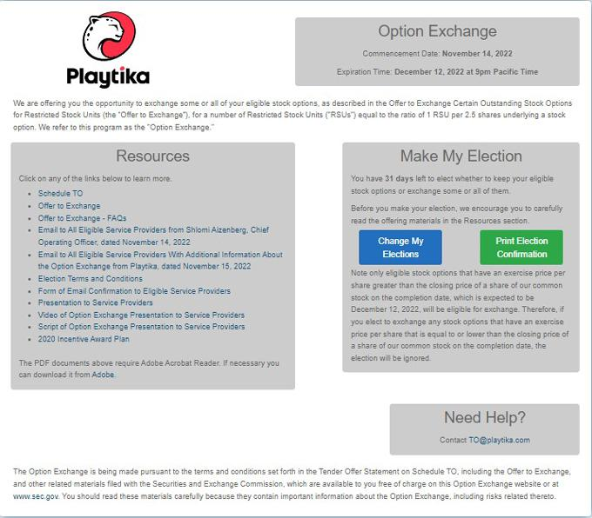

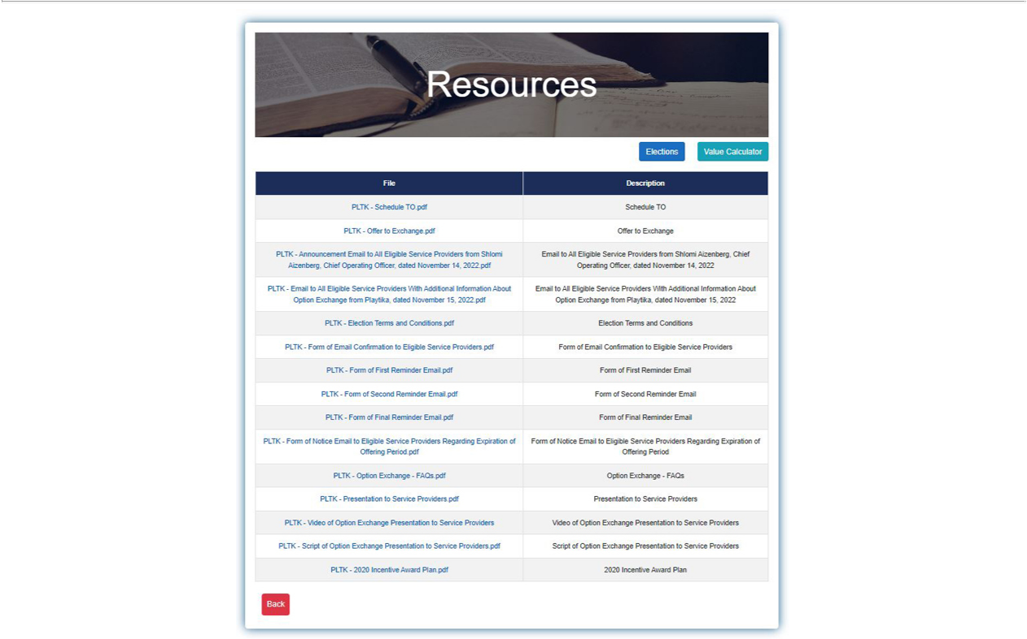

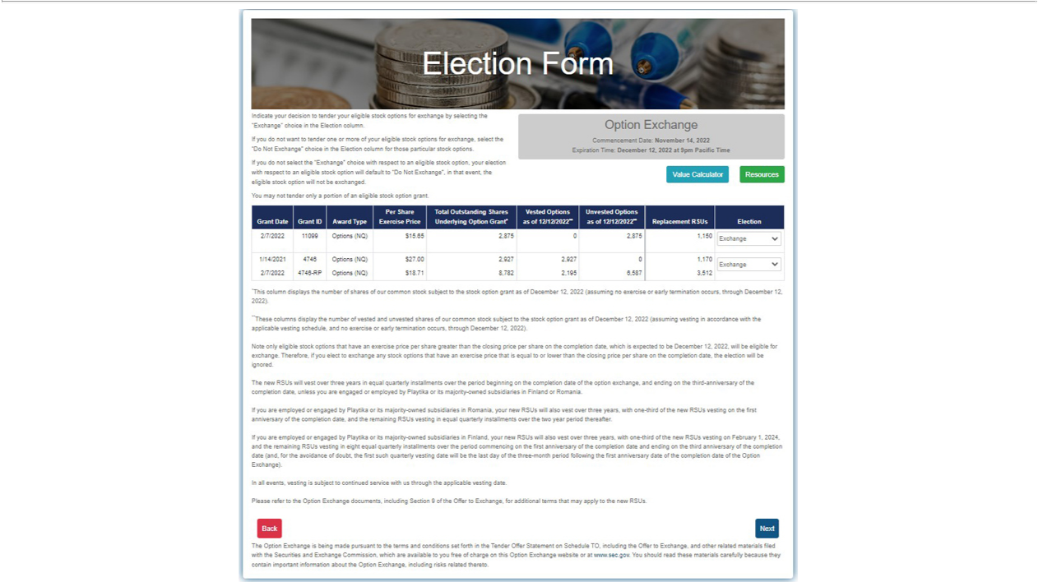

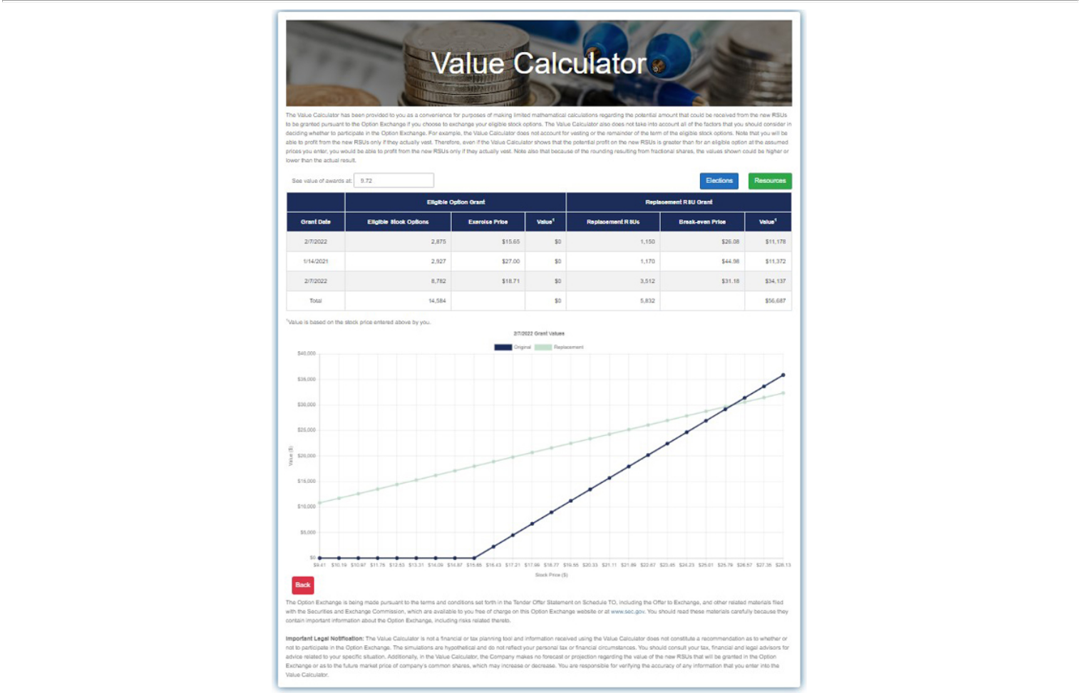

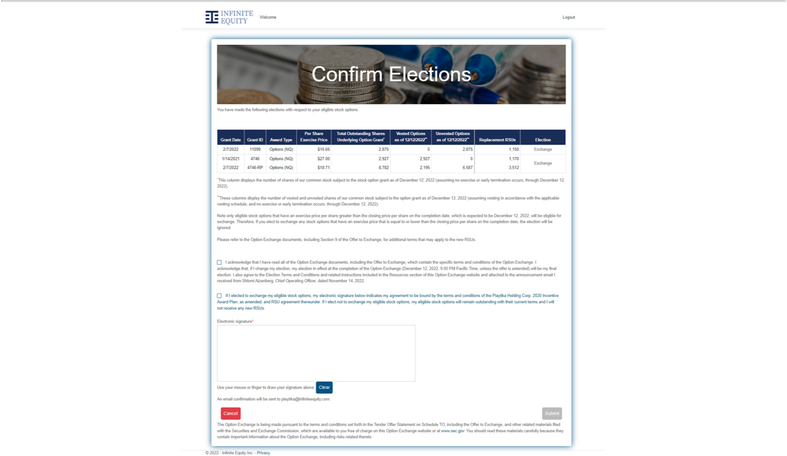

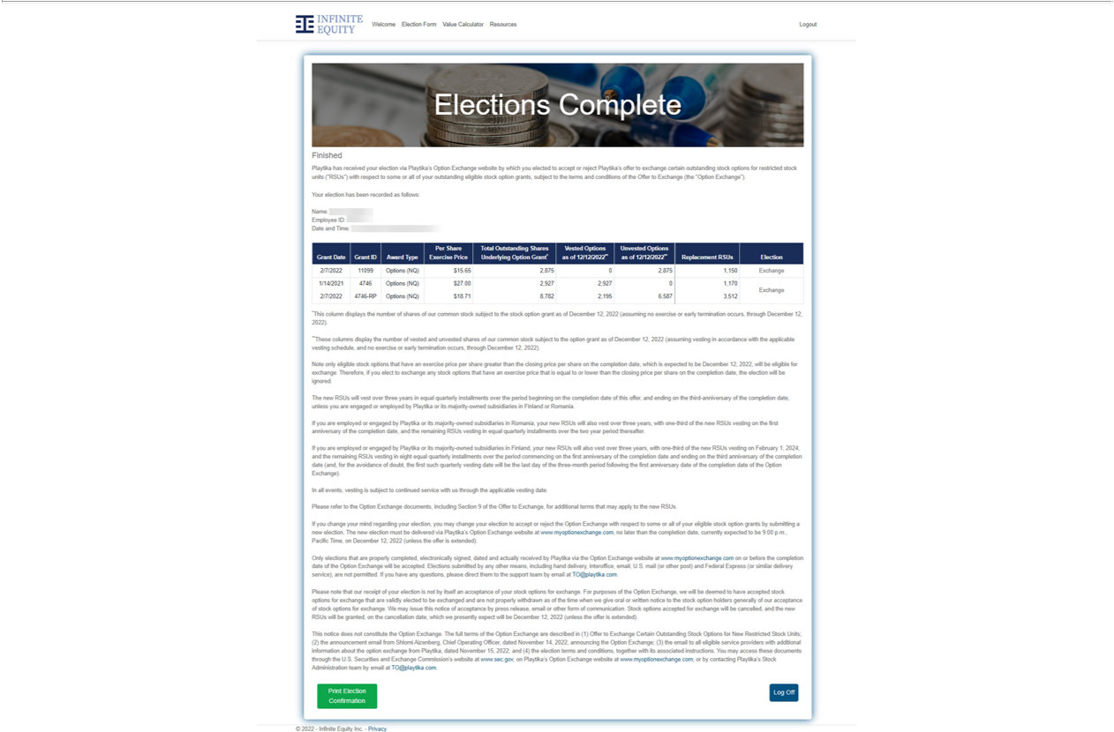

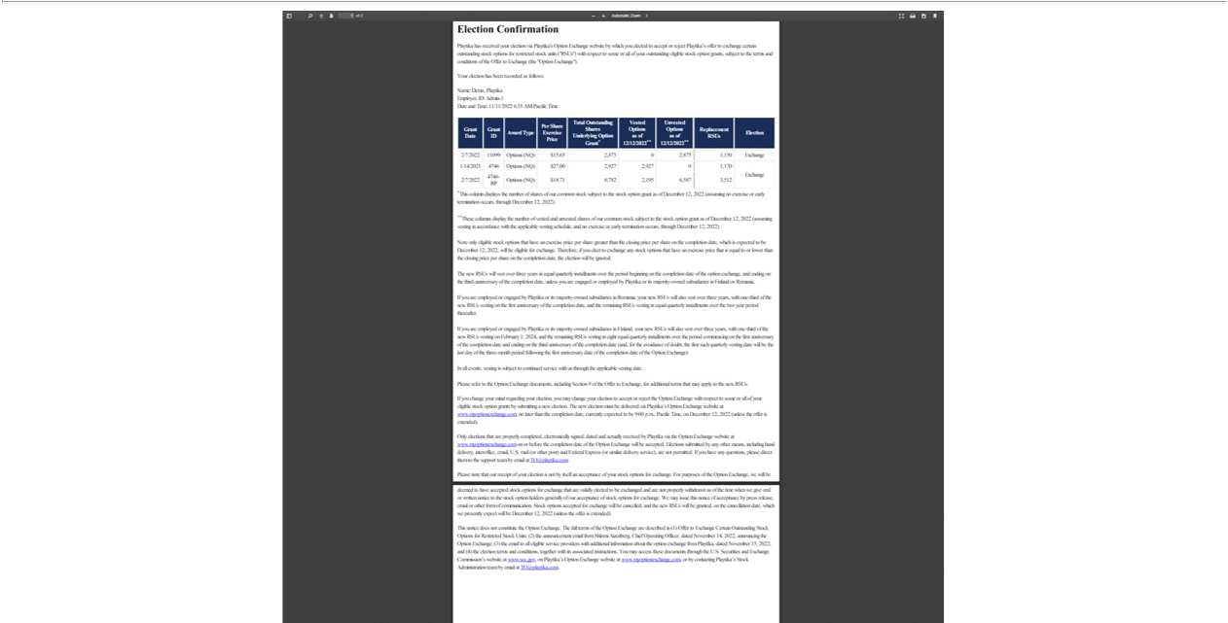

 | Exhibit (a)(1)(xi)
PLAYTIKA HOLDING CORP.
OPTION EXCHANGE FREQUENTLY ASKED QUESTIONS
Background Information
Q1. What is the Option Exchange? | 3
Q2. What are some key terms used in the Option Exchange? | 3
Q3. Why is Playtika offering the Option Exchange? | 5
Q4. How do RSUs differ from stock options? | 5
Eligibility
Q5. How do I know whether I am eligible to participate in the Option Exchange? | 6
Q6. How do I know which options are eligible for the Option Exchange? | 6
Q7. Are there circumstances in which I would not be eligible to receive RSUs in the Option Exchange? | 7
Q8. Can I exchange shares of Playtika common stock that I acquired upon a previous exercise of Playtika options? | 7
Q9. How many new RSUs will I receive for the eligible options that I exchange? | 7
Q10. Will the terms and conditions of my new RSUs be the same as my exchanged options? | 8
Q11. Are there special considerations if I am located in Israel? | 9
Q12. When will I receive my new RSUs? | 10
Q13. When will my new RSU awards vest? | 10
Q14. Do I need to exercise my new RSUs in order to receive shares? | 12
Participating in the Option Exchange
Q15. How do I participate in the Offer to Exchange? | 12
Q16. Am I required to participate in the Option Exchange? | 14
Q17. Can I choose which eligible options I want to exchange? | 14
Q18. Are there any restrictions on the number of eligible options grants I must elect to exchange in order to participate in the Option | 14
Exchange?
Q19. What happens if I have an eligible option grant that is subject to a domestic relations order or comparable legal document as the | 14
result of the end of a marriage?
Q20. Do I have to pay for the new RSUs? | 15
Q21. How do I decide whether I should participate in the Option Exchange? | 15
Q22. Is Playtika making any recommendation as to whether I should exchange my eligible options? | 16
Q23. How will we determine whether an eligible option has been properly tendered? | 16
Q24. Will my decision to participate in the Option Exchange have an impact on my ability to receive options or other equity awards | 16
in the future?
Exchanged Options
Q25. When will my exchanged options be cancelled? | 17
Q26. Will I be required to give up all of my rights under the exchanged options? | 17
Q27. After I have elected to exchange eligible options, is there anything I must do to receive new RSUs after the completion date? | 17
Tax Consequences
Q28. Will I have to pay taxes if I participate in the Option Exchange? | 17

Options Not Exchanged
Q29. What happens to my eligible option grants if I choose not to participate or my eligible options are not accepted for exchange? | 18
Changing or Withdrawing Previous Elections
Q30. Can I change my mind about which eligible options I want to exchange? | 19
Q31. May I change my mind and withdraw from the Offer to Exchange? | 20
Q32. What if I withdraw my election and then decide again that I want to participate in the Option Exchange? | 20
Changes to the Offer to Exchange and Conditions to the Option Exchange
Q33. If Playtika extends the Option Exchange or changes the Offer to Exchange, how will you notify me? | 20
Q34. Are there any conditions to the completion of the Option Exchange? | 21
Q35. What if Playtika is acquired by another company? | 21
Availability of Additional Information
Q36. Whom can I contact if I have questions about the Offer to Exchange, or if I need additional copies of communications issued to | 21
date?
2

Background Information

Q1. What is the Option Exchange?

A1. The Option Exchange is a one-time, voluntary opportunity for eligible service providers to exchange eligible “underwater” stock option awards for a lesser number of RSUs.

Further details can be found in Section 2 of the Offer to Exchange under “Types of Awards Granted in the Option Exchange; Number of New RSUs; Completion Date.”

See also: Answer to Question 7, “Are there circumstances in which I would not be eligible for RSUs in the Option Exchange?” of this Summary Term Sheet and Questions and Answers

Q2. What are some key terms used in the Option Exchange?

A2. Here are some key terms used when describing the Option Exchange:

Active service provider

An employee, consultant or other individual service provider of Playtika or Playtika’s majority-owned subsidiaries. An individual is not an “active service provider” if he or she (i) is on a “garden leave” or other leave that will result in a termination of employment with Playtika or one of Playtika’s majority-owned subsidiaries, (ii) has provided Playtika a notice of resignation or (iii) has received a notice of termination of employment or service from Playtika or one of Playtika’s majority-owned subsidiaries, in each case even if such resignation or termination will not take effect until following the completion of the Option Exchange.

Commencement date

November 14, 2022, the date the Option Exchange opens.

Completion date

The date and time the offering period for the Option Exchange expires, which is expected to be December 12, 2022, at 9:00 p.m., Pacific Time, but is subject to change. Playtika may extend the offering period and delay the completion date in its sole discretion.

The surrendered options will be cancelled, and the new RSUs will be granted, on the completion date of the Option Exchange.

Eligible service providers

Active employees, consultants or other individual service providers in eligible locations as of the commencement date who remain active employees, consultants or other individual service providers in eligible locations through the completion date.

Eligible locations

The countries, excluding Australia, where Playtika and its majority-owned subsidiaries employ or engage, as applicable, active service providers. Service providers located in Australia are not eligible to participate in the Option Exchange.

Eligible option

A stock option grant that was granted before November 10, 2022 and that remains outstanding and unexercised as of the completion date and is held by an eligible service provider.

An option will not be an eligible option (and any election with regard to such option will be disregarded) if, on the completion date, the per share exercise price of the option is less than the per share closing price of Playtika’s common stock on the completion date, as reported on the Nasdaq Global Select Market.

3

Exchanged options

Eligible options that, as of the completion date, an eligible service provider elects to exchange for new RSUs in the Option Exchange.

Exercise price

The purchase price per share of the common stock underlying a stock option, which is typically equal to the per share closing price of Playtika’s common stock on the grant date, as reported on the Nasdaq Global Select Market. The exercise price is a fixed price per share at which you can purchase Playtika common stock once the stock options vest.

Full vesting date

The date you fully own your equity award and can exercise or sell the shares underlying the award. For most stock options granted by Playtika, this date will be four years after the vesting commencement date of the option, which is usually the date of hire, promotion or grant, assuming continued employment with Playtika or one of Playtika’s majority-owned subsidiaries.

Grant date

The date an equity award, such as a stock option or RSU, is granted.

Intrinsic value

Intrinsic value with respect to an option is the absolute value of the difference between the trading price of Playtika’s common stock and the exercise price of the option. An underwater option has no intrinsic value since its exercise price is higher than the current trading price of the underlying common stock.

New RSUs

New RSUs that are granted to eligible service providers who choose to participate in the Option Exchange in exchange for the cancellation of their eligible options.

Offer to Exchange

The legal document entitled “Offer to Exchange Certain Outstanding Stock Options for Restricted Stock Units.” The Offer to Exchange contains the terms and conditions of the Option Exchange and may be amended and supplemented from time to time.

Offering period

The period between the commencement date and the completion date, during which eligible service providers can choose to exchange eligible options in and pursuant to the terms of the Option Exchange.

Currently, the offering period is November 14, 2022 through 9:00 p.m., Pacific Time, on December 12, 2022 but is subject to change. Playtika may extend the offering period and delay the completion date in its sole discretion.

Option Exchange

The exchange of eligible options for new RSUs pursuant to the offer in this Offer to Exchange.

Restricted stock unit (RSU)

The right to receive shares of Playtika’s common stock in the future; however, that right is “restricted” until the vesting criteria and other terms and conditions set forth in the 2020 Plan and the relevant RSU agreements are satisfied.

SEC

The U.S. Securities and Exchange Commission.

Option Exchange website

The website portal where eligible service providers can choose to participate in the Option Exchange and choose which, if any, eligible options they wish to exchange. The Option Exchange website also includes links to all of the documents referenced in the Offer to Exchange. The web address for the Option Exchange website is http://www.myoptionexchange.com.

Stock option expiration date

The date a stock option expires and is no longer available for exercise. For Playtika, this is typically 10 years following the grant date of a stock option.

4

Underwater Stock option grants that have an exercise price that is higher than the current trading price of Playtika’s

common stock are considered to be underwater.

Vesting date The date on which a portion of your stock option grant vests and becomes available for exercise or a portion

of your RSU grant vests and shares are released. Once an RSU vests, it becomes a share of Playtika common stock that you can hold, transfer, or sell.

Q3. Why is Playtika offering the Option Exchange?

A3. Playtika’s goal in providing equity compensation is not only to reward eligible service providers for their contributions, but also to help them think like stockholders, which we believe is critical to the company’s success. Playtika’s equity programs (e.g., stock options, RSUs) link service providers’ financial interests to those of our stockholders, and provide a way for service providers to share in the company’s long-term success.

Since Playtika’s initial public offering in January 2021, we have experienced a significant decline in our stock price. This decline in price has resulted in a considerable number of Playtika’s service providers holding stock options that are deeply “underwater”—making them less effective in helping us meet our goals.

Playtika is offering the Option Exchange to (i) provide a way for eligible service providers to realize value from eligible underwater options and

- to realign service provider and stockholder interests. The Option Exchange gives eligible service providers an opportunity to exchange certain options that are significantly “underwater” as of the commencement date for new RSUs that may provide value to eligible service providers, even if Playtika’s stock price does not increase. This approach of exchanging eligible options for a lesser number of new RSUs is consistent with Playtika’s current compensation strategy and provides what Playtika believes is a meaningful incentive for eligible service providers whose options are currently underwater.

See also: Section 3 of the Offer to Exchange

Q4. How do RSUs differ from stock options?

A4. The table below outlines some key differences between stock options and RSUs:

Stock Options RSUs

What they are | The right to purchase a fixed number of shares of Playtika common
 | stock at a fixed price for a fixed period of time.

The right to receive shares of Playtika common stock in the future upon vesting at no cost to the employee.

How they work Once a stock option grant vests, you can exercise the vested portion at

any time until the expiration date of that option. Exercising an option means you buy the stock at the exercise price set on the date of the grant.

If the price of Playtika’s stock is greater than the exercise price when you exercise and sell the shares, you receive the gain (after any taxes, of course).

However, when Playtika’s stock price is less than the exercise price, the stock option has

5

Once an RSU vests, a share of Playtika stock is issued to you and at no cost to you, other than withholding for applicable taxes associated with the RSU. An RSU has value equal to the then-current Playtika stock price. Once Playtika stock is issued to you following the vesting of the RSU, you can either keep it as an investment or sell it.

Example (assumes vested options and RSUs and no taxes)

Eligibility

no intrinsic value and is considered to be underwater.

If you are awarded a stock option with a per share exercise price of $15 and the Playtika stock price subsequently increases to $20, the option will be worth $5 if exercised on that later date.

If you are awarded a stock option with a per share exercise price of $15 and the Playtika stock price subsequently decreases to $10, the option will have no intrinsic value as of that later date.

If the stock price on the grant date of your RSU is $15, and the Playtika stock price subsequently increases to $20, each RSU will be worth $20 as of that later date.

If the stock price on the grant date of your RSU is $15, and the Playtika stock price subsequently decreases to $10, each RSU will be worth $10 as of that later date.

Q5. How do I know whether I am eligible to participate in the Option Exchange?

A5. You will be eligible to participate in the Option Exchange if:

- You are an active service provider of Playtika or any of its majority-owned subsidiaries on the commencement date;

- You remain an active service provider of Playtika or any of its majority-owned subsidiaries through the completion date of the Option Exchange; and

- You are not employed or engaged by Playtika or its majority-owned subsidiaries in any country where we determine that the Option Exchange would have regulatory, tax or other implications that are inconsistent with Playtika’s compensation policies and practices or this offer is prohibited under local regulations as of the date of the completion of the Option Exchange; and

- You hold at least one eligible option.

An individual is not an “active service provider” if he or she (i) is on a “garden leave” or other leave that will result in a termination of employment with Playtika or one of Playtika’s majority-owned subsidiaries, (ii) has provided Playtika a notice of resignation or (iii) has received a notice of termination of employment or service from Playtika or one of Playtika’s majority-owned subsidiaries, in each case even if such resignation or termination will not take effect until following the completion of the Option Exchange

Playtika reserves the right to withdraw the Offer to Exchange in any jurisdiction for which it determines that the Option Exchange would have regulatory, tax or other implications that are inconsistent with Playtika’s compensation policies and practices. If Playtika withdraws the Offer to Exchange in a particular jurisdiction, the Offer to Exchange will not be made to, nor will eligible options be accepted for exchange from or on behalf of, eligible service providers in that jurisdiction.

See also: Section 1 of the Offer to Exchange

Q6. How do I know which options are eligible for the Option Exchange?

A6. If you are eligible to participate in the Option Exchange, the Option Exchange website will indicate which of your stock options are eligible for exchange. In order for your stock option awards to be eligible, they must remain outstanding and unexercised on the commencement date and the completion date and have a per share exercise price more than the per share closing price of Playtika’s common stock on the completion date, as reported on the Nasdaq Global Select Market.

See also: Section 2 of the Offer to Exchange

6

Q7. Are there circumstances in which I would not be eligible to receive RSUs in the Option Exchange?

A7. Yes:

- If you cease being an active service provider prior to the completion date; and

- If you are located in Australia, you are not eligible to participate in the Option Exchange.

See also: Sections 1 and 2 of the Offer to Exchange

Q8. Can I exchange shares of Playtika common stock that I acquired upon a previous exercise of Playtika options?

A8. No. This Option Exchange relates only to outstanding Playtika options to purchase shares of our common stock. You may not exchange in this Option Exchange any shares of our common stock that you acquired upon a prior exercise of options or by any other means.

See also: Section 2 of the Offer to Exchange

Q9. How many new RSUs will I receive for the eligible options that I exchange?

A9. If you participate in the Option Exchange, you will receive one new RSU (representing the right to receive one share of our common stock) for every 2.5 shares of our common stock underlying eligible stock options surrendered pursuant to the Offer to Exchange. The number of new RSUs will be rounded down to the nearest whole share on a grant-by-grant basis. Fractional RSUs will not be granted in the Option Exchange.

New RSUs granted in the Option Exchange will not be vested on their date of grant regardless of whether the surrendered option was fully vested in whole or in part. Instead, the new RSUs granted in the Option Exchange will vest as follows:

- Over three years in equal quarterly installments over the period beginning on the completion date of this offer and ending on the third anniversary of the completion date, unless you are employed or engaged by Playtika or its majority-owned subsidiaries in Finland or Romania.

- If you are employed or engaged by Playtika or its majority-owned subsidiaries in Romania, your new RSUs will also vest over three years, with one-third of the new RSUs vesting on the first anniversary of the completion date, and the remaining RSUs vesting in equal quarterly installments over the two year period thereafter.

- If you are employed or engaged by Playtika or its majority-owned subsidiaries in Finland, your new RSUs will also vest over three years, with one-third of the new RSUs vesting on February 1, 2024, and the remaining RSUs vesting in eight equal quarterly installments over the period commencing on the first anniversary of the completion date and ending on the third anniversary of the completion date (and, for the avoidance of doubt, the first such quarterly vesting date will be the last day of the three-month period following the first anniversary date of the completion date of the Option Exchange).

- Your new RSUs will be subject to the terms and conditions of an RSU agreement between you and Playtika. In all events, vesting is subject to continued service with us through the applicable vesting date. Your participation in the Option Exchange and receipt of any new RSUs does not provide any guarantee or promise of continued service with us.

IMPORTANT INFORMATION FOR

ELIGIBLE SERVICE PROVIDERS IN ISRAEL

7

If you participate in the Option Exchange and you are subject to tax in Israel, the exchange of eligible options for the grant of new RSUs in the Option Exchange may result in a taxable event and any new RSUs may not be eligible for favorable tax treatment under the 102 Capital Gains Track (as defined in the 2020 Plan) under Section 102 of the ITO. Playtika will seek a tax ruling from the Israel Tax Authorities (“ITA”) which states that eligible option holders participating in the Option Exchange will not be subject to tax as a result of the exchange of eligible options for the new RSUs in the Option Exchange and that the new RSUs will be granted under the 102 Capital Gains Track under Section 102 (the “Israel Tax Ruling”).

While Playtika will seek to obtain the Israel Tax Ruling as promptly as practicable, there can be no assurance when or if the Israel Tax Ruling will be obtained in respect of the Option Exchange. Playtika does not expect to receive a determination from the ITA as to whether the Israel Tax Ruling will be obtained in respect of the Option Exchange prior to the completion date. As a result, eligible service providers who are subject to tax in Israel will need to consider whether to exchange their eligible options for the grant of new RSUs in the Option Exchange in light of this uncertainty regarding the tax consequences to them of the Option Exchange in Israel.

Please read the “Impact of the Option Exchange” section in Schedule G to this Offer to Exchange for more information about the potential tax consequences to you of participation in the Option Exchange. If the Israel Tax Ruling is not obtained by Playtika, the Option Exchange may be a taxable event and any new RSUs may not be granted under the 102 Capital Gains Track of Section 102.

The new RSUs granted in the Option Exchange will be governed by the terms and conditions of the 2020 Plan, an RSU agreement between you and Playtika, and any country-specific terms and conditions set forth in an appendix to the RSU agreement or the 2020 Plan.

Example

If you hold an eligible option to purchase 2,500 shares of Playtika common stock, you will receive 1,000 new RSUs on the completion date if you elect to participate in the Option Exchange.

You will not have to calculate the number of new RSUs you will receive for the eligible options you elect to exchange in the Option Exchange.

The Option Exchange website lists the number of new RSUs you are eligible to receive for each of your eligible option grants.

See also: Section 2 of the Offer to Exchange

Q10. Will the terms and conditions of my new RSUs be the same as my exchanged options?

A10. No. RSUs are a different type of award than stock options, and the terms and conditions of your new RSUs will be different from the exchanged options.

Options represent the right to purchase shares of Playtika shares at a fixed price for a specified term (generally ten years from the date of grant, subject to earlier termination in the event of your termination of employment or service). While the eligible options are currently underwater, in the event Playtika’s stock price increases in the future, the eligible options may have a greater value in the future than the new RSUs to be granted in the Option Exchange given that fewer new RSUs will be granted in exchange for the surrender of eligible options.

Also, the vesting schedule of new RSUs will be different from the vesting schedule of the exchanged options, many of which are vested as of the commencement date. For example, the awards granted to

8

employees in January 2021 in connection with our initial public offering will be nearly 50% vested on the commencement date of the Option Exchange.

New RSUs granted in the Option Exchange will not be vested on their date of grant regardless of whether the surrendered option was fully vested in whole or in part. Instead, the new RSUs granted in the Option Exchange will vest as follows:

- Over three years in equal quarterly installments over the period beginning on the completion date of this offer and ending on the third anniversary of the completion date, unless you are employed or engaged by Playtika or its majority-owned subsidiaries in Finland or Romania.

- If you are employed or engaged by Playtika or its majority-owned subsidiaries in Romania, your new RSUs will also vest over three years, with one-third of the new RSUs vesting on the first anniversary of the completion date, and the remaining RSUs vesting in equal quarterly installments over the two year period thereafter.

- If you are employed or engaged by Playtika or its majority-owned subsidiaries in Finland, your new RSUs will also vest over three years, with one-third of the new RSUs vesting on February 1, 2024, and the remaining RSUs vesting in eight equal quarterly installments over the period commencing on the first anniversary of the completion date and ending on the third anniversary of the completion date (and, for the avoidance of doubt, the first such quarterly vesting date will be the last day of the three-month period following the first anniversary date of the completion date of the Option Exchange).

- Your new RSUs will be subject to the terms and conditions of an RSU agreement between you and Playtika. In all events, vesting is subject to continued service with us through the applicable vesting date. Your participation in the Option Exchange and receipt of any new RSUs does not provide any guarantee or promise of continued service with us.

The new RSUs granted in the Option Exchange will be governed by the terms and conditions of the 2020 Plan, an RSU agreement between you and Playtika, and any country-specific terms and conditions set forth in an appendix to the RSU agreement or 2020 Plan. Links to the 2020 Plan and the current forms of RSU agreements under the 2020 Plan, including any country-specific appendices, and any other country-specific documentation, are included on the Option Exchange website as exhibits to a document Playtika filed with the SEC called a “Schedule TO,” which is available on the Option Exchange website and the SEC’s website at www.sec.gov.

In addition, the tax treatment and social insurance contribution obligations of the new RSUs may differ significantly from the tax treatment and social insurance contribution obligations of your exchanged options.

See also:

- Answers to Question 11, “Are there special considerations if I am located in Israel?”, Question 13, “When will my new RSU awards vest?” and Question 28, “Will I have to pay taxes if I participate in the Option Exchange?” of this Summary Term Sheet and Questions and Answers

- Sections 2 and 14 of the Offer to Exchange

- Schedules C through L of the Offer to Exchange, which contains country-specific tax disclosures

Q11. Are there special considerations if I am located in Israel?

A11. If you participate in the Option Exchange and you are subject to tax in Israel, the exchange of eligible options for the grant of new RSUs in the Option Exchange may result in a taxable event and any new RSUs may not be eligible for favorable tax treatment under the 102 Capital Gains Track (as defined in the 2020 Plan) under Section 102 of the ITO. Playtika will seek the Israel Tax Ruling from the ITA which states that

9

eligible option holders participating in the Option Exchange will not be subject to tax as a result of the exchange of eligible options for the new RSUs in the Option Exchange and that the new RSUs will be granted under the 102 Capital Gains Track under Section 102.

If the Israel Tax Ruling is obtained, the new RSUs will be granted under the 102 Capital Gains Track pursuant to which the new RSUs and any shares acquired at vesting of the new RSUs will be held in trust by the trustee designated by Playtika for at least 24 months from the date of grant of the new RSUs to comply with the required holding period.

Your eligible options may also have been granted under the 102 Capital Gains Track. Please note that you will not receive any holding period credit on your new RSU grants for the time period your eligible options were held in trust prior to the Option Exchange; rather, the required holding period will start over on the date the new RSUs are granted.

While Playtika will seek to obtain the Israel Tax Ruling as promptly as practicable, there can be no assurance when or if the Israel Tax Ruling will be obtained in respect of the Option Exchange. Playtika does not expect to receive a determination from the ITA as to whether the Israel Tax Ruling will be obtained in respect of the Option Exchange prior to the completion date. As a result, eligible service providers who are subject to tax in Israel will need to consider whether to exchange their eligible options for the grant of new RSUs in the Option Exchange in light of this uncertainty regarding the tax consequences to them of the Option Exchange in Israel.

Please read the “Impact of the Option Exchange” section in Schedule G to this Offer to Exchange for more information about the

potential tax consequences to you of participation in the Option Exchange. If the Israel Tax Ruling is not obtained by Playtika, the

Option Exchange may be a taxable event and any new RSUs may not be granted under the 102 Capital Gains Track of Section 102.

Q12. When will I receive my new RSUs?

A12. The grant date of the new RSUs will be the completion date. If the offering period is extended, the completion date and the grant of the new RSUs will be correspondingly delayed. Please note that it may take a few weeks from the completion date for you to receive an email related to your new RSUs and for the grant of new RSUs to be reflected in your online Shareworks account. Please review and accept your grant documents in your online Shareworks account. If your account has not been updated for the new RSUs within a few weeks following the completion date, please contact to@playtika.com. You will receive the shares of Playtika common stock subject to your new RSUs if and when your new RSUs vest.

Please note that it may take a few weeks from the completion date for you to receive an email related to your new RSUs and for the grant of new RSUs to be reflected in your online Shareworks account. Please review and accept your grant documents in your online Shareworks account.

See also:

- Answer to Question 13, “When will my new RSU awards vest?” of this Summary Term Sheet and Questions and Answers

- Sections 6 and 9 of the Offer to Exchange

Q13. When will my new RSU awards vest?

A13. New RSUs granted in the Option Exchange will not be vested on their date of grant regardless of whether the surrendered option was fully vested in whole or in part. Instead, the new RSUs granted in the Option Exchange will vest as follows:

- Over three years in equal quarterly installments over the period beginning on the completion date of this offer and ending on the third anniversary of the completion date, unless you are employed or engaged by Playtika or its majority-owned subsidiaries in Finland or Romania.

10

- If you are employed or engaged by Playtika or its majority-owned subsidiaries in Romania, your new RSUs will also vest over three years, with one-third of the new RSUs vesting on the first anniversary of the completion date, and the remaining RSUs vesting in equal quarterly installments over the two year period thereafter.

- If you are employed or engaged by Playtika or its majority-owned subsidiaries in Finland, your new RSUs will also vest over three years, with one-third of the new RSUs vesting on February 1, 2024, and the remaining RSUs vesting in eight equal quarterly installments over the period commencing on the first anniversary of the completion date and ending on the third anniversary of the completion date (and, for the avoidance of doubt, the first such quarterly vesting date will be the last day of the three-month period following the first anniversary date of the completion date of the Option Exchange).

- Your new RSUs will be subject to the terms and conditions of an RSU agreement between you and Playtika. In all events, vesting is subject to continued service with us through the applicable vesting date. Your participation in the Option Exchange and receipt of any new RSUs does not provide any guarantee or promise of continued service with us.

New RSUs granted in the Option Exchange will only vest if the holder remains in continuous service under the terms and conditions of the 2020 Plan, the applicable RSU agreement and other relevant Playtika policies, as each may be amended from time to time. Generally, new RSUs that are not vested at termination of continuous service to Playtika, as determined in accordance with the 2020 plan, will be forfeited.

IMPORTANT INFORMATION FOR

ELIGIBLE SERVICE PROVIDERS IN ISRAEL

Regardless of whether the Israel Tax Ruling is obtained, your new RSUs will be granted under the terms of the 2020 Plan, including the Sub-Plan for Israeli Participants. As mentioned above, if an Israel Tax Ruling is obtained, the new RSUs will be granted under the 102 Capital Gains Track pursuant to which the new RSUs and any shares acquired at vesting of the new RSUs will be held in trust by the trustee designated by Playtika for at least 24 months from the date of grant of the new RSUs to comply with the required holding period.

Your eligible options may also have been granted under the 102 Capital Gains Track. Please note that you will not receive any holding period credit on your new RSU grants for the time period your eligible options were held in trust prior to the Option Exchange; rather, the required holding period will start over on the date the new RSUs are granted.

While Playtika will seek to obtain the Israel Tax Ruling as promptly as practicable, there can be no assurance when or if the Israel Tax Ruling will be obtained in respect of the Option Exchange. Playtika does not expect to receive a determination from the ITA as to whether the Israel Tax Ruling will be obtained in respect of the Option Exchange prior to the completion date. As a result, eligible service providers who are subject to tax in Israel will need to consider whether to exchange their eligible options for the grant of new RSUs in the Option Exchange in light of this uncertainty regarding the tax consequences to them of the Option Exchange in Israel.

Please read the “Impact of the Option Exchange” section in Schedule G to this Offer to Exchange for more information about the potential tax consequences to you of participation in the Option Exchange. If the Israel Tax Ruling is not obtained by Playtika, the Option Exchange may be a taxable event and any new RSUs may not be granted under the 102 Capital Gains Track of Section 102.

11

Q14. Do I need to exercise my new RSUs in order to receive shares?

A14. Unlike stock options, which you must exercise in order to receive the vested shares subject to the option, you do not need to exercise RSUs in order to receive shares. If your new RSUs vest in accordance with the vesting schedule set forth in the applicable RSU agreement, you will automatically receive the shares subject to the new RSUs promptly thereafter (less taxes, of course). Generally, new RSUs that do not vest will be forfeited to Playtika, as determined in accordance with the 2020 Plan.

See also: Section 9 of the Offer to Exchange

Participating in the Option Exchange

Q15. How do I participate in the Offer to Exchange?

A15. If you choose to participate in the Option Exchange, you must take action no later than 9:00 p.m., Pacific Time, on the completion date.

  - First, you need to learn about the Offer to Exchange—what it is, whether you are eligible (eligibility varies by country based on regulatory requirements) and which stock options can be exchanged.

  - Next, evaluate your options. You will be able to model how many new RSUs you would receive for your eligible options on the Option Exchange website. Keep in mind that you can exchange some, all or none of your eligible option grants for new RSUs.

  - Lastly, choose which eligible options to exchange, if any. You must make your election online at the Option Exchange website during the offering period (i.e., between the commencement date and the completion date). Just follow these simple steps:

- Click on the link to the Option Exchange website in the announcement email you received from Shlomi Aizenberg, Chief Operating Officer, dated November 14, 2022, announcing the Option Exchange, or go to the Option Exchange website at http://www.myoptionexchange.com/Identity/Account/Register. Log in to the Option Exchange website using the login instructions provided to you in the announcement email (or if you previously logged into the Option Exchange website, your updated login credentials).

- After logging in to the Option Exchange website, review the information and proceed through to the “Election Form” page. You will be provided with personalized information regarding each eligible option grant you hold, including:

    - the grant date of the eligible option grant;

    - the per share exercise price of the eligible option grant;

    - the number of vested and unvested shares of our common stock subject to the eligible option grant as of December 12, 2022 (assuming vesting in accordance with the applicable vesting schedule, and no exercise or early termination occurs, through such date);

    - the number of shares of our common stock subject to the new RSU grant that would be granted in exchange for the eligible option grant; and

    - the vesting schedule of the new RSU grant.

- On the “Election Form” page, make your selection next to each of your eligible option grants to indicate which eligible option grants you choose to exchange in the Option Exchange by selecting “Exchange” or choose not to exchange in the Option Exchange by selecting “Do Not Exchange.”

12

- Proceed through the Option Exchange website by following the instructions provided. Review your election and confirm that you are satisfied with your election. After reviewing, acknowledging and agreeing to the terms and conditions stated on the Confirm Elections page and in the Option Exchange documents, submit your election. If you do not acknowledge and agree to the terms and conditions, you will not be permitted to submit your election.

- Upon submitting your election, a confirmation statement will be generated by the Option Exchange website. Please print and keep a copy of the confirmation statement for your records. A copy of the confirmation statement will also be sent to your Playtika email. At this point, you will have completed the election process via the Option Exchange website.

We must receive your properly completed and submitted election by the expiration of the Option Exchange, currently expected to be 9:00 p.m., Pacific Time, on December 12, 2022, unless otherwise extended. If you are unable to submit your election via the Option Exchange website as a result of technical failures of the Option Exchange website such as the Option Exchange website being unavailable or the Option Exchange website not enabling you to submit your election, please email to@playtika.com prior to the expiration of the Option Exchange.

If you elect to exchange any portion of an individual eligible option grant in the Offer to Exchange, you must elect to exchange the entire individual eligible option grant. If you hold more than one individual eligible option grant, however, you may choose to exchange one or more of such individual eligible option grants, on a grant-by-grant basis, without having to exchange all of your individual eligible option grants. No partial exchanges of an eligible option grant will be permitted. If you are eligible to participate in the Option Exchange, the Option Exchange website will list all of your eligible options.

We may extend this Option Exchange. If we extend the offering period, we will issue a press release, email or other communication disclosing the extension no later than 6:00 a.m., Pacific Time, on December 13, 2022 (the U.S. business day following the previously scheduled completion date).

This is a one-time offer, and we will strictly enforce the offering period. We reserve the right to reject any option tendered for exchange that we determine is not in the appropriate form or that we determine is unlawful to accept. Subject to the terms and conditions of this Option Exchange, we will accept all properly tendered eligible option grants promptly after the expiration of this Option Exchange.

IMPORTANT INFORMATION FOR

ELIGIBLE SERVICE PROVIDERS IN ISRAEL

If you participate in the Option Exchange and you are subject to tax in Israel, the exchange of eligible options for the grant of new RSUs in the Option Exchange may result in a taxable event and any new RSUs may not be eligible for favorable tax treatment under the 102 Capital Gains Track (as defined in the 2020 Plan) under Section 102 of the ITO. Playtika will seek the Israel Tax Ruling from the ITA which states that eligible option holders participating in the Option Exchange will not be subject to tax as a result of the exchange of eligible options for the new RSUs in the Option Exchange and that the new RSUs will be granted under the 102 Capital Gains Track under Section 102.

While Playtika will seek to obtain the Israel Tax Ruling as promptly as practicable, there can be no assurance when or if the Israel Tax Ruling will be obtained in respect of the Option Exchange. Playtika does not expect to receive a determination from the ITA as to whether the Israel Tax Ruling will be obtained in respect of the Option Exchange prior to the completion date. As a result, eligible service providers who are subject to tax in Israel will need to consider whether to exchange their eligible options for the grant of new RSUs in the Option Exchange in light of this uncertainty regarding the tax consequences to them of the Option Exchange in Israel.

13

Please read the “Impact of the Option Exchange” section in Schedule G to this Offer to Exchange for more information about the potential tax consequences to you of participation in the Option Exchange. If the Israel Tax Ruling is not obtained by Playtika, the Option Exchange may be a taxable event and any new RSUs may not be granted under the 102 Capital Gains Track of Section 102.

See also:

- Answer to Question 16, “Am I required to participate in the Option Exchange?” of this Summary Term Sheet and Questions and Answers

- Section 4 of the Offer to Exchange

Q16. Am I required to participate in the Option Exchange?

A16. No. Participation in the Option Exchange is voluntary. If you choose not to participate in the Option Exchange, you will continue to hold your eligible options on the same terms and conditions and pursuant to which they were originally granted.

See also: Section 2 of the Offer to Exchange

Q17. Can I choose which eligible options I want to exchange?

A17. You may choose to exchange some, all or none of your eligible options in the Offer to Exchange entirely at your discretion. However, if you elect to participate in the Option Exchange, to exchange an individual eligible option grant, you must elect to exchange the entire individual eligible option grant. Playtika is not accepting partial tenders of individual eligible option grants, except that you may elect to exchange the entire remaining portion of an eligible option grant that you have exercised partially. You otherwise may not elect to exchange only some of the shares covered by any particular individual eligible option grant.

See also: Section 2 of the Offer to Exchange

Q18. Are there any restrictions on the number of eligible options grants I must elect to exchange in order to participate in the Option Exchange?

A18. No. There is no minimum number of eligible options that you must elect to exchange in order to participate. However, if you elect to participate in the Option Exchange, to exchange an individual eligible option grant, you must elect to exchange the entire individual eligible option grant. Playtika is not accepting partial tenders of individual eligible option grants, except that you may elect to exchange the entire remaining portion of an eligible option grant that you have exercised partially. You otherwise may not elect to exchange only some of the shares covered by any particular individual eligible option grant.

Please note that there may be brokerage and/or wire fees associated with selling the shares of Playtika common stock acquired upon vesting of new RSUs which could affect the benefit you can realize from such sale.

See also:

- Answer to Question 20, “Do I have to pay for the new RSUs?” of this Summary Term Sheet and Questions and Answers

- Section 9 of the Offer to Exchange

Q19. What happens if I have an eligible option grant that is subject to a domestic relations order or comparable legal document as the result of the end of a marriage?

14

A19. If you have an eligible option grant that is subject to a domestic relations order (or comparable legal document as the result of the end of a marriage) and a person who is not an eligible service provider beneficially owns a portion of that eligible option grant, then in order to participate in the Option Exchange with respect to such eligible option grant, you may accept this Option Exchange with respect to the entire remaining outstanding portion of the eligible option grant, including the portion beneficially owned by the other person, as long as you are the legal owner of the eligible option grant. As described in Answer to Question 17, we are not accepting partial tenders of an eligible option grant, so you may not accept this Option Exchange with respect to a portion of an eligible option grant that is beneficially owned by you while rejecting it with respect to the portion beneficially owned by someone else. As you are the legal owner of the eligible option grant, we will respect an election properly made by you, but will not be responsible to you or the beneficial owner of the eligible option grant for any errors made by you with respect to such eligible option grant.

See also: Section 2 of the Offer to Exchange

Q20. Do I have to pay for the new RSUs?

A20. You do not have to make any cash payment to Playtika to receive a grant of new RSUs in exchange for your exchanged options. You also do not have to pay Playtika to receive the shares of Playtika common stock that become issuable to you if your new RSUs vest; however, you may have taxes due on the vesting of the RSUs.

Please also note that you will incur brokerage and/or wire fees in the event you decide to sell the shares of Playtika common stock issued to you upon vesting of your new RSUs.

See also:

- Answer to Question 28, “Will I have to pay taxes if I participate in the Option Exchange?” of this Summary Term Sheet and Questions and Answers

- Section 9 and 14 of the Offer to Exchange

- Schedules C through L of the Offer to Exchange, which contain country-specific tax disclosures

Q21. How do I decide whether I should participate in the Option Exchange?

A21. First, review all of the materials provided to you in connection with the Offer to Exchange, including this Summary Term Sheet and Questions and Answers. These materials can all be found on the Option Exchange website and in, or filed as exhibits to, a document filed by Playtika with the SEC called a “Schedule TO,” which is available on the SEC website at http://www.sec.gov.

In addition to reviewing the materials, please note the following:

- It’s not a one-for-one exchange. You will receive fewer new RSUs than the number of shares of our common stock underlying eligible options that you surrender for exchange.

- RSUs provide value upon vesting even if Playtika’s stock price does not increase after the grant date. However, because you will receive fewer new RSUs than the options you elect to exchange, it is possible that, at some point in the future, options you choose to exchange could be economically more valuable than the new RSUs received by you pursuant to the Option Exchange.

- New RSUs granted in the Option Exchange will be subject to a new vesting schedule, even if the eligible options you exchange were vested in whole or in part.

- Do not forget to consider taxes and social insurance contributions. In general, your new RSUs will be taxed, and social insurance contributions made, if applicable, when they vest. But taxation and social insurance contribution rules vary from country to country, so you will want to review all of the documents provided in connection with the Offer to Exchange carefully. If you are a resident of or

15

subject to the tax laws in more than one country, you should be aware that there may be additional or different tax consequences and social insurance contributions that may apply to you.

- Please also note that no one from Playtika is, or will be, authorized to provide you with advice or recommendations or to provide you additional information not included in the Offer to Exchange or the documents referenced in the Offer to Exchange. You must make your own personal decision as to whether or not to participate in the Option Exchange. You are strongly encouraged to consult with your personal legal counsel, accountant, financial, and/or tax advisor(s) for further advice.

See also:

- Sections 3 and 9 of the Offer to Exchange

- Schedules C through L of the Offer to Exchange, which contain country-specific tax disclosures

- Risks of Participating in the Option Exchange in the Offer to Exchange

Q22. Is Playtika making any recommendation as to whether I should exchange my eligible options?

A22. No. Playtika is providing you with as much information as possible to assist you in making your own informed decision. However, Playtika is not making any recommendation as to whether you should accept the Offer to Exchange. No one from Playtika is, or will be, authorized to provide you with advice or recommendations or to provide you additional information not included in the Offer to Exchange or the documents referenced in the Offer to Exchange. You must make your own personal decision as to whether or not to participate in the Option Exchange. You are strongly encouraged to consult with your personal legal counsel, accountant, financial, and/or tax advisor for further advice.

See also:

- Section 3 of the Offer to Exchange

- Schedules C through L of the Offer to Exchange, which contain country-specific tax disclosures

- Risks of Participating in the Option Exchange in the Offer to Exchange

Q23. How will we determine whether an eligible option has been properly tendered?

A23. We will determine, in our discretion, all questions about the validity, form, eligibility (including time of receipt) and acceptance of the documents you submit to accept the Option Exchange for any of your eligible options. Our determination of these matters will be given the maximum deference permitted by law. However, you have all rights accorded to you under applicable law to challenge such determination in a court of competent jurisdiction. Only a court of competent jurisdiction can make a determination that will be final and binding upon the parties. We reserve the right to reject any election or any options tendered for exchange that we determine is not in appropriate form or that we determine is unlawful to accept. We will accept all properly tendered eligible options that are not validly withdrawn, subject to the terms of this Option Exchange. No tender of eligible options will be deemed to have been made properly until all defects or irregularities have been cured or waived by us. We have no obligation to give notice of any defects or irregularities in any election, and we will not incur any liability for failure to give any notice.

See also: Section 4 of the Offer to Exchange

Q24. Will my decision to participate in the Option Exchange have an impact on my ability to receive options or other equity awards in the future?

A24. No. Your election to participate or abstain from participating in the Option Exchange will have no effect on our making future grants of options, other equity awards, or any other rights to you or anyone else.

See also: Section 1 of the Offer to Exchange

16

Exchanged Options

Q25. When will my exchanged options be cancelled?

A25. Your exchanged options will be cancelled as of the completion date. If the Offer to Exchange is extended and the completion date delayed, the cancellation of your exchanged options and the grant date of any new RSUs will be correspondingly delayed. Exchanged options that are cancelled will no longer be displayed through your online Shareworks account following the completion date.

See also: Section 6 of the Offer to Exchange

Q26. Will I be required to give up all of my rights under the exchanged options?

A26. Yes. Once Playtika has accepted your exchanged options, your exchanged options will be cancelled and you will no longer will have any rights under those exchanged options. Playtika will cancel all exchanged options as of the completion date. However, if the completion date is delayed, the date the exchanged options are cancelled and the grant date of any new RSUs will be correspondingly delayed.

See also: Section 6 of the Offer to Exchange

Q27. After I have elected to exchange eligible options, is there anything I must do to receive new RSUs after the completion date?

A27. No. Once your exchanged options have been cancelled, you do not need to take additional action in order to receive your new RSUs. Your new RSUs will be granted to you as of the completion date. If the Offer to Exchange is extended and the completion date delayed, the date on which new RSUs are granted will be correspondingly delayed. In order to receive the shares covered by the new RSU grant, you must continue to be an active service provider and eligible for vesting under Playtika’s policies, as amended from time to time, through the applicable vesting date.

Please note that it may take a few weeks from the completion date for you to receive an email related to your new RSUs and for the grant of new RSUs to be reflected in your online Shareworks account. You will be required to accept your grant documents in your online Shareworks account.

See also:

- Answer to Question 13, “When will my new RSU awards vest?” of this Summary Term Sheet and Questions and Answers

- Section 9 of the Offer to Exchange

Tax Consequences

Q28. Will I have to pay taxes if I participate in the Option Exchange?

A28. If you participate in the Option Exchange, you generally will not be required to recognize income for income taxes, social insurance contributions or other tax purposes at the time of the exchange, or when the new RSUs are granted. You generally will recognize income for income tax, social insurance contributions and other tax purposes when the new RSUs vest and the shares underlying the new RSUs are issued to you. If you are subject to tax in Israel, the timing of the taxes on your new RSUs may differ from this general statement. See below for more information.

You should consult with your personal legal counsel, accountant, financial, and/or tax advisor(s) to determine the personal tax consequences to you of participating in the Option Exchange. If you are a resident of or subject to the tax laws in more than one country, you should be aware that there may be additional or different income tax, social insurance contributions and other tax consequences that may apply to you.

17

If your eligible options were granted while you were providing services in one jurisdiction and you now work for Playtika in another jurisdiction, you may be subject to income taxes, social insurance contributions and other taxes at the time of the exchange in the jurisdiction in which the eligible option was originally granted. You should consult with your personal legal counsel, accountant, financial, and/or tax advisor(s) to determine the tax effect of your individual circumstances.

IMPORTANT INFORMATION FOR

ELIGIBLE SERVICE PROVIDERS IN ISRAEL

If you participate in the Option Exchange and you are subject to tax in Israel, the exchange of eligible options for the grant of new RSUs in the Option Exchange may result in a taxable event and any new RSUs may not be eligible for favorable tax treatment under the 102 Capital Gains Track (as defined in the 2020 Plan) under Section 102 of the ITO. Playtika will seek the Israel Tax Ruling from the ITA which states that eligible option holders participating in the Option Exchange will not be subject to tax as a result of the exchange of eligible options for the new RSUs in the Option Exchange and that the new RSUs will be granted under the 102 Capital Gains Track under Section 102.

While Playtika will seek to obtain the Israel Tax Ruling as promptly as practicable, there can be no assurance when or if the Israel Tax Ruling will be obtained in respect of the Option Exchange. Playtika does not expect to receive a determination from the ITA as to whether the Israel Tax Ruling will be obtained in respect of the Option Exchange prior to the completion date. As a result, eligible service providers who are subject to tax in Israel will need to consider whether to exchange their eligible options for the grant of new RSUs in the Option Exchange in light of this uncertainty regarding the tax consequences to them of the Option Exchange in Israel.

Please read the “Impact of the Option Exchange” section in Schedule G to this Offer to Exchange for more information about the potential tax consequences to you of participation in the Option Exchange. If the Israel Tax Ruling is not obtained by Playtika, the Option Exchange may be a taxable event and any new RSUs may not be granted under the 102 Capital Gains Track of Section 102.

See also:

- Section 14 of the Offer to Exchange

- Schedules C through L of the Offer to Exchange, which contain country-specific tax disclosures

Options Not Exchanged

Q29. What happens to my eligible option grants if I choose not to participate or my eligible options are not accepted for exchange?

A29. If you choose not to participate or your eligible options are not accepted for exchange, your eligible option grants will remain outstanding until they are exercised or expire by their terms, retain their current exercise price, retain their current vesting schedule and retain all of the other terms and conditions as set forth in the 2020 Plan and option agreement related to such eligible option grants.

See also: Section 6 of the Offer to Exchange

18

Changing or Withdrawing Previous Elections

Q30. Can I change my mind about which eligible options I want to exchange?

A30. To change an election you previously made with respect to some or all of your eligible option grants, including an election to withdraw all of your eligible options from this Option Exchange, you must deliver a valid new election indicating only the eligible option grants you wish to exchange in the Option Exchange or a valid new election indicating that you reject the Option Exchange with respect to all of your eligible options, by completing the election process via the following method outlined below on or before the completion date, currently expected to be 9:00 p.m., Pacific Time, on December 12, 2022, unless otherwise extended:

Election changes and withdrawals via the Option Exchange website

- Log in to the Option Exchange website at www.myoptionexchange.com.

- After logging in to the Option Exchange website, review the information and proceed through to the “Election Form” page, where you will find personalized information regarding each eligible option grant you hold, including:

  - the grant date of the eligible option grant;

  - the per share exercise price of the eligible option grant;

  - the number of vested and unvested shares of our common stock subject to the eligible option grant as of December 12, 2022 (assuming vesting in accordance with the applicable vesting schedule, and no exercise or early termination occurs, through such date);

  - the number of shares of our common stock subject to the new RSU grant that would be granted in exchange for the eligible option grant; and

  - the vesting schedule of the new RSU grant.

- On the “Election Form” page, change your selection next to each of your eligible option grants to indicate which eligible option grants you choose to exchange in the Option Exchange by selecting “Exchange” or choose not to exchange in the Option Exchange by selecting “Do Not Exchange.”

- Proceed through the Option Exchange website by following the instructions provided. Review your selections and confirm that you are satisfied with your selections. After reviewing, acknowledging and agreeing to the terms and conditions stated on the Confirm Elections page and in the Option Exchange documents, submit your election. If you do not acknowledge and agree to the terms and conditions, you will not be permitted to submit your election.

- Upon submitting your election, a confirmation statement will be generated by the Option Exchange website. Please print and keep a copy of the confirmation statement for your records. A copy of the confirmation statement will also be sent to your email. At this point, you will have completed the process for changing your previous election or withdrawing from participation in the Option Exchange via the Option Exchange website.

We must receive your properly completed and submitted election by the expiration of the Option Exchange, currently expected to be 9:00 p.m., Pacific Time, on December 12, 2022, unless otherwise extended. If you are unable to submit your election via the Option Exchange website as a result of technical failures of the Option Exchange website such as the Option Exchange website being unavailable or the Option Exchange website not enabling you to submit your election, please email to@playtika.com.

Your delivery of all documents regarding the Option Exchange, including elections, is at your risk. If you submit your election via the Option Exchange website, a confirmation statement will be generated by the Option Exchange website at the time that you complete and submit your election.

19

You should print and keep a copy of the confirmation statement for your records. A copy of the confirmation statement will also be sent to your email. The printed confirmation statement will provide evidence that you submitted your election. If you do not receive a confirmation, it is your responsibility to confirm that we have received your election. If you do not receive a confirmation, we recommend that you confirm that we have received your election by emailing playtika@infiniteequity.com. Only responses that are properly completed and actually received by us by the deadline through the Option Exchange website at www.myoptionexchange.com will be accepted. Responses submitted by any other means, including hand delivery, interoffice, email, U.S. mail (or other post) and Federal Express (or similar delivery service), are not permitted.

See also:

- Answer to Question 16, “Am I required to participate in the Option Exchange” of this Summary Term Sheet and Questions and Answers

- Sections 4 and 5 of the Offer to Exchange

Q31. May I change my mind and withdraw from the Offer to Exchange?

A31. Yes. You may change your mind after you have submitted an election and withdraw from the Offer to Exchange at any time on or before the completion date (which currently is expected to be December 12, 2022, at 9:00 p.m., Pacific Time) and retain your eligible options under their existing terms. If we extend the completion date, you may withdraw your election at any time until the extended Offer to Exchange expires. You may change your mind as many times as you wish, but you will be bound by the properly submitted election we receive last on or before the completion date.

See also:

- Answer to Question 16, “Am I required to participate in the Option Exchange” of this Summary Term Sheet and Questions and Answers

- Section 5 of the Offer to Exchange

Q32. What if I withdraw my election and then decide again that I want to participate in the Option Exchange?

A32. If you have withdrawn your election to participate with respect to some or all of your eligible option grants and then decide again that you would

like to participate in this Option Exchange, you may reelect to participate by submitting a new properly completed election via the Option Exchange website at www.myoptionexchange.com on or before the completion date, in accordance with the procedures described in Question 30, “Can I change my mind about which eligible options I want to exchange?” and Section 4 of the Offer to Exchange.

See also:

- Answer to Question 16, “Am I required to participate in the Option Exchange” of this Summary Term Sheet and Questions and Answers

- Sections 4 and 5 of the Offer to Exchange

Changes to the Offer to Exchange and Conditions to the Option Exchange

Q33. If Playtika extends the Option Exchange or changes the Offer to Exchange, how will you notify me?

A33. If Playtika extends the Option Exchange or otherwise changes the Offer to Exchange, Playtika will issue a press release, email and/or other form of communication disclosing the extension no later than 6:00 a.m., Pacific Time, on the next U.S. business day following the previously scheduled completion date.

20

See also: Sections 2 and 14 of the Offer to Exchange

Q34. Are there any conditions to the completion of the Option Exchange?

A34. Yes. The completion of the Option Exchange is subject to a number of customary conditions that are described in Section 7 of the Offer to Exchange. If any of these conditions are not satisfied, Playtika will not be obligated to accept and exchange properly tendered eligible option grants, though Playtika may elect to do so at its sole discretion.

The offer is not conditioned upon a minimum number of eligible stock options being surrendered for exchange or a minimum number of eligible service providers participating.

See also: Sections 2 and 7 of the Offer to Exchange

Q35. What if Playtika is acquired by another company?

A35. If Playtika merges or consolidates with or is acquired by another entity prior to the completion date, or enters into an agreement to do so, you may choose to withdraw any options which you tendered for exchange and your options will be treated in accordance with the 2020 Plan and applicable option agreement. Further, if Playtika is acquired prior to the completion date, Playtika reserves the right to withdraw the offer, in which case your eligible options and your rights under them will remain intact and exercisable for the time period set forth in your option agreement and you will receive no new RSUs in exchange for them pursuant to the Offer to Exchange. If Playtika is acquired prior to the completion date but does not withdraw the offer, Playtika (or the successor entity) will notify you of any material changes to the terms of the Offer to Exchange or the new RSUs, including any adjustments to the number of shares that will be subject to the new RSUs. Under such circumstances, the type of security and the number of shares covered by your new RSUs would be adjusted based on the consideration per share given to holders of Playtika’s common stock in connection with the acquisition. As a result of this adjustment, you may receive new RSUs covering more or fewer shares of the acquirer’s common stock than the number of shares subject to the eligible options that you tendered for exchange or than the number you would have received pursuant to the new RSUs if no acquisition had occurred.

Availability of Additional Information

Q36. Whom can I contact if I have questions about the Offer to Exchange, or if I need additional copies of communications issued to date?

A36. You may download copies of all of the documents referred to in the Offer to Exchange and this Summary Term Sheet and Questions and Answers from the Option Exchange website. Playtika has also publicly filed the documents with the SEC on exhibits to a document called a “Schedule TO,” which is available at http://www.sec.gov.

You may also direct questions about the Offer to Exchange and requests for additional copies of the Offer to Exchange and the other documents to herein to:

Email: to@playtika.com

See also: Section 17 of the Offer to Exchange

21

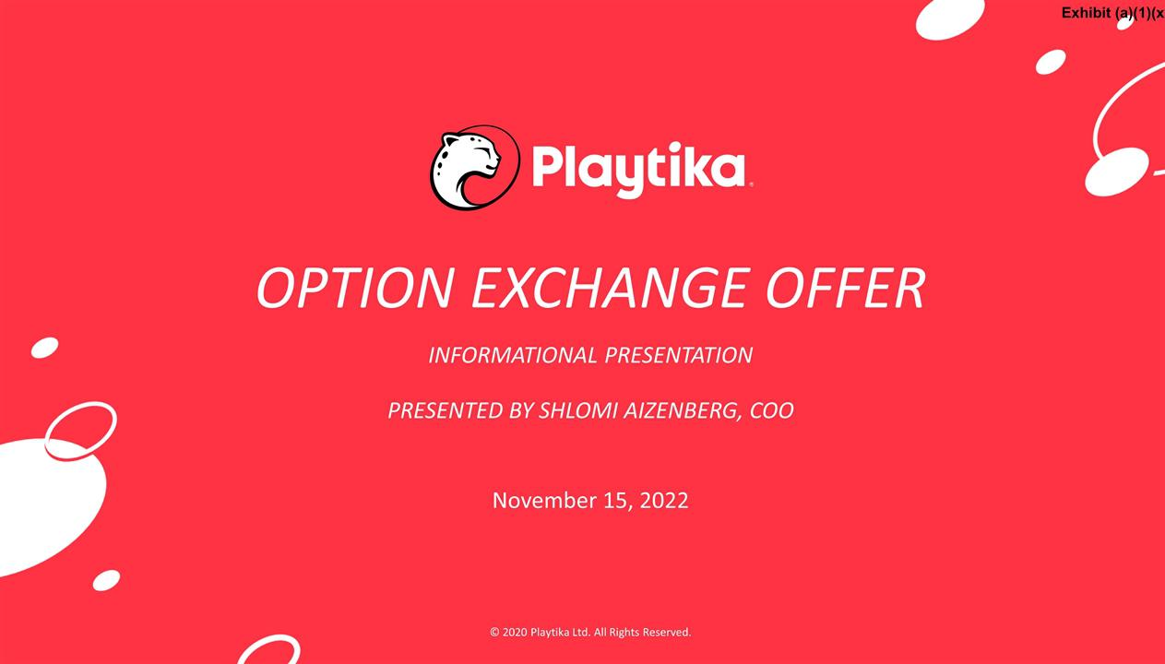



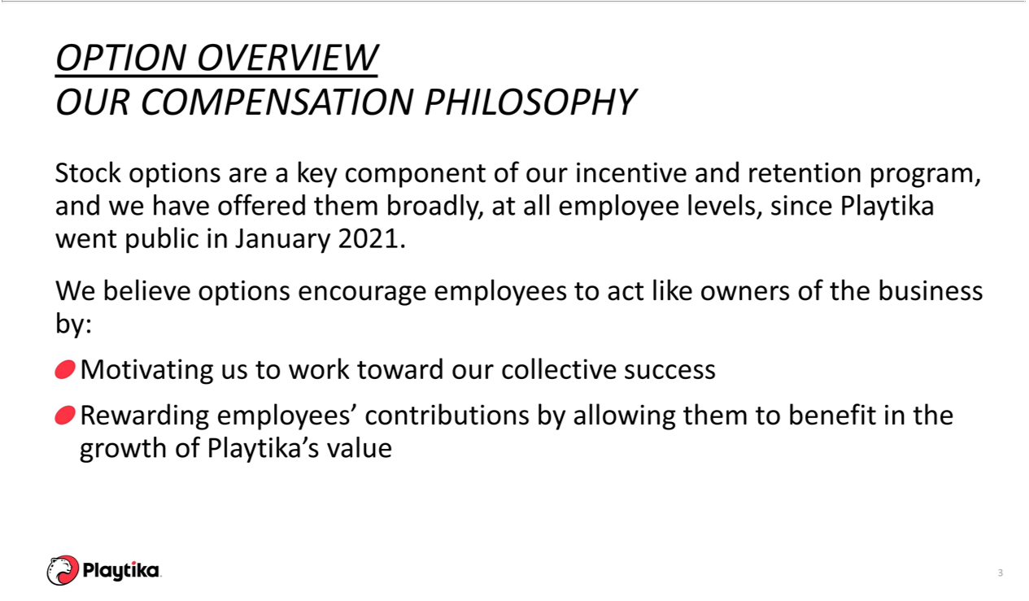

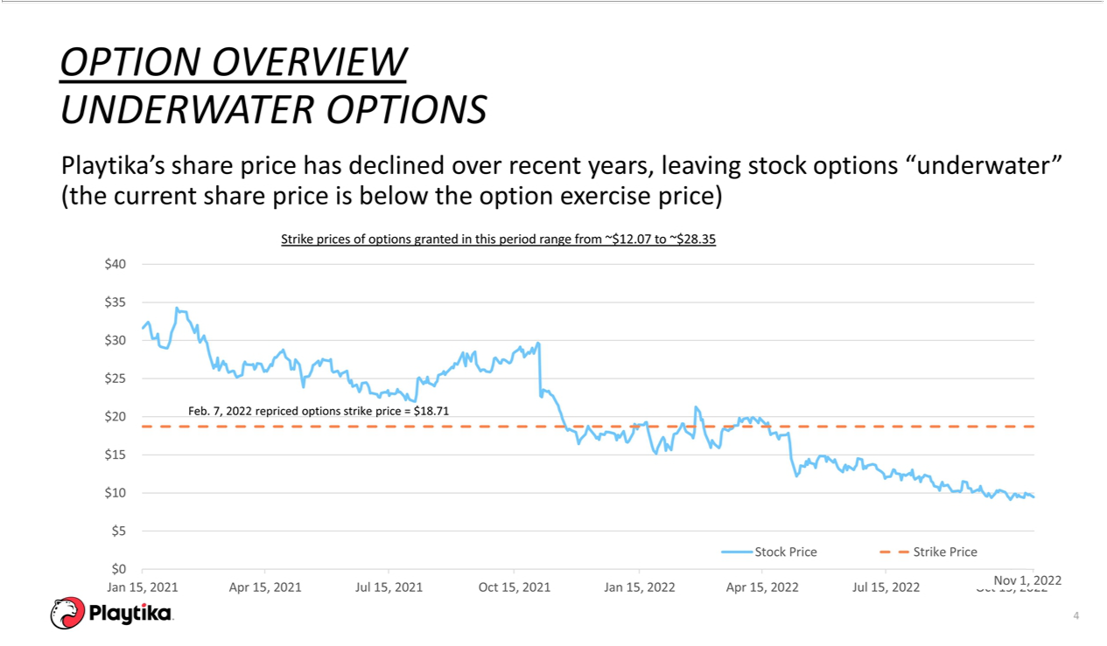

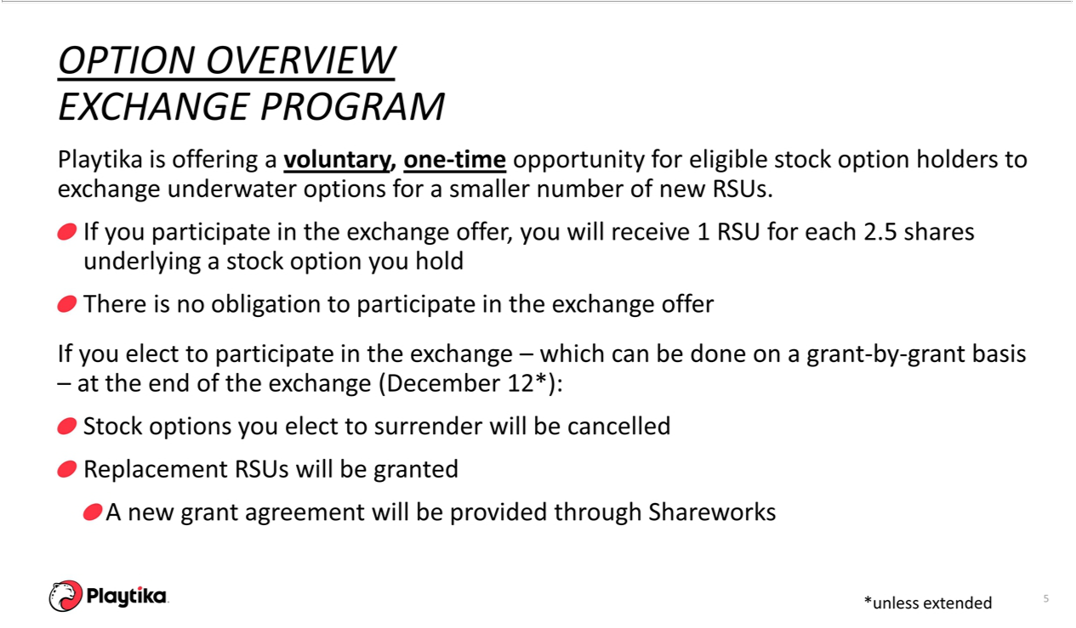



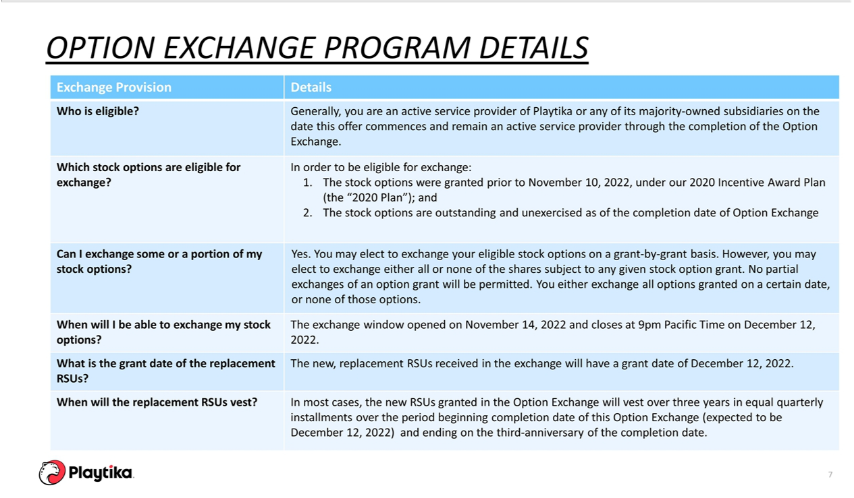

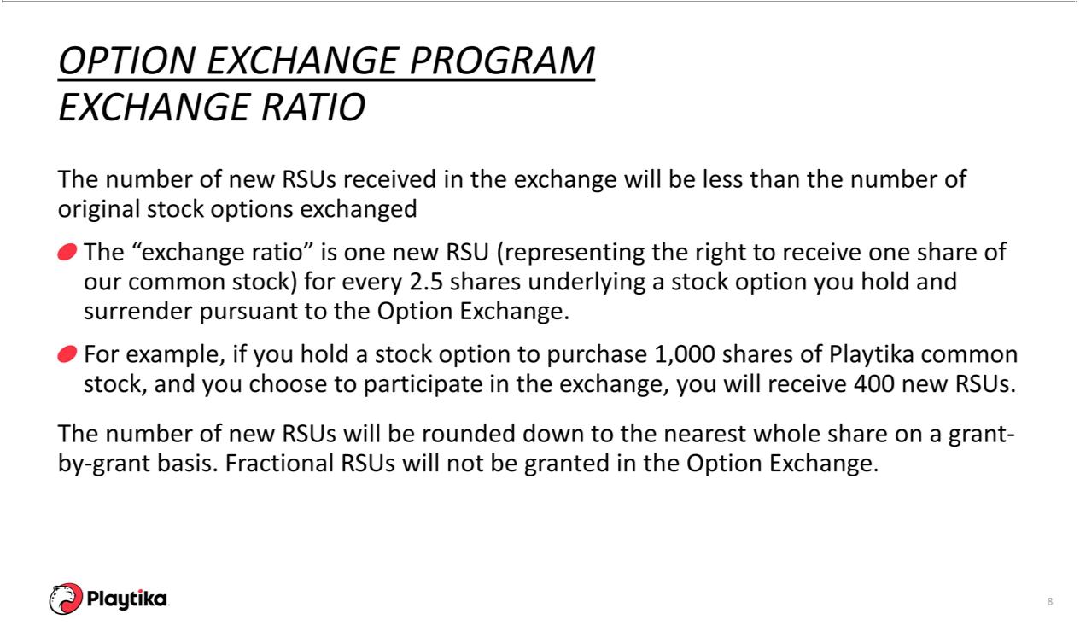

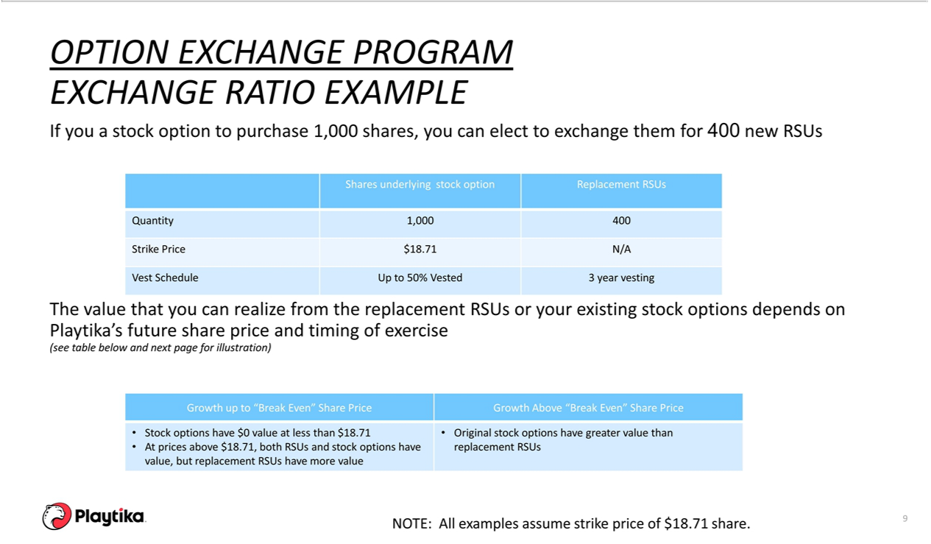

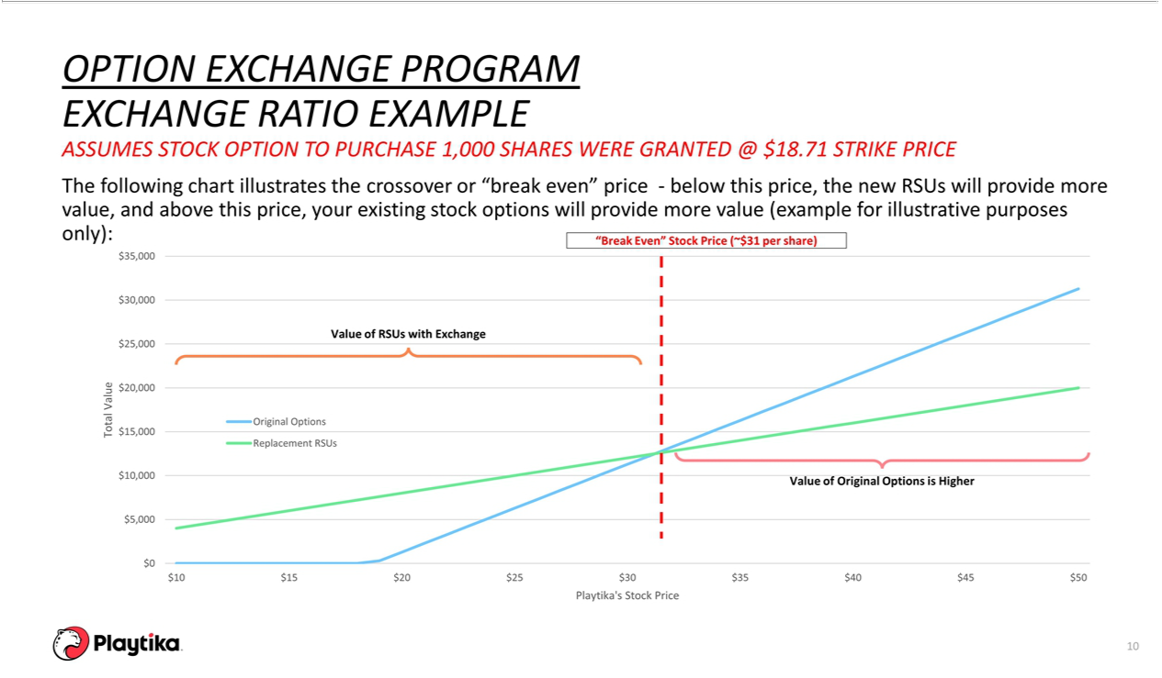

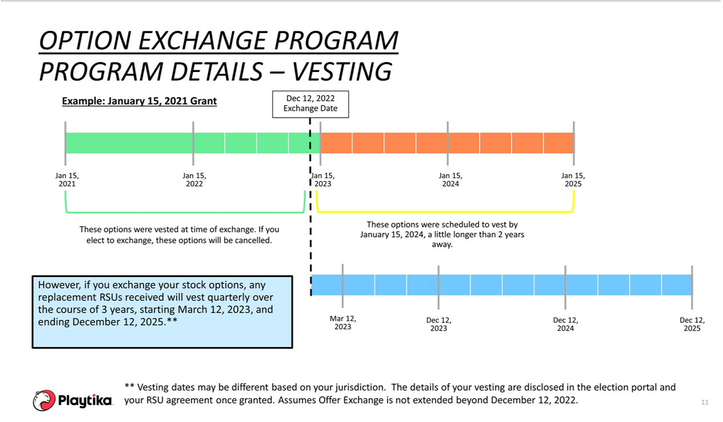

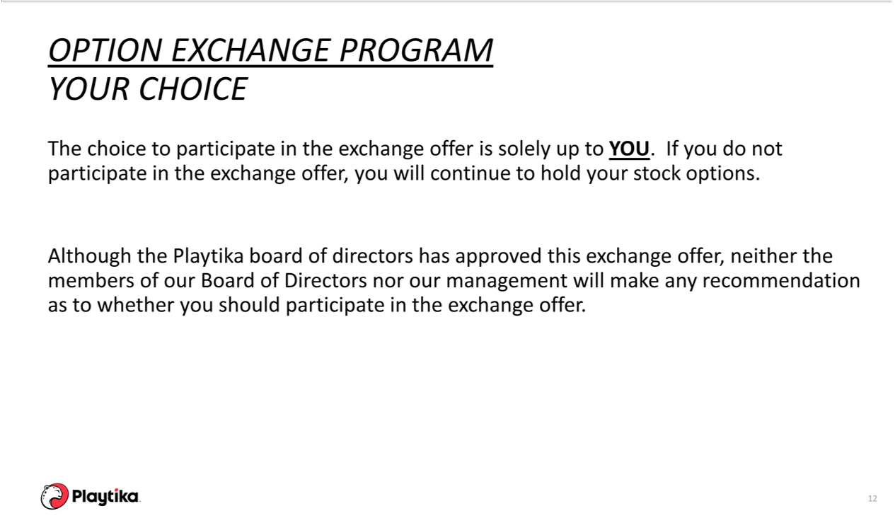

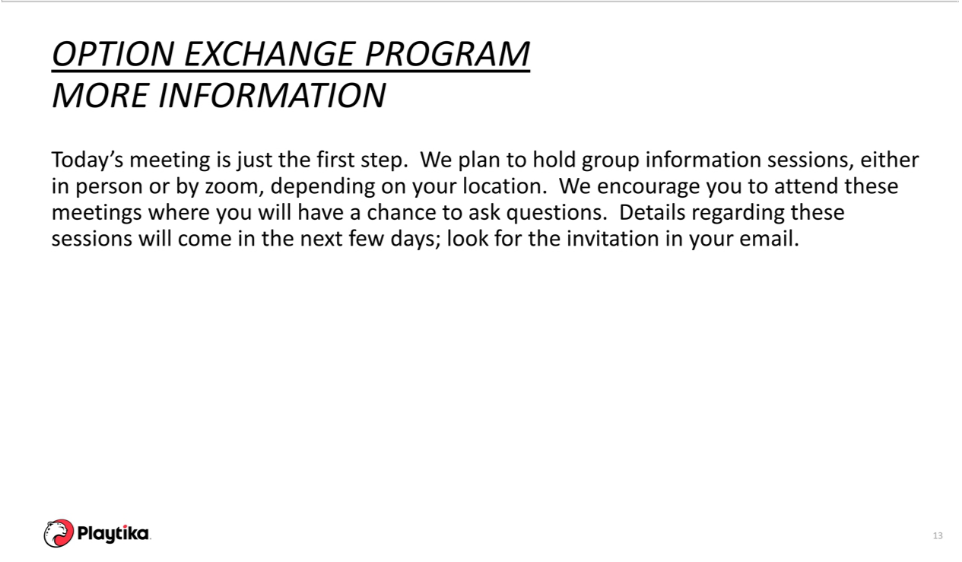



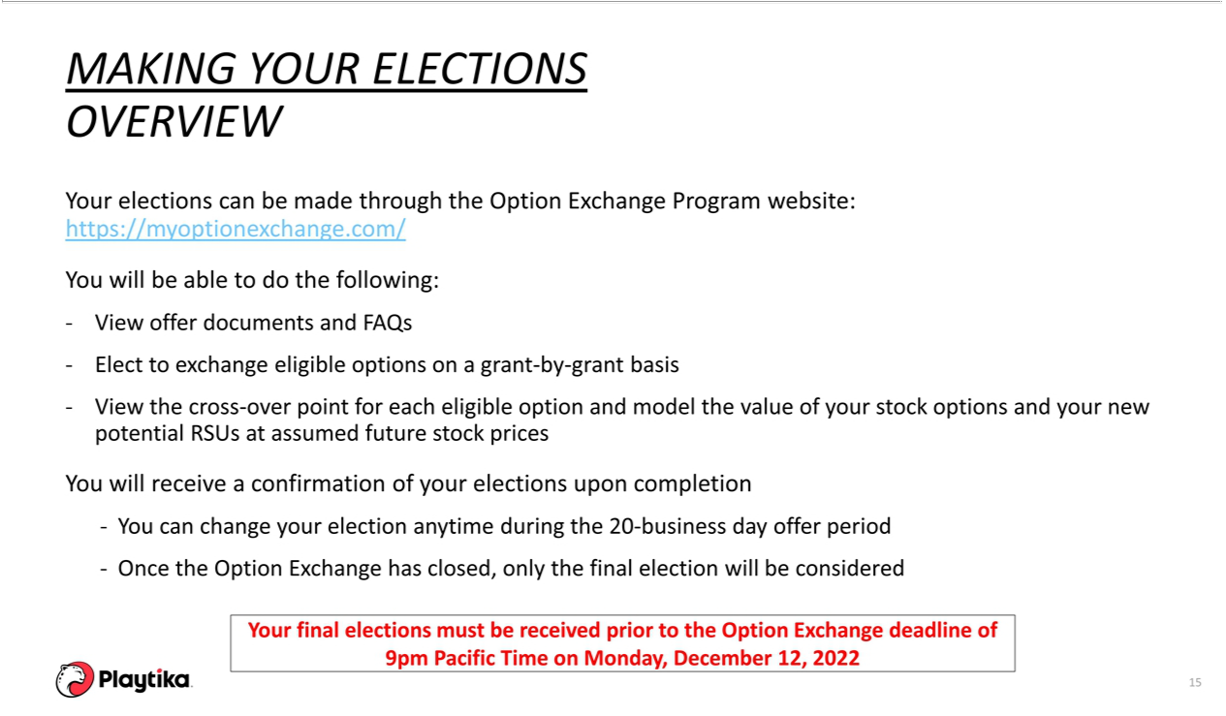

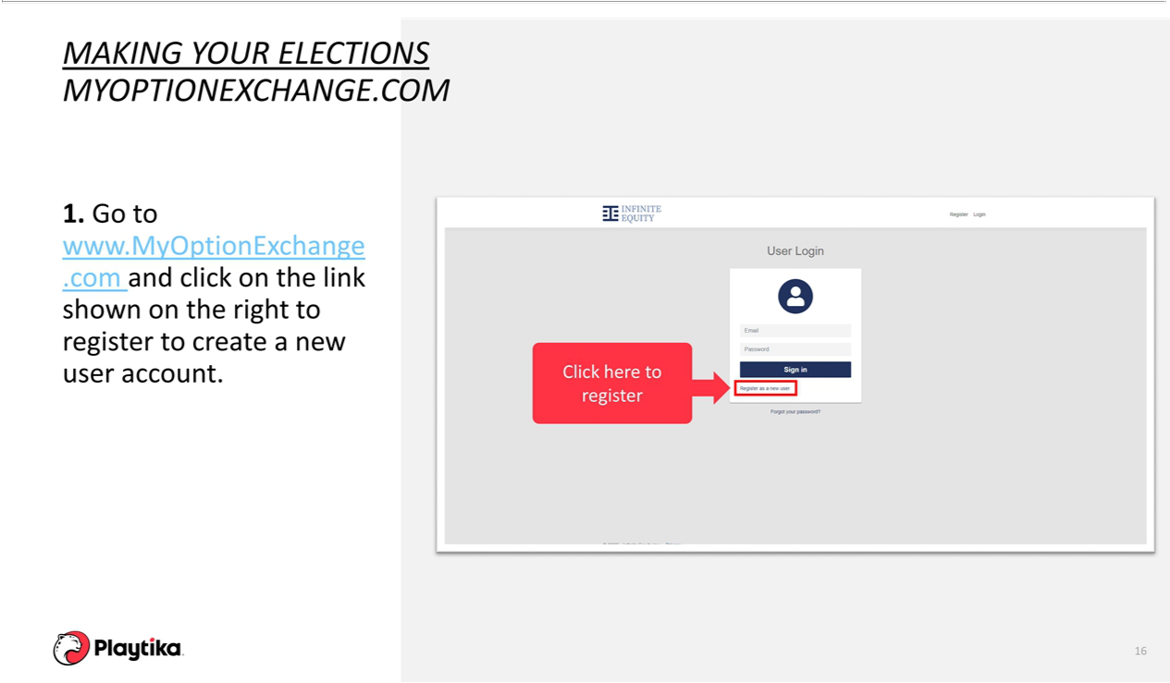

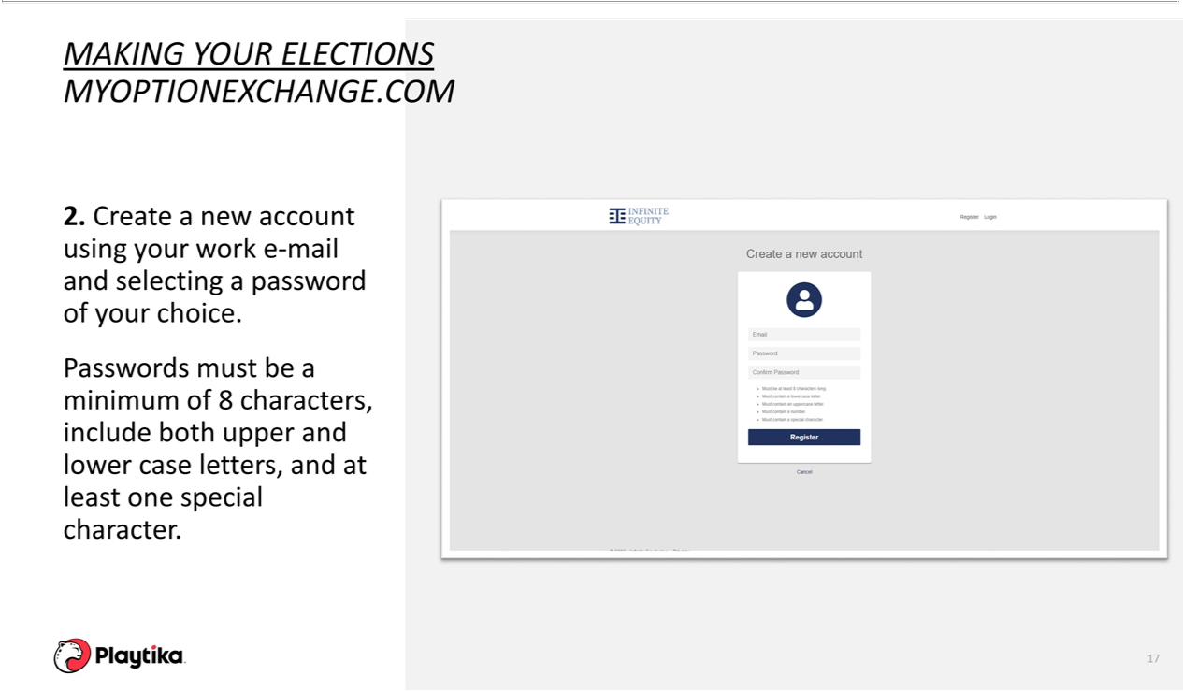

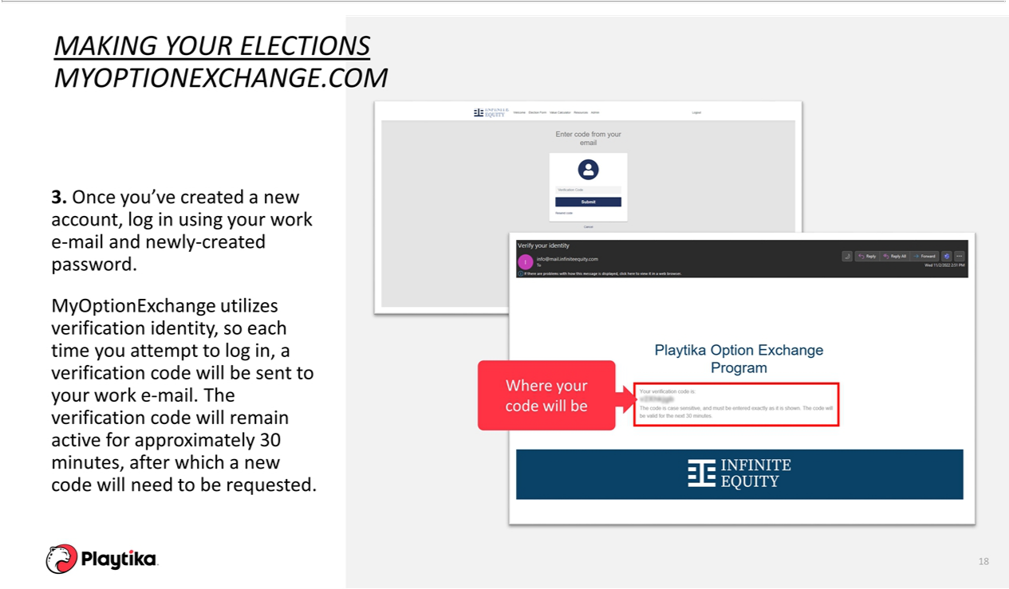

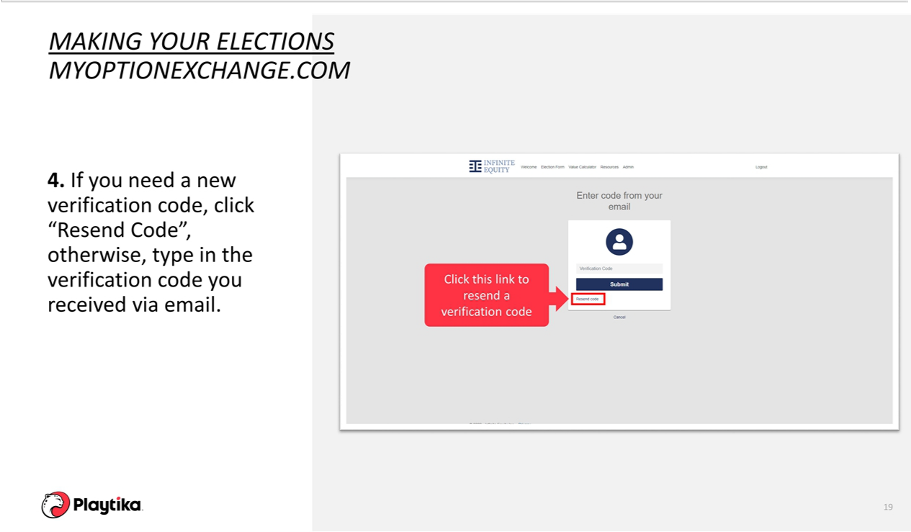

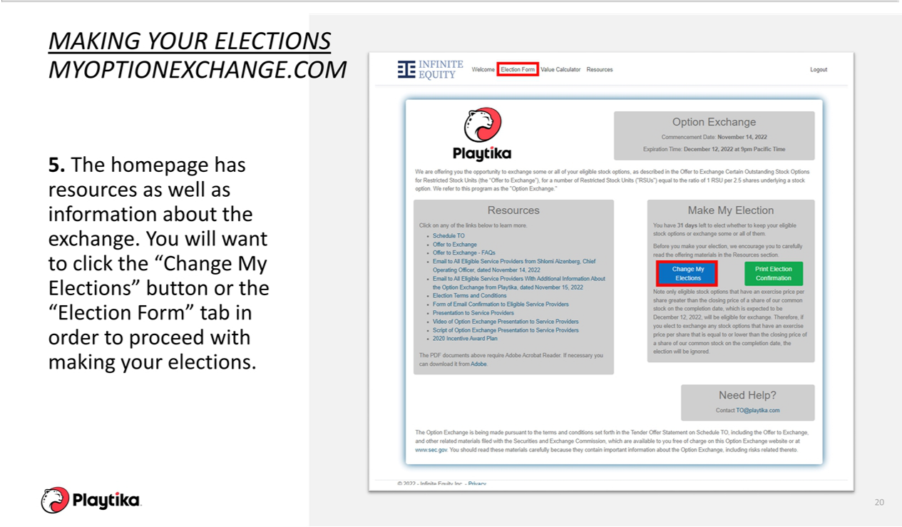

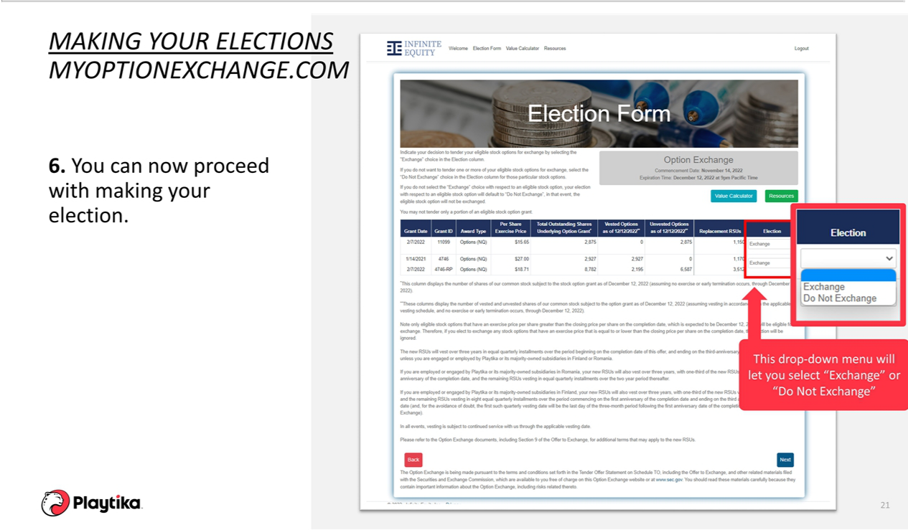

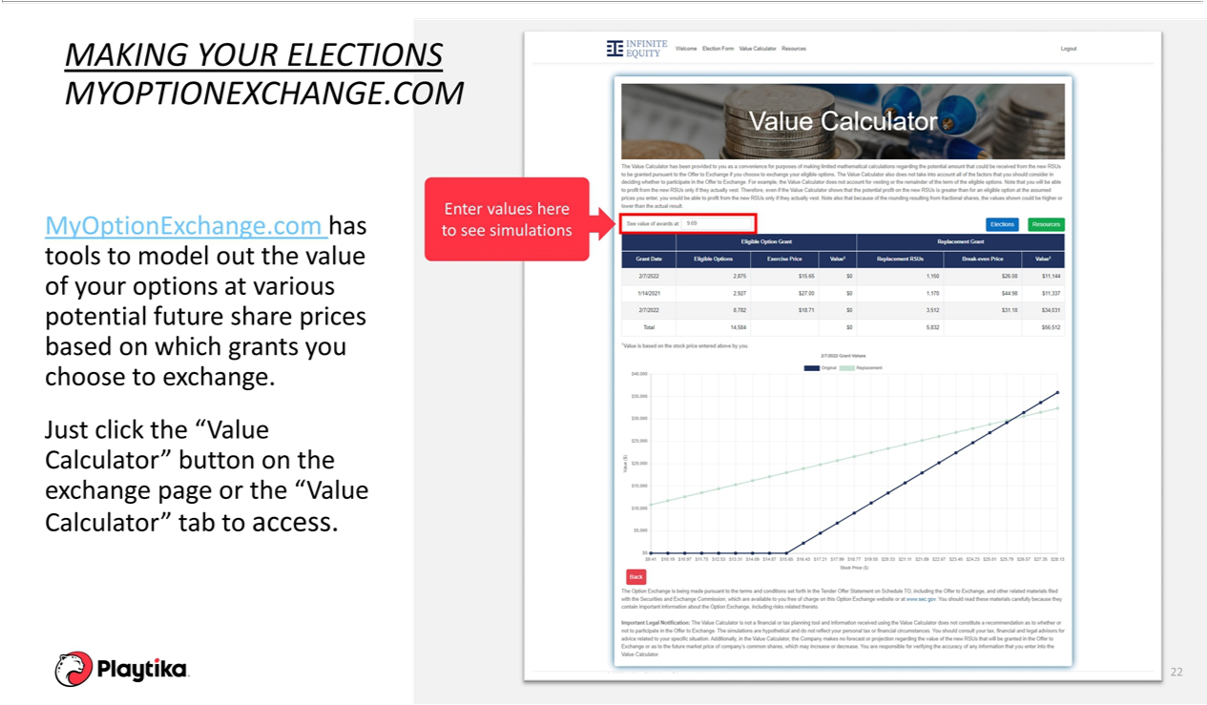

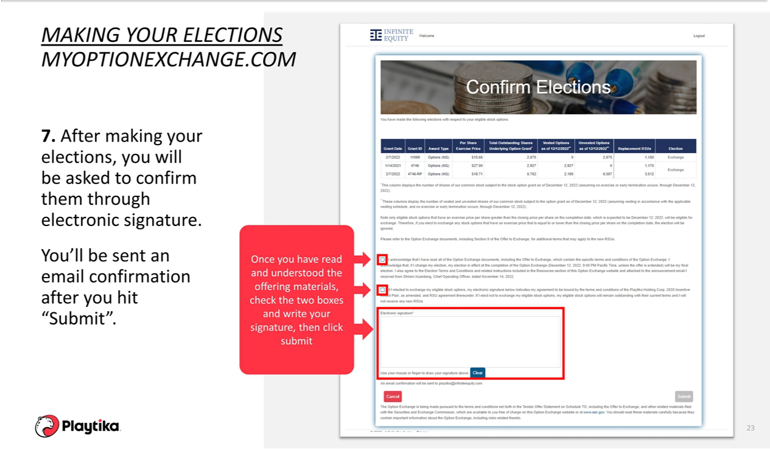

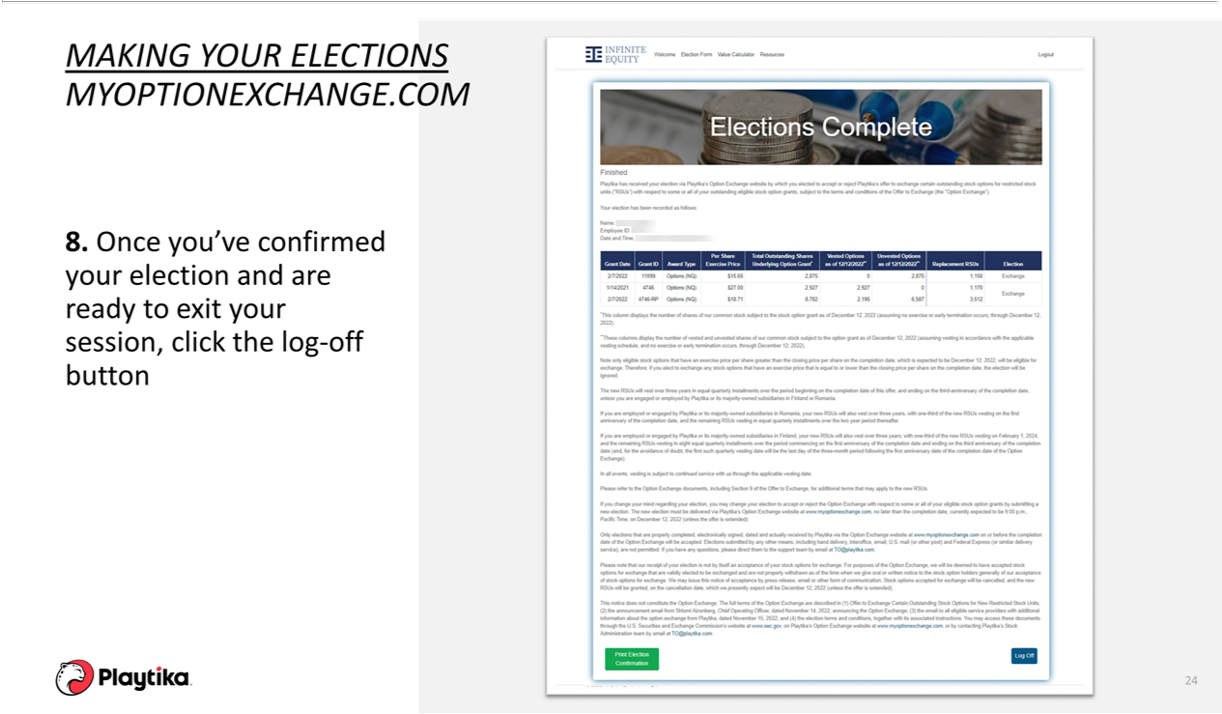



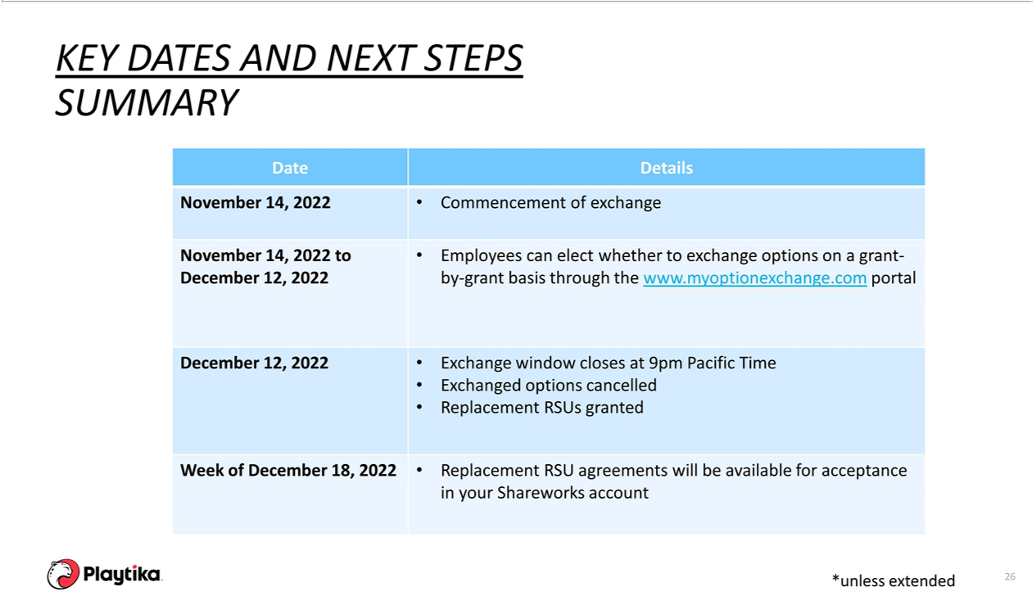

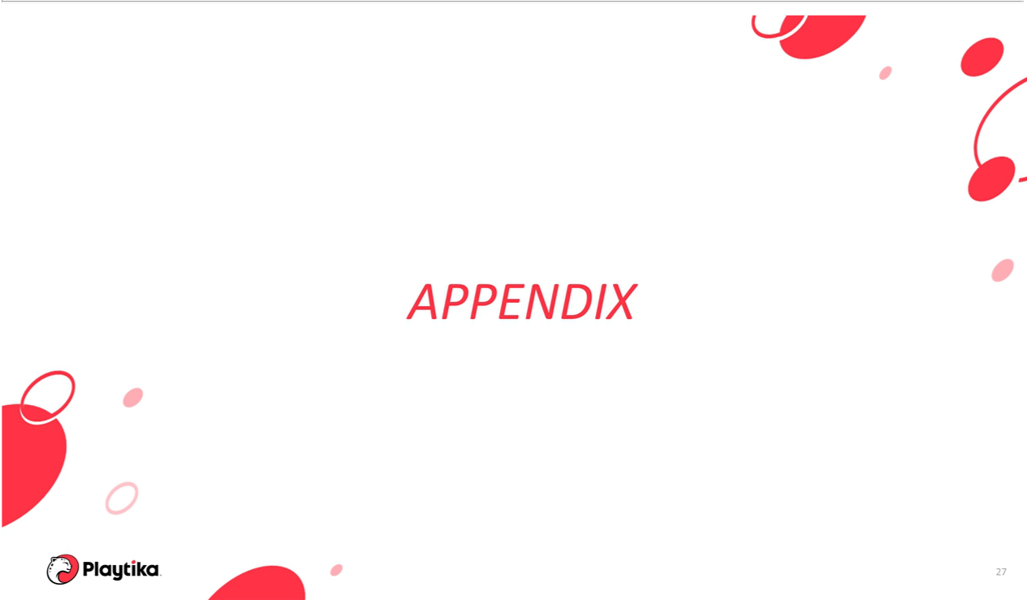

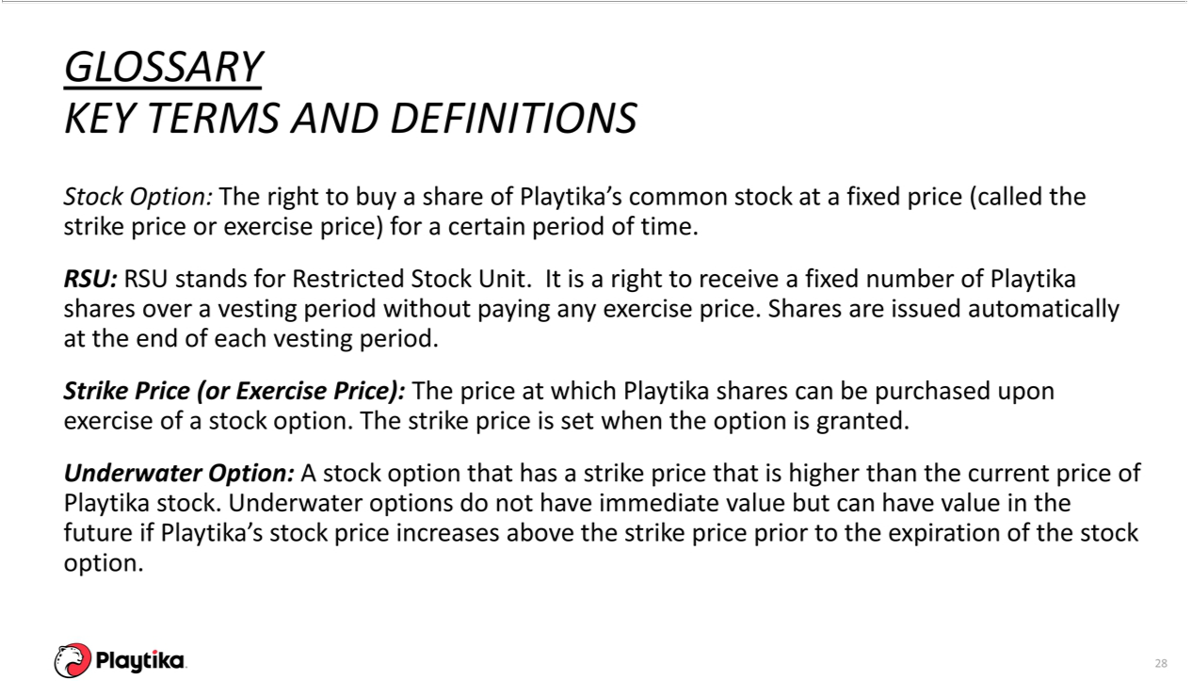

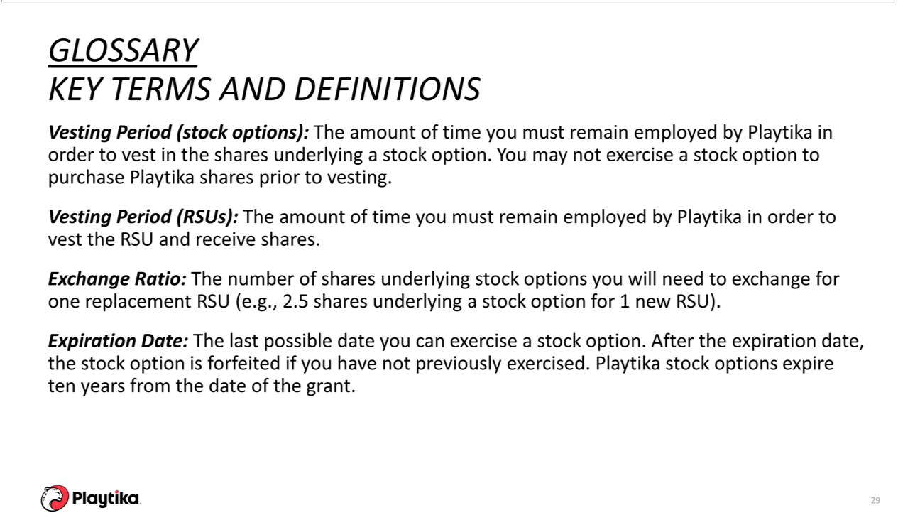





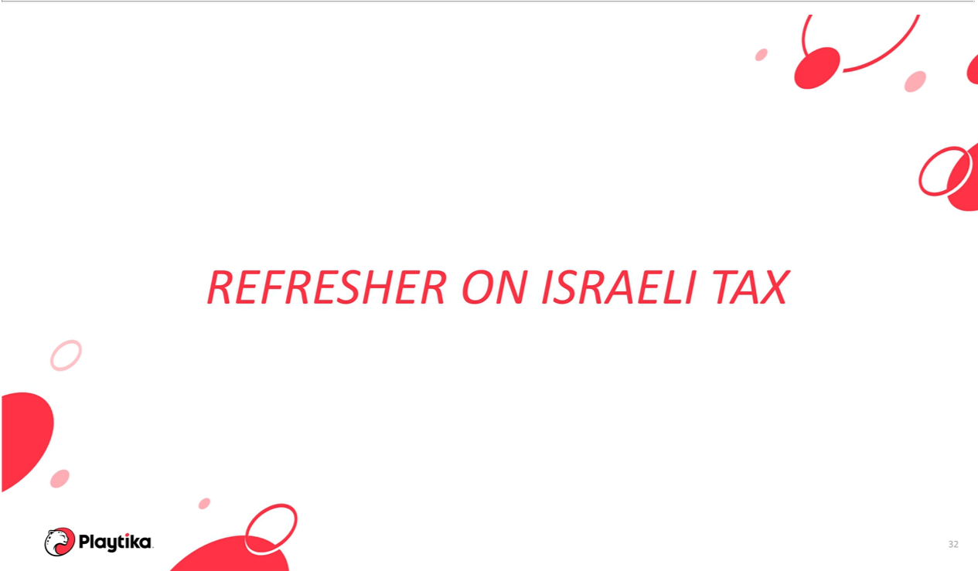

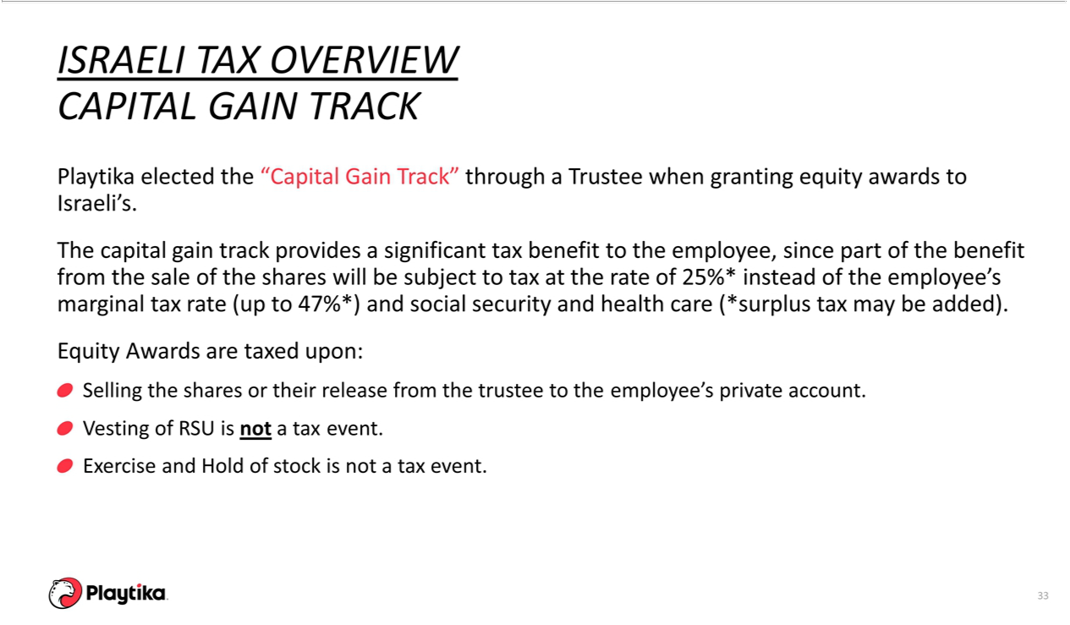

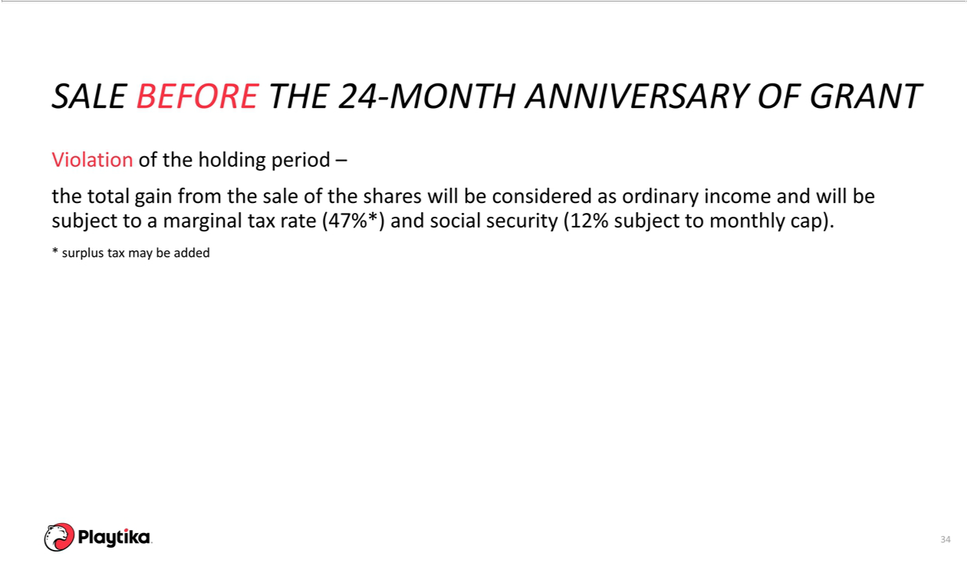

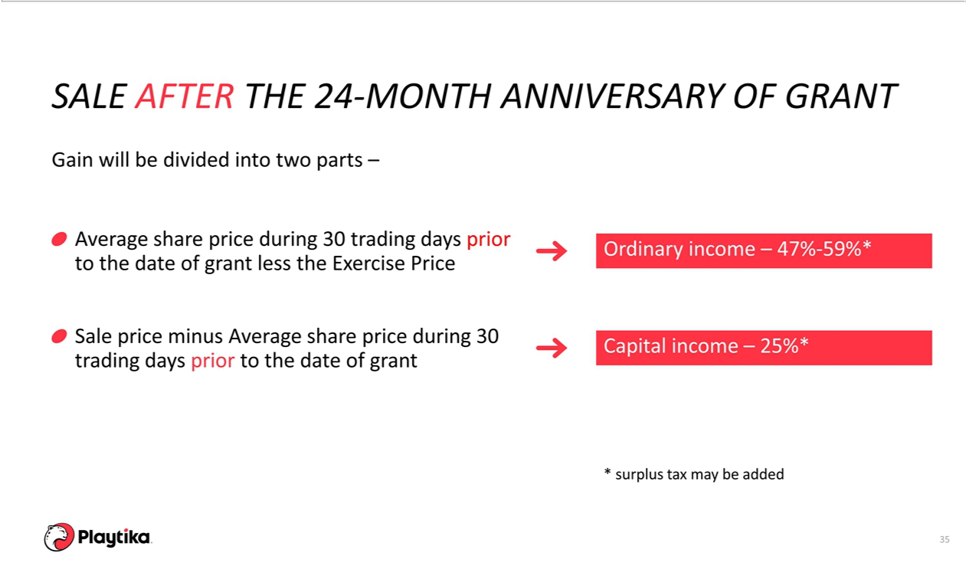



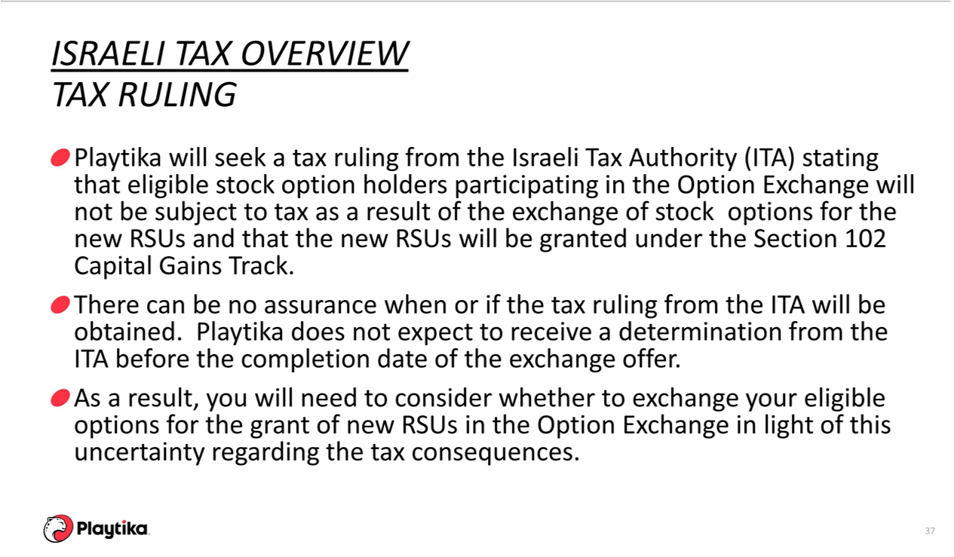

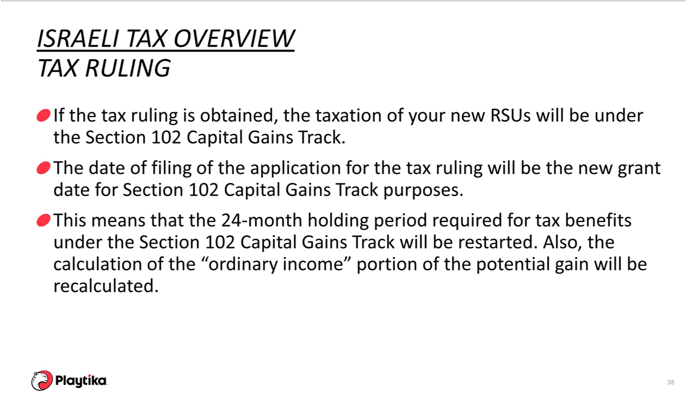

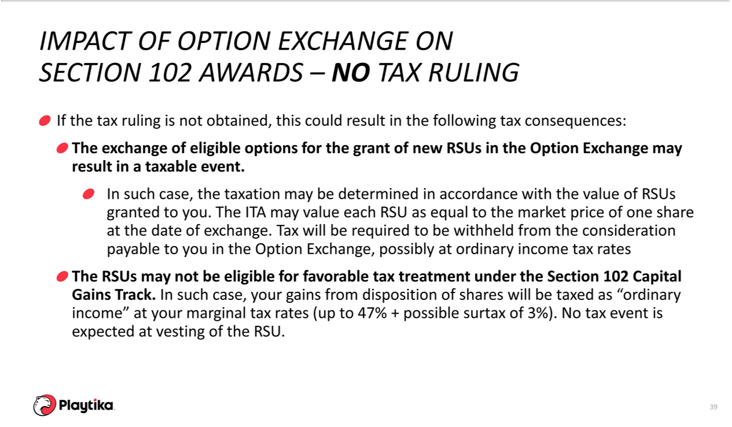



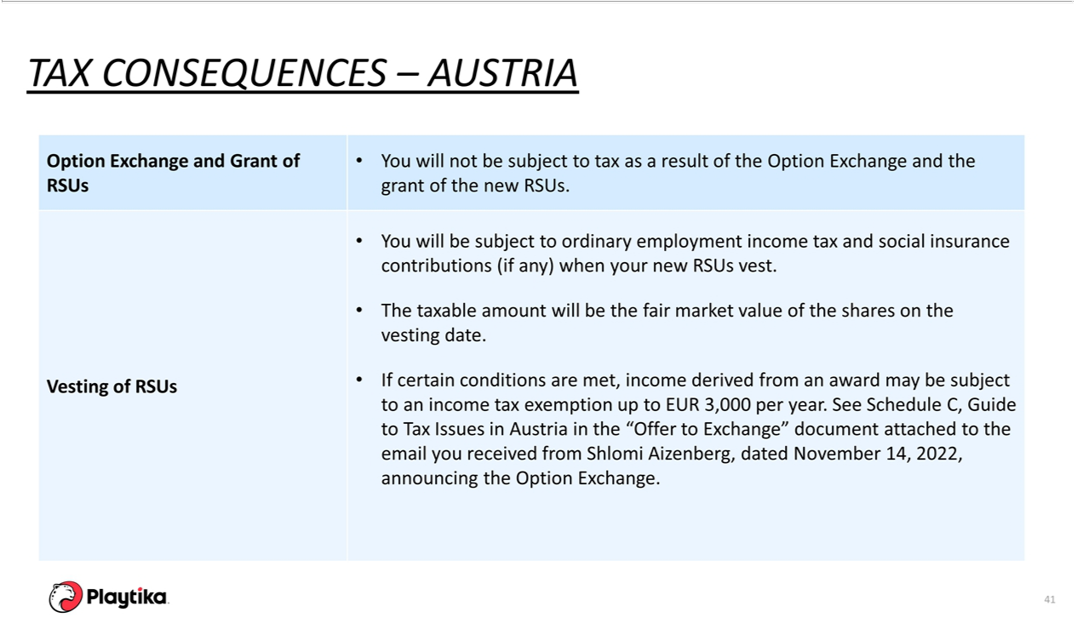

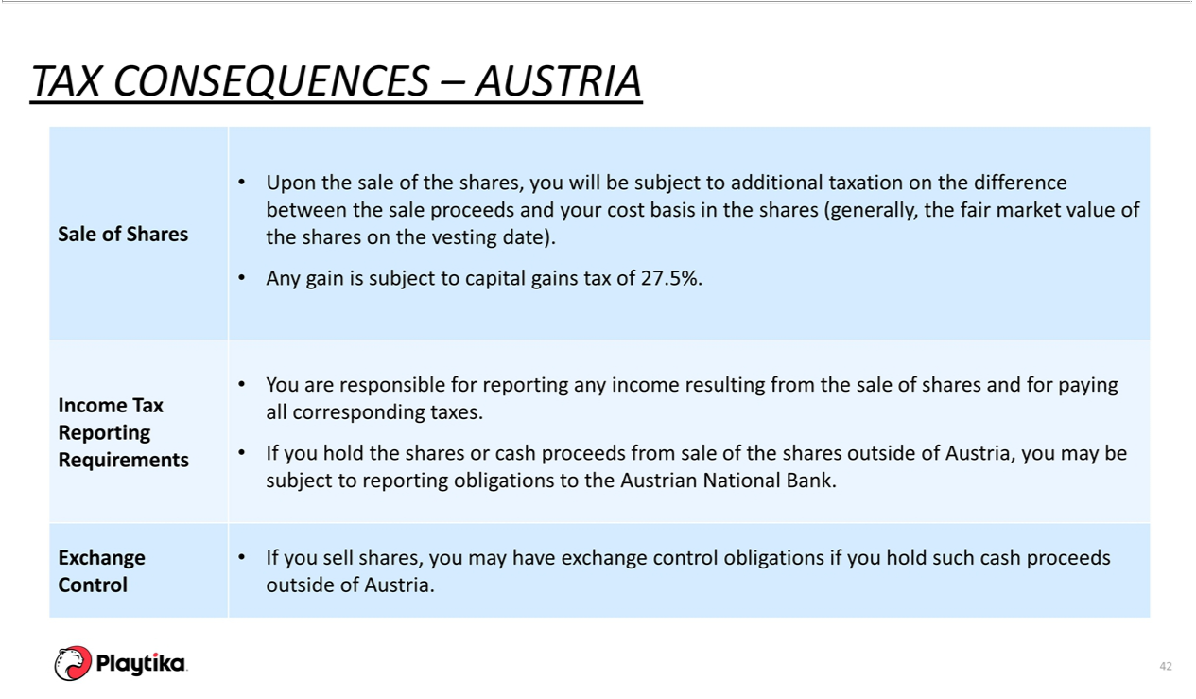



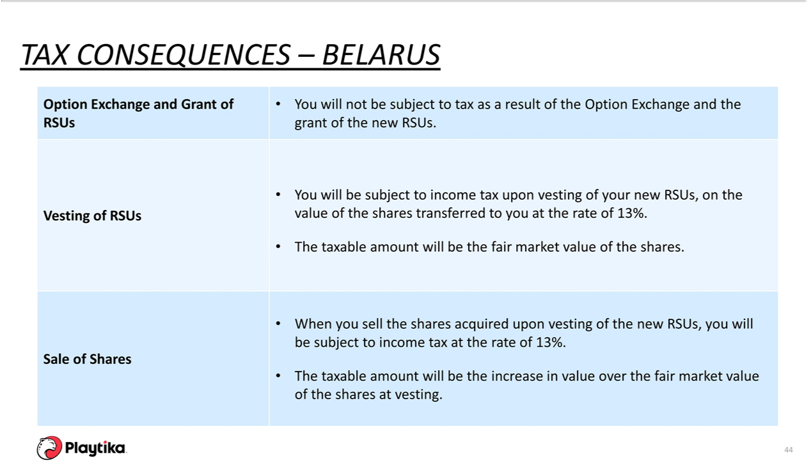

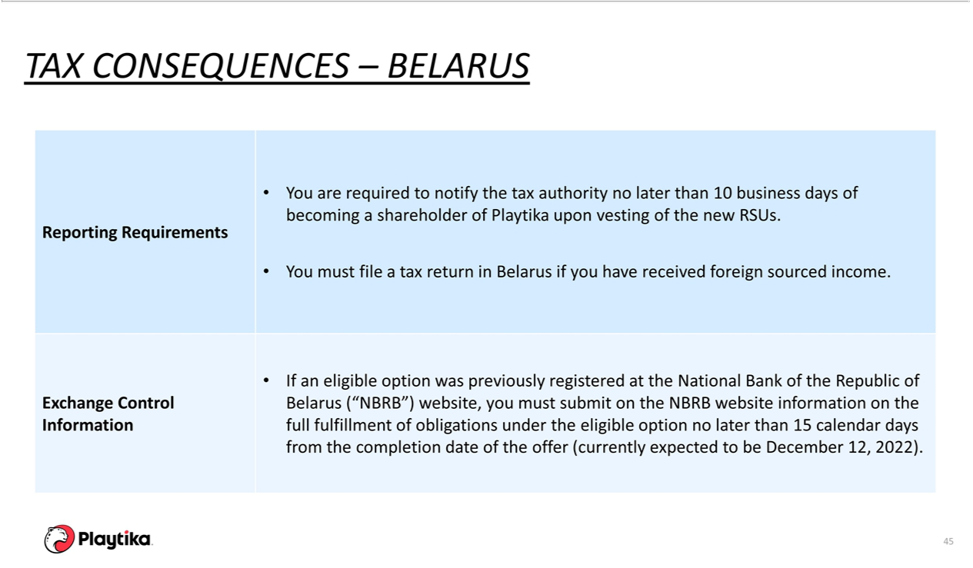



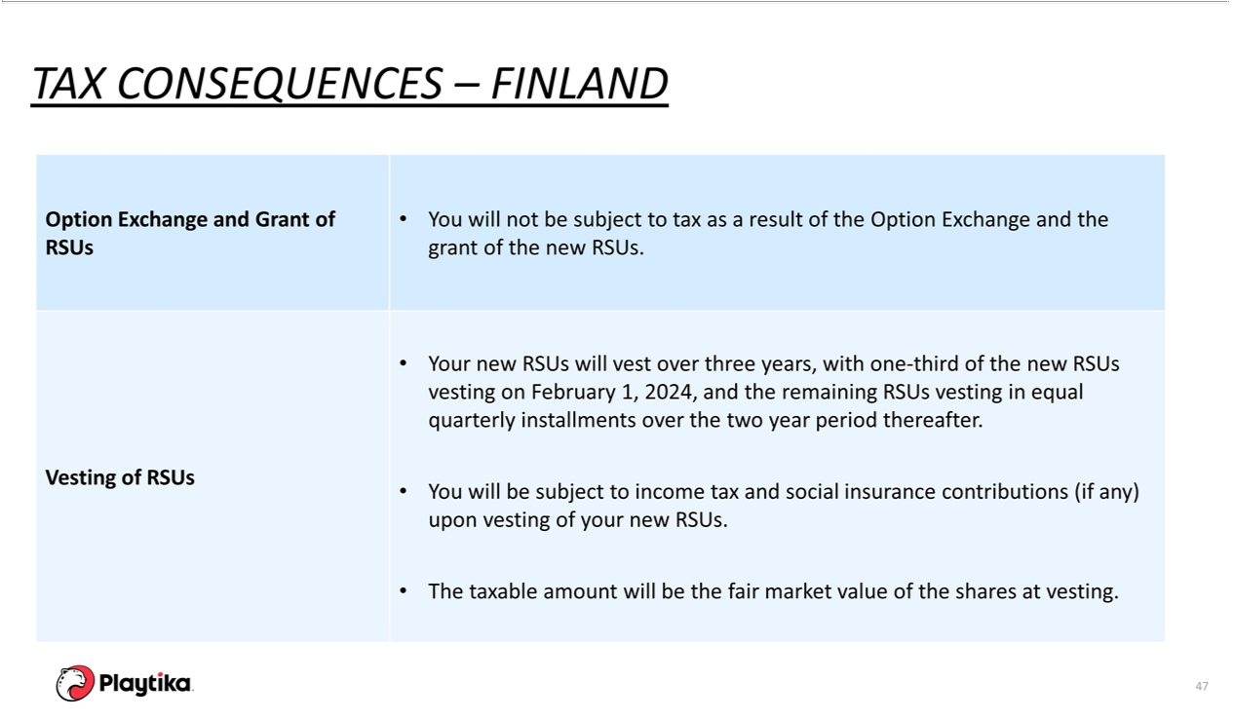

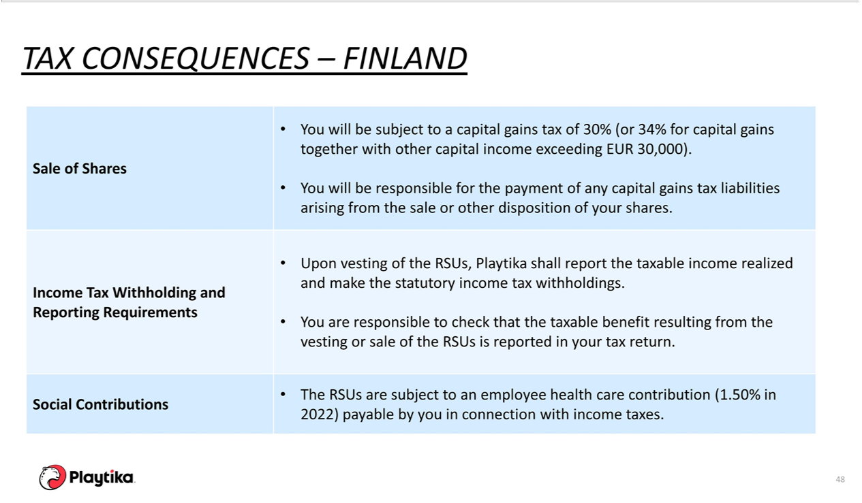



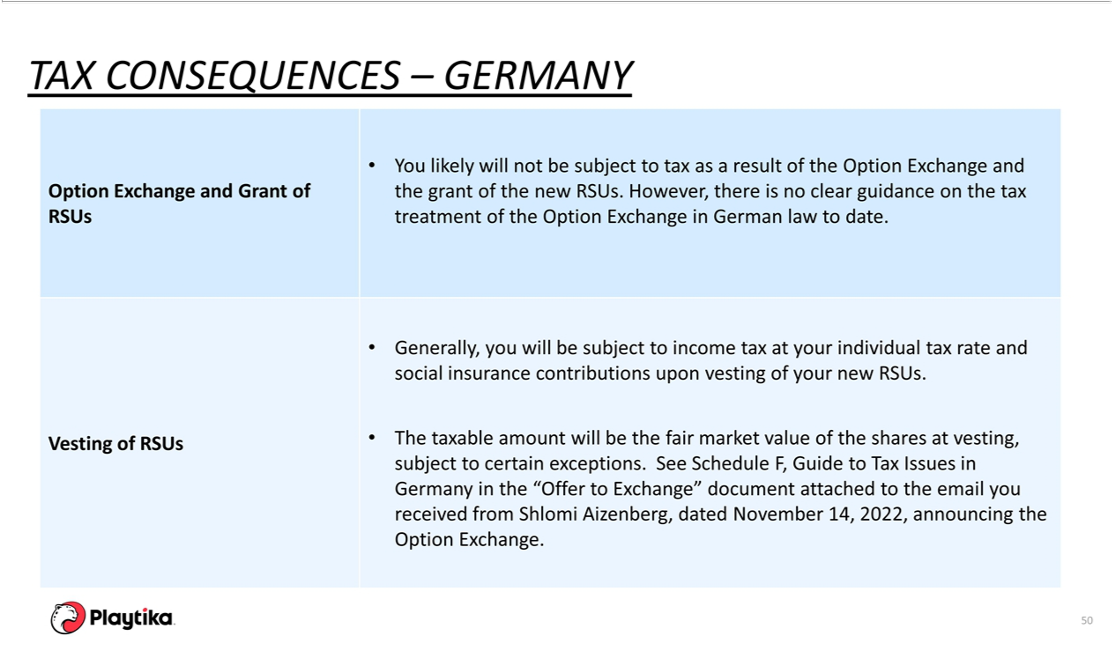

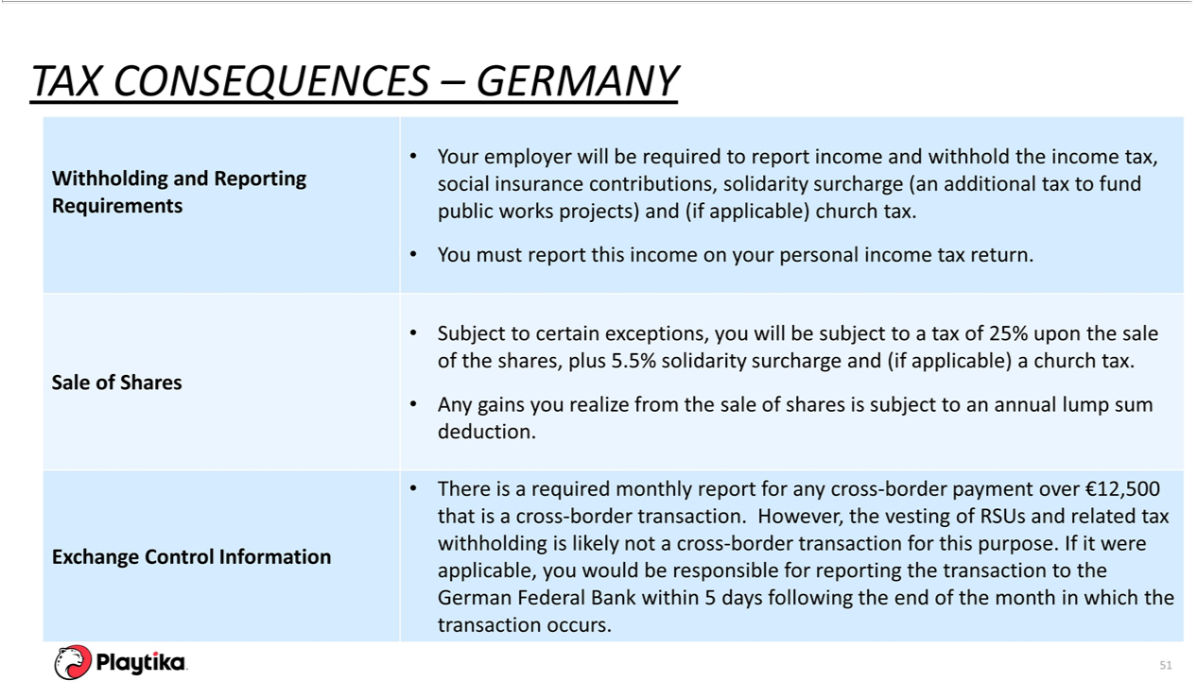



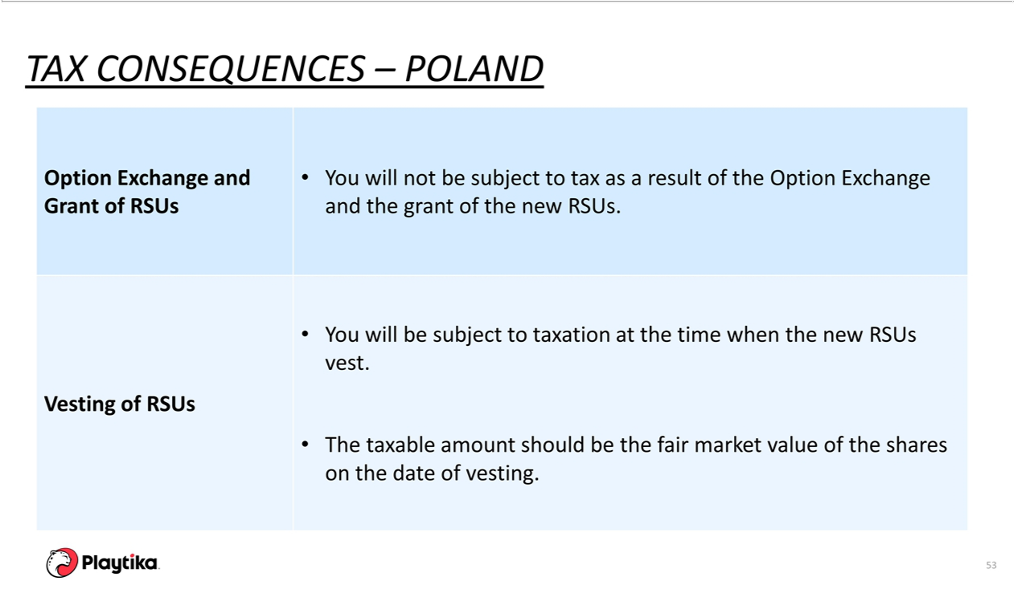

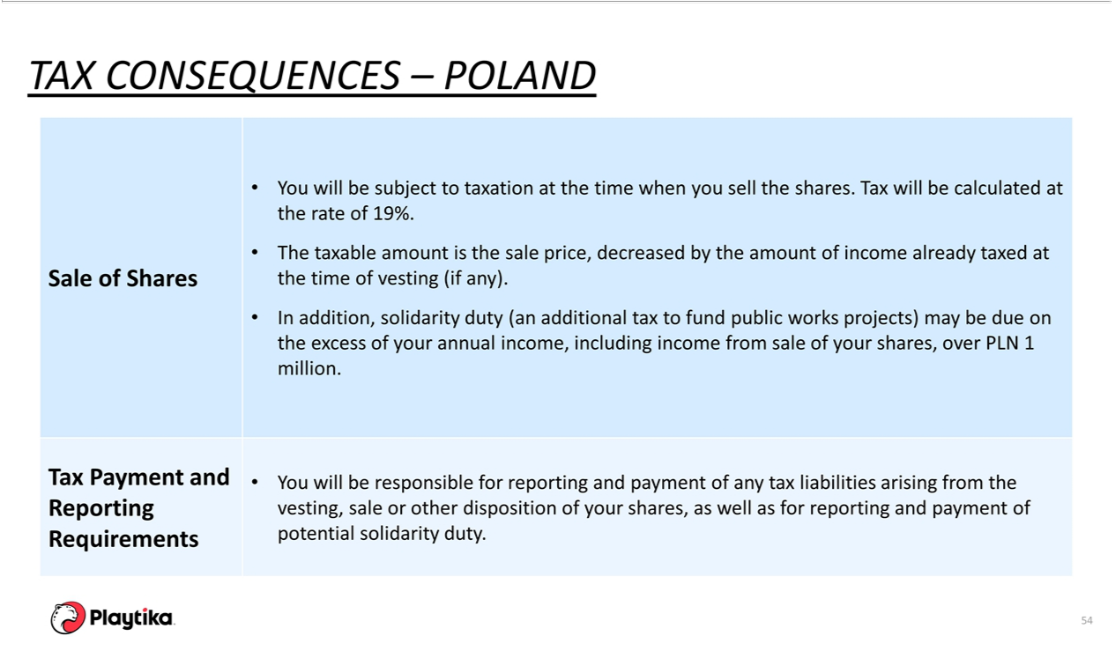



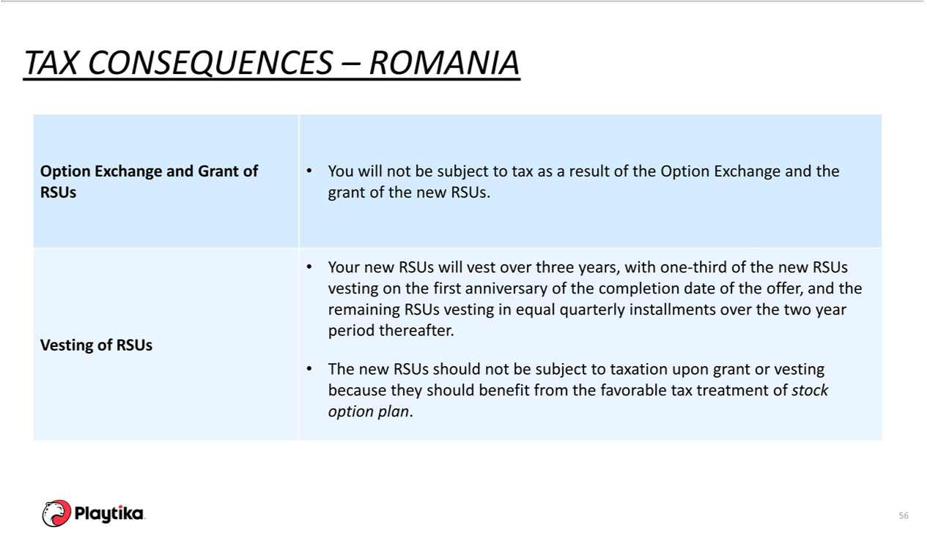

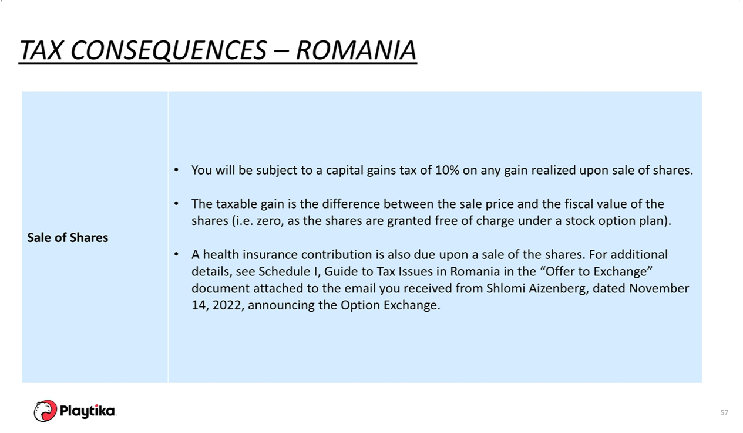

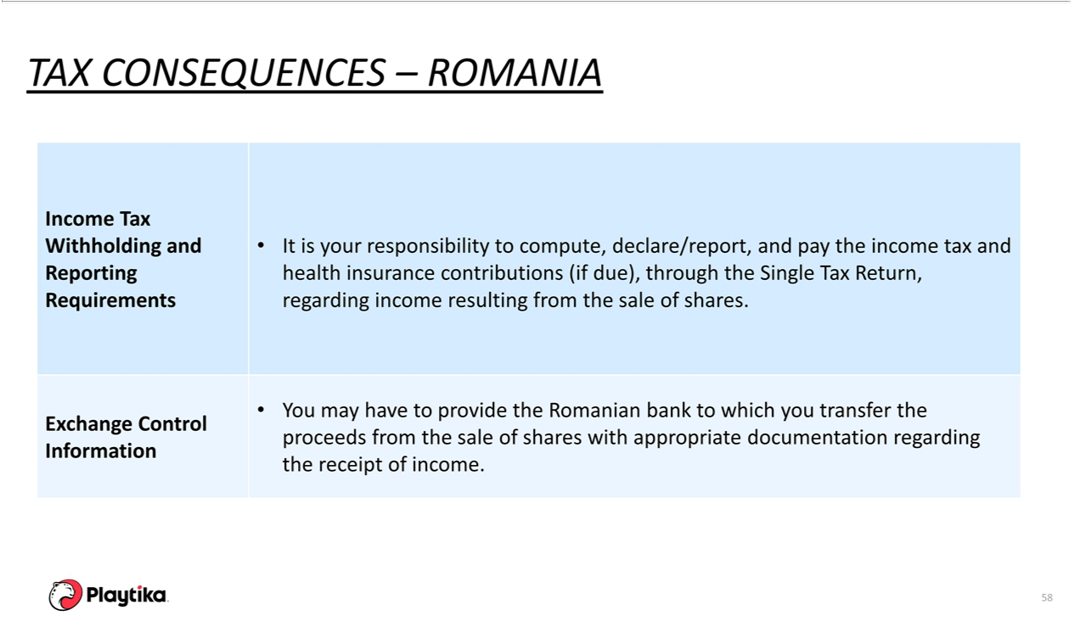



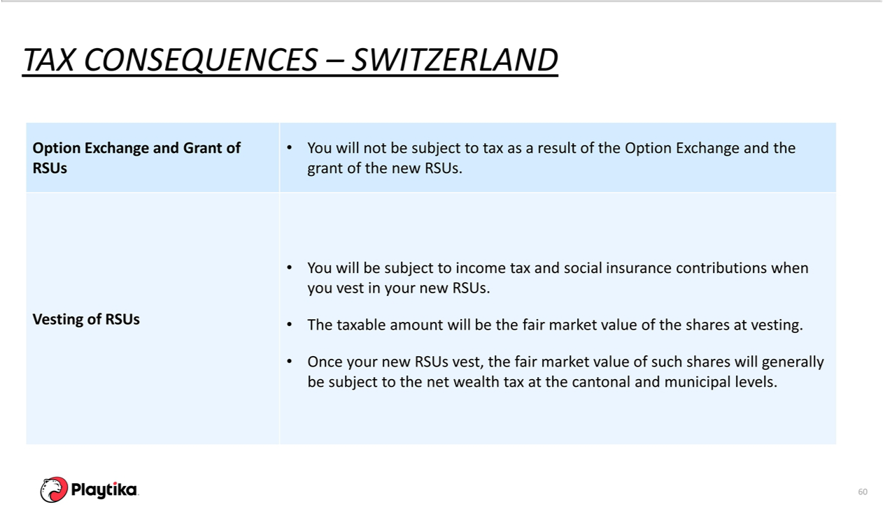

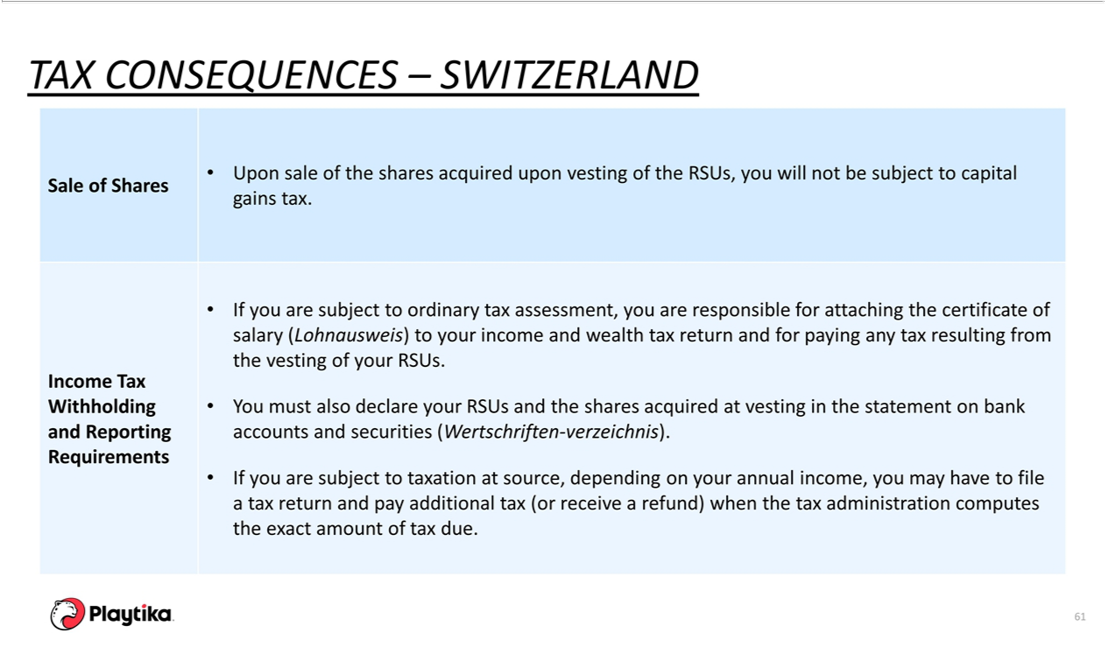



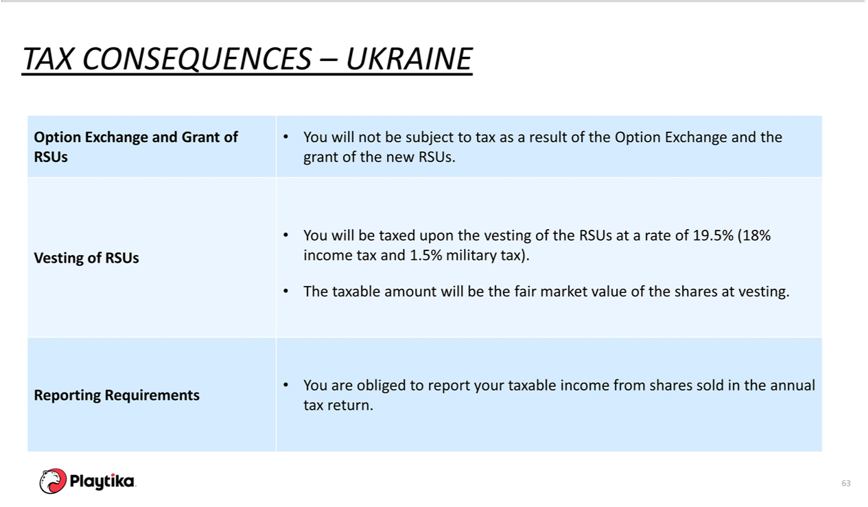

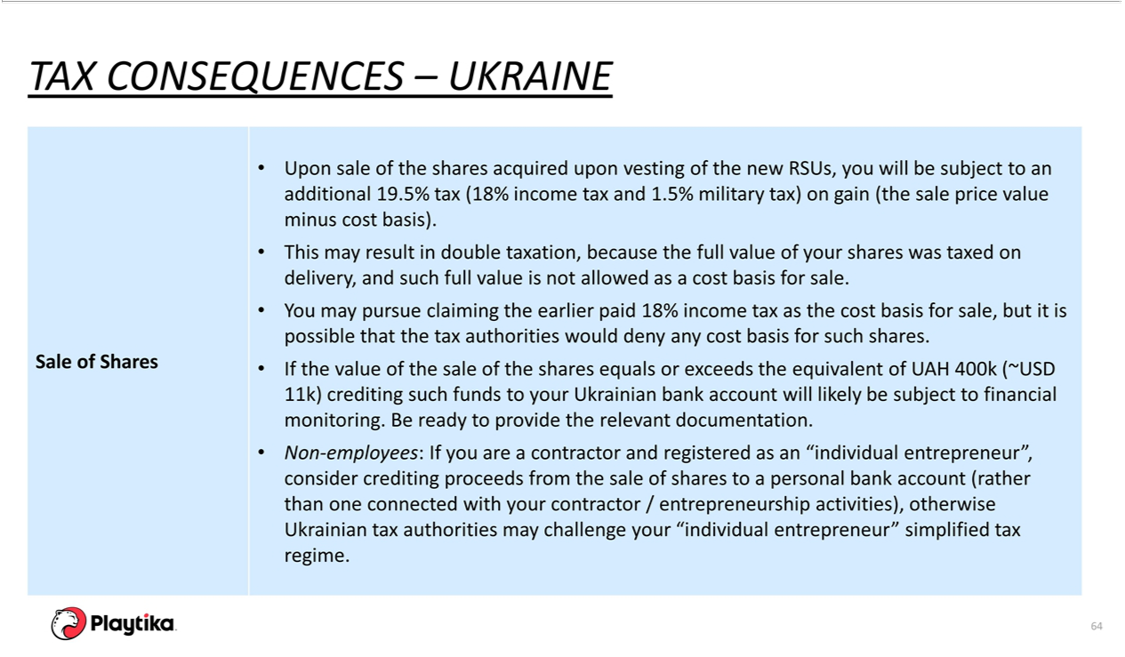



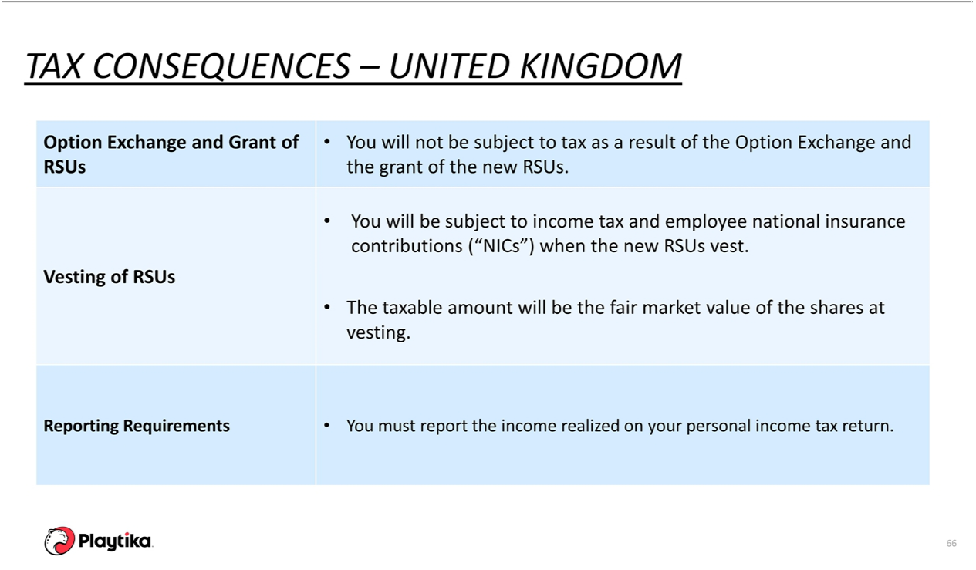

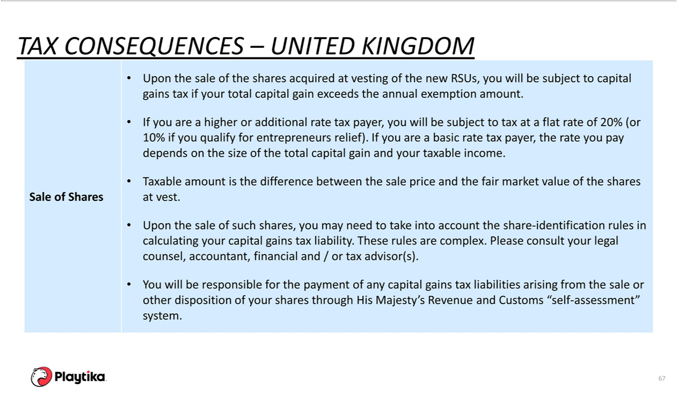



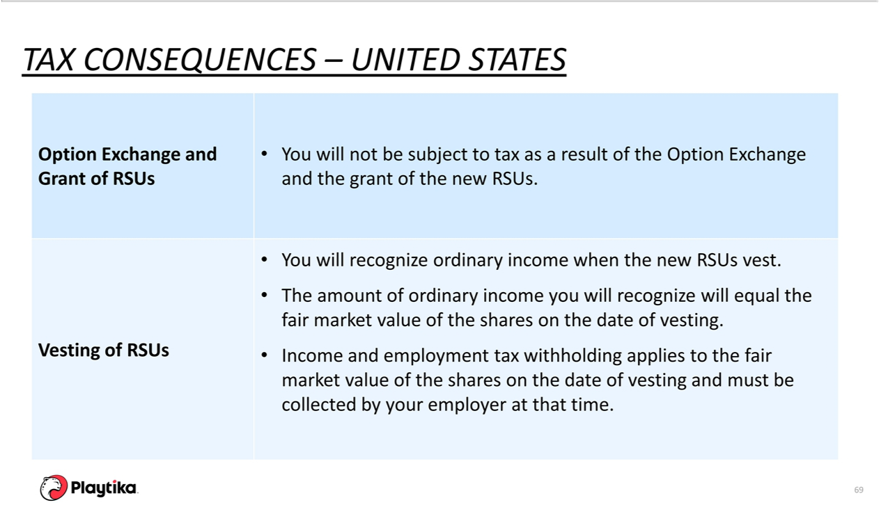

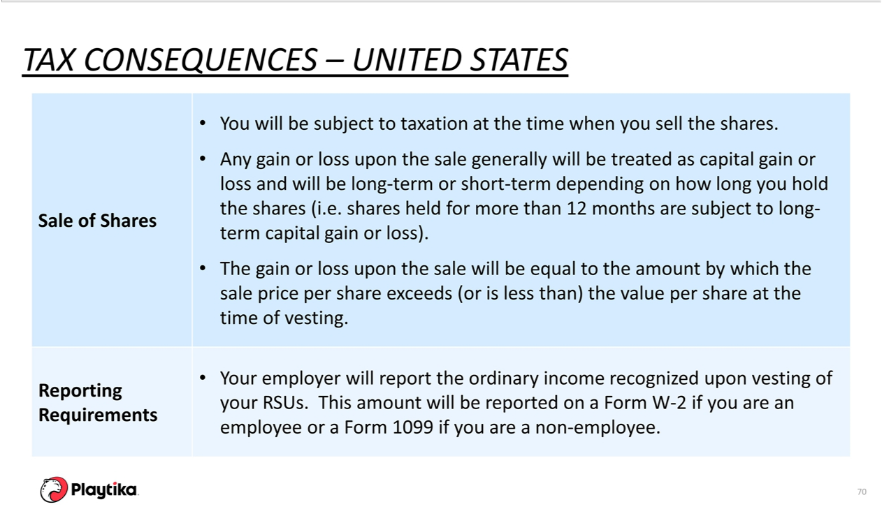

Exhibit a(1)(xiii)

Exchange Offer Script

November 15, 2022

Spokesperson: Shlomi Aizenberg, Chief Operating Officer

- Intro

  - Hello Playtikans.

- Option Overview: Our Compensation Philosophy

  - As you know, stock options are a key component of our incentive and retention compensation program and we have offered them broadly, at all employee levels, since Playtika went public in January 2021.

  - We believe stock options encourage employees to act like owners of the business by motivating us to work toward our collective goals and rewarding employees’ contributions by allowing them to benefit in the growth of Playtika’s value.

- Option Overview: Underwater Options

  - We have experienced a decline in our share price which has resulted in all stock options previously granted being “underwater” - meaning that the exercise price is above the current share price.

- Option Overview: Exchange Program

  - Today, I am pleased to announce Playtika has launched an Option Exchange for eligible employees and service providers.

  - In light of our current stock price, our Board of Directors has considered how to better align our employee and shareholder interests to generate long term shareholder value.

  - After much consideration, we have decided to offer eligible employees and service providers the ability to exchange their stock options, both vested and unvested, for new restricted stock units (RSUs). An RSU is a right to receive a fixed number of Playtika shares over a vesting period without paying any exercise price. Shares are issued automatically at the end of each vesting period.

  - There is no obligation to participate in the Option Exchange. It is completely your choice. If you do not choose to participate in the Option Exchange, you will continue to hold your stock options.

  - The exchange ratio is 1 RSU for every 2.5 shares underlying a stock option that you surrender.

  - If you elect to participate in the Option Exchange, which can be done on a grant-by-grant basis, the stock options you elect to surrender will be cancelled, replacement RSUs will be granted, and a new grant agreement will be provided through Shareworks.

- Option Exchange Program Details

  - This is a voluntary, one-time opportunity.

  - Eligible employees and service providers are able to participate in the Option Exchange program.

  - You may participate on a grant-by-grant basis, but for each grant, your selection must be on an all-or-nothing basis.

  - The exchange window opened on November 14, 2022 and closes on December 12, 2022 at 9:00 p.m., Pacific Time.

  - The new RSUs will vest over 3-years, with the exact cadence depending on your jurisdiction.

- Option Exchange Program: Exchange Ratio

  - The number of new RSUs received in the exchange will be less than the number of original stock options exchanged.

  - The exchange ratio is one new RSU for every 2.5 shares underlying a stock option you hold and surrender pursuant to the Option Exchange.

- Option Exchange Program: Exchange Ratio Example

  - Example

    - If you hold a stock option for 1,000 shares, you can elect to exchange it for 400 new RSUs.

    - The value that you can realize from the replacement RSUs, or your existing stock options, depends on Playtika’s future share price and timing of exercise.

- Option Exchange Program: Exchange Ratio Example

  - This chart shows the crossover price for stock option with an exercise price of $18.71 per share. As you can see in the chart, the RSUs have a greater value below the “breakeven” price of ~$31 per share. The stock options, however, have a greater value above the breakeven price.

  - Whether you exchange your stock options for RSUs can depend on a variety of factors, including your view of the stock price of Playtika in the future.

- Option Exchange Program: Program Details- Vesting

  - As mentioned earlier, if you exchange your stock options, any replacement RSUs received will generally vest quarterly over the course of 3 years.

  - Vesting dates may be different based on your jurisdiction.

- Option Exchange Program: Your Choice

  - As a reminder, choosing to participate in the Option Exchange is solely up to you.

  - Although Playtika’s Board has approved this offer, we will not make any recommendations as to whether you should participate in the offer. That is completely up to you.

- Option Exchange Program: More Information

  - We will be holding group meetings over the next couple weeks to provide an opportunity to ask any question you have.

- Making Your Elections: Overview

  - We have created an Option Exchange website for all employees and service providers, which includes:

    - FAQs, Election portal and cross over analysis.

  - You can make your selections anytime between now and December 12, 2022 at 9:00 p.m., Pacific Time.

- Step-by-Step Guide: Step 1

  - The Election portal is located at: www.MyOptionExchange.com

  - Click on the registration link.

- Step-by-Step Guide: Step 2

  - Create a new account using your work email.

  - Create a password conforming to the security requirements.

- Step-by-Step Guide: Step 3

  - The site uses 2-factor authentication.

  - Each time you want to log in, enter your email and password. Then you will get an email with a verification code.

  - The code will allow you to log in for 30 minutes.

- Step-by-Step Guide: Step 4

  - If you missed the email or 30 minutes have passed, you can click the “Resend Code” link to receive a new verification code.

- Step-by-Step Guide: Step 5

  - Once logged in, you’ll be directed to the homepage where you can find resources as well as information about the exchange. You will want to click the “Change my Elections” button or the “Election Form” tab in order to proceed with making elections.

- Step-by-Step Guide: Step 6A

  - The election form will show you all option grants that are eligible for exchange, as well as the number of replacement RSUs you will receive if you elect to exchange.

  - You can select “exchange” or “do not exchange”

    - Remember, you can make different elections for different grants, but each grant is “all or nothing”. You either exchange all options granted on a certain date or none of those options.

- Step-by-Step Guide: Step 6B

  - The value calculator tool will show you more details about the value of your stock options, including:

    - The value of your current options at whatever price you input.

    - The value of your replacement RSUs at whatever price you input

    - The crossover price, which is the point your original options would be worth more than the RSUs received in the exchange.

- Step-by-Step Guide: Step 7

  - After you make your elections, you will go to a confirmation page.

  - If you have read and understood the offering materials, you can select the two checkboxes.

  - Sign with your signature in the signature box and hit submit if you wish to have your selections processes.

    - Remember, the elections become final on December 12 at 9:00 p.m., Pacific Time. Until then, you can log in and change your elections.

  - You’ll be sent an email confirmation after you hit “Submit”.

- Step-by-Step Guide: Step 8

  - Once you have confirmed your election, you can proceed to log off.

- Key Dates and Next Steps

  - The Option Exchange opened yesterday, November 14, 2022 and will be open until December 12, 2022 at 9:00 p.m., Pacific Time.

  - During the week of December 18, replacement RSU agreements will be available for acceptance in your Shareworks account.

- Conclusion

  - We have included a list of key terms and definitions to help clear up any confusion.

  - We encourage you to attend your local meetings to ask questions. More details on the local meetings to come soon.

  - If you have any other questions ahead of or following those meetings, please direct them to: to@playtika.com.

  - Thank you.

Exhibit (d)(4)

PLAYTIKA HOLDING CORP.

2020 INCENTIVE AWARD PLAN

RESTRICTED STOCK UNIT GRANT NOTICE FOR ISRAELI PARTICIPANTS

Capitalized terms not specifically defined in this Restricted Stock Unit Grant Notice (the “Grant Notice”) have the meanings given to them in the 2020 Incentive Award Plan and the Sub-Plan for Israeli Participants (the “Sub-Plan,” and jointly with the 2020 Incentive Award Plan, as each may be (as amended from time to time, the “Plan,” except where the context otherwise requires), in each case, of Playtika Holding Corp. (the “Company”).

The Company hereby grants to the participant listed below (“Participant”) the Restricted Stock Units described in this Grant Notice (the “RSUs”), subject to the terms and conditions of the Plan and the Restricted Stock Unit Agreement attached hereto as Exhibit A (the “Agreement”), both of which are incorporated into this Grant Notice by reference, Section 102(b) of the ITO and the Rules promulgated in connection therewith and the Trust Agreement entered into between the Trustee and the Company, a copy of which has been provided to Participant or made available for Participant’s review. Each RSU is hereby granted in tandem with a corresponding dividend equivalent to the extent a portion of such RSU is vested, as further described in Article III of the Agreement (the “Dividend Equivalents”).

Participant:

[Insert Participant Name]

Grant Date:

[Insert Grant Date]

Number of RSUs:

[Insert Number of RSUs]

Vesting Commencement Date:

[Insert Vesting Commencement Date]

Vesting Schedule:

[To be specified in individual agreements]

Tax Status:

102 Capital Gains Track

If the Company uses an electronic capitalization table system (such as Shareworks) and the fields in this Grant Notice are blank or the information is otherwise provided in a different format electronically, the blank fields and other information shall be deemed to come from the electronic capitalization system and is considered part of this Grant Notice.

By Participant’s signature below or electronic acceptance or authentication in a form authorized by the Company, Participant agrees to be bound by the terms of this Grant Notice, the Plan, the Agreement, Section 102(b) of the ITO and the Rules promulgated in connection therewith, and the Trust Agreement. In addition, by Participant’s signature below, Participant agrees that the Award shall be issued to the Trustee to hold on Participant’s behalf, pursuant to the terms of the ITO, the Rules and the Trust Agreement¹. Furthermore, by Participant’s signature below, Participant confirms that the Company, its assignees and successors shall be under no duty to ensure, and no representation or commitment is made, that the Award qualifies or shall qualify under any particular tax treatment such as the “capital gains track” under Section 102, nor shall the Company, its assignees or successors be required to take any action for the qualification

- Any reference to issuance of Awards and underlying Shares to the Trustee to be held in Trust for the benefit of the Participant shall mean the supervision of the Trustee on such Awards and underlying Shares, including the application of any tax withholding requirements thereunder, pursuant to a relevant tax ruling to be obtained from the Israeli Tax Authority.

of any Award under such tax treatment. Participant confirms that the Award is granted in exchange for a previous award of stock options granted to the Participant and that the Company has filed an application with the ITA for a tax ruling that will provide that this Award is eligible for taxation under the 102 Capital Gains Track. Participant confirms that he or she is aware that if such tax ruling is not provided by the ITA, the ITA may claim that the 102 Capital Gains Track should not apply to this Award. In such case, the gains from disposition of shares subject to this Award will be taxed as “ordinary income” at marginal tax rates (up to 47% in 2022 plus possible surtax of 3%) and in addition, Israeli National Insurance payments and National Health Insurance payments shall be imposed. The Company shall have no liability of any kind or nature in the event that, as a result of Applicable Laws, actions by the Trustee or any position or interpretation of the ITA, or for any other reason whatsoever, an Award shall be deemed not to qualify for any particular tax treatment. Participant has reviewed the Plan, this Grant Notice, the Agreement and the Trust Agreement, in their entirety, has had an opportunity to obtain the advice of counsel prior to executing this Grant Notice and fully understands all provisions of the Plan, this Grant Notice and the Agreement. Participant has been provided with a copy or electronic access to a copy of the prospectus for the Plan. In addition, Participant confirms that he/she is familiar with the terms and provisions of Section 102 of the ITO, particularly the 102 Capital Gains Track described in subsection (b)(2) thereof, and agrees that he/she shall not require the Trustee to release the Award or Shares to him/her, or to sell the Award or Shares to a third party, during the Required Holding Period, as set forth in the Sub-Plan, unless permitted to do so by Applicable Laws. Participant hereby agrees to accept as binding, conclusive and final all decisions or interpretations of the Administrator upon any questions arising under the Plan, this Grant Notice or the Agreement. Counterparts may be delivered via facsimile, electronic mail (including pdf or any electronic signature complying with the U.S. federal ESIGN Act of 2000, Uniform Electronic Transactions Act or other applicable law) or other transmission method and any counterpart so delivered will be deemed to have been duly and validly delivered and be valid and effective for all purposes.

PLAYTIKA HOLDING CORP. |  | PARTICIPANT
By: |  | By:
Print Name: |  | Print Name:
Title: |  | ID:

EXHIBIT A

RESTRICTED STOCK UNIT AGREEMENT

Capitalized terms not specifically defined in this Agreement have the meanings specified in the Grant Notice or, if not defined in the Grant Notice, in the Plan or in the Sub-Plan.

ARTICLE I.

GENERAL

1.1 Award of RSUs and Dividend Equivalents. The Company has granted the RSUs to Participant effective as of the grant date set forth in the Grant Notice (the “Grant Date”). Each RSU represents the right to receive one Share, as set forth in this Agreement. Participant will have no right to the distribution of any Shares until the time (if ever) the RSUs have vested. Each vested portion of the RSU has a corresponding Dividend Equivalent as described in Article III.

1.2 Incorporation of Terms of Plan. The RSUs and the Dividend Equivalents are subject to the terms and conditions set forth in this Agreement and the Plan, which is incorporated herein by reference. In the event of any inconsistency between the Plan and this Agreement, the terms of the Plan will control.

1.3 Unsecured Promise. The RSUs and Dividend Equivalents will at all times prior to settlement represent an unsecured Company obligation payable only from the Company’s general assets.

ARTICLE II.

VESTING; FORFEITURE AND SETTLEMENT

2.1 Vesting; Forfeiture. The RSUs will vest according to the vesting schedule in the Grant Notice (the “Vesting Schedule”), except that any fraction of an RSU that would otherwise be vested will be accumulated and will vest only when a whole RSU has accumulated. Except as provided in the Grant Notice, in the event of Participant’s Termination of Service for any reason, all unvested RSUs and any unpaid Dividend Equivalents will immediately and automatically be cancelled and forfeited, except as otherwise determined by the Administrator or provided in a binding written agreement between Participant and the Company.

2.2 Settlement.

- RSUs will be paid in Shares to the Trustee as soon as administratively practicable after the vesting of the applicable RSU, but in no event more than sixty days after the applicable vesting date, who will hold them in trust for the benefit of Participant in accordance with the terms and provisions of this Agreement, the Plan and the Trust Agreement.

- All distributions shall be made by the Company in the form of whole shares of Common Stock.

- The Company shall notify the Trustee of the distribution of any Shares in respect of the RSUs set forth in this Agreement. If such issuance occurs during the Required Holding Period, the Shares issued upon the settlement of the RSUs shall be issued in the name of the Trustee, and held in trust on Participant’s behalf by the Trustee. In the event that such settlement occurs after the end of the Required Holding Period, the Shares issued upon the settlement of the RSUs shall either (i) be issued in the name of the Trustee, or (ii) be transferred to Participant directly, provided that Participant first complies with the tax provisions of the Plan and Sub-Plan, as provided in Section 4.2 below. In the event that Participant elects

to have the Shares transferred to Participant without selling such Shares, Participant shall become liable to pay taxes immediately in accordance with the provisions of the ITO.

ARTICLE III.

DIVIDEND EQUIVALENTS

3.1 Award of Dividend Equivalents. To the extent a portion of an RSU has vested, but such vested portion of such RSU has not yet settled pursuant to Section 2.2, such vested portion of such RSU granted hereunder is hereby granted in tandem with a corresponding Dividend Equivalent, which Dividend Equivalent shall remain outstanding from such date of vesting until the earlier of the settlement or forfeiture of the RSU to which it corresponds. Pursuant to each outstanding Dividend Equivalent, Participant shall be entitled to receive additional RSUs (or cash as set forth in Section 3.4) equal to the value of any dividends, if any, that Participant would have received in respect of the Share underlying the RSU to which such Dividend Equivalent relates, had such Share been outstanding on the applicable dividend record date.

3.2 Crediting of Additional RSUs. Subject to Section 3.3 below, when such dividends are so declared, the following shall occur:

- On the date that the Company pays a cash dividend in respect of outstanding Shares, the Company shall credit Participant with a number of full and fractional RSUs equal to the quotient of (i) the total number of vested RSUs subject to this Award but not yet distributed, multiplied by the per Share dollar amount of such dividend, divided by (ii) the Fair Market Value of a Share on the date such dividend is paid;

- On the date that the Company pays a Common Stock dividend in respect of outstanding Shares, the Company shall credit Participant with a number of full and fractional RSUs equal to the product of (i) the total number of vested RSUs subject to this Award but not yet distributed, multiplied by (ii) the number of Shares distributed with respect to such dividend per Share;

- On the date that the Company pays any other type of distribution in respect of outstanding Shares, the Company shall credit Participant in an equitable manner based on the total number of RSUs subject to this Award but not yet distributed, as determined in the sole discretion of the Administrator; or

- Pursuant to this Article III, in the event additional RSUs are credited to Participant as a result of any Dividend Equivalent right, the Company will provide Participant notice of the crediting of such additional RSUs.

3.3 Additional RSUs Subject to Same Terms. To the extent that any additional RSUs are credited to Participant in respect of Participant’s Dividend Equivalent rights, such additional RSUs shall be subject to the same terms as the original RSUs to which they relate.

3.4 Termination of Dividend Equivalents. Dividend Equivalent rights shall remain outstanding from the date of vesting through the earlier to occur of (i) the forfeiture for any reason of the RSU to which such Dividend Equivalent right corresponds or (ii) the delivery to Participant of payment for the RSU (in accordance with Section 2.2 above) to which such Dividend Equivalent right corresponds. For the avoidance of doubt, if a Dividend Equivalent right terminates after the applicable record date for a Company dividend (other than due to the forfeiture of the RSU to which such Dividend Equivalent right corresponds) and prior to the corresponding payment date thereof, Participant shall still be entitled to payment of the Dividend Equivalent right amount determined in accordance with this Article III, if and when the Company pays the underlying dividend; provided, however, that, unless otherwise provided by

A-2

the Administrator, such Dividend Equivalent right amount shall be made in cash (rather than RSUs to be paid in Shares) within thirty days following the applicable dividend payment date. Further, if no dividend (or dividend record date) is declared by the Board prior to the date of forfeiture or date of settlement of the RSU to which such Dividend Equivalent right corresponds, such Dividend Equivalent right shall automatically be cancelled on such forfeiture date or settlement date.

3.5 Tax Implications. Dividend Equivalent rights and amounts that become distributable in respect thereof shall be treated separately from the original RSUs and the rights arising in connection therewith for the purposes of qualification of the original RSUs under the Capital Gains Route and the entitlement to any tax benefits under Section 102 to the ITO.

ARTICLE IV.

TAXATION AND TAX WITHHOLDING

4.1 Representation. Participant represents to the Company that Participant has reviewed with Participant’s own tax advisors the tax consequences of this Award and the transactions contemplated by the Grant Notice and this Agreement. Participant is relying solely on such advisors and not on any statements or representations of the Company and/or the Trustee or any of their agents.

4.2 Taxes; Tax Withholding.

- The Company shall not be obligated to deliver any certificate representing Shares issuable with respect to the RSUs or the Dividend Equivalents to Participant or his or her legal representative unless and until Participant or his or her legal representative shall have paid or otherwise satisfied in full the amount of all federal, state, local and foreign taxes applicable with respect to the taxable income of Participant resulting from any taxable event related to the RSUs or the Dividend Equivalents (the “Tax Withholding Obligation”).

- At the time of any sale of the Shares underlying the RSU or the transfer of the Shares underlying the RSU from the Trustee to Participant, Participant shall be subject to tax. Such tax will be calculated and withheld at source by the Company and/or its Related Entities and/or the Trustee according to the requirements under the Applicable Laws. Participant may elect to satisfy the Tax Withholding Obligation by any means provided in accordance with Section 9.5 of the Plan, which includes Participant’s ability to instruct and authorize the Company to, with respect to the Tax Withholding Obligation arising as a result of the sale of the Shares underlying the RSUs or the transfer of the Shares underlying the RSUs from the Trustee to Participant (in each case, including additional RSUs granted pursuant to Section 3.2), withhold a net number of vested Shares otherwise issuable pursuant to the RSUs having a then-current Fair Market Value not exceeding the amount necessary to satisfy the Tax Withholding Obligation of the Company and its Related Entities.

- Subject to Section 9.5 of the Plan, the applicable Tax Withholding Obligation will be determined based on Participant’s Applicable Tax Withholding Rate. Participant’s “Applicable Tax Withholding Rate” shall mean (i) the greater of (A) the minimum applicable statutory tax withholding rate or (B) with Participant’s consent, the maximum individual tax withholding rate permitted under the rules of the applicable taxing authority for tax withholding attributable to the underlying transaction; provided, further, that in no event shall Participant’s Applicable Tax Withholding Rate exceed the maximum individual statutory tax rate in the applicable jurisdiction at the time of such withholding; provided, however, that the number of Shares tendered or withheld, if applicable, pursuant to Section 4.2(b) shall be rounded up to the nearest whole Share sufficient to cover the applicable Tax Withholding Obligation, to the extent rounding up to the nearest whole Share does not result in the liability classification of the RSUs and Dividend Equivalents under generally accepted accounting principles.

A-3

- Participant acknowledges that Participant is ultimately liable and responsible for all taxes owed in connection with the RSUs and the Dividend Equivalents, regardless of any action the Company or any Related Entity or the Trustee takes with respect to any Tax Withholding Obligations that arise in connection with the RSUs and the Dividend Equivalents. Neither the Company nor any Related Entity nor the Trustee makes any representation or undertaking regarding the tax treatment to Participant in connection with the RSUs and the Dividend Equivalents or the subsequent sale of Shares. The Company and the Related Entities and the Trustee do not commit and are under no obligation to structure the RSUs and the Dividend Equivalents to reduce or eliminate Participant’s tax liability. Furthermore, Participant agrees to indemnify the Company and/or its Related Entities and/or the Trustee and hold them harmless against and from any and all liability for any such tax or interest or penalty thereon, including without limitation, liabilities relating to the necessity to withhold, or to have withheld, any such tax from any payment made to Participant for which Participant is responsible. The Company or any of its Related Entities and the Trustee may make such provisions and take such steps as it/they may deem necessary or appropriate for the withholding of all taxes required by law to be withheld with respect to the Award and the settlement thereof. In addition, Participant will be required to pay any amount that exceeds the tax to be withheld and transferred to the tax authorities, pursuant to applicable Israeli tax regulations.

ARTICLE V.

OTHER PROVISIONS

5.1 Award Not Transferable; Other Restrictions. Without limiting the generality of any other provision hereof, the Award shall be subject to the restrictions on transferability set forth in Section 9.1 of the Plan. Without limiting the generality of any other provision hereof, Participant hereby expressly acknowledges that Section 10.8 (“Lock-Up Period”) of the Plan is expressly incorporated into this Agreement and are applicable to the Shares issued pursuant to this Agreement. In addition, the Award and any Shares underlying the RSUs shall be subject to the applicable restrictions provided in the Sub-Plan, in particular, those restrictions imposed in the framework of Section 102(b) of the ITO with respect to the Required Holding Period.

5.2 Stop-Transfer Orders.

- Stop-Transfer Notices. Participant agrees that, in order to ensure compliance with the restrictions referred to herein, the Company may issue appropriate “stop transfer” instructions to its transfer agent, if any, and that, if the Company transfers its own securities, it may make appropriate notations to the same effect in its own records.

- Refusal to Transfer. The Company shall not be required (i) to transfer on its books any Shares that have been sold or otherwise transferred in violation of any of the provisions of this Agreement or (ii) to treat as owner of such Shares or to accord the right to vote or pay dividends to any purchaser or other transferee to whom such Shares shall have been so transferred.

- Other Restrictions on Transfer. In addition to the limitations contained in Section 5.1 above and this Section 5.2, Participant agrees and acknowledges that Participant will not transfer in any manner the Shares issued pursuant to this Agreement unless (a) the transfer is pursuant to an effective registration statement under the Securities Act or the rules and regulations in effect thereunder, or (b) counsel for the Company shall have reasonably concluded that no such registration is required because of the availability of an exemption from registration under the Securities Act. To the extent permitted by Applicable Laws, the Plan and this Agreement shall be deemed amended to the extent necessary to conform to such laws, rules and regulations.

A-4

5.3 Adjustments. Participant acknowledges that the RSUs, the Dividend Equivalents and the Shares issuable with respect thereto are subject to adjustment, modification and termination in certain events as provided in this Agreement and the Plan.

5.4 Notices. Any notice to be given under the terms of this Agreement to the Company must be in writing and addressed to the Company in care of the Company’s Secretary at the Company’s principal office or the Secretary’s then-current email address or facsimile number. Any notice to be given under the terms of this Agreement to Participant must be in writing and addressed to Participant at Participant’s last known mailing address, email address or facsimile number in the Company’s personnel files. By a notice given pursuant to this Section, either party may designate a different address for notices to be given to that party. Any notice will be deemed duly given when actually received, when sent by email, when sent by certified mail (return receipt requested) and deposited with postage prepaid in a post office or branch post office regularly maintained by the United States Postal Service or any equivalent non-U.S. postal service, when delivered by a nationally recognized express shipping company or upon receipt of a facsimile transmission confirmation.

5.5 Titles. Titles are provided herein for convenience only and are not to serve as a basis for interpretation or construction of this Agreement.

5.6 Conformity to Securities Laws. Participant acknowledges that the Plan, the Grant Notice and this Agreement are intended to conform to the extent necessary with all Applicable Laws and, to the extent Applicable Laws permit, will be deemed amended as necessary to conform to Applicable Laws.

5.7 Successors and Assigns. The Company may assign any of its rights under this Agreement to single or multiple assignees, and this Agreement will inure to the benefit of the successors and assigns of the Company. Subject to the restrictions on transfer set forth in the Plan, this Agreement will be binding upon and inure to the benefit of the heirs, legatees, legal representatives, successors and assigns of the parties hereto.

5.8 Entire Agreement. The Plan, the Grant Notice, this Agreement (including any exhibit hereto) and the Trust Agreement constitute the entire agreement of the parties and supersede in their entirety all prior undertakings and agreements of the Company and Participant with respect to the subject matter hereof, including without limitation, the provisions of any employment agreement or offer letter regarding equity awards to be awarded to Participant by the Company, or any other oral, implied or written promises, statements, understandings, undertakings or agreements by the Company or any of its representatives regarding equity awards to be awarded to Participant by the Company. Participant hereby agrees to execute such further instruments and to take such further action as the Company requests to carry out the purposes and intent of this Agreement and the Plan, including, without limitation, restrictions on the transferability of the Shares. [This Agreement may not be amended without the written consent of Participant and an authorized officer of the Company.]² [This Agreement may be amended by the Company in accordance with Section 9.6 of the Plan.]³

5.9 Agreement Severable. In the event that any provision of the Grant Notice or this Agreement is held illegal or invalid, the provision will be severable from, and the illegality or invalidity of the provision will not be construed to have any effect on, the remaining provisions of the Grant Notice or this Agreement.

- NTD: Insert for Israeli executives.
- NTD: Insert for Israeli non-executives.

A-5

5.10 Limitation on Participant’s Rights. Participation in the Plan confers no rights or interests other than as herein provided. This Agreement creates only a contractual obligation on the part of the Company as to amounts payable and may not be construed as creating a trust. Neither the Plan nor any underlying program, in and of itself, has any assets. Participant will have only the rights of a general unsecured creditor of the Company with respect to amounts credited and benefits payable, if any, with respect to the RSUs and the Dividend Equivalents, and rights no greater than the right to receive the Shares as a general unsecured creditor with respect to the RSUs and the Dividend Equivalents, as and when settled pursuant to the terms of this Agreement.

5.11 Rights as a Stockholder. Neither Participant nor any person claiming under or through Participant will have any of the rights or privileges of a stockholder of the Company in respect of any Shares deliverable hereunder unless and until certificates representing such Shares (which may be in book-entry form) will have been issued and recorded on the records of the Company or its transfer agents or registrars, and delivered to Participant or the Trustee (including through electronic delivery to a brokerage account unless otherwise required by the Trustee for compliance with Section 102). Except as otherwise provided herein, after such issuance, recordation and delivery, Participant or the Trustee, as applicable, will have all the rights of a stockholder of the Company with respect to such Shares, including, without limitation, the right to receipt of dividends and distributions on such Shares, except that any and all rights issued in respect of the Shares, including bonus shares but excluding cash dividends (“Rights”), shall be deposited with the Trustee and held thereby until the lapse of the Required Holding Period, and such Rights shall be subject to Section 102. Notwithstanding the aforesaid, Participant may sell Shares or Rights or execute a transfer of such Shares or Rights to Participant prior to the lapse of the Required Holding Period, provided that tax is withheld at source by the Company in accordance with the ITO, the Rules and the terms and conditions of the Trust Agreement. In such case, Participant’s gains shall be classified as ordinary income and Participant shall be subject to tax on such income at marginal tax rates plus social security and national health insurance payments. The issuance of Shares under this Award to Participant shall be subject to Participant’s satisfaction of the conditions under Section 10.14 of the Plan.

5.12 Not a Contract of Employment. Nothing in the Plan, the Grant Notice or this Agreement confers upon Participant any right to continue in the employ or service of the Company or any Related Entity or interferes with or restricts in any way the rights of the Company and its Related Entities, which rights are hereby expressly reserved, to discharge or terminate the services of Participant at any time for any reason whatsoever, with or without Cause, except to the extent expressly provided otherwise in a written agreement between the Company or a Related Entity and Participant.

5.13 Counterparts. The Grant Notice may be executed in one or more counterparts, including by way of any electronic signature, subject to Applicable Laws, each of which will be deemed an original and all of which together will constitute one instrument.

5.14 Governing Law. The provisions of the Plan and all Awards made thereunder, including the RSUs and the Dividend Equivalents, shall be governed by and interpreted in accordance with the laws of the State of Delaware, disregarding choice-of-law principles of the law of any state that would require the application of the laws of a jurisdiction other than such state.

5.15 Section 102 Compliance.

- As a 102 Capital Gains Track Grant, the Award shall be deposited with the Trustee as required by law to qualify under Section 102, for the benefit of Participant. Participant shall comply with the ITO, the Rules, and the terms and conditions of the Trust Agreement.

A-6

- The Trustee shall hold the Award or any Shares issued upon settlement of the Award for the Required Holding Period, as set forth in the Sub-Plan. It is acknowledged that as long as the Shares are held by the Trustee, the Trustee shall be the registered shareholder of the Shares, and hold such Shares for the benefit of Participant.

- In the event that Participant disposes of any Shares underlying the Award prior to the expiration of the Required Holding Period or directs a transfer of the Shares underlying the Award from the Trustee to Participant prior to the expiration of the Required Holding Period, Participant acknowledges and agrees that any additional gains from the sale of such Shares shall not qualify for the tax treatment under the 102 Capital Gains Track and shall be subject to taxation in Israel in accordance with ordinary income tax principles. Participant further acknowledges and agrees that in such instance, Participant shall be liable for the employer’s component of payments to the Israeli National Insurance Institute (to the extent such payments by Participant’s employer are required).

- Participant hereby undertakes to release the Trustee from any liability in respect of any action or decision duly taken and bona fide executed in relation to the Plan, or any Award or Shares issued to Participant thereunder.

- Participant hereby confirms that Participant shall execute any and all documents which the Company or the Trustee may reasonably determine to be necessary in order to comply with the ITO and particularly, the Rules.

5.16 Limitations Applicable to Section 16 Persons. Notwithstanding any other provision of the Plan or this Agreement, if Participant is subject to Section 16 of the Exchange Act, the Plan, the Grant Notice, this Agreement and the RSUs will be subject to any additional limitations set forth in any applicable exemptive rule under Section 16 of the Exchange Act (including any amendment to Rule 16b-3) that are requirements for the application of such exemptive rule. To the extent Applicable Laws permit, this Agreement will be deemed amended as necessary to conform to such applicable exemptive rule.

* * * * *

A-7

Exhibit (d)(5)

PLAYTIKA HOLDING CORP.

2020 INCENTIVE AWARD PLAN

RESTRICTED STOCK UNIT GRANT NOTICE FOR ISRAELI PARTICIPANTS

Capitalized terms not specifically defined in this Restricted Stock Unit Grant Notice (the “Grant Notice”) have the meanings given to them in the 2020 Incentive Award Plan and the Sub-Plan for Israeli Participants (the “Sub-Plan,” and jointly with the 2020 Incentive Award Plan, as each may be (as amended from time to time, the “Plan,” except where the context otherwise requires), in each case, of Playtika Holding Corp. (the “Company”).

The Company hereby grants to the participant listed below (“Participant”) the Restricted Stock Units described in this Grant Notice (the “RSUs”), subject to the terms and conditions of the Plan and the Restricted Stock Unit Agreement attached hereto as Exhibit A (the “Agreement”), both of which are incorporated into this Grant Notice by reference and Section 3(i) of the ITO. Each RSU is hereby granted in tandem with a corresponding dividend equivalent to the extent a portion of such RSU is vested, as further described in Article III of the Agreement (the “Dividend Equivalents”).

Participant:

[Insert Participant Name]

Grant Date:

[Insert Grant Date]

Number of RSUs:

[Insert Number of RSUs]

Vesting Commencement Date:

[Insert Vesting Commencement Date]

Vesting Schedule:

[To be specified in individual agreements]

Tax Status:

3(i) RSU

If the Company uses an electronic capitalization table system (such as Shareworks) and the fields in this Grant Notice are blank or the information is otherwise provided in a different format electronically, the blank fields and other information shall be deemed to come from the electronic capitalization system and is considered part of this Grant Notice.

By Participant’s signature below or electronic acceptance or authentication in a form authorized by the Company, Participant agrees to be bound by the terms of this Grant Notice, the Plan, the Agreement and Section 3(i) of the ITO. Participant has reviewed the Plan, this Grant Notice and the Agreement, in their entirety, has had an opportunity to obtain the advice of counsel prior to executing this Grant Notice and fully understands all provisions of the Plan, this Grant Notice and the Agreement. Participant has been provided with a copy or electronic access to a copy of the prospectus for the Plan. Participant hereby agrees to accept as binding, conclusive and final all decisions or interpretations of the Administrator upon any questions arising under the Plan, this Grant Notice or the Agreement. Counterparts may be delivered via facsimile, electronic mail (including pdf or any electronic signature complying with the U.S. federal ESIGN Act of 2000, Uniform Electronic Transactions Act or other applicable law) or other transmission method and any counterpart so delivered will be deemed to have been duly and validly delivered and be valid and effective for all purposes.

PLAYTIKA HOLDING CORP. |  | PARTICIPANT
By: |  | By:
Print Name: |  | Print Name:
Title: |  | ID:
EXHIBIT A

RESTRICTED STOCK UNIT AGREEMENT

Capitalized terms not specifically defined in this Agreement have the meanings specified in the Grant Notice or, if not defined in the Grant Notice, in the Plan or in the Sub-Plan.

ARTICLE I.

GENERAL

1.1 Award of RSUs and Dividend Equivalents. The Company has granted the RSUs to Participant effective as of the grant date set forth in the Grant Notice (the “Grant Date”). Each RSU represents the right to receive one Share, as set forth in this Agreement. Participant will have no right to the distribution of any Shares until the time (if ever) the RSUs have vested. Each vested portion of the RSU has a corresponding Dividend Equivalent as described in Article III.

1.2 Incorporation of Terms of Plan. The RSUs and the Dividend Equivalents are subject to the terms and conditions set forth in this Agreement and the Plan, which is incorporated herein by reference. In the event of any inconsistency between the Plan and this Agreement, the terms of the Plan will control.

1.3 Unsecured Promise. The RSUs and Dividend Equivalents will at all times prior to settlement represent an unsecured Company obligation payable only from the Company’s general assets.

ARTICLE II.

VESTING; FORFEITURE AND SETTLEMENT

2.1 Vesting; Forfeiture. The RSUs will vest according to the vesting schedule in the Grant Notice (the “Vesting Schedule”), except that any fraction of an RSU that would otherwise be vested will be accumulated and will vest only when a whole RSU has accumulated. Except as provided in the Grant Notice, in the event of Participant’s Termination of Service for any reason, all unvested RSUs and any unpaid Dividend Equivalents will immediately and automatically be cancelled and forfeited, except as otherwise determined by the Administrator or provided in a binding written agreement between Participant and the Company.

2.2 Settlement.

- RSUs (including any RSUs credited as Dividend Equivalents) will be paid in Shares to the Participant as soon as administratively practicable after the vesting of the applicable RSU, but in no event more than sixty days after the applicable vesting date.

- All distributions shall be made by the Company in the form of whole shares of Common Stock.

ARTICLE III.

DIVIDEND EQUIVALENTS

3.1 Award of Dividend Equivalents. To the extent a portion of an RSU has vested, but such vested portion of such RSU has not yet settled pursuant to Section 2.2, such vested portion of such RSU granted hereunder is hereby granted in tandem with a corresponding Dividend Equivalent, which Dividend Equivalent shall remain outstanding from such date of vesting until the earlier of the settlement or forfeiture of the RSU to which it corresponds. Pursuant to each outstanding Dividend Equivalent, Participant shall be

entitled to receive additional RSUs (or cash as set forth in Section 3.4) equal to the value of any dividends, if any, that Participant would have received in respect of the Share underlying the RSU to which such Dividend Equivalent relates, had such Share been outstanding on the applicable dividend record date.

3.2 Crediting of Additional RSUs. Subject to Section 3.3 below, when such dividends are so declared, the following shall occur:

- On the date that the Company pays a cash dividend in respect of outstanding Shares, the Company shall credit Participant with a number of full and fractional RSUs equal to the quotient of (i) the total number of vested RSUs subject to this Award but not yet distributed, multiplied by the per Share dollar amount of such dividend, divided by (ii) the Fair Market Value of a Share on the date such dividend is paid;

- On the date that the Company pays a Common Stock dividend in respect of outstanding Shares, the Company shall credit Participant with a number of full and fractional RSUs equal to the product of (i) the total number of vested RSUs subject to this Award but not yet distributed, multiplied by (ii) the number of Shares distributed with respect to such dividend per Share;

- On the date that the Company pays any other type of distribution in respect of outstanding Shares, the Company shall credit Participant in an equitable manner based on the total number of RSUs subject to this Award but not yet distributed, as determined in the sole discretion of the Administrator; or

- Pursuant to this Article III, in the event additional RSUs are credited to Participant as a result of any Dividend Equivalent right, the Company will provide Participant notice of the crediting of such additional RSUs.

3.3 Additional RSUs Subject to Same Terms. To the extent that any additional RSUs are credited to Participant in respect of Participant’s Dividend Equivalent rights, such additional RSUs shall be subject to the same terms as the original RSUs to which they relate.

3.4 Termination of Dividend Equivalents. Dividend Equivalent rights shall remain outstanding from the date of vesting through the earlier to occur of (i) the forfeiture for any reason of the RSU to which such Dividend Equivalent right corresponds or (ii) the delivery to Participant of payment for the RSU (in accordance with Section 2.2 above) to which such Dividend Equivalent right corresponds. For the avoidance of doubt, if a Dividend Equivalent right terminates after the applicable record date for a Company dividend (other than due to the forfeiture of the RSU to which such Dividend Equivalent right corresponds) and prior to the corresponding payment date thereof, Participant shall still be entitled to payment of the Dividend Equivalent right amount determined in accordance with this Article III, if and when the Company pays the underlying dividend; provided, however, that, unless otherwise provided by the Administrator, such Dividend Equivalent right amount shall be made in cash (rather than RSUs to be paid in Shares) within thirty days following the applicable dividend payment date. Further, if no dividend (or dividend record date) is declared by the Board prior to the date of forfeiture or date of settlement of the RSU to which such Dividend Equivalent right corresponds, such Dividend Equivalent Right shall automatically be cancelled on such forfeiture date or settlement date.

3.5 Tax Implications. Dividend Equivalent rights and amounts that become distributable in respect thereof shall be treated separately from the original RSUs and the rights arising in connection therewith for the purposes of Section 3(i) to the ITO.

A-2

ARTICLE IV.

TAXATION AND TAX WITHHOLDING

4.1 Representation. Participant represents to the Company that Participant has reviewed with Participant’s own tax advisors the tax consequences of this Award and the transactions contemplated by the Grant Notice and this Agreement. Participant is relying solely on such advisors and not on any statements or representations of the Company or any of its agents.

4.2 Taxes; Tax Withholding.

- The Company shall not be obligated to deliver any certificate representing Shares issuable with respect to the RSUs or the Dividend Equivalents to Participant or his or her legal representative unless and until Participant or his or her legal representative shall have paid or otherwise satisfied in full the amount of all federal, state, local and foreign taxes applicable with respect to the taxable income of Participant resulting from any taxable event related to the RSUs or the Dividend Equivalents (the “Tax Withholding Obligation”).

- At the time of the settlement of the RSU or the Dividend Equivalents into Shares, the Participant shall be subject to tax and a Tax Withholding Obligation will arise. Such Tax Withholding Obligation will be calculated and withheld at source by the Company and/or its Related Entities according to the requirements under Applicable Laws. Unless Participant elects to satisfy the Tax Withholding Obligation by some other means in accordance with Section 9.5 of the Plan, Participant’s acceptance of this Award constitutes Participant’s instruction and authorization to the Company to, and the Company shall, with respect to the Tax Withholding Obligation arising as a result of the settlement of the RSUs with Shares (including additional RSUs granted pursuant to Section 3.2), withhold a net number of vested Shares otherwise issuable pursuant to the RSUs having a then-current Fair Market Value not exceeding the amount necessary to satisfy the Tax Withholding Obligation of the Company and its Related Entities.

- Subject to Section 9.5 of the Plan, the applicable Tax Withholding Obligation will be determined based on Participant’s Applicable Tax Withholding Rate. Participant’s “Applicable Tax Withholding Rate” shall mean the applicable marginal tax rate and surtax, if applicable, that apply to Participant’s benefits from the RSUs or the Dividend Equivalents; provided, however, that in no event shall Participant’s Applicable Tax Withholding Rate exceed the maximum individual statutory tax rate in the applicable jurisdiction at the time of such withholding (or such other rate as may be required to avoid the liability classification of the applicable award under generally accepted accounting principles in the United States of America); provided, further, that the number of Shares tendered or withheld, if applicable, pursuant to Section 4.2(b) shall be rounded up to the nearest whole Share sufficient to cover the applicable Tax Withholding Obligation, to the extent rounding up to the nearest whole Share does not result in the liability classification of the RSUs and Dividend Equivalents under generally accepted accounting principles.

- Participant acknowledges that Participant is ultimately liable and responsible for all taxes owed in connection with the RSUs and the Dividend Equivalents, regardless of any action the Company or any Related Entity takes with respect to any Tax Withholding Obligations that arise in connection with the RSUs and the Dividend Equivalents. Neither the Company nor any Related Entity makes any representation or undertaking regarding the tax treatment to Participant in connection with the RSUs and the Dividend Equivalents or the subsequent sale of Shares. The Company and the Related Entities do not commit and are under no obligation to structure the RSUs and the Dividend Equivalents to reduce or eliminate Participant’s tax liability. Furthermore, Participant agrees to indemnify the Company and/or its Related Entities and hold them harmless against and from any and all liability for any such tax or interest or penalty thereon, including without limitation, liabilities relating to the necessity to withhold, or

A-3

to have withheld, any such tax from any payment made to Participant for which Participant is responsible. The Company or any of its Related Entities may make such provisions and take such steps as it/they may deem necessary or appropriate for the withholding of all taxes required by law to be withheld with respect to the Award and the settlement thereof. In addition, Participant will be required to pay any amount that exceeds the tax to be withheld and transferred to the tax authorities, pursuant to applicable Israeli tax laws and regulations.

ARTICLE V.

OTHER PROVISIONS

5.1 Award Not Transferable; Other Restrictions. Without limiting the generality of any other provision hereof, the Award shall be subject to the restrictions on transferability set forth in Section 9.1 of the Plan. Without limiting the generality of any other provision hereof, Participant hereby expressly acknowledges that Section 10.8 (“Lock-Up Period”) of the Plan is expressly incorporated into this Agreement and are applicable to the Shares issued pursuant to this Agreement. In addition, the Award and any Shares underlying the RSUs shall be subject to the applicable restrictions provided in the Sub-Plan.

5.2 Stop-Transfer Orders.

- Stop-Transfer Notices. Participant agrees that, in order to ensure compliance with the restrictions referred to herein, the Company may issue appropriate “stop transfer” instructions to its transfer agent, if any, and that, if the Company transfers its own securities, it may make appropriate notations to the same effect in its own records.

- Refusal to Transfer. The Company shall not be required (i) to transfer on its books any Shares that have been sold or otherwise transferred in violation of any of the provisions of this Agreement or (ii) to treat as owner of such Shares or to accord the right to vote or pay dividends to any purchaser or other transferee to whom such Shares shall have been so transferred.

- Other Restrictions on Transfer. In addition to the limitations contained in Section 5.1 above and this Section 5.2, Participant agrees and acknowledges that Participant will not transfer in any manner the Shares issued pursuant to this Agreement unless (i) the transfer is pursuant to an effective registration statement under the Securities Act or the rules and regulations in effect thereunder, or (ii) counsel for the Company shall have reasonably concluded that no such registration is required because of the availability of an exemption from registration under the Securities Act. To the extent permitted by Applicable Laws, the Plan and this Agreement shall be deemed amended to the extent necessary to conform to such laws, rules and regulations.

5.3 Adjustments. Participant acknowledges that the RSUs, the Dividend Equivalents and the Shares issuable with respect thereto are subject to adjustment, modification and termination in certain events as provided in this Agreement and the Plan.

5.4 Notices. Any notice to be given under the terms of this Agreement to the Company must be in writing and addressed to the Company in care of the Company’s Secretary at the Company’s principal office or the Secretary’s then-current email address or facsimile number. Any notice to be given under the terms of this Agreement to Participant must be in writing and addressed to Participant at Participant’s last known mailing address, email address or facsimile number in the Company’s personnel files. By a notice given pursuant to this Section, either party may designate a different address for notices to be given to that party. Any notice will be deemed duly given when actually received, when sent by email, when sent by certified mail (return receipt requested) and deposited with postage prepaid in a post office or branch post office regularly maintained by the United States Postal Service or any equivalent non-U.S. postal service,

A-4

when delivered by a nationally recognized express shipping company or upon receipt of a facsimile transmission confirmation.

5.5 Titles. Titles are provided herein for convenience only and are not to serve as a basis for interpretation or construction of this Agreement.

5.6 Conformity to Securities Laws. Participant acknowledges that the Plan, the Grant Notice and this Agreement are intended to conform to the extent necessary with all Applicable Laws and, to the extent Applicable Laws permit, will be deemed amended as necessary to conform to Applicable Laws.

5.7 Successors and Assigns. The Company may assign any of its rights under this Agreement to single or multiple assignees, and this Agreement will inure to the benefit of the successors and assigns of the Company. Subject to the restrictions on transfer set forth in the Plan, this Agreement will be binding upon and inure to the benefit of the heirs, legatees, legal representatives, successors and assigns of the parties hereto.

5.8 Entire Agreement. The Plan, the Grant Notice and this Agreement (including any exhibit hereto) constitute the entire agreement of the parties and supersede in their entirety all prior undertakings and agreements of the Company and Participant with respect to the subject matter hereof, including without limitation, the provisions of any employment agreement or offer letter regarding equity awards to be awarded to Participant by the Company, or any other oral, implied or written promises, statements, understandings, undertakings or agreements by the Company or any of its representatives regarding equity awards to be awarded to Participant by the Company. Participant hereby agrees to execute such further instruments and to take such further action as the Company requests to carry out the purposes and intent of this Agreement and the Plan, including, without limitation, restrictions on the transferability of the Shares. This Agreement may be amended by the Company in accordance with Section 9.6 of the Plan.

5.9 Agreement Severable. In the event that any provision of the Grant Notice or this Agreement is held illegal or invalid, the provision will be severable from, and the illegality or invalidity of the provision will not be construed to have any effect on, the remaining provisions of the Grant Notice or this Agreement.

5.10 Limitation on Participant’s Rights. Participation in the Plan confers no rights or interests other than as herein provided. This Agreement creates only a contractual obligation on the part of the Company as to amounts payable and may not be construed as creating a trust. Neither the Plan nor any underlying program, in and of itself, has any assets. Participant will have only the rights of a general unsecured creditor of the Company with respect to amounts credited and benefits payable, if any, with respect to the RSUs and the Dividend Equivalents, and rights no greater than the right to receive the Shares as a general unsecured creditor with respect to the RSUs and the Dividend Equivalents, as and when settled pursuant to the terms of this Agreement.

5.11 Rights as a Stockholder. Neither Participant nor any person claiming under or through Participant will have any of the rights or privileges of a stockholder of the Company in respect of any Shares deliverable hereunder unless and until certificates representing such Shares (which may be in book-entry form) will have been issued and recorded on the records of the Company or its transfer agents or registrars, and delivered to Participant (including through electronic delivery to a brokerage account). Except as otherwise provided herein, after such issuance, recordation and delivery, Participant will have all the rights of a stockholder of the Company with respect to such Shares, including, without limitation, the right to receipt of dividends and distributions on such Shares. The issuance of Shares under this Award to Participant shall be subject to Participant’s satisfaction of the conditions under Section 10.14 of the Plan.

A-5

5.12 Not a Contract of Employment. Nothing in the Plan, the Grant Notice or this Agreement confers upon Participant any right to continue in the employ or service of the Company or any Related Entity or interferes with or restricts in any way the rights of the Company and its Related Entities, which rights are hereby expressly reserved, to discharge or terminate the services of Participant at any time for any reason whatsoever, with or without Cause, except to the extent expressly provided otherwise in a written agreement between the Company or a Related Entity and Participant.

5.13 Counterparts. The Grant Notice may be executed in one or more counterparts, including by way of any electronic signature, subject to Applicable Laws, each of which will be deemed an original and all of which together will constitute one instrument.

5.14 Governing Law. The provisions of the Plan and all Awards made thereunder, including the RSUs and the Dividend Equivalents, shall be governed by and interpreted in accordance with the laws of the State of Delaware, disregarding choice-of-law principles of the law of any state that would require the application of the laws of a jurisdiction other than such state.

5.15 Section 3(i) of the ITO. The Grant Notice and this Agreement are subject to the provisions of Section 3(i) of the ITO. Accordingly, the taxable income that should be attributed to Participant as a result of the grant of the RSUs or Dividend Equivalents will be tax-free on the date of grant, but will be taxed on the settlement of the RSUs or Dividend Equivalents into Shares. At the time of the settlement of the RSUs or Dividend Equivalents into Shares, Participant shall be subject to income tax at marginal tax rates, plus national and health insurance tax, which will be calculated, in general, according to the difference between (a) the market price (or the actual sale price) of the Shares at such time, and (b) the consideration paid for the Shares, if any.¹ The tax consequences resulting from the settlement of the RSUs or Dividend Equivalents into Shares are Participant’s sole and absolute responsibility, and payment of the tax is a precondition for the settlement of the RSUs or Dividend Equivalents into Shares. According to Applicable Law, pursuant to Section 4.2 of this Agreement, the Company shall withhold the tax that is levied upon the settlement of the RSUs or Dividend Equivalents into Shares.

5.16 Limitations Applicable to Section 16 Persons. Notwithstanding any other provision of the Plan or this Agreement, if Participant is subject to Section 16 of the Exchange Act, the Plan, the Grant Notice, this Agreement and the RSUs will be subject to any additional limitations set forth in any applicable exemptive rule under Section 16 of the Exchange Act (including any amendment to Rule 16b-3) that are requirements for the application of such exemptive rule. To the extent Applicable Laws permit, this Agreement will be deemed amended as necessary to conform to such applicable exemptive rule.

* * * * *

- The above tax description is a general summary only and does not refer to expenses involved with the settlement of the RSUs into Shares and sale of Shares or changes in the Israeli Consumer Price Index, which may impact the final tax calculation.

A-6

Exhibit (d)(6)

PLAYTIKA HOLDING CORP.

2020 INCENTIVE AWARD PLAN

RESTRICTED STOCK UNIT GRANT NOTICE

FOR PARTICIPANTS OUTSIDE OF THE UNITED STATES

Capitalized terms not specifically defined in this Restricted Stock Unit Grant Notice (the “Grant Notice”) have the meanings given to them in the 2020 Incentive Award Plan (as amended from time to time, the “Plan”) of Playtika Holding Corp. (the “Company”).

The Company hereby grants to the participant listed below (“Participant”) the Restricted Stock Units described in this Grant Notice (the “RSUs”), subject to the terms and conditions of the Plan and the Restricted Stock Unit Agreement attached hereto as Exhibit A (including any additional terms and conditions for Participant’s country included in the appendix attached hereto) (the “Agreement”), both of which are incorporated into this Grant Notice by reference. Each RSU is hereby granted in tandem with a corresponding dividend equivalent to the extent a portion of such RSU is vested, as further described in Article III of the Agreement (the “Dividend Equivalents”).

Participant:

[Insert Participant Name]

Grant Date:

[Insert Grant Date]

Number of RSUs:

[Insert Number of RSUs]

Vesting Commencement Date:

[Insert Vesting Commencement Date]

Vesting Schedule:

[To be specified in individual agreements]

If the Company uses an electronic capitalization table system (such as Shareworks) and the fields in this Grant Notice are blank or the information is otherwise provided in a different format electronically, the blank fields and other information shall be deemed to come from the electronic capitalization system and is considered part of this Grant Notice.

By Participant’s signature below or electronic acceptance or authentication in a form authorized by the Company, Participant agrees to be bound by the terms of this Grant Notice, the Plan and the Agreement. Participant has reviewed the Plan, this Grant Notice and the Agreement in their entirety, has had an opportunity to obtain the advice of counsel prior to executing this Grant Notice and fully understands all provisions of the Plan, this Grant Notice and the Agreement. Participant has been provided with a copy or electronic access to a copy of the prospectus for the Plan. Participant hereby agrees to accept as binding, conclusive and final all decisions or interpretations of the Administrator upon any questions arising under the Plan, this Grant Notice or the Agreement. Counterparts may be delivered via facsimile, electronic mail (including pdf or any electronic signature complying with the U.S. federal ESIGN Act of 2000, Uniform Electronic Transactions Act or other applicable law) or other transmission method and any counterpart so delivered will be deemed to have been duly and validly delivered and be valid and effective for all purposes.

PLAYTIKA HOLDING CORP. PARTICIPANT

By: |  | By:
Print Name: |  | Print Name:
Title:
 |  | A-1

EXHIBIT A

RESTRICTED STOCK UNIT AGREEMENT

Capitalized terms not specifically defined in this Agreement have the meanings specified in the Grant Notice or, if not defined in the Grant Notice, in the Plan.

ARTICLE I.

GENERAL

1.1 Award of RSUs and Dividend Equivalents. The Company has granted the RSUs to Participant effective as of the grant date set forth in the Grant Notice (the “Grant Date”). Each RSU represents the right to receive one Share, as set forth in this Agreement. Participant will have no right to the distribution of any Shares until the time (if ever) the RSUs have vested. Each vested portion of the RSU has a corresponding Dividend Equivalent as described in Article III.

1.2 Incorporation of Terms of Plan. The RSUs and the Dividend Equivalents are subject to the terms and conditions set forth in this Agreement (including any additional terms and conditions for Participant’s country set forth in the appendix attached hereto (the “Appendix”)) and the Plan, which is incorporated herein by reference. In the event of any inconsistency between the Plan and this Agreement, the terms of the Plan will control.

1.3 Unsecured Promise. The RSUs and Dividend Equivalents will at all times prior to settlement represent an unsecured Company obligation payable only from the Company’s general assets.

ARTICLE II.

VESTING; FORFEITURE AND SETTLEMENT

2.1 Vesting; Forfeiture. The RSUs will vest according to the vesting schedule in the Grant Notice (the “Vesting Schedule”), except that any fraction of an RSU that would otherwise be vested will be accumulated and will vest only when a whole RSU has accumulated. Except as provided in the Grant Notice, in the event of Participant’s Termination of Service for any reason, all unvested RSUs and any unpaid Dividend Equivalents will immediately and automatically be cancelled and forfeited, except as otherwise determined by the Administrator or provided in a binding written agreement between Participant and the Company or the Employer (as defined below).

2.2 Settlement.

- RSUs (including any RSUs credited as Dividend Equivalents) will be paid in Shares as soon as administratively practicable after the vesting of the applicable RSU, but in no event more than sixty days after the applicable vesting date. Neither the time nor form of distribution of Shares with respect to the RSUs may be changed, except as may be permitted by the Administrator in accordance with the Plan and Section 409A of the Code and the Treasury Regulations thereunder.

- All distributions shall be made by the Company in the form of whole shares of Common Stock.

- Neither the time nor form of distribution of Shares with respect to the RSUs or the Dividend Equivalents may be changed, except as may be permitted by the Administrator in accordance with the Plan and Section 409A of the Code and the Treasury Regulations thereunder.

A-2

ARTICLE III.

DIVIDEND EQUIVALENTS

3.1 Award of Dividend Equivalents. To the extent a portion of an RSU has vested, but such vested portion of such RSU has not yet settled pursuant to Section 2.2, such vested portion of such RSU granted hereunder is hereby granted in tandem with a corresponding Dividend Equivalent, which Dividend Equivalent shall remain outstanding from such date of vesting until the earlier of the settlement or forfeiture of the RSU to which it corresponds. Pursuant to each outstanding Dividend Equivalent, Participant shall be entitled to receive additional RSUs (or cash as set forth in Section 3.4) equal to the value of any dividends, if any, that Participant would have received in respect of the Share underlying the RSU to which such Dividend Equivalent relates, had such Share been outstanding on the applicable dividend record date.

3.2 Crediting of Additional RSUs. Subject to Section 3.3 below, when such dividends are so declared, the following shall occur:

- On the date that the Company pays a cash dividend in respect of outstanding Shares, the Company shall credit Participant with a number of full and fractional RSUs equal to the quotient of (i) the total number of vested RSUs subject to this Award but not yet distributed, multiplied by the per Share dollar amount of such dividend, divided by (ii) the Fair Market Value of a Share on the date such dividend is paid;

- On the date that the Company pays a Common Stock dividend in respect of outstanding Shares, the Company shall credit Participant with a number of full and fractional RSUs equal to the product of (i) the total number of vested RSUs subject to this Award but not yet distributed, multiplied by (ii) the number of Shares distributed with respect to such dividend per Share; or

- On the date that the Company pays any other type of distribution in respect of outstanding Shares, the Company shall credit Participant in an equitable manner based on the total number of RSUs subject to this Award but not yet distributed, as determined in the sole discretion of the Administrator.

3.3 Additional RSUs Subject to Same Terms. To the extent that any additional RSUs are credited to Participant in respect of Participant’s Dividend Equivalent rights, such additional RSUs shall be subject to the same terms as the original RSUs to which they relate.

3.4 Termination of Dividend Equivalents. Dividend Equivalent rights shall remain outstanding from the date of vesting through the earlier to occur of (i) the forfeiture for any reason of the RSU to which such Dividend Equivalent right corresponds or (ii) the delivery to Participant of payment for the RSU (in accordance with Section 2.2 above) to which such Dividend Equivalent right corresponds. For the avoidance of doubt, if a Dividend Equivalent right terminates after the applicable record date for a Company dividend (other than due to the forfeiture of the RSU to which such Dividend Equivalent right corresponds) and prior to the corresponding payment date thereof, Participant shall still be entitled to payment of the Dividend Equivalent right amount determined in accordance with this Article III, if and when the Company pays the underlying dividend; provided, however, that, unless otherwise provided by the Administrator, such Dividend Equivalent right amount shall be made in cash (rather than RSUs to be paid in Shares) within thirty days following the applicable dividend payment date. Further, if no dividend (or dividend record date) is declared by the Board prior to the date of forfeiture or date of settlement of the RSU to which such Dividend Equivalent right corresponds, such Dividend Equivalent shall automatically be cancelled on such forfeiture date or settlement date.

A-3

3.5 Section 409A. Dividend Equivalent rights and any amounts that may become distributable in respect thereof shall be treated separately from the RSUs and the rights arising in connection therewith for purposes of the designation of time and form of payments required by Section 409A.

ARTICLE IV.

TAXATION AND TAX WITHHOLDING

4.1 Representation. Participant represents to the Company that Participant has reviewed with Participant’s own tax advisors the tax consequences of this Award and the transactions contemplated by the Grant Notice and this Agreement. Participant is relying solely on such advisors and not on any statements or representations of the Company or any of its agents.

4.2 Taxes; Tax Withholding.

- Regardless of any action the Company, any Related Entity or Participant’s employing company, if different (the “Employer,” and, collectively, the “Company Group”) takes with respect to any or all Tax Obligations (as defined below), Participant understands that Participant (and not the Company) shall be responsible for any Tax Obligations, which may exceed the amount actually withheld by the Company Group. Participant agrees to indemnify and keep indemnified the Company Group from and against any such Tax Obligations.

- The Company shall not be obligated to deliver any certificate representing Shares issuable with respect to the RSUs or the Dividend Equivalents to Participant or his or her legal representative unless and until Participant or his or her legal representative shall have paid or otherwise satisfied in full the Tax Obligations resulting from the grant, vesting or settlement of the RSUs or the Dividend Equivalents, the distribution of the Shares issuable with respect thereto, or any other taxable event related to the RSUs or the Dividend Equivalents. Participant acknowledges that if Participant is subject to Tax Obligations in more than one jurisdiction, the Company Group may be required to withhold or account for Tax Obligations in more than one jurisdiction. Participant agrees to pay the Company Group any Tax Obligations that cannot be satisfied by the means described in this Section 4.2.

- Participant specifically authorizes the Company Group, or their respective agents, to satisfy Participant’s obligations in regards to any Tax Obligations through the withholding by the Company Group or their respective agents from any wages or other compensation paid or payable to Participant an amount sufficient to satisfy such Tax Obligations. Unless Participant elects to satisfy the Tax Obligation by some other means in accordance with Section 9.5 of the Plan, Participant’s acceptance of this Award constitutes Participant’s instruction and authorization to the Company to, and the Company shall, with respect to the Tax Obligation arising as a result of the grant, vesting or settlement of the RSUs (including additional RSUs granted pursuant to Section 3.2), withhold a net number of vested Shares otherwise issuable pursuant to the RSUs having a then-current Fair Market Value not exceeding the amount necessary to satisfy the Tax Obligations with respect to the vesting or distribution of the RSUs.

- For purposes of this Agreement, “Tax Obligations” shall mean (i) all federal, state, local and foreign withholding or other taxes applicable to Participant’s taxable income, plus (ii) if permitted under the laws of the jurisdiction in which Participant resides, any liability of the Company Group for income tax, withholding tax, wage tax, solidarity surcharge, and any other employment related taxes or social security contributions in any jurisdiction, in each case resulting from the grant or vesting of the RSUs, the distribution of the Shares issuable with respect thereto, or any other taxable event related to the RSUs.

A-4

- Subject to Section 9.5 of the Plan, the Company may withhold or account for Tax Obligations by considering statutory withholding amounts or other applicable withholding rates, including maximum rates applicable in Participant’s jurisdiction(s). In the event of over-withholding, Participant may receive a refund of any over-withheld amount in cash and (with no entitlement to the equivalent in Shares) or if not refunded, Participant may seek a refund from the local tax authorities. In the event of under-withholding, Participant may be required to pay any additional Tax Obligations directly to the applicable tax authority or to the Company Group. The satisfaction of the Tax Obligations shall be subject to any limitations set forth in Section 9.5 of the Plan to the extent required to avoid the liability classification of the applicable award under generally accepted accounting principles in the United States of America.

- Participant acknowledges that Participant is ultimately liable and responsible for all Tax Obligations in connection with the RSUs and the Dividend Equivalents, regardless of any action the Company Group takes with respect to any Tax Obligations that arise in connection with the RSUs and the Dividend Equivalents. Neither the Company nor any member of the Company Group makes any representation or undertaking regarding the tax treatment to Participant in connection with the awarding, vesting or payment of the RSUs and the Dividend Equivalents or the subsequent sale of Shares. The Company Group does not commit and are under no obligation to structure the RSUs and the Dividend Equivalents to reduce or eliminate Participant’s tax liability.

ARTICLE V.

OTHER PROVISIONS

5.1 Award Not Transferable; Other Restrictions. Without limiting the generality of any other provision hereof, and notwithstanding the restrictions on transferability set forth in Section 9.1 of the Plan, this Award shall not be transferable except by will or the laws of descent and distribution. Without limiting the generality of any other provision hereof, Participant hereby expressly acknowledges that Section 10.8 (“Lock-Up Period”) of the Plan is expressly incorporated into this Agreement and are applicable to the Shares issued pursuant to this Agreement.

5.2 Stop-Transfer Orders.

- Stop-Transfer Notices. Participant agrees that, in order to ensure compliance with the restrictions referred to herein, the Company may issue appropriate “stop transfer” instructions to its transfer agent, if any, and that, if the Company transfers its own securities, it may make appropriate notations to the same effect in its own records.

- Refusal to Transfer. The Company shall not be required (i) to transfer on its books any Shares that have been sold or otherwise transferred in violation of any of the provisions of this Agreement or (ii) to treat as owner of such Shares or to accord the right to vote or pay dividends to any purchaser or other transferee to whom such Shares shall have been so transferred.

- Other Restrictions on Transfer. In addition to the limitations contained in Section 5.1 above and this Section 5.2, Participant agrees and acknowledges that Participant will not transfer in any manner the Shares issued pursuant to this Agreement unless (i) the transfer is pursuant to an effective registration statement under the Securities Act or the rules and regulations in effect thereunder, or (ii) counsel for the Company shall have reasonably concluded that no such registration is required because of the availability of an exemption from registration under the Securities Act. To the extent permitted by Applicable Laws, the Plan and this Agreement shall be deemed amended to the extent necessary to conform to such laws, rules and regulations.

A-5

5.3 Adjustments. Participant acknowledges that the RSUs, the Dividend Equivalents and the Shares issuable with respect thereto are subject to adjustment, modification and termination in certain events as provided in this Agreement and the Plan.

5.4 Notices. Any notice to be given under the terms of this Agreement to the Company must be in writing and addressed to the Company in care of the Company’s Secretary at the Company’s principal office or the Secretary’s then-current email address or facsimile number. Any notice to be given under the terms of this Agreement to Participant must be in writing and addressed to Participant at Participant’s last known mailing address, email address or facsimile number in the Company’s personnel files. By a notice given pursuant to this Section, either party may designate a different address for notices to be given to that party. Any notice will be deemed duly given when actually received, when sent by email, when sent by certified mail (return receipt requested) and deposited with postage prepaid in a post office or branch post office regularly maintained by the United States Postal Service or any equivalent non-U.S. postal service, when delivered by a nationally recognized express shipping company or upon receipt of a facsimile transmission confirmation.

5.5 Titles. Titles are provided herein for convenience only and are not to serve as a basis for interpretation or construction of this Agreement.

5.6 Conformity to Securities Laws. Participant acknowledges that the Plan, the Grant Notice and this Agreement are intended to conform to the extent necessary with all Applicable Laws and, to the extent Applicable Laws permit, will be deemed amended as necessary to conform to Applicable Laws.

5.7 Successors and Assigns. The Company may assign any of its rights under this Agreement to single or multiple assignees, and this Agreement will inure to the benefit of the successors and assigns of the Company. Subject to the restrictions on transfer set forth in the Plan, this Agreement will be binding upon and inure to the benefit of the heirs, legatees, legal representatives, successors and assigns of the parties hereto.

5.8 Entire Agreement. The Plan, the Grant Notice and this Agreement (including the Appendix hereto) constitute the entire agreement of the parties and supersede in their entirety all prior undertakings and agreements of the Company and Participant with respect to the subject matter hereof, including without limitation, the provisions of any employment agreement or offer letter regarding equity awards to be awarded to Participant by the Company, or any other oral, implied or written promises, statements, understandings, undertakings or agreements by the Company or any of its representatives regarding equity awards to be awarded to Participant by the Company. Participant hereby agrees to execute such further instruments and to take such further action as the Company requests to carry out the purposes and intent of this Agreement and the Plan, including, without limitation, restrictions on the transferability of the Shares. This Agreement may be amended by the Company in accordance with Section 9.6 of the Plan.

5.9 Agreement Severable. In the event that any provision of the Grant Notice or this Agreement is held illegal or invalid, the provision will be severable from, and the illegality or invalidity of the provision will not be construed to have any effect on, the remaining provisions of the Grant Notice or this Agreement.

5.10 Limitation on Participant’s Rights. Participation in the Plan confers no rights or interests other than as herein provided. This Agreement creates only a contractual obligation on the part of the Company as to amounts payable and may not be construed as creating a trust. Neither the Plan nor any underlying program, in and of itself, has any assets. Participant will have only the rights of a general unsecured creditor of the Company with respect to amounts credited and benefits payable, if any, with respect to the RSUs and the Dividend Equivalents, and rights no greater than the right to receive the Shares

A-6

as a general unsecured creditor with respect to the RSUs and the Dividend Equivalents, as and when settled pursuant to the terms of this Agreement.

5.11 Rights as a Stockholder. Neither Participant nor any person claiming under or through Participant will have any of the rights or privileges of a stockholder of the Company in respect of any Shares deliverable hereunder unless and until certificates representing such Shares (which may be in book-entry form) will have been issued and recorded on the records of the Company or its transfer agents or registrars, and delivered to Participant (including through electronic delivery to a brokerage account). Except as otherwise provided herein, after such issuance, recordation and delivery, Participant will have all the rights of a stockholder of the Company with respect to such Shares, including, without limitation, the right to receipt of dividends and distributions on such Shares. The issuance of Shares under this Award to Participant shall be subject to Participant’s satisfaction of the conditions under Section 10.14 of the Plan.

5.12 Not a Contract of Employment. Nothing in the Plan, the Grant Notice or this Agreement confers upon Participant any right to continue in the employ or service of the Company Group or interferes with or restricts in any way the rights of the Company Group, which rights are hereby expressly reserved, to discharge or terminate the services of Participant at any time for any reason whatsoever, with or without Cause, except to the extent expressly provided otherwise in a written agreement between the Company or a Related Entity and Participant.

5.13 Counterparts. The Grant Notice may be executed in one or more counterparts, including by way of any electronic signature, subject to Applicable Laws, each of which will be deemed an original and all of which together will constitute one instrument.

5.14 Section 409A.

- Notwithstanding any other provision of the Plan, this Agreement or the Grant Notice, the Plan, this Agreement and the Grant Notice shall be interpreted in accordance with, and incorporate the terms and conditions required by, Section 409A of the Code (together with any Department of Treasury regulations and other interpretive guidance issued thereunder, including without limitation any such regulations or other guidance that may be issued after the Grant Date, “Section 409A”). The Administrator may, in its discretion, adopt such amendments to the Plan, this Agreement or the Grant Notice or adopt other policies and procedures (including amendments, policies and procedures with retroactive effect), or take any other actions, as the Administrator determines are necessary or appropriate to comply with the requirements of Section 409A.

- This Agreement is not intended to provide for any deferral of compensation subject to Section 409A, and, accordingly, the Shares issuable pursuant to the RSUs (including RSUs credited as Dividend Equivalents) shall be distributed to Participant, and any payments in respect of Dividend Equivalents shall be paid to Participant, no later than the later of: (A) the fifteenth (15th) day of the third month following Participant’s first taxable year in which such RSUs and/or Dividend Equivalents, as applicable, are no longer subject to a substantial risk of forfeiture, and (B) the fifteenth (15th) day of the third month following first taxable year of the Company in which such RSUs and/or Dividend Equivalents, as applicable, are no longer subject to substantial risk of forfeiture, as determined in accordance with Section 409A.

- For purposes of Section 409A (including, without limitation, for purposes of Treasury Regulation Section 1.409A-2(b)(2)(iii)), each payment that Participant may be eligible to receive under this Agreement shall be treated as a separate and distinct payment.

A-7

5.15 Governing Law. The provisions of the Plan and all Awards made thereunder, including the RSUs and the Dividend Equivalents, shall be governed by and interpreted in accordance with the laws of the State of Delaware, disregarding choice-of-law principles of the law of any state that would require the application of the laws of a jurisdiction other than such state.

5.16 Appendix. Notwithstanding any provisions in this Agreement, the Award shall be subject to any additional terms and conditions for Participant’s country set forth in the Appendix attached hereto. Moreover, if Participant relocates to one of the countries included in the Appendix, the additional terms and conditions for such country, if any, will apply to Participant, to the extent the Company determines that the application of such terms and conditions is necessary or advisable for legal or administrative reasons. The Appendix constitutes part of this Agreement.

* * * * *

A-8

APPENDIX TO THE PLAYTIKA HOLDING CORP.

2020 INCENTIVE AWARD PLAN

RESTRICTED STOCK UNIT AGREEMENT

FOR PARTICIPANTS OUTSIDE OF THE UNITED STATES

This Appendix includes additional terms and conditions applicable to Participants who provide services to the Company Group in the countries identified below. These terms and conditions are in addition to those set forth in the Grant Notice and Agreement and to the extent there are any inconsistencies between these terms and conditions and those set forth in the Grant Notice or the Agreement, these terms and conditions shall prevail. Any capitalized term used in this Appendix without definition shall have the meaning ascribed to such term in the Plan, the Grant Notice or the Agreement, as applicable. This Appendix forms part of the Agreement.

If Participant is a citizen or resident of a country other than the one in which Participant is currently residing and/or working, transfers employment and/or residency to another country after the Grant Date, or is considered a resident of another country for local law purposes, the Company shall, in its discretion, determine to what extent the terms and conditions contained herein shall be applicable to Participant.

For Participant’s convenience and information, the Company has provided certain general information regarding some of the tax and/or exchange control requirements that may apply to Participant in certain of the countries identified below. The Company undertakes no obligation to update any such information and does not ensure that it is complete or correct. As a result, the Company strongly recommends that Participant not rely on the information in this Appendix as the only source of information relating to the consequences of Participant’s participation in the Plan because the information may be out of date at the time Participant acquires Shares or sells Shares acquired under the Plan. The absence of any information on tax or foreign exchange requirements for any particular country should not be regarded as an indication that no such requirements apply in that country. The laws, rules and regulations of any country regarding the holding of securities may be subject to frequent change.

Participant is advised to seek appropriate professional advice as to how the relevant exchange control and tax laws in Participant’s country may apply to Participant’s individual situation.

GLOBAL PROVISIONS

- Termination of Service. For purposes of the Award, a Termination of Service will be deemed to have occurred as of the date Participant is no longer actively providing services to the Company Group (regardless of the reason for such Termination of Service and whether or not later found to be invalid or in breach of employment laws in the jurisdiction where Participant is employed or otherwise rendering services, or the terms of Participant’s employment or other service agreement, if any). Participant’s employment or service relationship will not be extended by any notice period (e.g., Participant’s period of service will not be extended by any contractual notice period or period of “garden leave” or similar period mandated under employment laws in the jurisdiction where Participant is employed or otherwise rendering services, or the terms of Participant’s employment or other service agreement, if any). Unless otherwise expressly provided in the Plan or determined by the Company, Participant’s right to vest in the Award, if any, will terminate as of the date of Termination of Service. Notwithstanding the forgoing, the Administrator shall have exclusive discretion to determine when a Termination of Service has occurred for purposes of the Award (including when Participant is no longer considered to be actively providing services while on a leave of absence). In the event of Participant’s leave of absence, vesting of the Award shall be

APPENDIX A-1

governed by the Company’s leave of absence policies, as may be amended from time to time, and in accordance with Applicable Laws.

- Acknowledgment of Nature of Plan and Rights. In participating in the Plan, Participant acknowledges that:

  - for employment and labor law purposes, the Award and any Shares issuable upon settlement of the Award are an extraordinary item that do not constitute wages of any kind for services of any kind rendered to the Company Group, and the award of rights is outside the scope of Participant’s employment or service contract, if any;

  - for employment and labor law purposes, the Award and any Shares issuable upon settlement of the Award are not part of normal or expected wages or salary for any purposes, including, but not limited to, calculation of any severance, resignation, termination, redundancy, dismissal, end of service payments or entitlements, notice of termination or indemnity, compensation or damages in lieu of such notice, bonuses, holiday pay, long-service awards, pension or retirement benefits or similar payments and in no event should be considered as compensation for, or relating in any way to, past services for the Company Group;

  - the Award and any Shares issuable upon settlement of the Award are not intended to be an integral component of compensation or to replace any pension rights or compensation;

  - neither the rights nor any provision of Plan or the policies adopted pursuant to the Plan confer upon any Participant any right with respect to service or employment or continuation of current service or employment and shall not be interpreted to form a service or employment contract or relationship with the Company Group;

  - the future value of the underlying Shares is unknown and cannot be predicted with certainty;

  - if the underlying Shares do not increase in value, the right may have no value;

  - if Participant acquires Shares upon settlement of the Award, the value of the Shares acquired upon purchase may increase or decrease

in value; and

  - in consideration of the grant of the Award hereunder, no claim or entitlement to compensation or damages arises from termination of the Award, and no claim or entitlement to compensation or damages shall arise from forfeiture of the Award resulting from termination of Participant’s employment by the Company Group (for any reason whatsoever, whether with or without Cause, whether with or without prior notice, and whether or not in breach of local employment or labor laws) and Participant irrevocably releases the Company Group from any such claim that may arise; if, notwithstanding the foregoing, any such claim is found by a court of competent jurisdiction to have arisen, Participant shall be deemed irrevocably to have waived Participant’s entitlement to pursue such claim.

- Insider Trading Restrictions/Market Abuse Laws. Participant may be subject to insider trading restrictions and/or market abuse laws in

applicable jurisdictions, including the United States and Participant’s country, if different, which may affect Participant’s ability to directly or indirectly, for himself or herself or for a third party, acquire or sell, or attempt to sell, Shares during such times as such Participant is considered to have “inside information” regarding the Company (as defined by Applicable Laws) or the trade in Shares. Any restrictions under these laws or regulations may be separate and in addition to any restrictions that may be imposed under any applicable Company insider trading policy. It shall be each

A-2

Participant’s responsibility to comply with any applicable restrictions, and each Participant should speak with a personal advisor on this matter.

- Foreign Asset/Account Reporting; Exchange Controls. Each country may have certain foreign asset and/or account reporting requirements and/or exchange controls which may affect Participant’s ability to purchase or hold Shares or cash received in respect of the Award (including from any dividends received or sale proceeds arising from the sale of Shares) in a brokerage or bank account outside Participant’s country. Participant may be required to report such accounts, assets or transactions to the tax or other authorities in Participant’s country. Participant also may be required to repatriate sale proceeds or other funds received as a result of his or her participation in the Plan to Participant’s country through a designated bank or broker and/or within a certain time after receipt. It shall be Participant’s responsibility to be compliant with such regulations, and Participant should consult a personal legal advisor for any details.

- No Representations With Respect to Tax Qualification. Although the Company may endeavor to (a) qualify the Award for favorable tax

treatment under the laws of the United States or jurisdictions outside of the United States or (b) avoid adverse tax treatment (e.g., under Section 409A of the Code), the Company makes no representation to that effect and expressly disavows any covenant to maintain favorable or avoid unfavorable tax treatment, anything to the contrary in this Plan. The Company shall be unconstrained in its corporate activities without regard to the potential negative tax impact on Participants under the Plan.

- Paperless Administration. By accepting this Award, Participant hereby agrees to receive documentation related to the Award by electronic delivery, such as a system using an internet website or interactive voice response, maintained by the Company or a third party designated by the Company.

- Language. Participant acknowledges that Participant is proficient in the English language and understands the provisions in this Agreement and the Plan or has had the ability to consult with an advisor who is sufficiently proficient in the English language, as to allow Participant to understand the terms of this Agreement and any other documents related to the RSUs. Further, if Participant has received this Agreement or any other document related to the Plan translated into a language other than English and if the meaning of the translated version is different than the English version, the English version will control.

- Additional Restrictions. The Company reserves the right to impose other requirements on the Award and the Shares issuable upon settlement of the Award, to the extent the Company determines it is necessary or advisable in order to comply with local laws or facilitate the administration of the Plan, and to require Participant to sign any additional agreements or undertakings that may be necessary to accomplish the foregoing.

- No EU Prospectus. This document does not constitute a prospectus within the meaning of Regulation (EU) 2017/1129 (“European Prospectus Regulation”). In participating in the Plan, Participant acknowledges that no prospectus will be published for the purpose of the offering, issuance and sale of the underlying Shares and any offering of the Shares is conducted by the Company in reliance on an exemption from the obligation to publish a prospectus set forth in Article 1 of the Regulation (EU) 2017/1129 of the European Parliament and of the Council of 14 June 2017 on the prospectus to be published when securities are offered to the public or admitted to trading on a regulated market, and repealing Directive 2003/71/EC.

AUSTRALIA

A-3

- Australian Offer Document. This offer of RSUs under the Plan is made under Part 7.12 Division 1A of the Corporations Act 2001 (Cth). Additional details are set forth in the Offer Document for the offer of RSUs to Australian-resident employees attached hereto as Annex A.

- Exchange Control Information. Exchange control reporting is required for cash transactions exceeding AUD$10,000 and international fund transfers. The Australian bank assisting with the transaction will file the report. If there is no Australian bank involved in the transfer, Participant will be required to file the report.

- Payment After Vesting. The grant of RSUs does not provide any right for Participant to receive a cash payment, and settlement of the RSUs is payable only in Shares.

- Tax Information. The Plan is a plan to which subdivision 83A-C of the Income Tax Assessment Act 1997 (Cth) applies (subject to conditions in the Act).

AUSTRIA

- Exchange Control Information. If Participant is an Austrian resident and Participant holds Shares acquired under the Plan outside of Austria, Participant must submit a report to the Austrian National Bank. An exemption applies if the value of the Shares as of any given quarter does not meet or exceed EUR 30,000,000 or if the value of the Shares in any given year as of December 31 does not meet or exceed EUR 5,000,000. If the former threshold is exceeded, quarterly obligations are imposed, whereas if the latter threshold is exceeded, annual reports must be given. The quarterly reporting date is as of the last day of the respective quarter and the deadline for filing the quarterly report is the 15th day of the month following the end of the respective quarter. The annual reporting date is December 31 and the deadline for filing the annual report is January 31 of the following year. A separate reporting requirement applies when Participant sells Shares acquired under the Plan, receive a cash dividend paid on such Shares or Dividend Equivalents paid in cash. In that case, there may be exchange control obligations if the cash proceeds are held outside of Austria. If the transaction volume of all cash accounts abroad meets or exceeds EUR 10,000,000, the movements and balances of all accounts must be reported monthly, as of the last day of the month, on or before the 15th day of the following month, on the prescribed form (Meldungen SI-Forderungen und/oder SI-Verpflichtungen).

- Tax Information. The grant, vesting or settlement of the RSUs or the Dividend Equivalents, and the distribution of the Shares issuable with respect thereto, might have tax implications under Austrian tax laws. Please review the Plan prospectus for further details.

BELARUS

- Compliance with Law. In the event Participant is residing in the Republic of Belarus, Participant shall at his or her own cost comply with any requirements of the laws and regulations of the Republic of Belarus (including but not limited to currency regulations).

- Tax Obligations. If Participant is a tax resident of the Republic of Belarus, nothing in the Agreement shall require the Company (and/or the Employer or any Related Entity) to fulfill any obligations, including but not limited to the withholding, reporting and payment obligations in the Republic of Belarus, related to taxation of Participant in the Republic of Belarus, which shall be handled by Participant.

- Securities Law Information. Shares and the RSUs will not be listed in Belarus and accounted for in the depositary system of Belarus. Shares, the RSUs, this Agreement and the Plan will not be subject to securities regulations in Belarus directly. The RSUs and the issuance of any Shares thereunder

A-4

are not intended to be publicly offered in or from the Republic of Belarus. Neither this Agreement nor any other materials relating to the RSUs

- constitute a prospectus as such term is understood pursuant to the Law of the Republic of Belarus “On the securities market”, (b) may be publicly distributed nor otherwise made publicly available in the Republic of Belarus, or (c) have been or will be filed with, approved or supervised by any Belarusian regulatory authority.

  - Language Consent. By participating in the Plan, participant acknowledges that he or she is proficient in reading and understanding English and fully understands the terms of the documents related to the grant, including the Plan and this Agreement, which were provided in the English language. Participant accepts the terms of those documents accordingly.

Языковое согласие. Участвуя в Плане, участник подтверждает, что он или она имеет достаточный уровень знания, чтения и понимания английского языка, прочитал(-а) и подтверждает, что он или она полностью понимает условия всех документов о присуждении вознаграждения, включая План и настоящий Договор, которые были предоставлены на английском языке. Участник соответственно принимает условия этих документов.

CANADA

1. Termination of Service. The following provision replaces Section 1 of this Appendix:

For purposes of the Award and any related rights or entitlements, Participant’s Termination of Service is deemed to occur (regardless of the reason for the termination, whether with or without Cause, whether with or without prior notice, and whether or not later found to be invalid or in breach of Applicable Laws in the jurisdiction where Participant is employed or otherwise rendering services or the terms of Participant’s employment or service agreement, if any) on the date that is the earliest of (a) the effective termination date of Participant’s employment or service agreement, or (b) the date Participant is no longer actively employed by or actively providing services to the Company or any of its Related Entities following Participant’s receipt of a notice of termination of employment or service agreement, or Participant’s delivery of a notice of resignation or termination of service agreement to the Company or any of its Related Entities, in any such case regardless of (and without including) any notice of termination or resignation period or any period of pay, indemnity, compensation or damages in lieu of such notice mandated under Applicable Laws (including, but not limited to, statutory law, regulatory law, civil law and/or common law) in the jurisdiction where Participant is employed or otherwise rendering services or the terms of Participant’s employment or other service agreement, if any. For greater certainty, for purposes of this Award and any related rights or entitlements, Participant will not be considered to be employed by or providing services to the Company or any of its Related Entities, whether actively or otherwise, and shall not be entitled to further vesting of the Award, or any indemnity, compensation or damages in lieu thereof, in respect of any notice of termination period required or any retroactive period during which Participant is deemed to be in the employ or service of the Company or any of its Related Entities, whether pursuant to Applicable Laws in the jurisdiction where Participant is employed or rendering services or pursuant to a decision of a court or tribunal of competent jurisdiction.

Notwithstanding the foregoing, if applicable employment standards legislation explicitly requires continued participation in the Plan during a minimum statutory notice period, Participant acknowledges that his or her right to participate in the Plan, if any, will terminate effective as of the last day of Participant’s minimum statutory notice period, but Participant will not earn or be entitled to pro-rata vesting if the vesting date falls after the end of Participant’s statutory notice period, nor will Participant be entitled to any compensation for lost vesting.

A-5

- Payment After Vesting. The grant of RSUs does not provide any right for Participant to receive a cash payment, and settlement of the RSUs is payable only in Shares.

- Language. The following provisions will apply if Participant is a resident of Quebec. The parties acknowledge that it is their express wish that the Agreement, as well as all documents, notices and written communications relating directly or indirectly hereto be drawn up in English.

Langue: Les parties reconnaissent avoir exigé la rédaction en anglais de cette convention, ainsi que de tous documents, avis et communications écrites s’y rattachant, directement ou indirectement.

- Securities Law Information. Canadian residents are permitted to sell shares of Common Stock acquired under the Plan through the designated broker appointed under the Plan, if any, provided the sale of such shares acquired under the Plan takes place outside Canada through the Nasdaq stock exchange on which the shares of Common Stock are listed.

- Notwithstanding any other provisions, the Company designates that any stock issued under the RSUs granted herein is a “non-qualifying security” pursuant to subsection 110(1.4) of the Income Tax Act (Canada).

- Foreign Asset/Account Reporting Information. Canadian taxpayers are required to report any foreign specified property, including Shares acquired under the Plan and rights to receive Shares (e.g., RSUs) on Form T1135 (Foreign Income Verification Statement) if the total cost of the foreign specified property exceeds C$100,000 at any time during the year. RSUs must be reported (generally, at nil cost) if the C$100,000 cost threshold is exceeded because of other foreign specified property held by Participant. For Shares acquired under the Plan, cost generally is the adjusted cost basis (“ACB”), which would ordinarily be equal the fair market value of such shares at the time of acquisition. If, however, Participant owns other Shares in the Company, the ACB of the Shares acquired under the Plan will need to be averaged with the ACB of the other Shares. The statement is due at the same time as Participant’s annual tax return. Participant should consult his or her personal tax advisor to ensure compliance with applicable reporting obligations.

FINLAND

- Notice Regarding Potential Social Contributions. The benefit from the RSUs is not subject social contributions except for Participant’s health care contribution (1.65% in 2021) payable by Participant in connection with income taxes. Should any Shares be issued within 12 months of Participant’s execution of this Agreement, such difference would be subject to ordinary salary social contributions at the level of approximately 30% (including Participant’s part and the Employer’s part).

FRANCE

- Consent to Receive Information in English. By accepting the grant of the RSUs, Participant confirms having read and understood the Plan and Agreement, which were provided in the English language. Participant accepts the terms of those documents accordingly.

A-6

En acceptant cette attribution gratuite d’actions, vous confirmez avoir lu et compris le Plan et ce Contrat, incluant tous leurs termes et conditions, qui ont été transmis en langue anglaise. Vous acceptez les termes de ces documents en connaissance de cause.

- Foreign Asset/Account. Reporting Information. If Participant maintains a foreign bank or brokerage account in which Participant holds cash or securities (e.g., shares of Common Stock), Participant must report such accounts, including any accounts that were closed during the tax year, to the French tax authorities when filing Participant’s annual tax return. Failure to comply could trigger significant penalties.

- Additional Tax Provisions. The RSUs are not intended to qualify for the French tax and social security treatment applicable to free shares granted under Articles L. 225-197-1 to L. 225-197-5 and L. 22-10-59 et seq. of the French Commercial Code (Code de Commerce), as amended.

GERMANY

- Exchange Control Information. Cross-border payments in excess of EUR 12,500 must be reported monthly to the German Federal Bank (Bundesbank). In the event Participant makes or receives a payment in excess of this amount, he or she must report the payment to Bundesbank electronically using the “General Statistics Reporting Portal” (“Allgemeines Meldeportal Statistik”) available via Bundesbank’s website (www.bundesbank.de).

- Foreign Asset/Account Reporting Information. If Participant’s acquisition of Shares acquired under the Plan leads to a so-called qualified participation at any point during the calendar year, Participant may need to report the acquisition when Participant files his or her tax return for the relevant year. A qualified participation is attained if (a) the value of the Shares acquired exceeds €150,000 or (b) in the unlikely event Participant holds Shares exceeding 10% of the Company’s total Shares. However, if the Shares are listed on a recognized U.S. stock exchange and Participant owns less than 1% of the Company, this requirement will not apply to Participant.

- Additional Tax Provisions. Each Participant who is either (a) resident for tax purposes in Germany or (b) otherwise subject to German income tax and/or social security contributions in respect of earnings received from the Company Group shall be obliged to notify their Employer of the grant, vesting or payment of RSUs or Dividend Equivalents. Participant understands that they may suffer adverse tax consequences as a result of the RSUs or Dividend Equivalents. Neither the Company nor the Employer or any Related Entity makes any representation or undertaking regarding the treatment of any tax withholding in connection with the grant, vesting or payment of the RSUs or Dividend Equivalents. The Company Group does not commit and is under no obligation to structure the Plan to reduce or eliminate Participant’s tax liability. Participant represents that he or she has had the opportunity to consult with any tax consultants he or she deems advisable in connection with the Plan and that he or she is not relying on the Company or the Employer for any tax advice. Participant is relying solely on such advisors and not on any statements or representations of the Company, the Employer or any of their agents.

- Acknowledgment of Nature of Plan and Awards. Any person entitled under the Plan acknowledges that:

  - for labor law purposes, an Award granted under the Plan is an extraordinary item that does not constitute wage of any kind for services of any kind rendered to the Company or any subsidiary, and the grant of an Award issued upon settlement is outside the scope of the person’s service / employment contract, if any;

A-7

- for labor law purposes, an Award issued upon settlement is not part of normal or expected fees for any purposes, including, but not limited to, calculation of any severance, resignation, termination, redundancy, dismissal, end of service payments, bonuses, holiday pay, long-service awards, pension or retirement benefits or similar payments and in no event should be considered as compensation for, or relating in any way to, past services for the Company or any subsidiary or affiliate of the Company;

- an Award issued upon settlement is not intended to replace any pension rights or compensation; and

- the future value of the underlying Award is unknown and cannot be predicted with certainty.

POLAND

- Exchange Control Information. Polish residents holding foreign securities (including Shares) and maintaining accounts abroad must file reports with the National Bank of Poland if the aggregate value of Shares and cash held in such foreign accounts exceeds PLN 7,000,000. If required, the reports are due on a quarterly basis by the 20th day following the end of each quarter and must be filed on special forms available on the website of the National Bank of Poland. In addition, Polish residents are required to transfer funds through a bank account in Poland if the transferred amount in any single transaction exceeds a specified threshold (currently EUR 15,000 (or PLN 15,000 if such transfer of funds is associated with the business activity of a consultant)). Participant must store all documents connected with any foreign exchange transactions Participant engages in for a period of five years from the end of the year when such transactions were made. Penalties may apply for failure to comply with exchange control requirements.

- Acknowledgment of Nature of Plan and Rights. This provision supplements the acknowledgments set forth above in Section 2 of this Appendix:

In participating in the Plan, Participant acknowledges that no prospectus will be published for the purpose of the offering, issuance and sale of the underlying Shares and any offering of the Shares is conducted by the Company in reliance on the exemption from the obligation to publish a prospectus set forth in Article 1 of the Regulation (EU) 2017/1129 of the European Parliament and of the Council of 14 June 2017 on the prospectus to be published when securities are offered to the public or admitted to trading on a regulated market, and repealing Directive 2003/71/EC.

ROMANIA

- Exchange Control Information. Any transfer of funds exceeding EUR 15,000 (whether via one transaction or several transactions that appear to be linked to each other) must be reported to the National Office for Prevention and Control of Money Laundering on specific forms by the relevant bank or financial institution. If Participant deposits proceeds from the sale of Shares or the receipt of dividends or Dividend Equivalents in a bank account in Romania, Participant may be required to provide the Romanian bank assisting with the transaction with appropriate documentation explaining the source of the income. Participant should consult with a legal advisor to determine whether Participant will be required to submit such documentation to the Romanian bank.

The acquisition, payment, holding and sale of foreign securities by the Romanian residents, as well as the receipt of dividends in foreign currency should not be subject to any restrictions/ special requirements from the perspective of the exchange control regulations. To be noted, while probably not the case, the acquisition of foreign securities representing 10% or more of the issuer’s share capital requires prior notification of the National Bank of Romania.

A-8

- Language Consent. Participant acknowledges that a Romanian language version of the Agreement is available from the Company upon request by contacting Playtika Ltd., HaChoshlim St 8, Herzliya Pituarch, Israel, telephone number: 972-73-316-3251, and is also available through the Company’s online equity plan administrator, Shareworks. Participant hereby confirms that he or she is able to read and understand the terms of this Agreement and any other documents related to the RSUs.

SWITZERLAND

- Securities Law Information. The RSUs and the issuance of any Shares thereunder is not intended to be publicly offered in or from Switzerland. Neither this Agreement nor any other materials relating to the RSUs (a) constitute a prospectus as such term is understood pursuant to article 35 et seq. of the Swiss Financial Services Act, (b) may be publicly distributed nor otherwise made publicly available in Switzerland, or (c) have been or will be filed with or approved by any Swiss reviewing body or any Swiss regulatory authority.

UKRAINE

- Securities Law Information. The RSU and the issuance of any Shares thereunder is not intended to be publicly offered in or from Ukraine.

- Exchange Control Information. If transfer of funds, including at repatriation of RSU-related proceeds, falls under the categories of “threshold transaction” or “suspicious transaction”, it will be subject to financial monitoring in Ukraine.

A “threshold transaction” shall mean a transaction which equals to or exceeds UAH 400,000 (approximately EUR 11,700) and (a) any participant of the transaction is registered/located in a country that fails to comply with FATF and other international anti-money laundering rules, or (b) financial transaction is carried out by a politically exposed person(s), their family members and affiliates, or (c) transaction provides for the cross-border transfer of funds, or (d) transaction provides for financial operations with cash. A “suspicious transaction” shall mean a transaction in respect of which irrespectively of its amount a Ukrainian bank has sufficient grounds to suspect that funds are a result of criminal activity or are related to terrorist financing or the proliferation of weapons of mass destruction.

Participant understands that Participant is responsible for complying with the applicable exchange control regulations in Ukraine. As the exchange control regulations in Ukraine may change without notice, Participant has been advised to consult a legal advisor prior to opening any account outside of Ukraine and in connection with the acquisition and the sale of any shares of Common Stock under the Plan to ensure Participant’s compliance with the regulations.

- Tax Obligations. If Participant is a tax resident of Ukraine, nothing in this Agreement shall require the Company (or any Related Entity) to fulfill any obligations related to taxation of Participant in Ukraine in relation to the RSU and the relevant Shares, which shall be handled by Participant. Participant is obliged to report income in the annual tax return to be filed before May 1 and the tax to be paid before August 1 of the respective following year.

Ukrainian tax legislation does not have specific rules for taxation of RSUs and related events such as “grant, vesting of RSUs and settlement/payment of RSUs by Shares” and adverse interpretations of the law by tax authorities are possible.

Participant shall normally not be taxed on grant and vesting of RSUs.

A-9

On delivery of the Shares, Participant will be obliged to pay 19.5% tax (18% income tax and 1.5% military tax) on the market value of Shares transferred to such Participant “free of charge” in settlement of RSUs (including any Dividend Equivalents settled in additional RSU). Assuming that the Shares were received by Participant free of charge (as a gift). Sale of such Shares by Participant will be subject to an additional 19.5% tax (18% income tax and 1.5% military tax) on gain which is calculated as the amount equal to the sale price value minus Participant’s cost basis in the Shares. Such cost is not the full value of the gift, but only the amount of 18% income tax previously paid by Participant on receipt of such gift. This may result in double taxation for Participant on part of the gain.

If during settlement of the RSUs, no Shares are delivered and no title to Shares passes to Participant, but rather Participant receives an amount of cash of an equal value (including any Dividend Equivalents settled in cash), such amount will be subject to 19.5% tax (18% income tax and 1.5% military tax).

UNITED KINGDOM

- Incorporation of Terms of the Plan. Notwithstanding anything in the Plan to the contrary, in the United Kingdom only Employees are eligible to be granted Awards. Other persons who are not Employees are not eligible to receive Awards in the United Kingdom. This Agreement forms the rules of the employee share scheme applicable to United Kingdom-based Employees. All Awards granted to Employees who are based in the United Kingdom will be granted on similar terms. This Agreement incorporates the terms of the Plan with the exception that reference to “Service Provider” when used in the Plan (as incorporated into the Agreement) and in the Agreement itself shall mean Employee only and shall not include other persons providing services to the Company or any Related Entity. Accordingly, all references in the Agreement to Participant’s service, service agreement or termination of service shall be interpreted as references to Participant’s employment, contract of employment or termination of employment.

- Tax Withholding and Indemnity. This provision supplements Section 4.2 of the Agreement:

  - If Participant is a resident of the United Kingdom, then the “Tax Obligations” shall also include Participant’s primary (employee) national insurance contributions and, at the Company’s discretion, any secondary (employer) national insurance contributions of the Company Group (or other similar obligations wherever in the world arising). Participant agrees that Participant is liable for all Tax Obligations and hereby covenants to pay all such Tax Obligations as and when requested by the Company Group or by Her Majesty’s Revenue and Customs (“HMRC”) (or any other tax authority or any other relevant authority). Participant also agrees to indemnify and keep indemnified the Company Group against any Tax Obligations that they are required to pay or withhold or have paid or will pay to HMRC (or any other tax authority or any other relevant authority) on Participant’s behalf that is attributable to: (1) the grant or settlement of, or any benefit derived by Participant from, the RSUs or the Shares which are the subject of the RSUs; (2) the transfer or issuance of Shares on the settlement of the RSUs; (3) any restrictions applicable to any Shares held by Participant ceasing to apply thereto; or (4) the disposal of any Shares (each, a “Taxable Event”).

  - The RSUs cannot be settled until Participant has made such arrangements as the Company may require for the satisfaction of any Tax Obligations that may arise in connection with the vesting and settlement of the RSUs and/or the acquisition of Shares by Participant. The Company shall not be required to issue, allot or transfer Shares until Participant has satisfied this obligation. Participant undertakes that, upon request by the Company, Participant will join with his or her Employer in electing, pursuant to Section 431(1) of the Income Tax (Earnings and Pensions) Act 2003 (“ITEPA”) that, for

A-10

relevant tax purposes, the market value of the Shares issued upon vesting of the RSUs on any occasion will be calculated as if the Shares were not restricted and Sections 425 to 430 (inclusive) of ITEPA are not to apply to such Shares.

  - Participant agrees that if Participant does not pay or the Company Group does not withhold from Participant the full amount of all Tax Obligations that Participant owes due to any Taxable Event within ninety (90) days after the end of the tax year in which the Taxable Event occurred, or such other period specified in Section 222(1)(c) of ITEPA, then the amount that should have been withheld shall constitute a loan owed by Participant to the Employer, effective ninety (90) days after the end of the tax year in which the Taxable Event occurred. Participant agrees that the loan will bear interest at the HMRC’s official rate and will be immediately due and repayable by Participant, and the Company and/or the Employer may recover it at any time thereafter by withholding the funds from salary, bonus or any other funds due to Participant by the Employer, by withholding in Shares issued upon vesting and settlement of the RSUs or from the cash proceeds from the sale of Shares or by demanding cash or a cheque from Participant. Participant also authorizes the Company to delay the issuance of any Shares to Participant unless and until the loan is repaid in full.

  - Notwithstanding the foregoing, if Participant is a director or executive officer of the Company (within the meaning of Section 13(k) of the Exchange Act), Participant understands that the foregoing provision will not apply. Instead, any Tax Obligations not collected within ninety

- days of the end of the UK tax year in which an event giving rise to the Tax Obligation occurs may constitute a benefit to Participant on which additional income tax and national insurance contributions may be payable. Participant understands that he or she will be responsible for reporting and paying any income tax due on this additional benefit directly to HMRC under the self-assessment regime and for paying to the Company and/or the Employer (as appropriate) the amount of any national insurance contributions due on this additional benefit, which can be recovered by any means set out in the Agreement.

A-11

ANNEX A TO THE

APPENDIX TO THE PLAYTIKA HOLDING CORP.

2020 INCENTIVE AWARD PLAN

RESTRICTED STOCK UNIT AGREEMENT

FOR PARTICIPANTS IN AUSTRALIA

Securities Law Notice and Australia Offer Document

This disclosure has been prepared in connection with offers to employees in Australia under the Playtika Holding Corp. 2020 Incentive Award Plan (the “Plan”) and the Restricted Stock Unit Award Agreement (“Agreement”). A copy of the terms of the Plan and the Agreement are enclosed. It has been prepared to ensure any offer under the Plan (“Offer”) satisfies the conditions for exemptions granted by the Australian Securities and Investments Commission (“ASIC”) under ASIC Class order 14/1000.

This offer is made under Part 7.12 Division 1A of the Corporations Act 2001 (Cth) (“Corporations Act”) and has been prepared to ensure any offer under the Plan (“Offer”) satisfies the conditions for regulatory relief under the Corporations Act.

General Advice Only

Any advice given to Participant in connection with the Offer is general advice only. It does not take into account Participant’s objectives, financial situation and needs. No financial product advice is provided in the documentation relating to the Plan and nothing in the documentation should be taken to constitute a recommendation or statement of opinion that is intended to influence Participant in making a decision to participate in the Plan. This means that Participant should consider obtaining his or her own financial product advice from an independent person who is licensed by the Australian Securities and Investment Commission (“ASIC”) to give such advice.

Value of underlying Shares

The Company will make available upon Participant’s request the Australian dollar equivalent of the Exercise Price and the current market price of the underlying Shares subject to the RSUs. Participant can get those details by contacting the Company at HaChoshlim St 8, Herzliya Pituarch, Israel, telephone number: 972-73-316-3251. The Participant may determine the value of the underlying Shares subject to the RSUs with reference to the current market price at which the Company’s shares are trading on the Nasdaq Global Select Market under ticker symbol “PLTK” from time to time.

Australian Dollar Equivalents

The RSUs will be issued for no consideration which means Participant will not have to pay anything to receive the RSUs or the underlying Shares. However the Australian dollar equivalent of the current published market price of the underlying Shares subject to the RSUs may be determined by reference to the daily exchange rate published by the Reserve Bank of Australia on the relevant date. Note that the exchange rate may fluctuate, and the Australian dollar equivalent of the current market price of a Share on a given date will depend on the then-current U.S. dollar/Australian dollar exchange rate.

Risks of Participation in the Plan

Participation in the Plan and acquiring Shares in the Company carries inherent risks. These risks include the possibility of fluctuations (and decrease) in the price of the Shares in relation to Company

AUSTRALIA ANNEX A-1

performance, as well as general market performance. Participant should carefully consider these risks in light of Participant’s investment objectives and personal circumstances.

Form of Settlement

RSUs granted to employees resident in Australia will be satisfied in Shares only. In no circumstances will cash be paid to satisfy any of such RSUs or Shares following vesting, notwithstanding any discretion contained in the Plan to the contrary.

A-2

Statement under Section 83A-105 of the Income Tax Assessment Act 1997 (Cth)

Subdivision 83A-C of the Income Tax Assessment Act 1997 (Cth) (the “Act”) applies to the Plan and these RSUs, subject to the requirements of the Act. Broadly speaking when a participant acquires a right to Shares under the Act, his or her assessable income includes any “discount” (compared to market value) given in relation to the right to Shares.

In this situation the exact number of Shares Participant will be entitled to will not be determined until the RSUs vest. That means there is a real risk that, under the conditions of the Plan, Participant will forfeit or lose his or her RSUs (other than by disposing of it, exercising it or letting them lapse) (“real risk of forfeiture or RROF”). Based on current Australian Tax Office guidance, the Company believes that the condition requiring Participant to have been continuously employed by the Company or a Related Entity from the date on which the RSU is granted to Participant to the date of vesting (inclusive) will satisfy the real risk of forfeiture test. Accordingly, it is intended for income tax in relation to the RSUs to be deferred until they vest, unless Participant’s employment terminates for any reason prior to exercise. If dealing in Shares acquired is further restricted, the taxing point may be deferred further. However, the Company is not providing tax advice, and Participant should consult his or her personal advisor for the precise tax treatment of the RSUs.

A-3

Exhibit 107

Calculation of Filing Fee Table

SC TO-I

(Form Type)

Playtika Holding Corp.

(Exact Name of Registrant as Specified in its Charter)

Table 1 – Transaction Valuation

 | Transaction |  | Amount of
 | Valuation | Fee Rate | Filing Fee
Fees to Be Paid | $43,970,859(1) | 0.00011020 | $4,845.59(2)
Fees Previously Paid | — | — | —
Total Transaction Valuation | $43,970,859(1)
Total Fees Due for Filing |  |  | $4,845.59
Total Fees Previously Paid |  |  | —
Total Fee Offsets |  |  | —
Net Fee Due |  |  | $4,845.59

- Estimated for purposes of calculating the amount of the filing fee only. The calculation of the Transaction Valuation assumes that all outstanding options to purchase shares of Playtika Holding Corp. common stock that may be eligible for exchange in the offer will be exchanged pursuant to the offer. These options cover an aggregate of 13,523,596 shares of Playtika Holding Corp. common stock and have an aggregate value of $43,970,859 as of November 7, 2022, calculated using the Black-Scholes option pricing model.
- The amount of the filing fee, calculated in accordance with Rule 0-11(b) of the Securities Exchange Act of 1934, as amended, equals $110.20 per $1,000,000 of the aggregate amount of the Transaction Valuation (or 0.01102% of the aggregate Transaction Valuation). The Transaction Valuation set forth above was calculated for the sole purpose of determining the filing fee and should not be used for any other purpose.

